VWoW – Virtual World of Whisky
An Educational and Social Networking Platform for Scotch Whisky

http://www.aiai.ed.ac.uk/project/i-room/

Project Final Report

Jessica Chen-Burger, Austin Tate, David Richardson and Stephen Potter
School of Informatics, University of Edinburgh, Edinburgh

Ian Bankier
Glenkeir Whiskies Limited, Glasgow

March 19, 2008

1. Introduction
The VWoW (Virtual World of Whisky) project has explored Virtual World technologies (using Second Life and OpenSim as two exploratory platforms) and related Intelligent Systems (IS) techniques for building collaborative systems for educational purposes.
The goal of the project was to examine the technical feasibility of using Virtual World technology to promote one of Scotland’s most iconic products, Scotch Whisky.
Glenkeir Whiskies Limited (trading as Whisky Shop) in Glasgow had previously approached Informatics to discuss commercial opportunities in Virtual Worlds. With a successful e-commerce portal already in place, Ian Bankier (Chief Executive of Glenkeir Whiskies) engaged with the School of Informatics to examine the feasibility of developing his technical and commercial capability in Virtual Worlds. While there are commercial challenges with developing such a platform, this ERDF funded project was initiated to examine the technical challenges for Glenkeir Whiskies.
Several experiments have been conducted and digital resources have been created for future exploration and technological advancement. Among these resources are a set of educational virtual tours that can be used as a template for creating other tours; a virtual tutorial room in Second Life (The Whisky Shop) built on Informatics virtual real estate to provide a venue for future demonstrations and for holding demonstration whisky-tasting events; a video of a live whisky-tasting was produced for Burns Night 2008. The video demonstrates the use of intelligent technologies in Second Life in the context of Scotch whisky; and videos of a live whisky-tasting event held by Glenkeir Whiskies in the virtual whisky shop which is an interesting mirror of whisky-tasting events that the company regularly holds as a part of its real life events (recordings of both live events have been made available through the VWoW project website). Outcomes of this project include a set of generic educational resources which, in this instance, have been applied to the Scottish Whisky industry, but could easily be utilised in other domains.
The project has also received excellent feedback from Glenkeir Whiskies and has been featured in a national newspaper: appendix A includes an article published by Scotland on Sunday on March 9th, 2008.
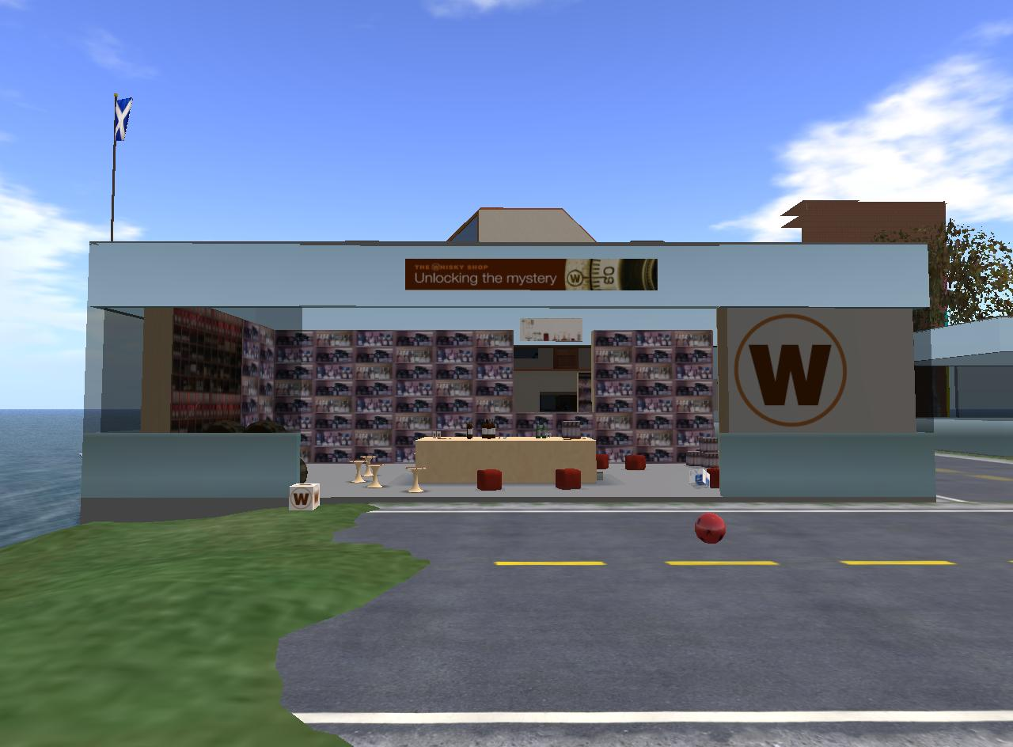
Figure 1: The Virtual World of Whisky I-Room in Second Life, built on the Virtual University of Edinburgh (Vue) site.
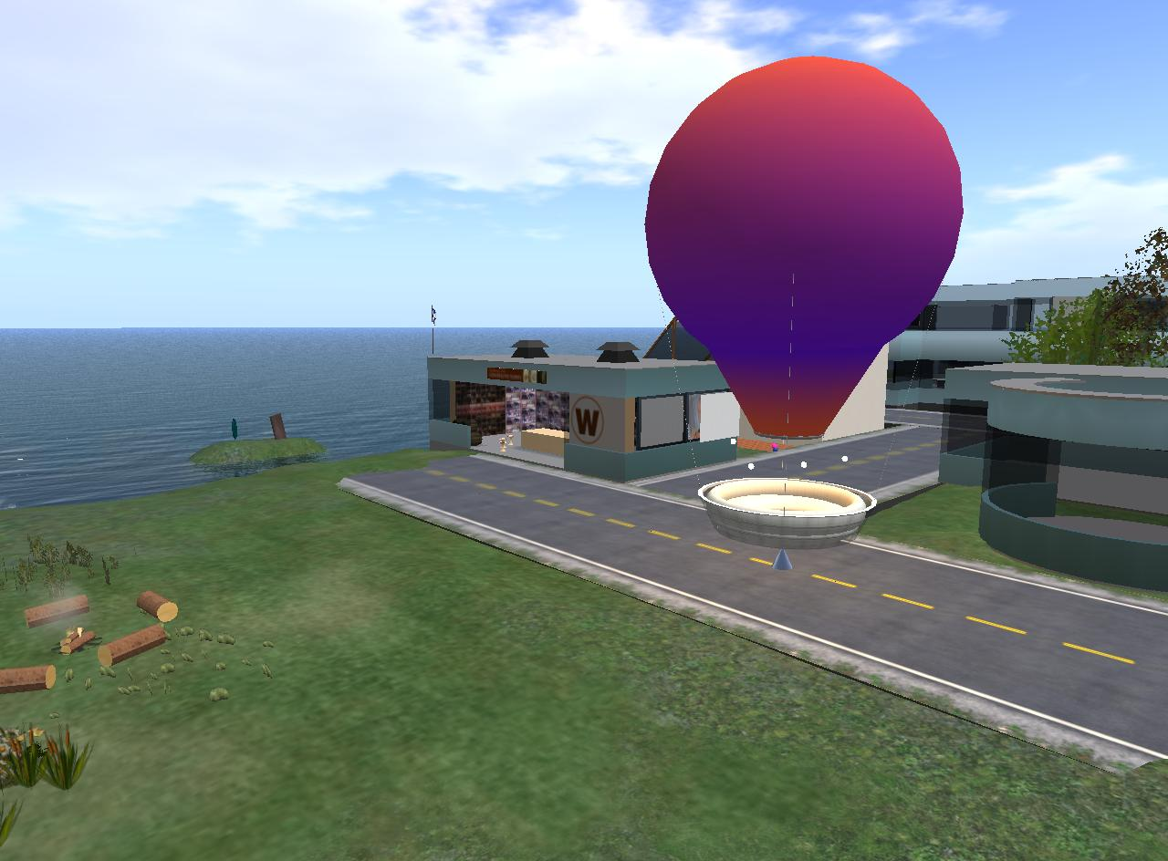
Figure 2: Educational Balloon Ride just outside the VWoW I-Room.

2. Meetings
An initial three-hour meeting was held at AIAI, University of Edinburgh on November 27th, 2007. Present at the meeting were Mr. Ian Bankier (Glenkeir Whiskies), Prof. Austin Tate (AIAI), Dr. Jessica Chen-Burger (AIAI), and Mr. David Richardson (School of Informatics) and Mr. Danny Helson (Edinburgh-Stanford Link).
During the meeting, project requirements were outlined, domain interests from both sides were exchanged and the detailed mechanism for carrying out this project was discussed and scoped. Ian Bankier also provided an overview on the Scotch Whisky Industry and discussed the possible involvement from his external web development providers, Beattie Communications.
Jessica Chen-Burger also visited the Whisky Shop premises in Princes Mall, Edinburgh. Additional background information was obtained and several other resources were obtained including a Scotch whisky book and a sample whisky-tasting glass. The whisky tasting glass was used as a template for creating a virtual 3D model which was then imported into Second Life, creating an in-world replica. This 3D replica glass is freely supplied to visiting avatars in the virtual whisky tasting room. Through the use of a (Linden) script, it animates the avatars with a tasting gesture, adding to the fun atmosphere in the virtual whisky tasting room. The information obtained from the meetings was also applied to the whisky tasting tutorials and virtual tour.
A second ‘virtual’ meeting was held in the Second Life whisky tasting room on January 25th, 2008, to coincide with the traditional Scottish celebration of Burns Night, when Prof. Austin Tate held a live whisky-tasting event focusing on the demonstration of how different intelligent tools may work together in an educational event in a virtual world. As a part of this virtual event, Second Life avatars sat and listened to the live tutorial, sampled virtual whiskies in the tasting room; the tutorial was delivered via live video feed into the Virtual World and participants sampled real whisky.
The tutorial utilised the I-X intelligent planning and activity management platform developed by AIAI in Edinburgh. Materials used to illustrate the talk and discussions were delivered using the I-X intelligent task and process support platform (http://www.aiai.ed.ac.uk/project/ix/) which was connected externally to the virtual world. Participants in this meeting were Austin Tate, David Reid (from Beattie Communications), David Richardson, Jessica Chen-Burger, Jussi Stader, Jeff Dalton, Gerhard Wickler and Stephen Potter (the last five persons are from AIAI). A recording of this live event was produced as a result.
A third virtual meeting (the final project demonstration) was held in Second Life and in real life on February 25th, 2008. Ian Bankier visited AIAI in Appleton Tower to hold a second live whisky-tasting event. The emphasis for this session was to demonstrate characteristics of Scotch whiskies using a knowledge base with enhanced functionality. The event also mirrored the whisky tasting events in real life. Other participants in this meeting were Austin Tate, David Richardson, Danny Helson, Jessica Chen-Burger, Jeff Dalton and Stephen Potter. A recording of this live event was also produced as a result.
A fourth meeting was held on March 3rd, 2008 in AIAI with Ian Bankier and AIAI staff, to refine the work performed during the previous meeting. Video content of the previous meeting was reviewed and elements were re-recorded at higher quality. A series of generic video clips covering the six whisky regions of Scotland was recorded for future demonstration purposes. This meeting also involved an interview with William Lyons, the business reporter for Scotland on Sunday.

3. Technical Exploration of 3D models in Virtual Worlds

The project explored a number of technical aspects of ways in which content for virtual worlds could be rapidly created, and external models and information could be imported. As well as Second Life, the Opensim open source virtual worlds server platform was employed for a large number of the experiments. Opensim, and other relevant open source tools, are an important aspect of how virtual worlds technologies might be deployed in future. This project provided an initial opportunity to develop such facilities.

An OpenSim server was deployed for the purpose of testing an open source solution. In a commercial deployment, this could allow Glenkeir to host a Virtual World on a local machine and enable them with enhanced control. This is also important should the company wish to restrict access to the local network.

3.1 Rapid Creation of 3D content and Context in Virtual Worlds

The project examined different ways in which externally created landform height maps, representing for example Scotland (see Figure 3), can be used to rapidly set up appropriate terrain. Custom regions for Scotland on a 2x2 region grid, and other custom shapes up to 10 regions have been created and imported into Opensim. This was used as an example of a potentially important capability for organisations who wish to establish a suitably tailored presence in a virtual world. It also means there is the possibility of hosting such facilities on corporate networks in the future where confidential collaboration and internal meetings are required.

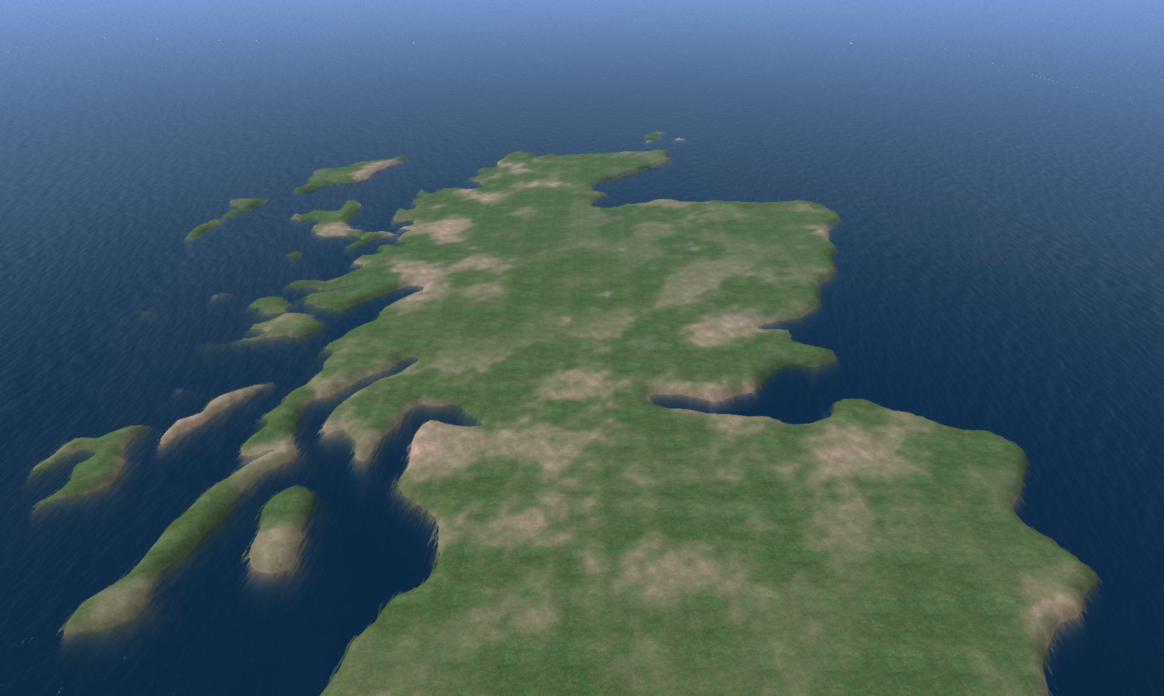
Figure 3: A Terrain Map of Scotland

3.2 Sculptured primitives techniques in Virtual Worlds

One aim was to see if externally generated 3D models could be imported into Second Life and OpenSim, which typically uses a very simple primitive shape model. Recently introduced methods to import a “sculptured” externally defined shape into Second Life have become available. This allows the shape to be loaded as single complex shaped object– via so called “sculptured primitives”. The Whisky Shop “Glencairn Glass” shape (see Figure 4) was used as an experiment for this.
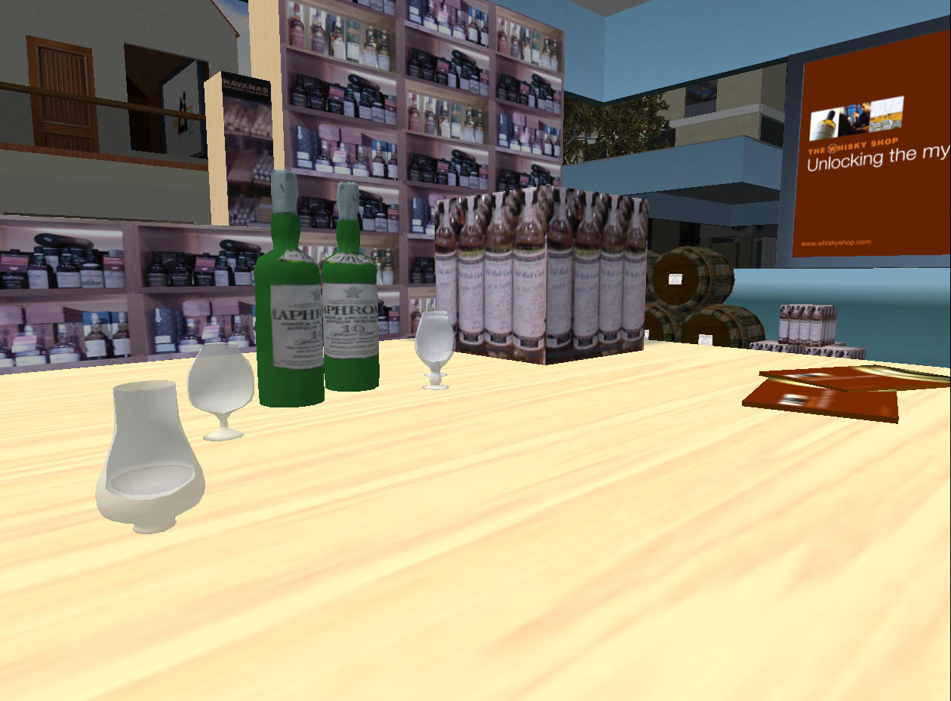

Figure 4: Sculptured primitive glasses offered
in the virtual whisky tasting room

4. Technical Demonstrations in the Virtual World

The VWoW I-Room in Second Life can be seen in Figure 5. This room contains a number of objects and decorative elements that help create the atmosphere of a real whisky shop, chairs for avatars to be seated on during the tasting (reinforcing the notion of attendance at an event) and animated whisky glass objects that the avatars are free to use (reinforcing the idea that this is specifically a whisky-tasting event). Two screens are used to relay external video streams (and their audio tracks) and static images to the participants. The link to the intelligent systems technology, in the form of an I-X system external to the virtual world, is provided through the presence of an I-X Helper object in the room. The Helper plays a mediating role, receiving and executing tutoring activities from I-X on the one hand, and on the other, passing information about the occupants of the room and the state of the session out of Second Life and back to the I-X system.
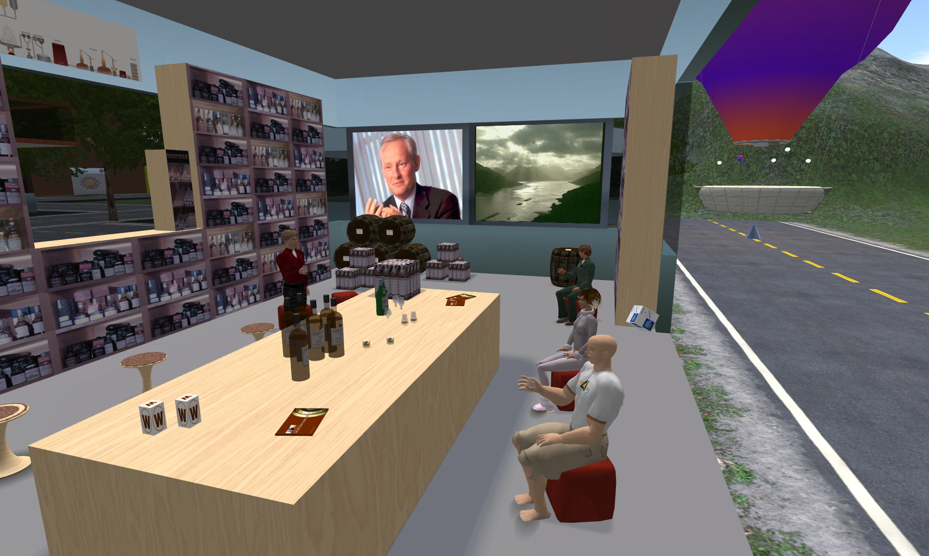
Figure 5: The Virtual World of Whisky I-Room

With this mechanism in place, an I-X whisky tutorial application has been developed. It is assumed that the tutor has access to an I-X Process Panel, which provides a primary ‘to-do list’-like interface for process control, and allows the tutor to access a number of different process models specifically tailored for this domain. These include models for delivering a number of different tutorials to the occupants of the room: a tutorial giving a general introduction to whisky, a tutorial describing the process of making whisky, and tutorials about specific (regional types of) whisky. To exploit the visual and auditory capabilities of Second Life, these processes contain references to video and image content. This content is available using static URLs to allowing the easy delivery of this sort of structured tutorials (and perhaps even the automation of tutorials). However, the system is also flexible enough to allow a tutor to provide a less rigid tutorial as and when the occasion dictates, providing mechanisms by which images can be dynamically selected, arranged into a single composite image (necessary to overcome the Second Life restriction to but a single external image stream at any given time), notified to the tutorial room and then juxtaposed on the twin screens.
A further aspect of the tutorial support offered by I-X lies in the use of Natural Language Generation (NLG) technologies to automatically generate text. This exploits a comprehensive whisky knowledge base, describing whisky types, characteristics, classifications, distilleries and so on. One use of NLG is through a structured tasting tutorial that generates simple sentences introducing the whisky in question, saying something about the distillery and the whisky’s geographical classification, and describing its characteristics of nose, colour, palate, and so on. These sentences could be used by the tutor as the factual basis of his tutorial or to supplement his words, or else could be used to support simple automated tasting tutorials. A more complex use of NLG that has been explored is to provide richer tasting descriptions, closer in style to the sort of tasting notes that a human expert would use, and transmitting, one would hope, something of the tutor’s enthusiasm for whisky to his audience.
Each of these tutorial processes is supported by the in-world I-X Helper object. In accordance with the notions of I-X as an activity-support tool, this is accomplished by passing activities to the Helper. These can be activities that the Helper can perform directly (such as “say” something to the occupants of the room), or activities that the Helper can perform through exploiting the capabilities of other objects in the room (such as “display” some image, which is passed on to one or other of the screens). (Activities that the Helper can neither perform directly or indirectly are echoed to the room in the hope that a listening avatar or object can perform this action.) In addition, the Helper can monitor certain events, such as the arrival or departure of avatars, which are sent to the I-X system as state information. This state information can be used to guide or qualify behaviour; for example, the start of a certain tutorial process may require (as a precondition) the presence of a certain number of avatars in the room. The Helper also provides some indication of when its activities have been performed; this can be useful in processes containing strict sequential constraints (for example, before describing the whisky regions of Scotland, one might first want to ensure that the corresponding map has been displayed to the occupants of the room).

5. Virtual World of Whisky Educational Balloon Tour

To carry out this part of the project, an initial search on organisations (in Second Life) that provide tours was carried out. It was found that most proprietary tour systems were not automated. The project aimed to examine the use of automated methods enabling any visitor to experience an on-demand tour without any human assistance. The Guided Tour Company was identified as a suitable source for obtaining a Tour Guide Utility (secondlife://Mocha/238/74/32 ).

The Guided Tour System (GTS) was used for the purposes of developing an interactive tour for the Whisky industry. Our ambition is to create an automated guided tour for a small group of visitors. We have therefore chosen to purchase a Balloon Vehicle that may sit a maximum of 8 persons. The balloon vehicle when equipped with appropriate instructions (written in Linden Scripting Language) can visit a large number of specified locations, travel automatically in a pre-determined manner and route, give descriptions to landscape and landmarks as passing by, producing sound effects and even interact with objects on the ground if such objects exist in the land passing by.

Due to the infancy of the chosen tour guide platform, development was not straightforward. The system lacked complete and accurate technical information and limited customer support was available. A number of experimental trial-and-error steps were taken to determine the best approach. Moreover, complicated issues of touring virtual land have arisen. One key challenge was enabling the tour guide to pass over land where access permissions were limited (in cases where land was owned by other entities). Example issues included accessing land, producing animated effects via running scripts and crossing land boundaries. Crossing land boundaries was especially challenging as different simulators with varying capabilities were sometimes involved These issues create technical challenges for any large scale commercial development.

For the difficulties mentioned, we identified suitable solutions and work-arounds. The GTS providers were helpful in guiding our advanced uses of their system, as they are also educators. We documented our approach and produced a “user friendly” manual for the GTS system so that new users of the system could replicate our approach. Although the GTS system is subject to changes in the future, our documentation is written in such a way that it helps its reader to understand the principles of how tour guide systems work and provides a valuable resource for further development. This document is titled “Creating a Tour with the Guided Tour System” and is available for download on the project web site.

Moreover, in order to assist future rapid generation of guided tours, we have created a library of sample tour scripts for future reuse.

As a result, an automated educational virtual balloon tour has been created and placed just outside of the virtual whisky tasting room, as pictured in Figure 2. This tour operates 24/7 for its visitors. It travels around landscape around the virtual The Whisky Shop (as previously shown in Figure 1) and gives introductions to nearby buildings and activities carried out in them.

Such virtual touring facilities are generic and can be applied to any domain where a virtual tour could provide benefit. The system development could be modified and enhanced by Glenkeir Whiskies should this be required in the future.

6. Project Results - Legacies Left for the Future

The project focus was to develop the Virtual World of Whisky (VWoW) and its demonstration in two areas (related to the whisky industry):
  - Virtual World of Whisky Geographical Tour, and
  - Virtual Whisky Tasting/Tutorial Room.
Work has been carried out in both of these areas. In particular, the two demonstrations have been described in detail in Section 4 and 5. We provide here a list of resources which has been produced by this project.
Resources left inside the virtual world of Second Life are provided below: (all are free to visit and used by all avatars, where appropriate)
- The virtual whisky room, The Whisky Shop: It provides facilities for carrying out live demonstrations, free virtual whisky tasting glasses and the tasting of virtual whiskies for all visiting avatars. The Second Life address of The Whisky Shop is: secondlife://Informatics/187/158/25
- Balloon ride around The Whisky Shop – it provides a free introduction ride to landmarks around The Whisky Shop. The tour starts at the Whisky Shop.
- Balloon ride for touring around the Vue – this provides a tour of 4 lands owned by the Vue development. It does not include the far-north and far-south lands, such as Edinburgh Castle and AIAI areas. The tour starts at: secondlife://Informatics/51/21/22

In addition, this project has left documentation and digital resources covering aspects of knowledge of virtual world technologies.
These include:

- Generic advice and pointers for new comers to the virtual world of Second Life: a report entitled “Generic advice on Creating and Styling Your Avatar”.
- User manual on how to use the GTS system for producing guided tours: a documented entitled “Creating a Tour with the Guided Tour System”
- A library of working script templates that gives examples of running the GTS vehicles.
- A set of Whisky tutorial slides that has been used to support the production of whisky live tasting events.
- Video recordings of the two live whisky tasting events.
- Photo gallery of images from the VWoW project.
- A tour guide and tutor avatar has been created as a part of this project, Skye Gears. Her web site is available at: http://www.aiai.ed.ac.uk/~skye/ where additional educational material regarding Second Life is available.

7. Work Packages Diligences

In this section, we map efforts carried out in the project with work packages originally outlined in the proposal.

WP1 – Meeting Glenkeir Whiskies Limited (Whisky Shop) for user requirements meetings. Requirements specification and project scope with help from Glenkeir Whiskies Ltd. [2 man weeks]
Result: complete, works summarised in Section 2.
WP2 – Study of relevant asset available from other educators and researcher, or tools widely available in Second Life – e.g. whiteboards, picture screens, presentation screens, presence indicators, virtual tour sites, virtual tour systems, interactive user interfaces for virtual entities and avatars. Write a reference report on relevant technologies and tools. Build project resources web site. [1 man month]
Result: complete, works summarised in Section 3-6.
WP3 - Exploration of relevant technologies and rapid creation of a region in Second Life seeking to maximise the use of external content, resources and tools, e.g. landform upload, signs, tour data, etc. Test on Virtual AIAI Grid and a potential new island in Second Life.
Result: complete, works summarised in Section 3.
WP4 – Creation of a Virtual World of Whisky Geographical Tour: to build an interactive virtual world tour and its operators. Create interactive objects that are responsive to virtual world entities. [1 man month]
Result: complete, works summarised in Section 5.
WP5 – Creation of a Virtual Whisky Tasting Room: to research how “Questioning and Answering” functions may be facilitated and to enable the logging of such activities. In addition, it is also to provide multi-media communications, such as video and audio presentations, “tasting” of whisky, interacting with objects, etc. To design and implement the Virtual Whisky Tasting/Tutorial Room. [1 man month]
Result: complete, works summarised in Section 4.
WP6 – Knowledge Transfer: to provide 2 system demos as detailed in the “Demo Components” session provided below; to create tutorial manuals and educational materials as how to use and configure the Whisky Tour system based on an original full four system manuals of a tour package. Enrich project web site with links, results and resources. Provide final report, lesson learned and issues, etc. [2 man weeks]

Result: complete, works summarised in Section 2-6. This document is also a part of the deliverables.

8. Future Work

Virtual World technologies such as Second Life and OpenSim will play an important part in future communication and collaboration activities. The first (US dollar) millionaire was made solely from trading in the Second Life back in 2006. Today, Second Life has 6 millions registered users and worth of 300 Millions pounds annually in terms of traded items. Several large technology companies are putting hefty investment in virtual world technologies, including Microsoft and Sony. The current position of virtual world technologies could be considered similar to the early stages of the WWW (World Wide Web). Should this be the case, there is huge commercial potential for new and existing businesses to exploit different kinds of business models.

This ERDF funded project has allowed Glenkeir Whiskies Limited to examine the possibilities of trading and participating in a Virtual Worlds. This could lead to a significant commercial advantage for the company going forward.

During the course of this project, the participants have been given a valuable insight into Virtual Worlds and the opportunity they bring. We have explored and exposed relevant technologies which could be applied to a commercial solution.

This project has been successful at achieving its goals and provided Glenkeir Whiskies with a number of areas which could be covered in follow-up activities.

This could include examining how intelligent technologies may be composed differently and in more interactive ways, e.g. to animate and enact different objects in the virtual world so that they can interact with avatars and with each other; to keep memory of previous interactions with avatars and other objects so that they can react accordingly when received a new “relevant” action; to be enriched and empowered with human natural language capabilities so that avatars can hold simple conversations with VW animated objects. These capabilities are not possible yet, can they be achieved? What are required to be there to make this happen?

9. Glenkeir Whiskies Feedback

“This project has opened our eyes to the commercial opportunities that will inevitably emerge from the current developments in 3D graphics technology. The School of Informatics were extremely good to work with. They were fast, to the point and practical and they delivered exactly what they said they would within the stated time frame. The virtual whisky shop works and can be commercialised without too much difficulty. It only remains to be seen how web sites like Second Life will evolve across the world’s computer community as they mature.”

Ian P Bankier
Executive Chairman
Glenkeir Whiskies Limited
Glasgow, G11 7YF

Acknowledgements

This project is co-sponsored by the ERDF (European Regional Development Fund), the University of Edinburgh and Glenkeir Whiskies Limited. ERDF provided financial support (4.5 man months). The University of Edinburgh provides background technical knowledge, personnel time (Prof. Austin Tate 10% and David Richardson approx 5%), purchase of the Guided Tour System in Second Life and computing resources used for this project. The computing resources sponsored also included the use of land purchased in the Second Life by the School of Informatics. Ian Bankier, Glenkeir Whiskies Limited, Glasgow, has also provided his time, expertise and some products for demonstration purposes.
The University of Edinburgh is a charitable body, registered in Scotland, with registration number SC005336.

Appendix A. News Article Published by Scotland on Sunday

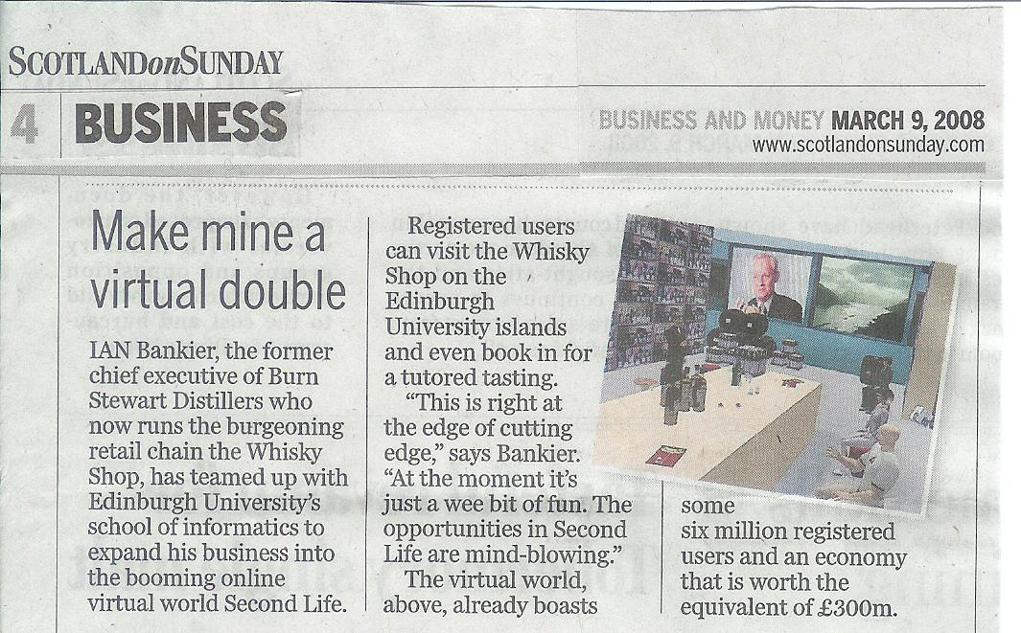

This project is co-funded by ERDF and the University of Edinburgh.
Linden Scripting Language (LSL) is a high level programming language used in Second Life.
Burns Night is a traditional Scottish dinner celebration to commemorate the life and works of Scotland’s most famous poet, Robert Burns. For this event, Whisky drinking is an important part of the ceremony as well as a part of the meal.
http://opensimulator.org
This work done in collaboration with Chris Christodoulopoulos, an Informatics MSc student at the University of Edinburgh.

