ERDF Slam Games Project Report

http://www.aiai.ed.ac.uk/project/i-room/
11th April 2008
Jussi Stader, Austin Tate, Stephen Potter, Jeff Dalton (AIAI)
David Richardson (Informatics), Chris Walton (Slam Games/Metaforic)

Introduction
The aim of this ERDF-funded project was to assess the feasibility and demonstrate the practical application of Virtual World technologies in the computer gaming industry. The outcomes of this project could be used to develop new and innovative products and services for the gaming industry.
We decided to investigate scenarios in three broad areas: work and play. For SLAM, this would mean
- one scenario that supports the collaborative development of games, and
- one scenario that addresses areas of game playing.
Each scenario was deployed using the I-Room approach developed by the Artificial Intelligence Applications Institute at the School of Informatics. Any demonstrators developed were packaged and documented in a way that enables non-expert users to rapidly set up their own I-Room application.
The longer term aim of the I-Room research programme within the School of Informatics is to provide an intelligent assistant for the coordination of agents within virtual meeting environments.

Meetings
A meeting was held at AIAI’s offices on 5th September 2007 to discuss direction and requirements for the project. Present at the meeting were Chris Walton (SLAM), Austin Tate, Jussi Stader and Stephen Potter (all AIAI), along with David Richardson and Danny Helson (both Informatics BDE). A second meeting was held on 5th November 2007 with the same participants plus Jeff Dalton (AIAI). At this meeting, initial developments were demonstrated, scenarios were fleshed out, and development plans were made. The final project meeting was held on 28th February at AIAI, attended by Chris Walton, Austin Tate, Jussi Stader, Stephen Potter, Jeff Dalton and David Richardson, and at which the results of the project were presented.

SLAM’s Current Working Practices
SLAM currently make two types of games:
- games that are downloaded to the player’s own device where they are played without further interaction with the internet;
- “flash” games for which an internet link to a central game server is maintained for saving, viewing and comparing high-scores.
In the future, SLAM is planning to provide more of the latter games and establish game lobbies and virtual, multi-player environments that can serve a community of players.

Game Development and Collaboration
For game development, SLAM itself concentrates on the design, programming and development of the game core while the design and production of most artwork, sound and other media are outsourced, often to geographically remote locations (e.g. Malaysia). Communication with the (external) artists (and media companies) is mainly via e-mail and sometimes by phone.
Usually, SLAM prepares a brief for the artists who then produce a first draft of the artwork (textures, 3D models, animations, etc). The artwork is passed to SLAM which evaluates it and request changes where necessary. SLAM has a resident artist who deals with most of the artwork (including preparing briefs). If required, the resident artist will present alternative work for colleagues so that a collaborative decision can be taken as to which artwork to use. These options are presented in the form of 2D stills taken from the 3D models produced by the artists.
In addition, some of the games programming work is outsourced to contractors. In these situations, some face-to-face meetings are necessary, but most collaboration happens via:
- the Confluence enterprise wiki. This stores all contacts, media, data, etc. This is used extensively in-house, with contractors having limited access, restricted to only the area directly relevant to their work.
- the Campfire chat environment using (typed, no voice) instant messaging with multiple participants. A room metaphor is used for virtual meetings, and records are kept for future reference.
- JIRA for reporting bugs, testing, and milestone management.
In addition to external collaboration with artists or programmers, SLAM’s internal work is also collaborative. This internal collaboration happens at weekly intervals where issues are discussed, progress is monitored and milestones are managed. These meetings are also supported with the tools above.

SLAM Project Work - Details
At the start of a project, a project plan is generated with monthly milestones. Weekly internal meetings are held as “sprint” meetings using an “agile” methodology. Tasks (actions) from the previous meeting are discussed in turn and dealt with. Minutes and notes from previous meetings are available for clarification. If required, artwork is discussed in these meetings too. Progress against the next set of milestones is also checked. Any carried or new tasks are noted.

SLAM's “List of Difficult Things”
SLAM’s resident artist has listed a number of problems that arise when collaborating with external artists:
- Preparing specs and briefs takes a long time. Often it is quicker for the artist to do the work themselves.
- Turnaround is slow – comments on external artists’ work take time to specify, to be acted on and to be returned to SLAM.
- Feedback mechanisms are difficult (using mainly e-mail; it is hard to talk about pictures without being able to point).
- Communication about the artwork and other media can be difficult, especially when talking about animations. Misunderstandings occur about which part of a character’s animation needs to be changed. (Example problem: “SLAM doesn't like the way there is a hop in the character’s gait in animation”; the artist makes changes, but in the next version the hop is still there because the artist understood the hop to be in a different part of the animation.)
- Artists don’t like reading:
- The time taken to prepare detailed brief is wasted (only the first line is read and the work produced on the basis of the information it contains). A picture brief may work better!
- Emailing texts is not conducive.
- Different artwork projects overlap:
- It is difficult to keep track of the status of each project (including which needs attention!).
- Sometimes projects are confused with each other.
- JIRA is difficult to use.
- Campfire is not ideal:
- Communication is slow! Typing is much slower than talking and does not lend itself to live discussions with several people. Therefore, discussions do not happen during these meetings and consensus is reached too quickly and without proper discussion of issues.
- It is difficult to manage different rooms with different meetings and it is easy to make mistakes! E.g. typing a comment into the wrong meeting.
  - Where should I be?
  - What discussions should I join?
  - Which discussion is my comment entering?
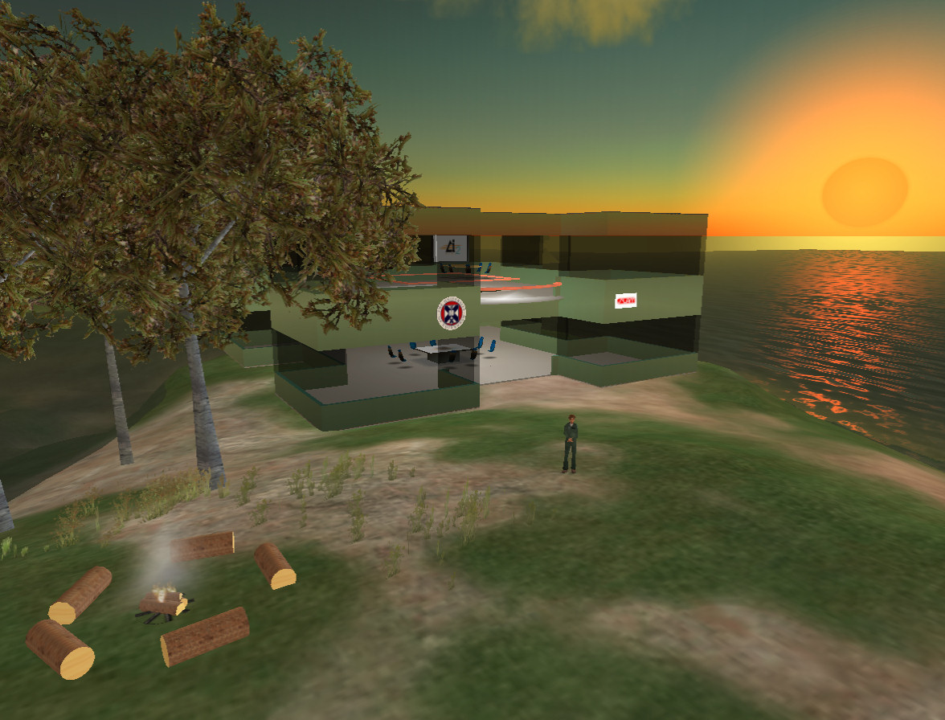
- HOWEVER: Campfire keeps a log of meetings which can be used to go back to previous discussions and replay what was said. This history keeping is useful!

Support for Game Playing
Currently, SLAM’s “games lobby” is web-based. SLAM players can nominate other players as “friends” and challenge them to beat their score, chat, etc. By visiting SLAM’s joyboost.com web site, users can log in with their username (or as guests). and they can launch a flash game (with their username as a parameter, giving them a UID) which is embedded in the web page. When their game is finished, the score is returned to the web-server (using the a RESTful approach), where it is stored. Players can then inspect their own and their friends’ scores.

The Scenarios
The two scenarios are:
- I-Room Media – a meeting room where developers (and artists) can meet for collaborative development of games, and;
- I-Room Games – a fun and games lobby where players can meet and chat about games and scores.

Scenario I: I-Room Media – Collaborative Game Development
We decided to use a scenario which represents a meeting some way through a project. A project plan has already been generated and milestones have been set. Some weekly meetings have already been held.
The demo meeting is a normal weekly meeting. Actions (tasks) from the previous meeting are discussed in turn and dealt with. Progress against the next set of milestones is also checked. Any carried or new tasks are noted.
In this particular meeting, artwork is to be discussed, which is presented by the resident artist in the form of 2D stills from 3D models.

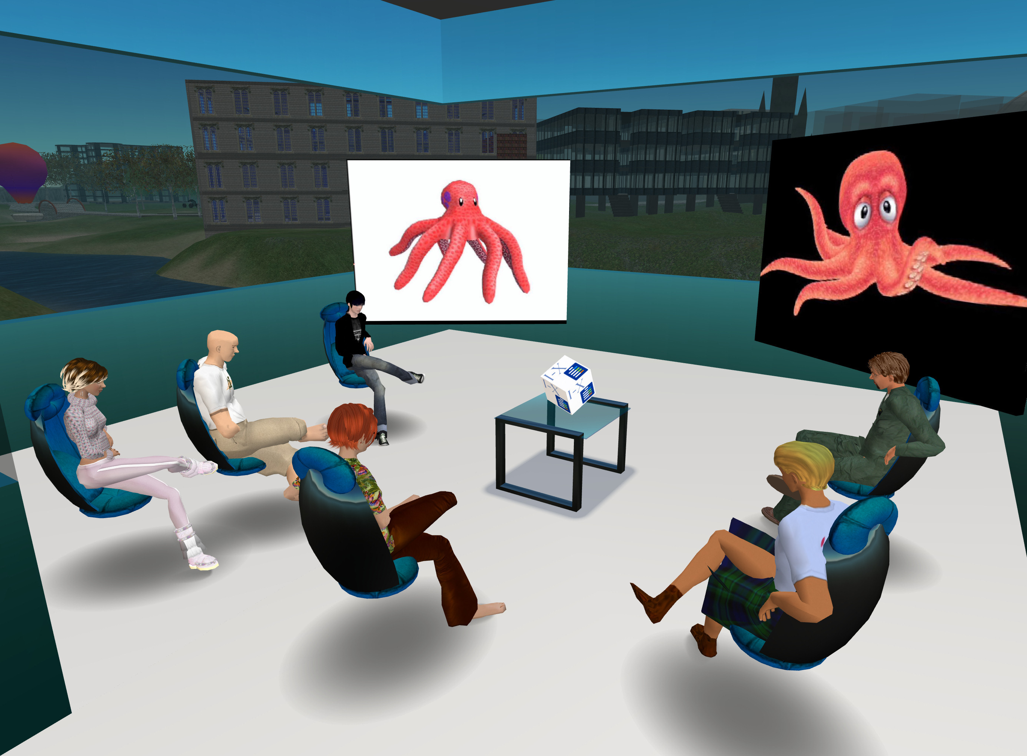
Support
The I-Room has mechanisms for displaying artwork and other media and showing animations (probably via screen-capture), as well as supporting the flow of meetings (e.g. via I-X) and recording arguments, communications, and decisions.
The I-Room is voice-enabled to support discussions to reach a proper consensus on issues. Minutes and actions can be recorded for future reference. In this demo, anything that is to be recorded must be ‘said’ by meeting participants on a specific chat channel. An in-world “I-Room Helper” agent is listening on this channel for specific keywords which indicate how to process the message (e.g. “action Ai Austin improve seating in meeting room” indicates an action placed on Ai Austin to be recorded and “minute we cannot agree on this issue without Jeff” indicates a minute to be associated with the current phase of the meeting). The use of a dedicated channel (which will not necessarily be known to all participants) allows a certain degree of control to be maintained, effectively allowing the chair of the meeting or a designated secretary to determine which items are destined for the meeting records; however the Helper echoes each item it receives to all in the room so that all meeting participants are aware of the items that are being recorded.
The actions of the last meeting are presented as a list of “discussion” activities for the current meeting, allowing actions to be marked as done, carried, or no longer applicable. Notes (minutes and actions) from previous meetings are available on request.
The project milestones for the month should also be available as a list of issues to address. Each of these should be discussed, addressing any risks related to meeting the milestone. New actions may arise from such discussions.
The use of a virtual world for meetings has the potential to address one of the main weaknesses of current practice, namely the inability to view and contrast artwork in a shared setting. Accordingly, there are mechanisms in the I-Room (the I-Room screens) for displaying different artworks, allowing the participants to discuss and compare and, where appropriate, to reach some consensus on which alternative to use.
There should be as much support as possible for the agile methodology (especially sprint meetings)

Scenario II. Games Lobby – Fun & Games I-Room
SLAM would like to establish a community of game-players who like SLAM games and who keep coming back to play. Ways to achieve this are to set up competition among players (high scores per day and overall, hall of fame, etc.), and to get players to chat to each other (and SLAM staff).
The I-Room could be set up as a games lobby where high-scores and trophies are displayed. There could be hooks to trigger a flash game which the player can go off and play, with scores being passed back to the I-Room to display.
The I-Room could display high-scores (daily/overall) and provide a space for players to meet and chat to other players (e.g. about the high-scores). It could display pictures of the games for people to chat about, maybe even allowing players to provide feedback to the developers and contribute to the development process, thereby heightening the sense of a SLAM community.

Results
In this project, the development of the I-Room Games scenario stopped with initial investigations, while for the I-Room Media scenario a working demonstrator was produced. The demonstrator implements many of the support requirements outlined for the scenario I above. A video of a sample meeting using the I-Room is available. For details on the I-Room Media demonstrator see its documentation.
SLAM’s reception of the I-Room Media Demonstrator was positive as indicated in this report from Chris Walton of Slam games/Metaforic on 11th April 2008:
Our experience of the I-Room media demonstrator was very positive. Slam Games operates in a distributed development environment, with the participants (e.g. programmers, artists, musicians) spread over multiple physical locations. This environment makes face-to-face meetings impractical, and so we use many different collaboration technologies to manage our interactions. The tools that we currently use are primarily text-based (e.g. email, IM, campfire, Confluence, and JIRA). While this is acceptable, we believe there are many advantages to having a visual component to our interactions, as provided by the I-Room demonstrator.
The main limitation of text-based tools is that it can be difficult to describe the source of a problem. In our experience, it often requires many messages to be sent back-and-forth before the source of the problem is properly communicated. By contrast, with face-to-face interactions we would simply be able to say “show me the problem”. The I-Room goes a long way towards addressing this issue. It provides a facility for displaying graphical images, and allows the participants to use text, voice, and gestures to effectively communicate the problem areas. This facility would significantly mitigate the communication issues that we currently have.
An additional advantage of the I-Room demonstrator is that it has low technology requirements for the participants. Essentially any computer with a reasonably Internet connection and a microphone can participate. This is very important for us as we do not want to become bogged down in complex technological requirements or installation procedures. We interact with many different groups of people, and these groups are constantly changing, so we do not want to impose technological barriers before they can talk to us. The requirements of the I-Room demonstrator appear to provide a good fit to our existing collaboration technologies.
The I-Room demonstrator provides a facility for gathering meeting minutes. This is essential for us, as we need to have a record of the decisions made in our meetings for contractual purposes. We need to be able to refer back to decisions made in meetings to ensure that any issues raised have been properly solved. Finally, the simple provision of a visual avatar for each of the meeting participants is a useful facility. We often do not want to communicate internal decisions to external contractors. The presence of the avatars is an important visual cue as to who is involved in the meeting, what topics should be discussed or avoided, and to ensure that all of the necessary participants are present.
In summary, the I-Room media demonstrator provides a direct solution to many of the issues of communication in a distributed environment, as we have at Slam Games. We will be giving serious consideration to adding this facility to our set of collaboration technologies.

Future Work
Developing and demonstrating the I-Room media work has already inspired many ideas of how it can be made more useful. The following list notes some of the ideas:
- A pointer in Second Life could be used by avatars to point to specific areas of the visual displays during discussions;
- Recording the meeting and retrieving bits of the meeting that happened around specific times would be useful, e.g. “what happened the 5 minutes before we created this action?”. Previous AIAI and University of Southampton work in the CoAKTinG project on a media replay tool linked to I-X could be relevant for this.
- There is scope in SL for avatars to participate in more than one meeting at a time. Managing different meetings happening in different rooms at the same time can help prevent avatars becoming confused and allow them to focus on the right meeting at the right time.

