Semantic Web (SWEB) Integration in ESG Enabling Experimentation (EEE)
By
Douglas Horner
Research Associate
Naval Postgraduate School

The objective of this subtask was to examine the use of SWEB technologies to support agents and a sensor grid. The SWEB is a vision of the future Internet that attaches explicit meaning to information and makes it possible for machines to process and integrate data to assist and enhance decision-making. This can be thought of as a series of layered language applications for the explicit representation of information and ultimately trusted knowledge. From bottom to top these layers consist of: Uniform Resource Identifier (URI), Extensible Markup Language (XML) and Namespaces, Resource Description Framework (RDF), Ontology vocabulary (DAML + OIL and WEB-ONT) and Logic and Inference Engines. Please see figure 1 and a Semantic Web overview for more information.

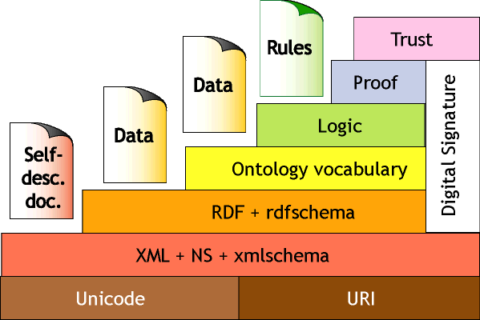

Figure 1

The focus on FY-02 experimentation within this subtask was to determine the applicability of the World Wide Web Consortium (W3C) recommendations within the agent-based and distributed computing environment of EEE. In other words, to determine how software agents could use the W3C recommendations to enhance mission effectiveness. Some of the questions we tried to address are as follows: Is the SWEB recommendations a necessary and sufficient technology to the ESG? Does use of these tools enhance the ability to deliver actionable and confirmable information to the war fighter? Will it promote a reduction in manpower for a sensor grid? Will the specifications be scalable? Will the tools enhance and promote the ability to integrate data in a meaningful way? Will the technologies be secure?

To try and answer these questions we developed a prototype called ArchAngel. It addresses the very basic starting point of how software agents can be used to enhance the ability of the war fighter. The ArchAngel premise is: If mission or unit commanders had their own set of personalized agents, what would they look like and do? Some initial starting points were as follows:

- These personalized agents work in your own self-directed interest.
- They provide individualized services including:
  - Collection of pertinent intelligence data
  - Mission recommendations
  - Mission analysis
  - Contextual Situational Awareness
- They are persistent in that they collect data and update the user on a continuous basis.

In any mission there is an operational continuum. This is the cycle that any military planner goes through in the tasking, planning and execution of a mission. It can be broadly broken into the following phases: pre-mission planning, insertion, infiltrate, actions at the objective area, exfil, extraction, post-mission analysis and reporting. Software agents can be effectively utilized to help military commanders through each phase. For initial development of the ArchAngel prototype, the emphasis was placed on the pre-mission tasking and planning and focused on a Combat Search Air Rescue (CSAR) mission scenario. It was developed and functions using the CoABS Grid Agent software. The ArchAngel methodology consists of the following steps (See figure 2):

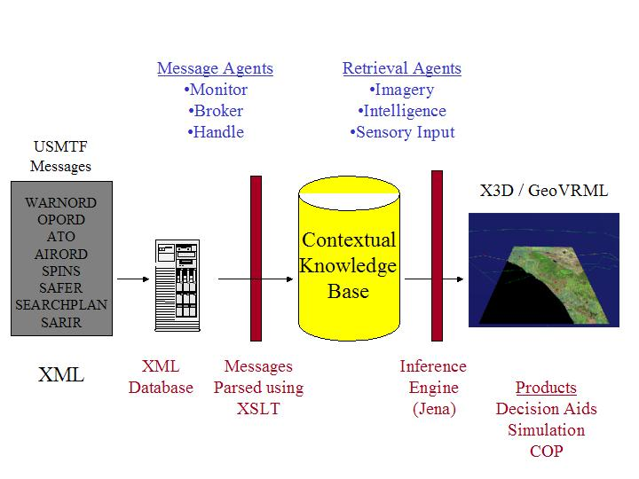
Figure 2

- Retrieving information from sources. In military operations, a primary source of initial information is received through USMTF message traffic. For pre-mission planning of a CSAR operation there are several messages that give the responding unit a point of departure for planning. Below is a list of some of the pertinent messages.
  - WARNORD – Warning Order. Used to notify units to get ready for mission tasking.
  - ORDER* – Operations Order. The order is used to provide the standard five-paragraph order and is used to transmit instructions and directives to subordinate and supporting military organizations.
  - ATO* – Air Tasking Order. The ATO is used to task air missions, assign cross force tasking, and intraservice tasking.
  - SPINS* – Special Instructions. An addendum to the ATO, normally giving pertinent CSAR instructions.
  - INTSUM* – Intelligence Summary including enemy units and locations.
  - SEARCHPLAN* – Search Action Plan. The SEARCHPLAN is used to designate the actions required of participating search and rescue units and agencies during a search and rescue mission.
  - AIRORD* – Air Order. Gives Route, Racetrack and control points in the Air Operations Area.
  - SAFER* - Situated Area for Evasion and Recovery.
  - SARIR – Search and Rescue Incident Report. The SARIR is used to report any situation which may require a search and rescue effort.

The above messages with asterisks were developed for an exemplar scenario. The full versions of the messages were stored in an XML database. The database used Xindice (pronounced zeen-dee-chay) as an open source, native XML database from IBM Alphaworks. All data that goes into and out of the Xindice server is XML. The query language used is XPath and the programming APIs support Document Object Model (DOM) and Simple API for XML (SAX). When working with XML data and Xindice, there is no mapping between different data models. You simply design your data as XML and store it as XML. This gives you tremendous flexibility. XML provides a flexible mechanism for modeling application data and in many cases will allow you to model constructs that are difficult or impossible to model in more traditional systems.
By using a native XML database such as Xindice to store this data, you can focus on building applications and not worry about how the XML construct maps to the underlying data store or trying to force a flexible data model into a rigid set of schema constraints. This is especially valuable when you have complex XML structures that would be difficult or impossible to map to a more structured database. DAML+OIL ontology structures are readily stored, along with Resource Description Framework (RDF) instance data, in Xindice with no special consideration needed for how to store or manage the complex structures.
Xindice can be accessed using Xincon. Xincon (pronounced zeen-con) is an open source web and web Distributed Authoring and Versioning (webDAV) interface for Xindice. Used together with the open source Apache Tomcat servlet engine, it provides remote XML content through a user interface that supports XPath queries. Tomcat is the servlet container that is used in the official Reference Implementation for the Java Servlet and JavaServer Pages technologies. The Java Servlet and JavaServer Pages specifications are developed by Sun under the Java Community Process. This configuration of applications allows easy human and/or programmatic storage, retrieval and searching of XML documents over the Internet using the HTTP protocol.
- Search for and parse incoming information. Agents are ideally suited for this type of assignment. For the prototype we used a team of 8 agents for handling the incoming USMTF message traffic, these broke down into the following types of agents: Message Handler (6), Message Broker (1) and a Message Watch (1) agent. All agents were developed using the Global InfoTek CoABS Grid software. For this team of agents the following steps were taken.
  - A Message Watch agent was responsible for viewing incoming messages to see if any pertained to the CSAR mission.
  - If there was a message match, the agent sent a message to a Message Broker agent. This Message Broker agent was responsible for contacting the MessageHandling agent and notifying it that there was a message for retrieval from the message-processing center.
  - For this initial design there was a Message Handling agent for each type of message. Each Message Handling agent: 1) Downloaded the message from the XML database. 2) Parsed the incoming message. 3) Stored the parsed message in the knowledge base.
Messages frequently contain information that may be redundant or not useful for mission planners. For this reason it was necessary to parse the messages before entry into the knowledge base. The messages were original written in XML and this permitted the messages to be easily parsed using the Extensible Stylesheet Language Transformation (XSLT). While messages currently are coded in a text-based format, a message encoded in XML is not a large leap. There is an effort underway called The Joint-NATO XML-MTF Initiative (Site is password protected), which has published draft recommendations for encoding MTF messages in XML.

- Import information into a contextual knowledge base (KB). XSLT was used to import and update the parsed messages into the KB. There are four parts to the KB (See Figure 3):
  - The Master Operational Context (MOC) document. An XML document which contained the parsed message information.
  - A military operations ontology encoded in DAML+OIL specifically for CSAR missions.
  - Instance data based on the military operations ontology. The data was encoded in DAML+OIL.
  - A XSLT style sheet that mapped the MOC data into the instance data of the DAML+OIL ontology.
This construction of the KB permitted a great degree of flexibility for development and experimenting with different types of ontologies.

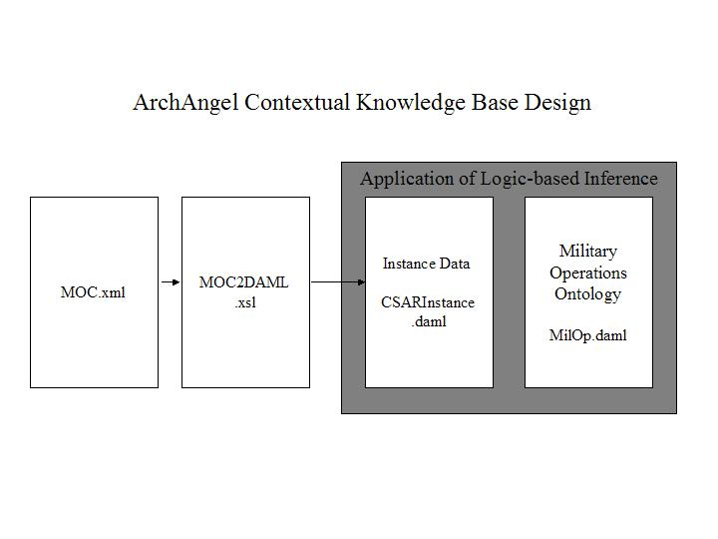
Figure 3

- Fill in missing holes/confirm existing data. Messages or any other information input into a KB will rarely be enough to support effective decision-making, but it can be used as a point of departure. In other words, agents can conduct analysis on the existing KB. This includes pursuing independent confirmation of the facts or filling in holes by searching for information needed to make effective decisions, improve situational awareness or augment modeling and simulation. For the ArchAngel prototype, this concept was demonstrated by taking the known target locations and having an agent search for the most recent satellite image of the target area and overlaying the image on the terrain mapping.
- Draw logical inferences to reach conclusions. Part of the process of developing the KB is to define inference mechanisms that can effectively answer questions posed in first-order logic. There are a number of tools available for reading and writing DAML+OIL and then applying an inference engine to obtain conclusions. The two APIs we started to work with are Hewlett-Packard’s Jena and Sandia National Laboratory’s Jess. Jena is a Java API for reading and writing RDF and DAML and Jess is an API for developing custom rules in Java. This is an ongoing area of research for the ArchAngel prototype.
- What to do with the information. There are at least three ways to use the KB effectively for ArchAngel, they are:
  - Decision-making
  - Situational awareness
  - Modeling and simulation

The first two have utility throughout the operational continuum. We believe that Modeling and Simulation is also relevant throughout the complete operational cycle but traditionally has been used normally only during the pre-mission and post-mission phases. For the ArchAngel prototype we focused on the display of the information to demonstrate the utility of the tool to enhance CSAR situational awareness. Simply described, we took the information provided by the USMTF messages and provided this as an overlay to a three-dimensional terrain visualization. It includes the following information:
  - Target locations
  - Enemy positions
  - SAFE areas
  - Spider routes
  - Air control points
  - Air control racetracks
  - Air routes
  - Areas of operation
    - Joint Special Operations Area
    - Air Operations Area
Because the information is being updated daily via messages, visualization of the area of operations can be effective for units on standby for downed pilot response. This can give all participants a better understanding of the CSAR domain.

Technically this was accomplished as follows: An agent was developed for taking the MOC and converting the information into a three-dimensional representation. The 3D representation was accomplished using the Extensible 3D Graphics (X3D) specification. Within the X3D scene, GeoVRML was used to combine terrain images with elevation data (Digital Terrain Elevation Data – Level 1) to produce a quad-tree, 3D terrain representation of the operating area. To produce the overlay in the X3D scene, the agent converted the MOC using 2 XSLT style sheets. This used JDOM and the Java Javax package to read in XML and apply XSL Transformations to produce the Virtual Reality Modeling Language (VRML97) scene. This is viewable using a Internet browser (Netscape 4.79) with 3D plug-in (Cosmo).

Lessons Learned

- The SWEB concepts developed for the Internet are extremely relevant for an agent-based sensor grid. The SWEB was developed in part to take full advantage of using software agents on the Internet. Continued experimentation using the W3C recommendations is critical to the success of the ESG or FORCEnet.
- Developing ontologies takes time and is an iterative process. Knowledge representation allows agents to work more effectively. This leads to the following recommendations:
  - Knowledge engineers should be responsible for developing the military ontologies. They should consult with subject matter experts and coordinate amongst services and communities to ensure capability and standardization. Much the same as the DISA XML registry, there should be an Ontology registry for DoD.
  - One needs to ensure that the knowledge base is fairly mature before it is used for storage and archiving. Otherwise, this will require ontology modifications and result in reloading the instance data from the beginning. (DAML does have constructs for modifying existing classes but it is probably best to get your knowledge base engineering right from the start).
  - An alternative is to keep the data in XML and use a XSL style sheet to generate the DAML instance data to go along with the DAML ontology. This way it permits easier modifications to the DAML ontology.
- XSLT is a robust, easy to work with W3C recommendation that is a key part of the SWEB concept. For the CoABS grid, XSLT would be useful for the data interchange supporting communication between disparate systems.
- Much can be done with only a set of common interoperable standards or APIs. The ArchAngel prototype was constructed mostly using a series of APIs and recommendations within in computer programming language which functions in most operating systems. Much of the same concept could be applied to a sensor grid. This will present challenges to the current way DoD builds and maintains its future C2 infrastructure.
- Many DoD systems use USMTF for submittal of data into C2 systems. XML encoded messages will permit new opportunities for modeling and simulation, decision aids and situational awareness tools.
- Finally this type of demonstration can be expanded to developing simulations that use real-time data sources for military operations modeling. A closer coupling of the simulation models with operations planning and execution at all levels may provide needed help for complex operational environments during operations.

Summary

The W3C has developed a series of layered recommendations with the intention of trying to provide more utility for Internet users by increasing searching capabilities and providing an environment for software agents to operate effectively and automate many laborious, time consuming chores. It makes inherent sense to leverage these and commercial efforts for a set of standardized APIs for addressing a sensor grid. While continued investigation is needed before they are recommended for military C2 systems, use of these standards will save time and money in development costs.

As far as the ArchAngel prototype, this type of design should be part of any contextually aware, agent-based system design. Namely, utilizing open source APIs to sparse incoming information, store it in an ontology knowledge base and outputting it a variety of user defined outputs. Software agents can be used for automating the handling the input and output of information as well as managing aspects of the KB. We’ve focused on using agents together with SWEB recommendations for helping the operational planner with the perennial difficulties of military decision aids, situational awareness and modeling and simulation, but the principles can be applied to effectively manage a sensor or information grid. A key for any distributed, netted grid is to push the processing of information as close to the sensors as possible. The combination of an Ontology KB with inference logic and software agents can be used to process information from disparate sources with contextual-aware machines and agents situated close to the “edge” of the network.

The following are questions posed in the initial experimentation plan. It was not the intention of this year’s research to rigorously test these questions but instead demonstrate the applicability of the technology to the sensor grid with the intention of developing more thorough hypothesis testing in the future. That said here are some general conclusions.

- Are the SWEB recommendations a necessary and sufficient technology to the ESG? XML, XLST have proven themselves as a robust and scalable solution for describing and manipulating data. The upper layers of the SWEB (RDF, DAML+OIL, WebOnt) are still in their infancy, but hold great promise. They are definitely necessary, but judgment is still out on whether they are sufficient to permit agents and machines to assist with complete management of sensory data.
- Does use of these tools enhance the ability to deliver actionable and confirmable information to the war fighter? Yes, as demonstrated with the ArchAngel prototype, the SWEB recommendations can be used to enhance the war fighter’s decision-making ability and situational awareness. This was accomplished with a simple set of open-source APIs and the government- owned CoABS Grid Software.
- Will it promote a reduction in manpower for a sensor grid? Reduction in manpower has at least two implications: 1) That software systems can manage the tasking, emplacement, support and positioning of the sensors and 2) That systems can parse and process the information generated. An intelligent agent system can help on both accounts but is probably more suitable for the second, at least initially.
- Will the specifications be scalable? Judging from the wide scale use of XML and XSLT the answer is yes. But there are difficult questions as to drawing inference from matching ontologies and the ability to capture domain knowledge on a large scale. More investigation needs to occur.
- Will the tools enhance and promote the ability to integrate data in a meaningful way? Again, I believe the answer to be yes, but it was not part of the investigation this year. Challenges will be developing the ontologies and logic inferences to be able to utilize information from various sources.
- Will the technologies be secure? Not an area of investigation this year. There are a number of W3C technologies addressing this concern but they need to be tested in the military domain.

