Annex M

MARITIME OPERATIONS

Chapter C-3 OPERATIONS

- Purpose. This Annex provides information concerning the operation of the Maritime Operations Cell within the Command Operations Center (COC) in the CTF HQs. Its primary function is integrating Maritime operations into the Commander CTF (CCTF) overall plan of operations for the CTF AO.

- CTF Maritime Operations Overview. Multinational maritime operations (MMOPs) cover a range of military operations during Military Operations Other Than War (MOOTW) and Small Scale Contingencies (SSC). The operational aim is to exercise sea control or project power ashore, to ensure Maritime operations are integrated with the other major CTF operational functions of land, air, and SOF forces, and to support the CTF Commander intent and guidance in achieving the CTF mission. Maritime forces are primarily navies; however may include maritime-focused air forces, amphibious forces, or other government agencies charged with sovereignty, security, or constabulary functions at sea.

- Maritime operation responsibility will be normally be assigned to a Maritime Component Commander (MCC). Maritime forces may be made up of one nation or multiple nations Maritime assets, depending on the situation and the interoperability factors of the nations involved.

- The CCTF will normally assign a Maritme Area of Operations (AO) to the MCC within the CTF AO, based upon the concept of the operation.

- The CCTF will also establish Supported and Supporting relationships between the MCC and other CTF components (Land Component, Air Component, and SOF Component) based upon mission requirements to assist in prioritizing actions, assist in establishing the main effort, and to establish formal command / coordination channels between the components for a specific operation / mission or phase.

- Maritime operations will be an integral part of CTF operations within the purview of the SOP because in the majority of MOOTW / SSC missions, the "exercise sea control or project power ashore” aspect, supporting the CTF AO, can only be accomplished by Maritime forces.

- A key aspect of Maritime Operations will be sustainability. The following factors will be dominant in the sustainability of Maritime Operations:

  - Availible Surface Ships (Combat and Amphibious)
  - Available Submarine assets
  - Maintenance
  - Supply
  - Storage Facilities

- Maritime Operations provides the CCTF with a multifunctional force that can transition from "support operations" to "combat operations" fairly quickly based upon the mission requirements. However, training of Maritime Forces within the CTF command for the specific mission parameters cannot be underestimated. The CCTF should consider establishment of common training modules or even certification training to ensure Maritime forces are trained for the missions assigned. Such training and certification of Maritime forces can occur prior to deployment to the CTF AO or occur after deployment.

- Responsibilities.

- Maritime Operations Cell. Performs those duties and responsibilities as directed by the C3 and under the supervision of the COC Chief. The Maritime operation cell is normally an integral part of the COC Watch officer organization.

- Chief COC. The Chief, COC is responsible for the integration of all operations into the The CTF Commanders mission.

    - Maintain overview of CTF Maritime operations.
    - Supervise the Watch Officer organization/ operation.
    - Advise the C3 on Maritime operations.
    - Develop Maritime operational and contingency plans.
    - Execute CTF Maritime operations.
    - Maintain understanding of future planning direction for Maritime operations.
    - Coordinate Maritime operations between components and supporting organizations.

- Deputy Chief, COC. The Deputy COC Chief is the COC Chief’s primary assistant.

      - Assume duties of the Chief during periods COC Chief’s absence.
      - Responsible for day-to-day operations of the COC.
      - Supervise activities of operations watch officers.
      - Prepare and coordinate daily and shift change briefings, etc.
      - Monitors the Commander, CTF daily SITREP to ensure timely and accurate submission.

- Maritime Watch Officer in Charge (OIC). The Maritime Watch Officer OIC ensures the COC Chief is current on status of all ongoing Maritime operations. Supervises Watch Officers to:

- Monitor situation, locations, status and actions of all Maritime forces in the CTF AO.
- Maintain a Maritime events log for each 24 operational period.
- Prepare daily Maritime situational reports.
- Ensure communication with all Maritime forces operating within the CTF AO.
- Prepare operational plans and orders for Maritime forces as directed by the Chief, COC.
- Coordinate with air, maritime, and special operations Watch Officers.

- Organization. The actual organization and manning requirements will be tailored and refined to meet the specific mission of the CTF Commander, functioning under a 24 Hour Watch Officer organizational system.
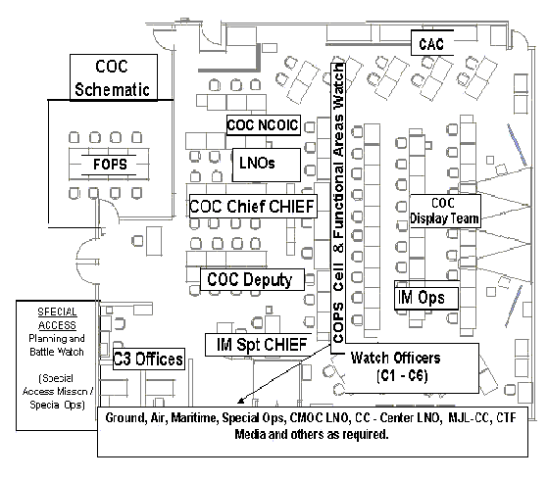
- The Maritime Operations Cell performs the following functions:
- Monitor situation, locations, status and actions of all Maritime forces in the CTF AO.
- Maintain a Maritime events log for each 24 operational period.
- Prepare daily Maritime situational reports.
- Ensure communication with all Maritime forces operating within the CTF AO.
- Prepare operational plans and orders for Maritime forces as directed by the Chief, COC.
- Coordinates with air, maritime, and special operations Watch Officers.

- Tasks, functions, and procedures. Provides supervision, control and coordination for all Maritime forces operating in the CTF AO. Develops plans and orders for Maritime Force Component Commanders to perform assigned missions and tasks.

- Maintain continuous picture of ongoing Maritime operations.

- Establish or maintain communication with all Maritime forces operating in the CTF AO.
- Prepare required reports information,e.g. Situational Reports, Dailey Reports.
- Maintain Maritime operations situational map.

- Prepare Plans and Orders.

- Prepare plans to support future operations
- Prepare and implement orders for Maritime forces.
- Coordinate with related shift leaders.

- Prepare Briefings.

- Prepare Maritime portion to daily briefings.
- Present situational briefings, as required.

- Maintain Ongoing Coordination with Air, Maritime, and Special Operations Cells.

- Standing Operating Procedures.

- The Maritime operations cell will cover all aspects of coordinating Maritime operations in the CTF AO.
- The Maritime operations cell will be the focal point for all incoming / outgoing information on Maritime forces operating in the CTF AO.

Considerations.

- Threat environment.
- Force structure and composition.
- Current plans, annexes, operating instructions, requirements—adaptation of future plans coordination to current operations.
- Technical and logistic support—Automated Data Processing (ADP) support, communications equipment, administration supply, and security.

- Planning Rhythm. See Part B of the SOP overview. The Maritime Operations Cell within the COC will maintain a planning rhythm that is supportive of the CTF Battle Rhythm.

- Checklists.. None.

- Reports. As established by the COC Chief and CTF reports matrix.

- References.

- Joint Pub 3-16, Joint Doctrine for Multinational Operations, dtd 5 April 2000.

