Chapter C-2

INTELLIGENCE

Purpose. This chapter provides guidance for strategic and operational level intelligence staffs conducting CTF operations. Depending on the scale and mission of a MNF operation, CTF C2 may be task organized with some or all of the types of organizations listed in this chapter. Examples of structures and names of organizations are provided to assist in setting-up a CTF Intelligence organization.

  - Primary documents describing starting points for intelligence support to CTF operations are:

    - Intelligence Support to Coalition Operations (ISCO) dtd 26 Dec 2000.

    - Joint Publications 3-16, Joint Doctrine for Multinational Operations.

    - As this SOP is revised, other multinational and national documents will be added based upon input participating MPAT nations.

  - For the purpose of the MNF SOP and CTF planning, the following definitions apply:

    - Intelligence. The product resulting from processing information through the intelligence cycle concerning foreign nations, hostile or potentially hostile forces or elements, or areas of actual or potential crisis operations (information on the area of operations (AO) or information on Military Operations Other Than War factors such as force protection and environmental impacts on accomplishment of the mission).

    - Intelligence Cycle. The process by which information is converted into intelligence and made available to users. Various nations have different cycles. For example the US intelligence cycle has six steps: planning and direction, collection, processing and exploitation, production, dissemination, and integration and evaluation. Australia utilizes a four-step sequence: direction, collection, processing, and dissemination. Such differences must be taken into consideration when establishing the planning and execution process within CTF headquarters.

    - Strategic Intelligence. Intelligence required for formulation of strategy, policy, and military plans at national and international levels.

    - Operational Intelligence. Intelligence required for planning and conducting operations within theatres or areas of operations

- Responsibilities.

  - The primary responsibility of CTF C2 intelligence staff is to present a clear, accurate, and timely analysis of the situation to aid the CTF commander and his staff in their planning and decision-making processes.

  - The CTF C2 must provide guidance and direction to all intelligence resources available to the CTF. The C2 is responsible for planning, implementing, and supervising intelligence activities.

  - The CTF C2 must ensure that shared publications, agreements, and memorandums are used as a basis for sharing of information and intelligence as required and coordinated.

    - Intelligence Support to Coalition Operations (ISCO). The ISCO document defines basic tactics, techniques and procedures for unified and effective intelligence support to forces in multi-national operations under U.S. leadership. However, it can also assist in development of “tailored” intelligence from many nations since “national concerns / issues” should parallel. The ISCO is designed for broad distribution to friends and allies throughout USPACOM AOR and can be found at the www.mpat.org.web site.

    - Sharing Classified intelligence. For a specific coalition effort, a detailed memorandum(s) / agreement(s) among nations will be required for sharing classified intelligence. This will be a key planning consideration during CTF activation.

- Organization. The CTF C2's organizational requirements are mission-dependent. At a minimum, a core element of analytical, requirement management, and administrative capabilities is required. Some intelligence functions may be performed via “reach-back” (networking links back to parent nation's networks) to each nation’s larger intelligence channels, or to other supporting organizations. The overview of this SOP established two extreme ranges for “levels of effort” for a CTF operation for planning purposes: (1) Small Sized Task Force; and (2) Medium Sized Task Force (see Chapter B-4). Outlined below are templates that can act as “starting points.”

  - Small Sized CTF: A C2 staff of between two to six persons should be adequate to support a small-sized multinational force of several hundred to 2500 coalition personnel. Small-sized task forces normally focus on the lower spectrum of MOOTW/SSC. The coalition intelligence cell can be small because there is no organized military threat to coalition forces. The intelligence cell will instead focus on force protection - environmental impacts on mission accomplishment and broad intelligence functions to the CTF. A template for support to such an operation is outlined below. See Annex A of this chapter for descriptions of the “cells” depicted below.
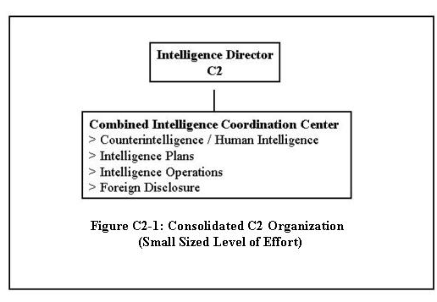
Note: In the above scenario, if the operation requires little intelligence support, C2 staff could be integrated into a C3 led CTF Coordination Center (no separate staff elements) with C2 staff being a “sub element” within this Center for very limited coalition operations. Example: Earthquake support.

Reachback capability to supporting nations can greatly reduce the personnel footprint “on site” for such a cell.

  - Medium Sized CTF: A larger C2 staff is needed to support a medium-sized multinational operation (up to 20,000 Coalition personnel). A multinational operation of this size is probably focused on the higher spectrum of MOOTW / SSC. This range of CTF operations has the inherent “use of force” implied in the mission (peacekeeping, HA/DR with force protection concerns, Non-Permissive NEO, peace operations with force protection concerns, etc.). Such a force requires a balanced organization with clear combat military capabilities and associated support requirements. Clearly, CTF C2 must tailor the intelligence cell to meet information requirements of the CTF commander. Reachback remains a good option to reduce the number of people physically located in the coalition intelligence center See Annex A of this chapter for descriptions of the “cells” depicted below.
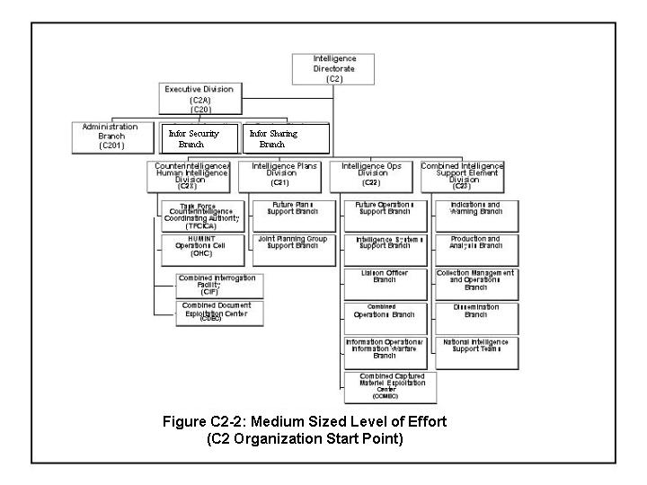

  - Augmentation to the CTF

    - CTF C2 staff augmentation is vital for coalition unity of effort. The Multinational Planning and Augmentation Team (MPAT) (Annex C, Chapter B-5) should be first to arrive to help transition the national JTF into a CTF. Upon request by the Lead Nation a MPAT will be formed to augment the national JTF. Note: A nation may create a CTF without using a JTF template, this will be situationally dependant.

    - The MPAT intelligence representative will assist CTF C2 in determining the best way to organize the coalition intelligence cell and identify any intelligence skill gaps in the Lead Nation's task force intelligence structure. Examples of intelligence skills that may require augmentation: skill-oriented area specialists, dissemination, systems, and collection management.

(1) National Intelligence Teams Support (NIST) . The CTF C2 may require unique intelligence or communication capabilities not present in coalition militaries. The C2 should make this need known through CTF Coalition Coordination Center (CCC) who can forward the requirement to supporting national command authorities. The CTF C2 must weigh advantages and disadvantages of requesting national level support. On the positive side, such support provides further evidence of a nation's support to a coalition operation. On the negative side, CTF C2 must ensure the NIST arrives with its own communication capability and that increasing the number of people in the coalition intelligence center does not violate any limit on the size of the intelligence organization.

(2) Other High Demand / Low Density Assets: The CTF C2 will identify and request through CTF CCC additional intelligence augmentation using CTF C1 personnel augmentation channels.

  - National Liaison Officers (LO) or Liaison Teams (LNO teams). The number of LO / LNO teams required by a CTF is tied to overall level of effort – a larger effort requires more liaisons. The CTF C2 must remember that liaisons are not part of his staff that he can task--they are representatives of units or commands supporting the CTF mission. An example of when a liaison is required is when CTF C2 must task an intelligence collection asset with which CTF C2 staff has no practical knowledge. A liaison helps ensure the collector is used properly. In smaller coalition efforts, one LNO team, tailored to the situation, may coordinate across all staff directorates within CTF HQ.

    - For larger efforts, liaison personnel from participating coalition members and / or other agencies / units will be incorporated into CTF C2 organization to enhance coordination with partners as situation dictates. LO or LNO teams will normally work within the C2 Operations cell.

    - For a medium-sized task force, CTF C2 may require liaison personnel from components. Component liaison personnel will coordinate their requirements via C2 Operations.

  - Representation to Boards and Cells. The CTF C2 may need to provide representatives to a number of boards, cells and working groups:

- Force Protection Working Group
- Coalition Coalition Search and Rescue Center
- Coalition Coalition Information Management Board
- Civil Military Operations Center
- Information Operations Cell
- Coalition Coalition Targeting Coordination Board / Coalition Fires Element
- Coalition Coalition Planning Group
- Coalition Coalition Operations Center
- Coalition Coalition Reconnaissance Center
- Deployment Management Team (DMT) Force Deployment Cells

- Tasks, functions, and procedures.

- Tasks. The CTF C2 must perform the following key tasks:

- Plan for and establish the C2 section and determine representation and liaison requirements.

- Develop and recommend commander’s Priority Information Requirements (PIR).

- Establish intelligence policy.

- Manage intelligence resources.

- Provide direction to CTF intelligence resources to provide the commander, his staff and components with necessary intelligence to aid planning and decision-making.

- Identify and conduct liaison with other CTF staff elements to fully support Operations and Plans.

- Provide mission-specific intelligence, such as Battle Damage Assessment (BDA) and target intelligence, in support of CTF objectives.

- Consider ROE and intelligence oversight (if mandated) implications for intelligence activities/operations.

- Functions. The C2 normally accomplishes the following functions to support CTF headquarters and components:

- Direct, collect, process, analyze, and disseminate focused, detailed, accurate, timely, responsive, and predictive intelligence in a useable format. This includes intelligence for component and supporting commands to support execution of CTF operational requirements and direction.

- Direct counterintelligence operations designed to detect, neutralize, or destroy the effectiveness of actual or potential hostile intelligence, terrorist, sabotage, or subversive activities.

- Receive, transmit, and control classified materials.

- Develop and maintain target intelligence and BDA capabilities that support CTF missions and priorities.

- Coordinate production and dissemination of geospatial information and services to ensure all coalition forces work with identical maps and charts (GI&S).

- Liaison with higher, subordinate, adjacent and allied commands on intelligence matters.

- Provide support to information operations and special operations, to include civil affairs.

- Conduct Coalition Intelligence Preparation of the Battlespace (CIPB).

- Coordinate with other CTF staff directorates to ensure all plans and orders contain the most current and relevant intelligence and intelligence requirements. This includes providing intelligence subject matter experts to participate in ongoing planning with the CTF Planning Cells (C5 Future Plans, C3 Future Operations, and C3 Current Operations).

- Exchange classified and unclassified information as required with assigned forces. Coordinate with liaisons or other coalition representatives to ensure that each country provides the maximum amount of releasable intelligence to the coalition intelligence center.

- Handle captured documents and material for exploitation, and interrogate / debrief captured personnel, defectors, and refugees, as required. Pre-determine languages and dialects in the AOR.

- Coordinate intelligence-related communications requirements with CTF C6, Supported Strategic Commander, and Supporting Strategic Commanders as required.

- Coordinate intelligence-related equipment and personnel movements with CTF C4 and C1, respectively.

- Procedures. CTF intelligence procedures reflect the intelligence cycle: planning and direction, collection, processing and exploitation, production, dissemination, and integration. Through these phases, information is obtained, assembled, converted into intelligence and made available to decision-makers. The cycle is synchronized with the CTF battle rhythm to assist the CTF Commander in the decision-making process. The following procedures are normally used to conduct CTF intelligence operations.

- Planning and Direction. The C2 plans and directs all intelligence activities within the CTF. The C2 sets priorities for intelligence activities and ensures timely, tailored intelligence is provided to all levels of command. Planning and direction is based upon the commander’s Priority Intelligence Requirements (PIRs). DIRLAUTH may be delegated to CTF C2 for coordination with various participating nations’ Supporting Strategic Commanders based upon requirements for additional intelligence support. If the CTF is already activated during the situation development phase, component intelligence staffs participate in planning, identify intelligence assets and capabilities, and augment the CTF intelligence staff as required.

- Collection. The C2 executes day-to-day all-source collection management responsibilities for collection assets assigned to the CTF. The Coalition / Combinded Collection Management Board (CCMB) recommends allocation of collection assets to meet prioritized collection requirements. The CTF collection manager works with the C3 to coordinate tasking of CTF assigned Intelligence, Surveillance, and Reconnaissance (ISR) assets. The C2 is the CTF intelligence collection requirement control authority. This is accomplished by preparing, maintaining, validating, and assigning intelligence collection requirements to organic collection assets. For collection requirements that will be met by theater or national-level collection assets from respective nations, the C2 will submit these requirements through liaison officers or other representatives to respective nations as needed. Processing channels for such support needs to be identified early in the planning process during CTF activation.

- Processing and Exploitation. The C2 uses the Coalition Intelligence Support Element (CISE) analytical sections for processing and exploiting collected information and intelligence. A “tailored” CISE serves as the “heart” for the entire intelligence cycle. The CISE is normally organized along air, ground, naval, geopolitical, and GIS lines. It is manned by subject matter experts (SMEs) from all intelligence disciplines. In the CISE, information is fused and expressed in terms relevant to operational objectives. The CISE manages CTF intelligence Requests for Information (RFIs), to include, validation, answering through reachback, forwarding, and tracking. The CISE coordinates with C2 administration for dissemination support.

- Production. The CISE creates intelligence products to support CTF staff and components. Among the CISE’s various products are:

- Coalition Intelligence Preparation of the Battlefield. This is an ongoing process that supports all phases of operations from planning through execution.

- Common Operational Picture - Enemy (COP-E). The COP-E is the most current CTF assessment of the location of hostile units, or in a HA/DR scenario, an assessment of environment, such as status of lines of communication, areas of disease outbreaks, and incidents of criminal activity. The COP-E is disseminated to the entire CTF.

- Target Intelligence, to include target systems analysis, target materials, BDA and target recommendations.

(4) Other analytical products, such as, Intelligence Summaries (INTSUM), Intelligence Reports (INTREP), and BDA Summaries (BDA SUM).

- Dissemination. The C2 is responsible for dissemination of intelligence throughout the CTF, via the fastest and most appropriate means. “Appropriate means” is that combination of software/hardware/networks/courier that permits secure, effective and efficient dissemination of intelligence. All products released by the C2 will provide clear analytical value and support to the commander’s decision-making process. All intelligence collectors organic to the CTF should submit to the C2 only reports releasable to the entire CTF. Intelligence collectors not organic to the CTF should submit to the CTF only reports releasable to the entire CTF. Intelligence products not releasable to the coalition force should be sent only through existing bilateral channels.

(1) The C2 must ensure critical products, such as COP-E, BDA, target intelligence and imagery from organic systems, are disseminated in a timely manner within the CTF and its components. The C2, in coordination with CTF components and the various supporting nations' intelligence communities, must develop policy stating which intelligence products must be "pushed" to the coalition intelligence cell and which can be "pulled" by coalition intelligence when needed.

(2) Pushing and pulling information. Smart push information is usually information that must be passed to the CTF C2 as quickly as possible to help prevent loss of coalition lives, such as, tactical threat warning. Such information is passed preferably by phone, with detailed email or fax follow up. "Pulled" information is not time critical but is still of value to the CTF. The CTF C2 staff, and other CTF/component staffers, can access this information "on line" or in hard copy received by other means at a time convenient to them. Examples of information best pulled are country studies and general political-military developments in the region.

(3) The CTF C2 must work to provide CTF intelligence personnel, operators, and planners with computer tools and communications pipelines (a C6 function) to "pull" intelligence. The CTF C2 also must try to anticipate operator and planner requirements, based on the phases of the CTF mission, and submit RFIs in advance so information will be available when needed. Coalition wide-area networks should be the primary means for dissemination during a Coalition operation. Means of Intelligence dissemination options include:

(a) Message traffic, at classification levels, IAW established agreement(s) with coalition partners.

(b) C2 Web Site(s). Upon CTF activation, the CTF C2 must consider establishing a “web-based” network to disseminate non-time-critical reports. All CTF C2 generated products should be posted to this secure web site. Other types of C2 information that can be posted to this site include current status of RFIs, Collection Requests, and current/future collection activity. The CTF C2 must ensure that a qualified "web-master" is included in the coalition intelligence cell augmentation request, if it is decided to set up a web-based intelligence architecture. The level of classification of this web must be decided on early by coalition members and the nation volunteering to provide equipment and expertise to set it up and maintain it.

(c) E-mail. Email on CTF networks can be used for point-to-point distribution and time-sensitive reporting.

(d) Collaborative software. This includes applications that permit file sharing, chat, voice, and video. Collaborative software can be used to coordinate time-sensitive issues between individuals or staffs.

(e) CTF Secure Voice. This is the preferred means for passing time-critical intelligence.

(f) Video Teleconferencing (VTC). VTC assets are traditionally used for " face-to-face" discussion of issues and presentation of material at the primary CTF staff and CTF command levels. Due to bandwidth constraints, VTC will be used sparingly. Most VTC coordination objectives can be accomplished by using desktop collaboration tools.

(g) Newsgroups. Use of newsgroups is at the discretion of CTF C2 and Component Intelligence staff elements. Newsgroups are typically used to make available non-time-sensitive information.

(h) CTF Secure Fax. Secure fax is used for passing non-time-sensitive information. Confirmation of receipt is required.

(i) National Assets. Each nation within the coalition will have use of its own national / global assets for communications / network usage.

- Integration. The final step in the intelligence cycle is integration. Intelligence is only valuable when it is understood and used by the reader.

- Staff Interaction. The C2 staff must interact with the CTF staff and higher, adjacent, component, and supporting commands. Staff interface ensures timely and focused intelligence support to operations, future plans and logistics elements (C5 Future Plans, C3 FOPS, C3 COPS, etc). This staff interaction gives intelligence personnel ability to write assessments with the correct operational focus. Intelligence personnel will be assigned to various boards and staff cells requiring intelligence support or membership. The CTF C2 should delegate to C2 Operations and Plans Officers responsibility to coordinate interaction with the staff.

- LO / LNO Teams. It is critical that Lead Nation components and coalition partners provide qualified LO / LNO teams to the C2 as required. Working closely with the CISE, these liaison officers represent their parent command’s intelligence requirements and provide feedback on CTF-level intelligence activities.

- Feedback. The CTF C2 must ensure his staff tailors intelligence products so they meet specific requirements of the CTF Commander, his staff, and components. Feedback is key to ensuring the products meet stated requirements.

- Considerations. The CTF C2 and Lead Nation must consider the points listed below when deciding on organization, location, functions, and capacity of the coalition intelligence cell.

  - Mission: What is the CTF purpose? What is the expected size of the CTF? Is there an organized military threat? What is the required intelligence task organization (equipment, units) for this mission/objective? What are the current intelligence capablilities? What is the required reach back (Theater/National) capability for each coalition participant? What are intelligence system and communications interoperability requirements within the CTF?

  - Support: Will the intelligence cell be co-located with the rest of CTF headquarters? How much space is needed for people, computers, printers, supplies, copiers, tables, chairs, safes for classified material, shredders? If conditions at the headquarters prevent some or all of the coalition intelligence cell from being located there, then force protection may become an issue. How reliable is the power supply. Will the intelligence cell have a backup power generator? Can intelligence spaces be made secure to handle classified information if the rest of the headquarters is not secure? Can all intelligence communication requirements be met at this location? Will each coalition partner desiring its own national intelligence facility be located close to the coalition intelligence cell? Can more reliance on reachback reduce the number of intelligence personnel at the headquarters?

  - Unique Requirements: Are there any mission-unique requirements that impact on intelligence? Examples can be the need for interpreters, translators, linguists, or intra-government agency representatives (e.g., International Red Cross, UN Teams, Media, International Rescue Committee, etc.).

  - To summarize, The CTF C2 must consider many factors, some beyond his control, when setting up his intelligence organization. Stay focused on supporting the CTF mission when forced to balance manpower needs with available locations and communications.

- Planning rhythm. The CTF C2 must ensure the intelligence planning process (battle rhythm) is in step with and alert to the CTF commander’s battle rhythm.
- Checklists. N/A.

- H. Reports. The following section briefly describes commonly used intelligence reports. Releasability concerns will influence how these reports are written, if they must be sent to nations or agencies not part of CTF. Different versions of the same report may have to be written. Chapter C-2, Annex B outlines these reports.

- C2 DELIVERABLES TABLE. A matrix summary of products CTF C2 staff will prepare for the CCTF and his staff.

- C2 MISSION ANALYSIS BRIEF. The Mission Analysis Brief provides an overview of the situation in the AOR and important considerations prior to commitment of forces. The brief is intended for presentation to commanders and key staff members.

- INTELLIGENCE SUMMARY. The Intelligence Summary (INTSUM) gives a detailed summary of the intelligence situation for a specific period of time. It should cover information of intelligence interest within the CTF area of operations to include forward and rear areas. The C2 and C3 battle rhythms will determine when CTF component INTSUM inputs are due and when the INTSUM is sent out.

- INTELLIGENCE REPORT. The Intelligence Report (INTREP) is prepared by the first intelligence organization to receive information that influences crisis / enemy capabilities or when a change in crisis / enemy capabilities is detected. The INTREP is sent as quickly as possible following receipt of the information. When time permits, it should include the originating office’s interpretation of the information being reported.

- RESOURCE STATUS REPORT. This report updates the CTF Collection Plan to include the status of theater, organic, and tactical collection assets.

- COLLECTION TASKING ORDER. The Collection Tasking Order provides components and the CTF the most current list of PIR and tasks for collection assets within the CTF and its components to cover specific Named Areas of Interest (NAI) in order to answer PIRs.

- BATTLE DAMAGE ASSESSMENT (BDA). BDA results are provided in three phased reports. The first phase report is an initial hit or miss assessment based upon single source data, such as a pilot’s In Flight Report. The second phase report builds on the Phase 1 report. It is a fused, all-source product, with a more detailed description of physical damage, an assessment of functional damage, an initial target system assessment, and any applicable munitions effectiveness assessments (MEA). The third phase report contains in-depth target system assessments.

- References

  - USPACOM Intelligence Support To Combined/Coalition Operations (ISCO) 26 Dec 2000.
  - JOINT PUB 2-01, Joint Intelligence Support To Military Operations.
  - JOINT PUB 3-16, Joint Doctrine for Multinational Operations.
  - Other Nations’ doctrinal publications to be added during staffing with MPAT nations. (Other nations beside MPAT player nations?)

- Annexes

- Annex A C2 NOTIONAL MANNING AND DUTY DESCRIPTIONS
- Annex B REPORTS

Page Intentionally Left Blank

Annex A

C2 NOTIONAL MANNING AND DUTY DESCRIPTIONS

Chapter C-2 INTELLIGENCE

CTF C2. This annex represents a very robust organizational and functional view of C2 operations and responsibilities. Task organization is a situational dependent issue and will be based upon the needs of the CTF Commander. Example structures and names of organizations are provided for notional purposes to assist in setting-up CTF Intelligence organization. Regardless of CTF organization, the CTF C2’s primary responsibility is to provide accurate, timely and actionable intelligence to the CCTF and staff. Examples of support required in a traditional military operation include hostile force capabilities and intentions; hostile force courses of action and centers of gravity; force protection issues; reconnaissance recommendations based on requirements or identified intelligence gaps; and target nominations. In non-traditional operations, such as humanitarian assistance and disaster relief, the "hostile force" may be hunger and disease, criminal threats and the forces of nature. The CTF C2 ensures CTF component forces have intelligence and intelligence reporting guidance to support planning and execution of the operational mission. The CTF C2 also provides intelligence on military, political, social and economic developments within the CTF’s area of operations / area of interest. The CTF C2 establishes requirements and sets priorities for intelligence activities in support of CTF mission objectives. In this capacity, the C2 will prioritize (in accordance with the CCTF’s PIRs) CTF component intelligence requirements and allocate organic collection assets or request external collection requirements.

- CTF C2A (Deputy C2). The C2A assists the CTF C2 as required. He directs the coalition intelligence cell in the C2's absence and ensures the administrative and logistical requirements of the C2 are met. The C2 Chief of Staff helps the C2A handle administrative and logistical issues.

- CTF Intelligence Divisions. The C2 organization can have up to four subordinate divisions in addition to separate Security and Administration sections.

- Executive Division (C20). The Executive Division falls under direct supervision of the C2A. The Executive Division acts as a go-between for the CTF C2 staff and other CTF staff organizations on issues such as work space and personnel support, physical and classified material security requirements, communications requirements, foreign disclosure, etc. The tasks of this division are divided into three primary functions: Administration, Information Security, and Information Sharing. A Special Security Office (SSO) is established when Sensitive Compartmented Information Facility (SCIF) operations are required. This division is also responsible for personnel, equipment and supplies.
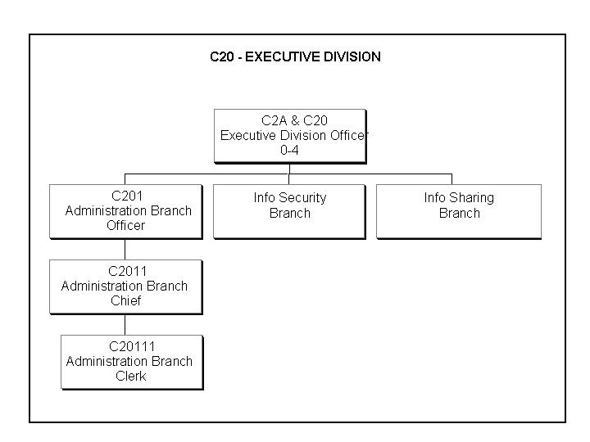
Figure C2-A-1: Example of C20 Executive Division Organization

a. Administration Branch. The Administration Section is responsible for systems maintenance, personnel, equipment, and supplies. This division also interfaces with CTF C2 staff and other CTF staff organizations on issues such as workspace and personnel support, security requirements, communications requirements, etc.

b. Information Security Branch. The CTF C2 may establish this branch to ensure protection of classified or sensitive intelligence information. If the CTF will produce or handle SCI, this branch will oversee sensitive compartmented information facility (SCIF) operations. Duties of this branch include: physical security, document security, and personnel security; decompartmenting and sanitizing SCI; General Officer privacy (back channel) communications support; and operating the SCI Communications Center.

c. Information Sharing Branch. This branch is responsible for coordinating the sharing of intelligence information with coalition partners. Planning and execution of CTF operations requires sharing of intelligence and operational information with coalition partners. Each nation contributing intelligence data, reports or products to the coalition intelligence center must determine which of its information all partners can use and which of its information only selected partners can use. For coalition unity of effort and for maintaining a Common Operational Picture, intelligence released to the coalition must satisfy operational requirements of the CCTF and staff and subordinate components. The number of coalition-related bilateral intelligence sharing arrangements should be minimized. Intelligence collectors organic to the coalition's components and tasked by the CTF should be configured so that their reports are automatically releasable to the coalition. Otherwise the owning country must write reports of the collection effort that are releasable to the coalition. Intelligence coming into the coalition intelligence center from sources outside the CTF will be written by owning countries at a coalition releasable level to the maximum extent possible. It is the owning nation's right to determine what intelligence it shares with the coalition.

- Counterintelligence/Human Intelligence CI/HUMINT (C2X). The C2X is comprised of a Task Force CI Coordinating Authority (TFCICA) staff and, a HUMINT Operations Cell (HOC). The C2X exercises CTF staff oversight over the Coalition Interrogation Facility and Coalition Document Exploitation Center. The C2X should have representation from all countries and services involved in the operation. Secure communications and interoperability with participating nations’ CI channels is desired, but may not always be fully achievable. Participating nations will follow their own laws and regulations concerning collection of HUMINT.
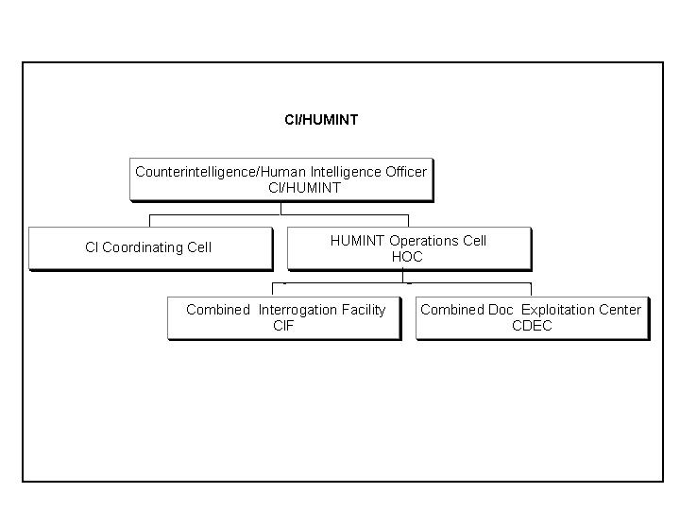

Figure C2-A-2: Example of CI/HUMINT CELL Organization

- Intelligence Plans Division (C21). C2 Plans is responsible for synchronizing intelligence support to CTF C5 future plans and the Coalition Planning Group. It does this by participating in C5 planning groups and coordinating with the Coalition Intelligence Support Element (CISE) for collections and/or production support to the C5. The focus is to formulate a concept of intelligence operations to support PIR development, Operation Plans (OPLANs), and Contingency Plans (CONPLANs), to include maintaining intelligence aspects of deploying forces. Planning support includes preparing intelligence estimates and annexes supporting CTF operations plans, contingency plans, and operation orders.
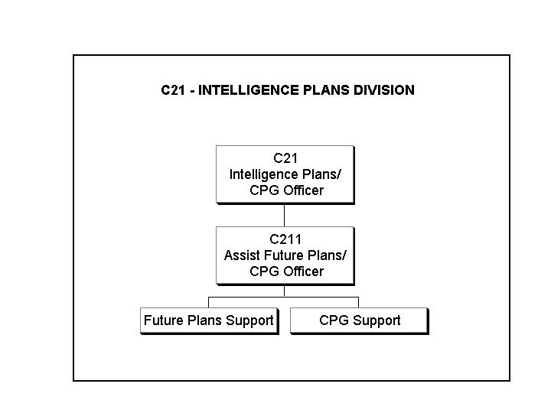
Figure C2-A-3: Example of C21 Intelligence Plans Division Organization

- Intelligence Operations Division (C22). C2 Operations ensures that the C5 Future Plans (PLANS) and C3 Future Operations (COPS) requirements for intelligence support are met. It does this through its Future Operations Branch participation in C3 and C4/Logistics’ planning groups and by coordinating with the CISE for collections and/or production support of the C3 and C4. C2 Operations provides CTF-level support to exploitation of captured materiel. The Operations Division also plans and manages assignment of intelligence augmentation forces to the CTF. C2 Operations provides support and coordination of LO teams sent from the CTF to other organizations. Systems support to the C2 organization is provided by the C2 Intelligence Systems Support Branch; this Branch also provides technical expertise to CTF Components and assists them with architectural planning and execution. The Information Operations Branch provides intelligence support to Information Operations. The Future Operations Branch and Intelligence Systems Branch are optional branches based upon the C2 requirements and situational factors. Two C2 Operations sections that may be required are explained more fully below.
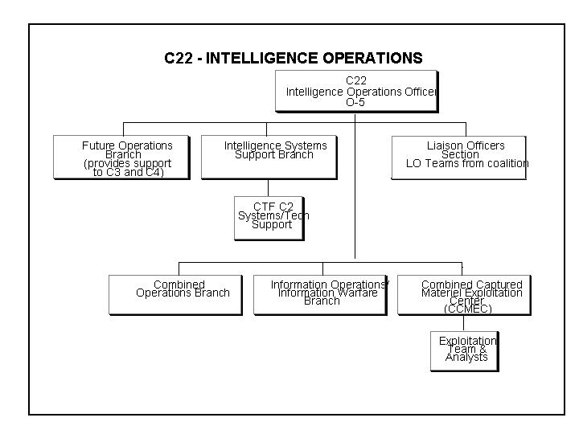
Figure C-2-A-4: Example of Intelligence Operation Organization

a. Future Operations Branch. The Future Operations Branch provides intelligence support to FOPS and PLANS cells within the CTF Planning Process (see Chapter B-6) focusing on the current phase and next phase logistical intelligence requirements. The branch identifies Priority Intelligence Requirements (PIR) for recommendation to the CTF and submits intelligence support requirements to the Coalition / Combined Intelligence Support Element (CISE), if required.

b. Intelligence Systems Branch. The Systems Branch is divided into five primary functions, with corresponding sections: Systems Architecture, Maintenance, Systems Administration, Web Administration, and Communications Security (COMSEC). The branch manages automated data-processing support, including operations and maintenance of all intelligence systems. The Systems Branch maximizes use of in-theater communication resources and deploys equipment to extend communications links from the CTF HQ to the war-fighter. This branch coordinates communication architecture requirements with C-6 and coordinates with C-4 and other logistics elements for timely delivery and installation of intelligence and communications systems. Interoperability problems must be resolved during the planning phase. There must be enough Systems Administrators and Maintenance Technicians assigned to the Systems Branch to ensure qualified personnel are always on duty.

- C2 CISE DIVISION (C23). The CISE is the centerpiece within the C2 for execution of CTF-wide intelligence analysis, production, and collection missions. The CISE provides support to the CTF Components and staff. Possible responsibilities of the CISE include: Indications and Warning; Joint Intelligence Preparation of the Battlespace (JIPB); operational intelligence support to the Commander, CTF and components; processing and exploitation of intelligence; dissemination and integration; synchronization of collection operations; threat assessments; target nominations; intelligence support to asymmetric threats, such as terrorism and sabotage; and coordination with theater intelligence staff and national agencies.
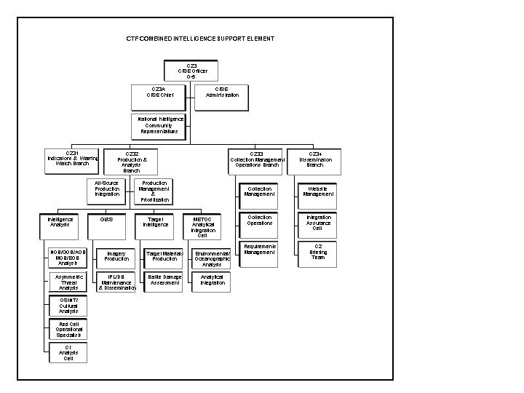

Figure C2-A-5: Example of CTF Coalition Intelligence Support Element Organization

- Billet Responsibilities within the CISE.

- CISE Officer. The CISE Officer’s primary job is to ensure the CISE operates effectively. To make this possible, the CTF C2 delegates authority to the CISE Officer to coordinate all functions performed within the CISE. Within that capacity, the CISE Officer is responsible for production and analysis of intelligence to support CTF-wide requirements, for the management and coordination of all assigned collection assets and for requesting support from higher headquarters when needed. When needed, the CISE Officer requests intelligence assets from participating nations not organic to the CTF through proper national channels within the CTF.

- CISE Chief. The CISE Chief provides CISE administrative support and maintenance of hard-copy intelligence files and documents.

- Indications and Warning (I&W) Branch. Functions of the Branch include: Receiving, processing when required, and conducting initial analysis and dissemination of time-sensitive I&W intelligence to the CTF staff, operating commands, and activities attached to or supporting the CTF mission. This branch also provides subordinate commands with guidance on required intelligence reports. CTF I&W will most often be satisfied by current intelligence reporting from organic CTF assets supplemented with national I&W support. Warnings of imminent hostile activity can also be obtained from the theater or national-level resources.

- Production and Analysis Branch. The Production and Analysis Branch performs detailed analysis of unclassified and classified information and produces intelligence products that support requirements of the CCTF, his staff, and CTF Components. CTF analysis must include all available information in order to produce quality intelligence, and it should be written in such a way that it could be shared with all CTF participants. Functions of the branch include: maintaining a detailed situational awareness of the battlespace; supporting C3 Current/Future Operations and C5 Future Plans requirements; producing intelligence reports and graphics to ensure situational awareness is maintained throughout the force; production of target intelligence and Battle Damage Assessment (BDA), mission assessment, supporting targeting and re-strike decisions; maintaining the CTF Joint Target List (JTL), including management of sensitive targets; managing the CTF "No Hit" List; integrated map and chart (geospatial) production; and, integration of Meteorological and Oceanographic (METOC) data into analytical efforts. If this branch is set up for a HA / DR type operation, it will report on subjects like local criminal activity, local political events that may impact the CTF operation, and location and status of refugees or internally displaced persons. The Production and Analysis branch may also utilize the cells discussed below, situation dependant.

(a) Red Cell concept. The Red Cell serves as a “thinking opposition force" that examines the CTF's future operations and future plans proposals. The Red Cell works separate from, but in close contact with, C2 analysts to determine how the opponent will act or react. The "Red Cell" concept is not documented in Coalition/CTF or Joint Doctrine, but it can be used as an analytical tool in traditional military MOOTW or SSC type operations. In HA/DR operation the Red Cell may help in dealing with risk assessment. Red Cell personnel should be experts on how the “enemy” thinks and operates. The Red Cell studies enemy capability, historical models and doctrine, then applies it to courses of action as presented by the CTF Planning Cells. The Red Cell acts as an advisor to C2 analysts by providing unique, detailed operational insights. As a result, the Red Cell becomes the focal point of shared analysis between intelligence, operations and logistics communities. Findings of the Red Cell are presented to the C2 for integration into the intelligence predictive analysis and mission analysis products.

(b) Asymmetric Threat Cell. This cell is established by CTF C2 if the CTF AO makes it advisable. The cell coordinates its assessments closely with the C3, C6 and applicable theater/national agencies.

(c) Open-Source (OSINT) and Cultural Intelligence Cell. This cell analyzes open-source, unclassified information and coordinates with government or academic Subject Matter Experts on the cultural, political, economic and medical situation in the CTF AO. The cell researches unclassified sources of information and coordinates with all available agencies/experts, which can provide the CTF with a continuing appreciation of these factors.

(d) Counterintelligence Analysis Cell. Directs and manages the CI/HUMINT analytical effort, coordinates with Coalition national-level intelligence sources and CI/HUMINT agencies within the CTF. It integrates CI/HUMINT analysis into the C2's overall assessments via the All-Source Production Integration Cell.

(5) Collection Management Branch. This branch covers requirements management and asset management. Specific functions are: Executing day-to-day all-source collection management of CTF collection assets; serving as the CTF's intelligence collection requirement control authority by preparing, maintaining, validating and levying intelligence collection requirements on organic tactical assets; preparing requests for theater and national collection support; developing the concept of collection operations, to include the CTF collection plan; and, coordinating the intelligence aspects of reconnaissance activities within the CTF area of responsibility with the C-3. Component intelligence staffs coordinate integration of organic collectors (CI/HUMINT, SIGINT, IMINT) with the CISE’s collection manager, the CI/HUMINT CELL and the Joint Exploitation Centers to ensure a unity of effort in the CTF collection plan. The CISE continuously fuses and tasks resources to provide predictive analysis and intelligence products to the CTF commander and his staff.

(6) Dissemination and Integration Branch. Functions of this branch include: Ensuring that intelligence is disseminated throughout the CTF in a timely manner and in a format that meets user requirements; ensuring that intelligence provided is understood by and is of use to the user; and, preparing and presenting intelligence briefings to the commander, staff and VIPs.

b. Information Flow. CTF intelligence operations must provide timely, complete, and accurate understanding of adversaries and the environment. Information, intelligence products, and requirements should flow through the CTF’s intelligence architecture in a timely manner. The diagram below illustrates this flow of information.
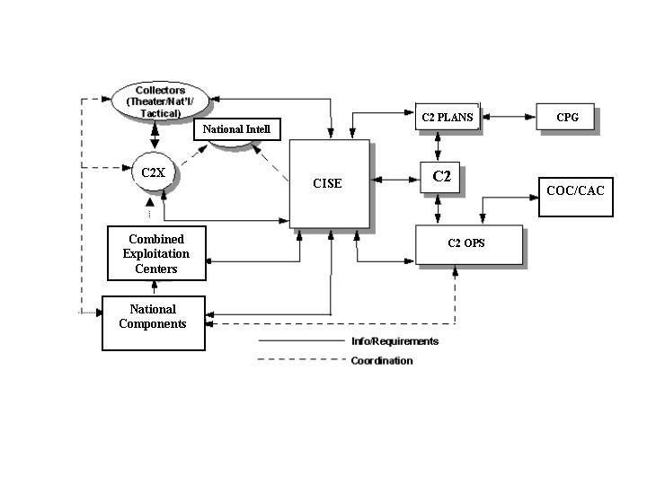
Figure C2-A-6: Example of Information / Intelligence Flow

c. Common Operational Picture (COP). The COP provides commanders with a near real time force tracking mechanism. The development and maintenance of the COP-Enemy (COP-E) is a coordinated effort among component intelligence staffs, the CISE order of battle (OB) analysts, and coalition national agencies, and is validated by the CISE Officer. The more complex the operation, the more difficult it will be to maintain the integrated COP. Information used to develop and update the COP-E comes from two sources. These sources are (1) intelligence collection assets organic to the CTF, and (2) collection assets held at theater or national levels. The CISE’s All-Source Production Integration Cell manages and fuses these data from both sources to create and maintain a reliable CTF COP-E. The fused COP-E is passed on to CISE Dissemination and C3’s COP Manager for dissemination to CTF, components, and participating national agencies.

Annex B

REPORTS

Chapter C-2 INTELLIGENCE

- Appendix 1 C2 Deliverables TABLE
- Appendix 2 C2 Mission Analysis Brief Form
- Appendix 3 INTELLIGENCE SUMMARY FORMAT
- Appendix 4 INTELLIGENCE REPORT FORMAT
- Appendix 5 COLLECTION TASKING ORDER FORM
- Appendix 6 BATTLE DAMAGE ASSESSMENT

  - TAB A: BATTLE DAMAGE ASSESMENT PHASE l INSTRUCTIONS
  - TAB B: BATTLE DAMAGE ASSESMENT PHASE II INSTRUCTIONS
  - TAB C: BATTLE DAMAGE ASSESMENT PHASE III INSTRUCTIONS

Appendix 1

C2 DELIVERABLES TABLE

Annex B REPORTS

Chapter C-2 INTELLIGENCE

C2 DELIVERABLES TABLE

Due to numerous requirements for meetings and Intelligence products levied on CTF C2, the C2 may decide to use a table as depicted below.
WHAT | WHO | REFERENCE | WHEN | TO WHOM
COLLECTION PLAN | COLLECTION MANAGER/ACE | DECISION SUPPORT TEMPLATE, PIR | OPLAN | ALL COMPONENTS, ASSET MANAGERS
NAI LIST | ACE/ C2 PLANS/ COLLECTION MANAGER | OPLAN | OPLAN, UPDATE AS NEEDED | ALL COMPONENTS, ASSET MANAGERS
CDR’S UPDATE | ACE/ SWO/ TFCICA | DAILY ALL SOURCE INTEL  TRAFFIC; INTSUM; SPOT REPORTS | MORNING & EVENING UPDATE | ALL
CDR’S ESTIMATE | C2, C2 PLANNERS | AVAILABLE ALL SOURCE INTEL | BETWEEN MISSION ANALYSIS AND COA DEVELOPMENT | CCTF
MISSION ANALYSIS BRIEF | ACE | AVAILABLE ALL SOURCE INTEL | FIRST PRODUCT UP FRONT IN CRISIS ACTION PLANNING | CCTF
COC HUDDLE BRIEF | WATCH OFFICER | ACE, INTSUM, CURRENT SITUATION | DURING COC HUDDLES OR SPECIAL VISITS | ALL
OPORD/  OPLAN BRIEF | ACE | AVAILABLE ALL SOURCE INTEL TRAFFIC | FINAL PLANNING PRODUCT | ALL
H-3 BRIEF | ACE/C2 | ACE, INTSUM, CURRENT SITUATION | H-3 | ALL/CG
POLICTICAL AWARNESS - AMBASSADOR’S BRIEF | C2, C2 PLANNER | NEO (F77), CURRENT SITUATION INTEL; POTENTIAL THREAT SLIDE | AFTER DEPLOYMENT | AMBASSADOR
Annex B | ACE | MISSION ANALYSIS; ALL SOURCE INTEL; COUNTRY STUDY, ETC. | AFTER MISSION ANALYSIS | ALL
INTELLIGENCE ESTIMATE | ACE | MA BRIEF, COUNTRY PRODUCTS FROM CAC, CURRENT ALL SOURCE INTEL | AFTER MISSION ANALYSIS | ALL
COLLECTION PLAN | COLLECTION MANAGER/ACE | DECISION SUPPORT TEMPLATE, PIR | AFTER MISSION ANALYSIS | ALL COMPONENTS, ASSET MANAGERS
CI | TFCICA |  | AFTER MISSION ANALYSIS | ALL
Appendix 4 NEO TRIGGERS | ACE | INDICATIONS AND WARNING | DURING MISSION ANALYSIS | ALL

Appendix 2

C2 MISSION ANALYSIS BRIEF FORMAT

Annex B REPORTS

Chapter C-2 INTELLIGENCE

1. MISSION ANALYSIS BRIEF. This is an example for mission analysis brief format.
Current threat situation in the AO.

CURRENT SITUATION: CTF AO

Overall situation in AO

The Area of Interest intelligence factors.

Current situation in potential contingencies:
area outside current AO

IMPACT ON CTF: WHAT IS HAPPENING
AND EFFECT ON CTF

Current number/location
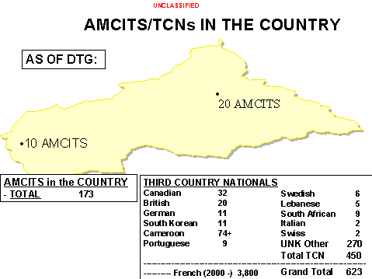
of evacuees/refugees.

Weather effects on friendly/threat operations.

Light Data
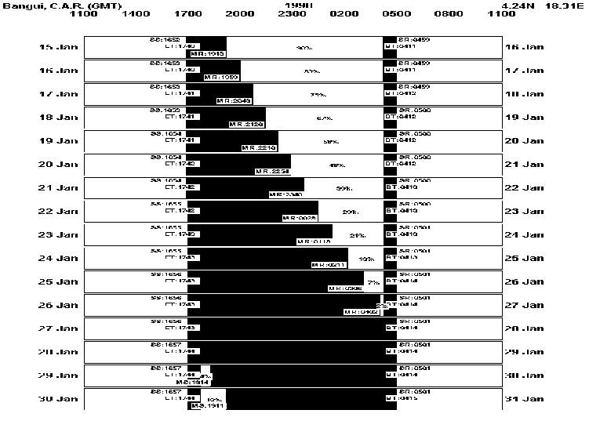

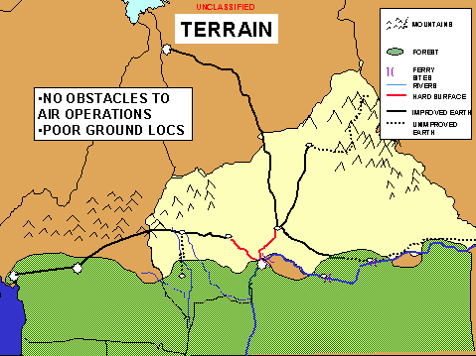

Terrain effects on friendly
and enemy operations.

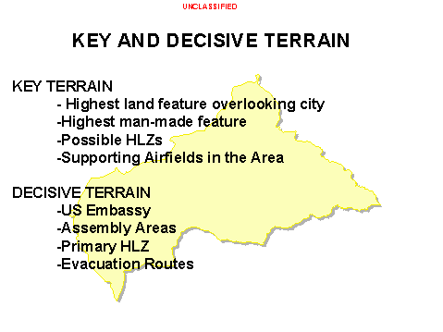
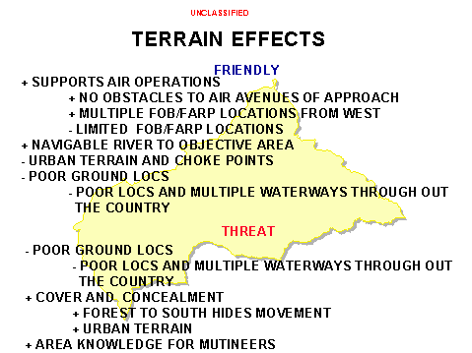

Key Players/Linked Analysis. Depicts key players that effect the operation in a complex political/military situation. Key players include; Host nation political and military organizations/individuals; political/military opposition groups; regional powers; international players; terrorist groups; ethnic/tribal groups; media organizations; NGO organizations.

Potential threat matrix. A list of numerous Threat evaluation. Series of slides
potential threats. Useful for operational and describing threat order of battle, tactics,
force protection analysis. doctrine, and weapons.

Threat centers of gravity. High value targets: lethal and non-lethal.

Spectrum of threat escalation. Likely threat situations from most likely to most dangerous that could impact planned operations.
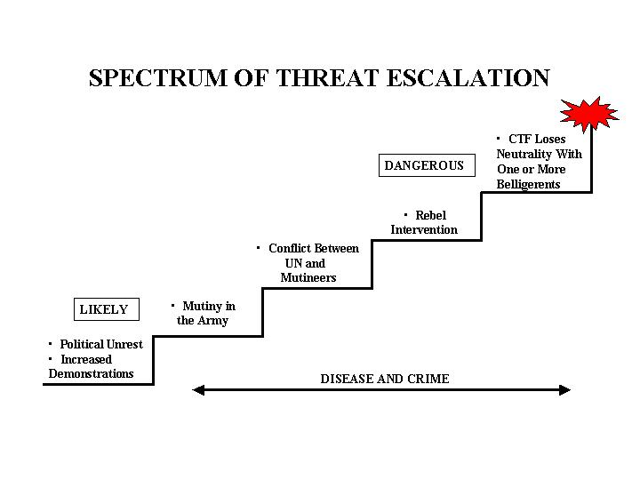

Appendix 3

Annex B REPORTS

Chapter C-2 INTELLIGENCE

INTELLIGENCE SUMMARY FORMAT

1. PURPOSE: To provide the CCTF and staff, components, Supported Strategic Commander, and Supporting Strategic Commander(s) a written intelligence summary.

2. GENERAL: This report contains a written intelligence analytical summary of the current threat situation, a 24 to 48 hour projection, a ground, air, air defense, naval and weather analytical update.

3. FORMAT: The Intelligence Summary (INTSUM) is a Word document or a message. These reports are placed on the C2 home page and/or distributed by fastest and most reliable secure means to the CTF staff, components, Supported Strategic Commander, and Supporting Strategic Commander(s). The contents below are recommended and may not apply to all situations.

=====================================================================================

CTF INTSUM DTG:

1. (U) SUMMARY OF THREAT SITUATION; CURRENT THREAT SITUATION. IDENTIFICATION OF POTENTIAL THREATS TO THE OPERATION. DISPOSITION OF THREATS//

2. (U) 24-48 HOUR PROJECTION: PREDICTIVE ANALYSIS OF LIKELY THREAT ACTIONS IN THE NEXT 24-48 HOURS//

3. (U) POLITICAL UPDATE: CURRENT POLITICAL SITUATION.//

4. (U) GROUND UPDATE: CURRENT THREAT SITUATION IN THE JOA WITH EMPHASIS ON ISB, FOB, AND OBJECTIVE AREAS//

5. (U) AIR UPDATE://

6. (U) AIR DEFENSE UPDATE: CURRENT OR POTENTIAL AIR DEFENSE THREAT IN THE JOA. EMPHASIS ON AIR ROUTES AND OBJECTIVE AREAS//

7. (U) NAVAL UPDATE://

8. (U) WEATHER (24-96 HOUR) AND TERRAIN CONDITIONS: FORECAST AND WEATHER AND TERRAIN EFFECTS ON CURRENT AND FUTURE OPERATIONS//

Appendix 4

INTELLIGENCE REPORT FORMAT

Annex B REPORTS

Chapter C-2 INTELLIGENCE

1. PURPOSE: To provide the CTF, components, Supported Strategic Commander, and Supporting Strategic Commander with near real time intelligence from spot reports gathered from CTF collectors. The Intelligence Report (INTREP) should be a standardized report which, based on its importance, is disseminated without regard to a specific schedule. It is passed to higher, lower, and adjacent units at discretion of the commander producing the report. It is sent as quickly as possible following receipt of information. If time permits, the INTREP includes the originating office’s interpretation of the reported information or intelligence. The INTREP is not used in lieu of the critical INTSUM.

2. FORMAT: The INTREP is a Word document or message. The first word of the report is INTREP, otherwise, there is no prescribed format for this report. The INTREP is placed on the C2 Home Page and / or distributed to the CTF staff, components, Supported Strategic Commander, and Supporting Strategic Commander(s). The contents below are recommended and may not apply to all situations.

CTF INTELL REPORT DTG

INTREP//

1. SIZE: Size and composition of threat force or group//

2. ACTIVITY: What is the threat force or group doing//

3. LOCATION//

4. TIME//

5. SIGNIFICANCE: The "so what" impacts on operations//

Appendix 5

INTELLIGENCE TASKING ORDER FORMAT

Annex B REPORTS

Chapter C-2 INTELLIGENCE

1. PURPOSE: Provides components and the CTF the most current list of PIR and tasks for collection assets within the CTF. The Intelligence Tasking Order should be provided to supported and supporting strategic Intelligence staffs and commanders to provide the overall CTF collection effort so they can better focus intelligence assets to support CTF PIR.

2. FORMAT: The Collection Tasking Order (CTO) can be a Word document or message. This report is placed on the C2 Home Page and/or distributed to the CTF staff, components, supported strategic command, and supported strategic commander. . The contents below are recommended and may not apply to all situations.

CTF TASKING ORDER DTG

1. CTF PIR AS OF (DTG):

2. SPECIFIC ORDERS TO SUBORDINATES AND COLLECTION ASSETS:

- THE SPECIFIC ASSET WILL DO THE FOLLOWING:

BEN | NAME | UTM | LAT (N) | LONG (E) | NAI

B. JUSTIFICATION:

C. PIR:

3. CTFCICA WILL COORDINATE ON THE FOLLOWING SUBJECTS:

4. POC IS C-2 COLLECTION MANAGER.//

Appendix 6

BATTLE DAMAGE ASSESSMENT PHASE REPORTS (1 – 3)

Annex B REPORTS

Chapter C-2 INTELLIGENCE

======================================================================

BDA PHASE REPORTS:

BATTLE DAMAGE ASSESSMENT (BDA). Results of the BDA process are provided in three phases of BDA reports. The first phase report is an initial physical damage assessment of hit or miss based upon single source data. Second phase reporting builds upon the Phase 1 initial report and is a fused, all-source product addressing a more detailed description of the physical damage, an assessment of the functional damage, an initial target system assessment and any applicable MEA comments. Phase III reports contain in-depth target system assessments.
=====================================================================================

TAB A: BDA PHASE I FORMAT

(Description: initial physical damage assessment of hit or miss based upon single source data)

The examples below use U.S. Message Text Format for the Phase 1 report. This format can be adapted to support specific coalition requirements. It is recommended that the “content” of this report format be retained as a foundation for standardization within the CTF.

The report below assumes a “coalition network” has been established where BDA reports can be filled for reference purposes.

OPER/GOLDEN GOOSE//

MSGID/BDAREP-PHASE1/NMJIC/I-0001//

GENTEXT/INFORMATION CUTOFF/011315ZJAN2000//

BDACELL/NMJIC/TEL:COM 777-666-9999/TEL:DSN 222-9999/SECTEL:999-3333//

GENTEXT/PURPOSE/THIS PHASE 1 BDA REPORT CONTAINS INITIAL PHYSICAL DAMAGE ASSESSMENTS. THE FOLLOWING BE NUMBER IS INCLUDED IN THE BDAREP: 1111-33333.

PHASE 1 IMAGERY CAN BE LOCATED ON THE SERVER USING THE KEYWORD 'PH1-BDA'.//

TARGT/BEN:1111-33333/-/-/NORTHERN HQ FACILITY/-/CC/SEC:334520N0443910E/

-/TMREF:BTG/TMDATE:19960415/TMREFID:EG 1111-33333//

TGTELEM/01/TGTEL:OPS BUNKER/-/-/-/-/TMPAGE:G2/TMGRID:J.4-U.1//

AIMPOINT/-/BUNKER/PHYDMG:MOD/CONF:CONF/-/TMPAGE:G2/TMGRID:J.4-U.1//

MSSNDAT/010730ZJAN2000/-/-/ACFT:1/ACMOD:F16//

TGTELEM/04/TGTEL:HQ BUILDING/-/-/-/-/TMPAGE:G2/TMGRID:A.5-S.5//
GENTEXT/DAMAGE NARR/OVERALL THE BUILDING WAS MODERATELY DAMAGED FROM ATTACKS

AGAINST THE NORTHERN AND SOUTHERN WINGS.//

AIMPOINT/AC/NORTH WING OF BLDG/PHYDMG:LT/CONF:CONF/-/TMPAGE:G2/TMGRID:A.5-S.7//

MSSNDAT/010700ZJAN2000/-/-/-/-/-/NUMWPN:1/WPNTYPE:TLAM-C-BLK3//

AIMPOINT/AE/SOUTH WING OF BLDG/PHYDMG:SEV/CONF:CONF/-/TMPAGE:G2/TMGRID:A.5-S.3//

MSSNDAT/010700ZJAN2000/-/-/-/-/-/NUMWPN:2/WPNTYPE:TLAM-C-BLK3//

COLDMG/NONE IDENTIFIED//

GENTEXT/ADDITIONAL DAMAGE/NONE IDENTIFIED//

BDASRC/IMINT//

IMAGERY/EO/GOOD/-/011205ZJAN2000//

TAB B: BDA PHASE II FORMAT

(Description: builds upon the Phase 1 initial report and is a fused, all-source product addressing a more detailed description of physical damage, an assessment of functional damage, an initial target system assessment, and any applicable MEA comments)

OPER/GOLDEN GOOSE//

MSGID/BDAREP-PHASE2/NMJIC/S-0005//

GENTEXT/INFORMATION CUTOFF/011630ZJAN2000//

REF/A/BDAREP-PHASE1/NMJIC/011315ZJAN2000/I-0007//

AMPN/PHASE 1 BDAREP WAS PERFORMED USING PARTIALLY OBSCURED IMAGERY.//

BDACELL/NMJIC/TEL:COM 777-666-9999/TEL:DSN 222-9999/SECTEL:999-3333//

GENTEXT/PURPOSE/THIS SECOND PHASE BDA REPORT IS AN ALL-SOURCE ASSESSMENT CONTAINING DETAILED PHYSICAL AND FUNCTIONAL DAMAGE ASSESSMENTS, INPUTS TO THE TARGET SYSTEM ASSESSMENT, AND COMMENTS ON MUNITION EFFECTIVENESS. THE FOLLOWING BE NUMBER IS INCLUDED IN THIS BDAREP: 1111-22222. PHASE 2 IMAGERY, IF PRODUCED, CAN BE LOCATED ON THE SERVER USING THE KEYWORD 'PH2-BDA'.//

TARGT/BEN:1111-22222/-/-/BIG CITY C2 FACILITY/CAT:33333/CC/SEC:333333N0444444E/
WGS 1984/TMREF:BTG/TMDATE:19940115/TMREFID:EG 1111-22222/FUNCDMG:DES/TGTSYS:C4I//

GENTEXT/TARGET OBJECTIVE/TO SEVERELY DISRUPT BIG CITY'S LEADERSHIP COMMAND & CONTROL CAPABILITIES.//

TGTELEM/-/TGTEL:C2 OPERATIONS BUILDING/FUNCDMG:DES/STCHG:Y/MINRECUP:3MON/

MAXRECUP:6MON/TMPAGE:G3/TMGRID:B.5-S.0//

GENTEXT/DAMAGE NARR/ALL-SOURCE INTELLIGENCE CONFIRMS THAT THE C2 OPERATIONS BUILDING SUFFERED SEVERE INTERNAL DAMAGE AND IS FUNCTIONALLY DESTROYED. EXTENSIVE SMOKE FROM INTERNAL FIRES IS CLEARLY VISABLE. NUMEROUS FIRE TRUCKS ARE IN THE FACILITY. COCKPIT VIDEO CONFIRMS FOUR WEAPONS IMPACTING, WITH AT ONE PENETRATING TO THE BASEMENT OF THE BUILDING. ESTIMATE BIG COUNTRY WILL REQUIRE SIGNIFICANT TIME, AND PROBABLE FOREIGN TECHNICAL ASSISTANCE, TO RECONSTITUTE C2 EQUIPMENT.//

AIMPOINT/-/OPS BUILDING/PHYDMG:SEV/CONF:CONF/-/TMPAGE:G3/TMGRID:B.5-S.0//

MSSNDAT/010800ZJAN2000/-/-/ACFT:1/ACMOD:F15E/CALL:GUMBY 11/NUMWPN:2/

WPNTYP:GBU10/DELAY/TIME:50MSEC//

MSSNDAT/010805ZJAN2000/-/-/ACFT:1/ACMOD:F16/CALL:SNOWBALL 1/NUMWPN:2/

WPNTYP:GBU24/DELAY/TIME:50MSEC//

TGTELEM/-/COMMS ANTENNA/FUNCDMG:DES/STCHG:Y/MINRECUP:3WK/

MAXRECUP:2MON/TMPAGE:G3/TMGRID:H.6-X.2//

GENTEXT/DAMAGE NARR/IMAGERY CONFIRMS THAT THE ANTENNA WAS PHYSICALLY AND FUNCTIONALLY DESTROYED BY THE WEAPONS WHICH CUT OFF THE TOP HALF OF THE STRUCTURE. ALTHOUGH DESTROYED, IT COULD BE REPAIRED QUICKLY.//

AIMPOINT/-/ANTENNA/PHYDMG:DES/CONF:CONF/-/TMPAGE:G3/TMGRID:H.6-X.2//

MSSNDAT/010802ZJAN2000/-/-/ACFT:1/ACMOD:F15E/CALL:GUMBY 2/NUMWPN:2/

WPNTYP:GBU10/AIR//

COLDMG/NONE IDENTIFIED//

GENTEXT/ADDITIONAL DAMAGE/NONE IDENTIFIED//

GENTEXT/BDA SUMMARY/TARGET FUNCTIONAL DESTROYED. DUE TO THE DAMAGE AT THIS TARGET, IT IS ASSESSED THAT MODERATE FUNCTIONAL DAMAGE HAS BEEN CAUSED TO TARGET SYSTEM. UNCONFIRMED REPORTING INDICATES ALTERNATE C2 PROBABLY CAPABLE OF ASSUMING LIMITED FUNCTIONS FOR THE BIG CITY LEADERSHIP. BASED UPON THE LEVEL OF TARGET FUNCTIONAL DAMAGE, IT IS ASSESSED THAT THE TARGETING OBJECTIVE HAS BEEN MET.//

GENTEXT/MUNITIONS EFFECTIVENESS SUMMARY/ALL THE WEAPONS IMPACTED THE AIMPOINT AND APPEAR TO HAVE FUNCTIONED PROPERLY.//

BDASRC/SIGINT/ACV/IMINT//

IMAGERY/EO/FAIR/OBLIQUE/011200ZJAN2000//

TAB C: BDA PHASE III FORMAT

(Description: Builds upon Phase I and II reports. Phase III reports contain in-depth target system assessments.)

OPER/GOLDEN GOOSE//

MSGID/BDAREP-PHASE3/NMJIC/T-0004//

GENTEXT/INFORMATION CUTOFF/012330ZJAN1999//

BDACELL/NMJIC/TEL:COM 777-666-9999/TEL:DSN 222-9999/SECTEL:999-3333//

GENTEXT/PHASE 3 ASSESSMENT/

1. (U) PURPOSE: This third phase BDA report is a national level input to the strategic assessment of target system functionality and residual capability. It is provided to the command for consideration in making target system functional damage assessment. The command is final authority for BDA in their AOR. The functional assessment statements reflect reporting on all targets damaged in that system to date. The 'Individual Target Functional Damage Updates' sections identify target functional damage changes (Yes) since a previous Phase III report, or if the target has been added, (New) to the assessment for the first time. The following target systems are included in this Phase III report: Electric Power and Lines of Communication.

2. (U) EXECUTIVE OVERVIEW: The following provides an executive overview of Phase III BDA to date by functional area. Details on specific targets to include functional damage/status/intelligence assessments/outlook are contained in the body of the message.

A. (U) ELECTRIC POWER: Although numerous targets have been attacked over the past two days, the overall effect is light functional damage to the entire electric power grid.

B. (U) LINES OF COMMUNICATION: The country's ability to move supplies to its forces remains moderately degraded since Day 1 attacks against critical bridges over the David River.

3. (U) TARGET SYSTEM: Electric Power (PWR)

- (U) TARGET OBJECTIVE: Disrupt/destroy enemy's electric power production capability in order to degrade military's ability to conduct and sustain wartime operations.

(U) INDIVIDUAL TARGET FUNCTIONAL DAMAGE UPDATES:
CAT Functional Status
BE Target Name Code Damage Change
1111-00011 BIG CITY TRANS STA, CC 12200 Light New
1111-00100 COUNTRY HPP, CC 13300 Light Yes
1111-00222 CAPITAL-1 TRANS STA, CC 12200 Severe New
1111-00550 CAPITAL-2 TRANS STA, CC 12200 Moderate Yes

C. (U) TARGET SYSTEM FUNCTIONAL DAMAGE: Light

D. (U) GENERAL ASSESSMENT: Capability to produce electric power and sustain operation of the national power grid, although degraded, remains intact. Functional damage to the electric power system is confined to the capital area and the southeast part of the country. Critical operations in these areas could still be maintained through use of local power sources. The objective has not been completely met.

E. (U) BDA SUMMARY: Today's limited air strikes were successful in hitting their aimpoints and causing damage to several electric power facilities around the capital. Physical and functional damage to these targets was limited to the switching equipment and transformers.

F. (U) OUTLOOK: Reconstitution has already begun, but will take several days to two weeks to repair damage.

4. (U) TARGET SYSTEM: Lines of Communication (LOC)

A. (U) TARGET OBJECTIVE: Disrupt enemy's ability to resupply their forces from numerous warehouse complexes and depots located north of the David River.

B. (U) INDIVIDUAL TARGET FUNCTIONAL DAMAGE UPDATES:
CAT Functional Status
BE Target Name Code Damage Change
No changes

C. (U) TARGET SYSTEM FUNCTIONAL DAMAGE: Moderate

D. (U) GENERAL ASSESSMENT: Damage to the three largest bridges over the David River has forced the enemy to re-route traffic over several small bridges. Although heavier volumes of traffic have been seen at these smaller bridges, it appears that supplies can still able be distributed from numerous warehouse and depot complexes that have not been damaged/destroyed. It is estimated that resupply flow over the David River has been cut by about 25 percent. Because of existing supplies with fielded forces, this decrease will not have an immediate effect on their military operations. Continued attacks against supply warehouses and fuel depots, and new attacks against remaining David River bridges will eventually have an effect on resupply. The objective has not been met yet.

E. (U) BDA SUMMARY: No new sorties have been flown against the bridges since the first day of the war. The functional damage assessments against these bridges has not changed over the last 24 hours (South Street Bridge - destroyed, Victory and War Hero Bridges - moderate).

F. (U) OUTLOOK: Although bridge repair work has not begun, nor has pontoon bridging equipment been identified in the area, it is estimated that the enemy will attempt to improve their LOC capabilities in the near future.//

