Wrapping the Legacy Sensor Database

- Install ant (http://jakarta.apache.org/builds/jakarta-ant/release/v1.4.1/bin/).

- Get a copy of the WrappingExample.zip file, which contains the files necessary for the sensor database wrapping example, and unzip it where you want to work. This document assumes that you unzip it to e:\. If you unzip it elsewhere, substitute that location for e:\ in the instructions below.

- Add the sensor database (Microsoft Access .mdb file as an ODBC data source)
- On Windows2000:
    - in Administrative Tools on the Control Panel, double-click on Data Sources (ODBC)
    - select the “System DSN” tab and click the “Add . . .” button
    - select “Microsoft Access Driver (*.mdb)” and click “Finish”
    - enter a data source name (the rest of this example assumes that “SensorDB” is entered)
    - click the “Select . . .” button, navigate to the “sensors.mdb” file in the WrappingExample directory, and click “OK”
    - click “OK”
    - click “OK”

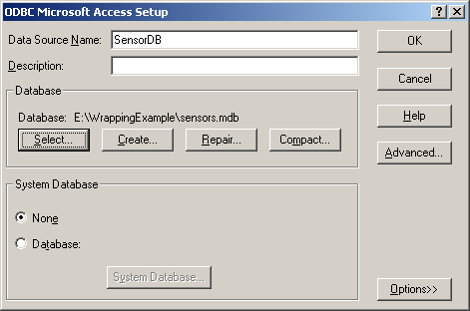

- Open a command prompt window and navigate to the SensorDB subdirectory of the WrappingExample directory.

- Type “ant –buildfile build-legacy.xml” to compile the back-end legacy files.

- Type “ant –buildfile build-legacy-client.xml” to compile the front-end legacy files.

- Type “ant –buildfile build-legacy-client.xml run” to run the legacy system. Ensure that it brings up the GUI and lets you manipulate the database. It should look like the following:

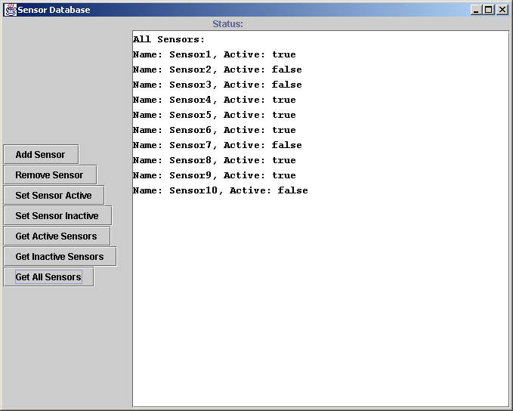

- In the Grid distribution directory, double click on AutoGenerator.jar to start the auto-generation tool

- Fill in the fields as follows:

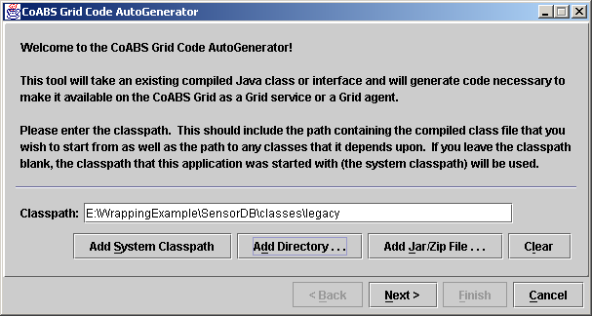

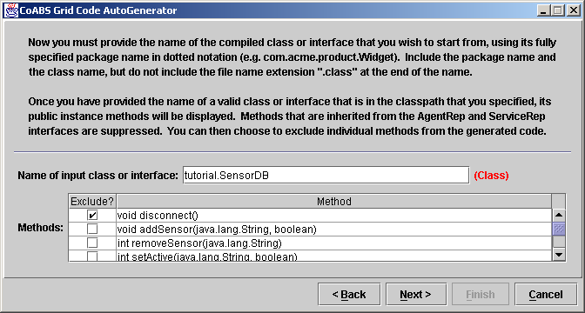

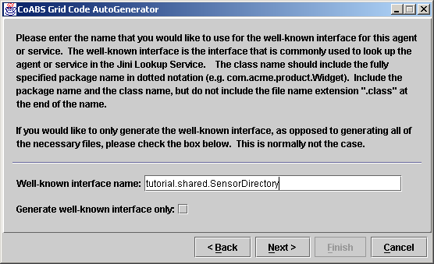

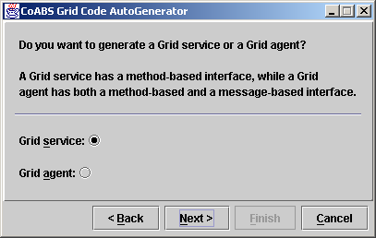

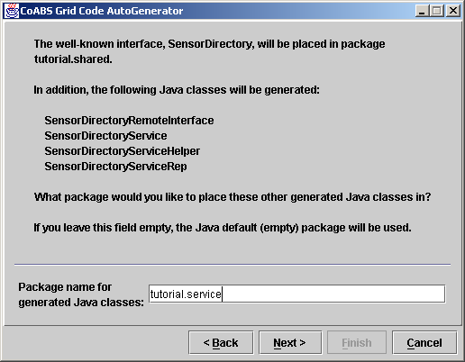

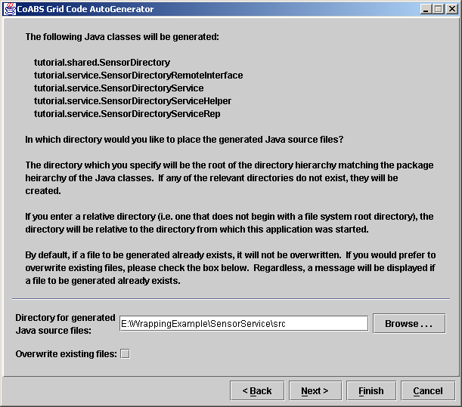

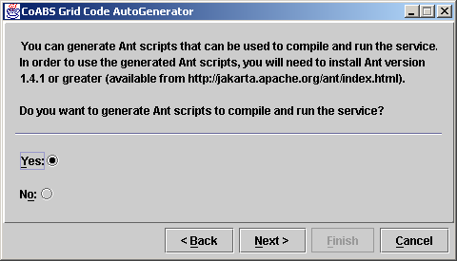

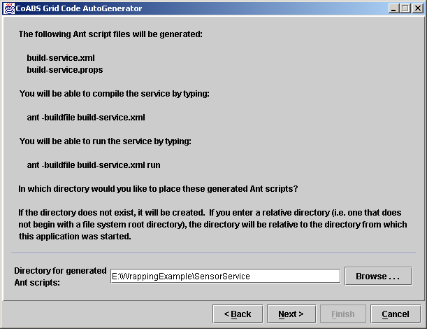

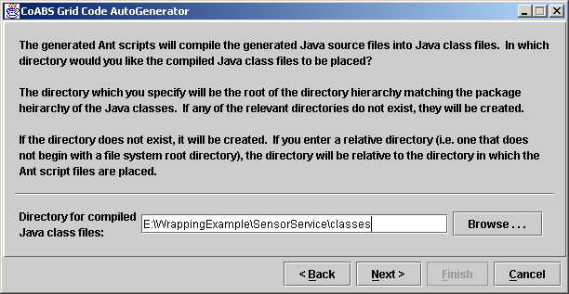

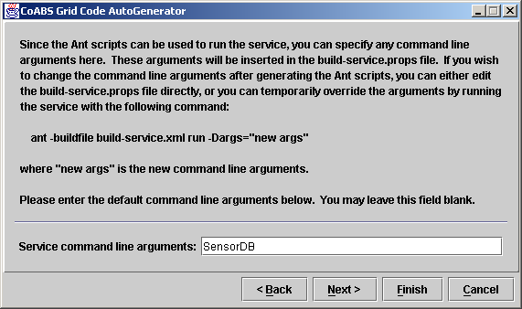

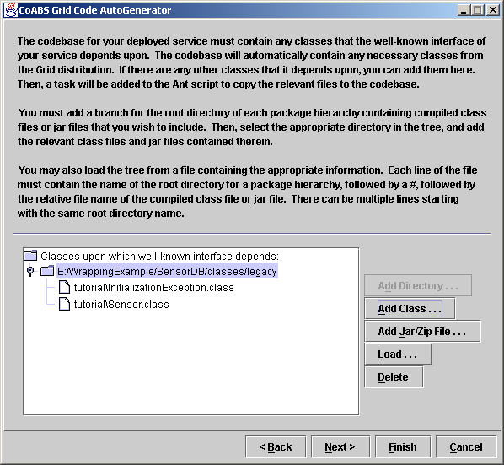

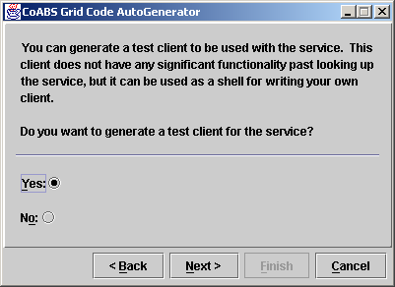

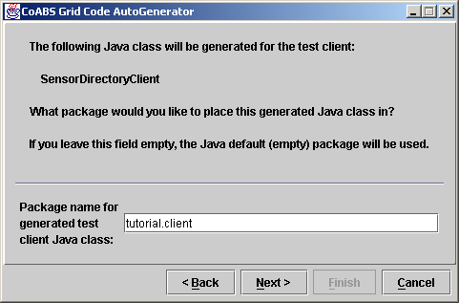

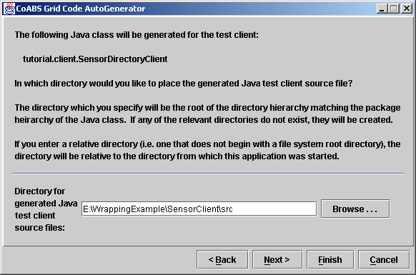

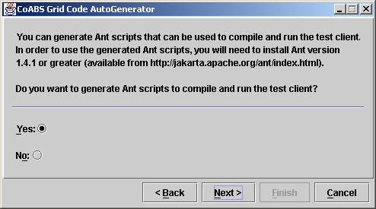

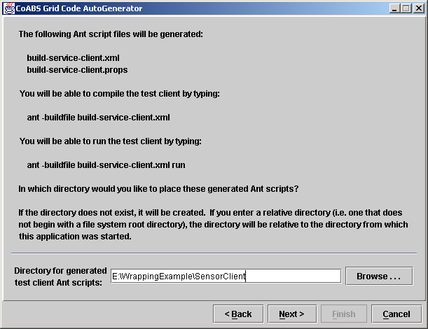

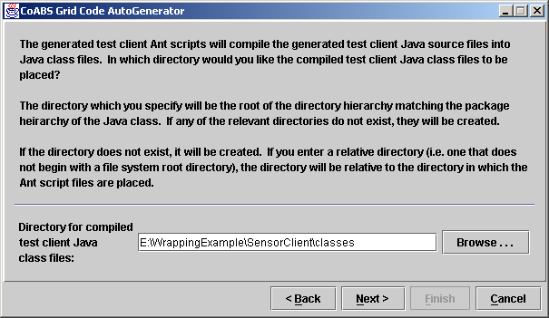

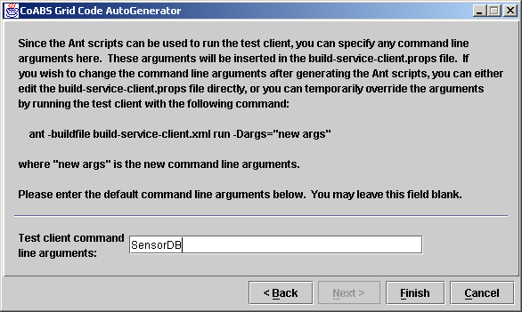

At this point, click “Finish”.

- Edit the generated main service file, SensorDirectoryService.java, in the SensorService\src\tutorial\service subdirectory as follows:

  - Add an import statement for tutorial.InitializationException and an import statement for java.sql.SQLException.

  - Add the following two exceptions to the throws clauses of the SensorDirectoryService constructor and the main method: InitializationException and SQLException.

  - Pass args[0] into the constructor for SensorDB.

  - In the cleanup() method in the ShutdownHook anonymous inner class, add the code that is in the SERVICE_INSERT_THIS file in the WrappingExtras subdirectory.

- In a command prompt window in the directory containing the generated Ant files, e:\WrappingExample\SensorService, type “ant –buildfile build-service.xml” to compile the generated service files.

- Edit the generated client file, SensorDirectoryServiceClient.java, in the SensorClient\src\tutorial\client subdirectory to add at the end, where it says “EDIT: place your client code here “, the code that is in the CLIENT_INSERT_THIS file in the WrappingExtras subdirectory.

- Copy the file SensorGUI.java from the WrappingExtras subdirectory to the SensorClient\src\tutorial\client directory.

- In a command prompt window in the directory containing the generated Ant files, e:\WrappingExample\SensorClient, type “ant –buildfile build-service-client.xml” to compile the generated test client files.

- In a command prompt window in the directory containing the generated Ant files, e:\WrappingExample\SensorService, type “ant –buildfile build-service.xml run” to run the generated service.

- In another command prompt window in the directory containing the generated Ant files, e:\WrappingExample\SensorClient, type “ant –buildfile build-service-client.xml run” to run the generated test client files. You should see the same interface that you saw in step 7 above, but now you are running the sensor database as a service.

