COAX NASHUA - 18-MONTH DEMO TECHNICAL SCRIPT
[Version as at 23 Oct 2001 1626]

Top, Part_1, Part_2, Part_3, Part_4, Part_5, Part_6, Part_7, Summary.

TTCP TP9 - 24 OCT 2001 at MALVERN, UK

OVERALL FORMAT

[20 minutes] Introductory briefing:
- Mike Kirton (overview intro), Austin Tate

[30 minutes] 18-month Technical Demonstration:
- Narrator Patrick Beautement. Operators, David Allsopp, Niranjan Suri, John Carson, Ed Durfee

[30 minutes] Partner's Technical Detail:
- Based on those present, 4 x 5 minutes plus Qs and changeover:
- AIAI - Intelligent Process Panels - A Tate
- Michigan - Plan Co-ordination - Ed Durfee
- QinetiQ - SitViewer, Semantic Web - DA
- Domain Management and Mobility Services - Niranjan Suri

[10 minutes] Coffee break

[10 minutes] CoAX Binni 2002 - Outline Plans:
- Patrick Beautement - outline of scope, approach and scenario (dynamic, new countries) and possible new partner roles:
- DSTO, Australia - represented by PB
- BBN, USA - represented by Austin Tate
- DREV, Canada - Jean Berger

[10 minutes] Outreach Programme - Austin Tate

[20 minutes] Discussion and Engagement with TTCP - All

18-MONTH Demonstration TECHNICAL DETAIL

SETUP FOR THE DEMO:

Various actions need to be carried out to prepare for the demo.

See DA's detailed script for starting up the Grid, various agents etc.
- Concerning the coordination of the Stimulator agents, given the start of a demo where Demo-hour is zero (D=0), then NB the following:
- Stim agent for Red forces - start at D=0 with a simulation time of 1500 and a simulation ratio of x2.
- Stim agent for Blue forces - start at D=0 with a simulation time of 1500 and a simulation ratio of x2.
- Dartmouth Ground Observers - start at D=0 with a simulation time of 1500 and a simulation ratio of x2. [These are set off by subscribing to an Observer Agent with the XSLT Translator Agent]

Other notes to follow:

DEMO STAGE MANAGEMENT

Actions such as "When to switch screens", which screen to display on and other 'stage management' tasks are included in the technical script below.
Demo Layout

START THE DEMO WITH A 'SCENE-SETTING' INTRODUCTION

While Narrator explains background to Binni and Execution Phase Issues, do the following:
- Fire-off the Stimulators / Ground movement.
- Complete checklists and get ready to start with Screen 1.
Top, Part_1, Part_2, Part_3, Part_4, Part_5, Part_6, Part_7, Summary.

PART 1 - Time: 1505

Overview of Narrator's text [??? Explain the panel and the other issues]:
- Storyboard Slide 1 PPT on one projector, and talk through " Information about the Firestorm has leaked to the media and there are concerns about the protected mammals in the Laki Safari Park. The UN Special Representative orders the JTFC to consider alternatives to the Firestorm mission and tasks JFACC to report on: moving objects under the Firestorm area, ground activity by Gao / Agadez and time left before 'cancel mission' has to be given".
- [Backup: talk through first part of I-DEEL / I-LEED screen cam (coax-aiai-ip2-tscc-18jul2001.avi) on the other].

Technical Actions:

SCREEN1 - At UN, use SGSR Panel (I-TEST):
- Send high priority message to I-LEED: "Consider Elephants Laki Safari Park"
- Set: Report Back - Ref: to "unsgosr1".
- Send to I-LEED (pass down the chain to JTF HQ).

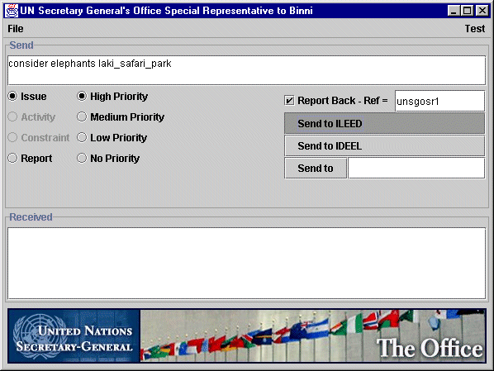

SCREEN1 - Next, at JTF HQ, use I-LEED:
- [NB: That UN message comes up as an issue].
- Expand: "Using Impact on Firestorm area"

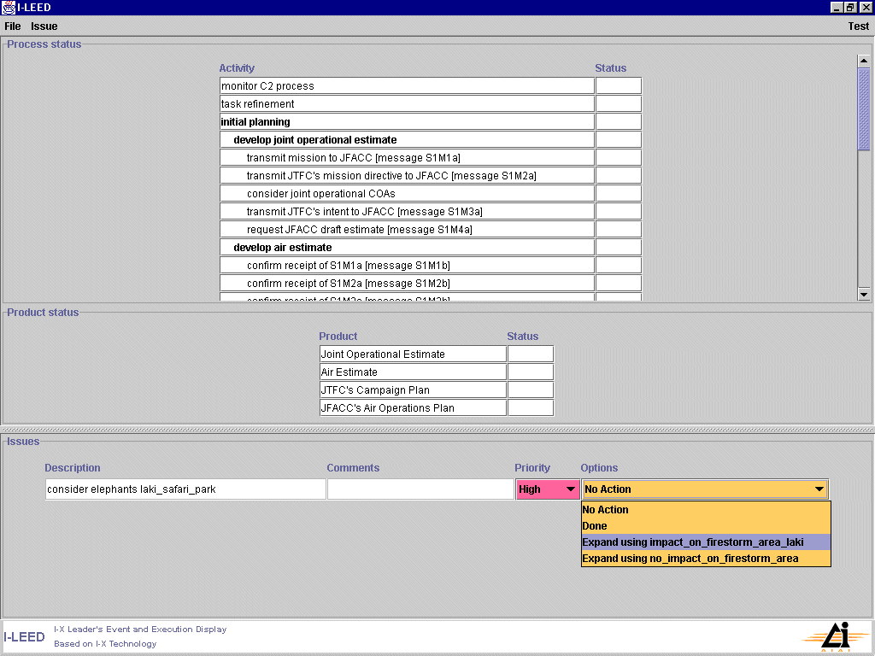
[NB: That the other option ("… no impact on Firestorm area") only deconflicts the plans and makes the Firestorm the pivot].

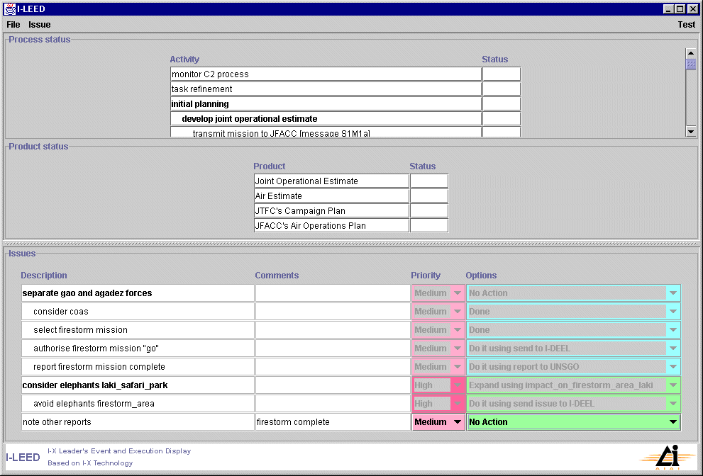

- SCREEN1 - From the options for "avoid elephants firestorm_area" select:
- Set priority to "High", then select:
- "Do it using send issue to I-DEEL" (ie, pass it down to JFAC HQ / Cbt Ops).

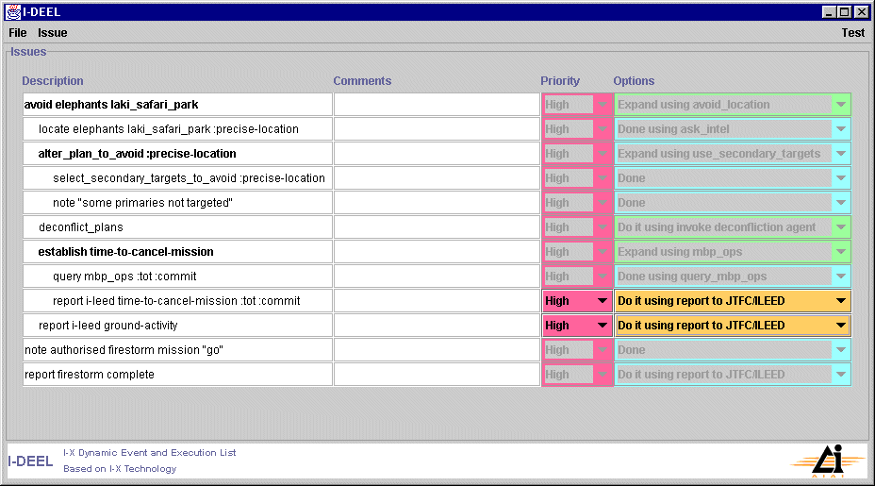

SCREEN1 - Next, at JFAC HQ (Combat Ops), use I-DEEL:
- [NB: That JTF HQ message comes up as an issue. Explain other actions already on panel and role of Combat Ops].
- Expand: "avoid elephants firestorm_area" and select:
- Set priority to "High", then select:
- "Expand using avoid_location".

[NB: There is another option ("… avoid_by_altering_timing") only deconflicts the plans and makes the Firestorm the pivot as before].

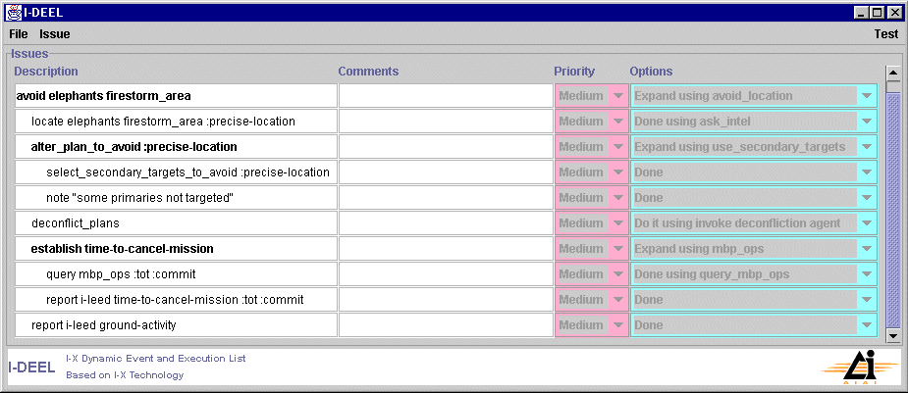

SCREEN1 - Set priority to "High" for ALL issues, then select:
- Expand: "locate elephants firestorm_area :precise-location" and note actions available:
- Show that "Done using ask_intel" is available as an option which will be 'ticked off' later when done.
- Note that "alter_plan_to_avoid :precise location" will be dealt with once the location is known.
- First thing to do is Expand: "establish time-to-cancel-mission" by selecting:
- "Expand using mbp_ops". We'll now see how this is done.

[??? Get this brought to the top of the list of issues - ^v arrows to re-order?].

Top, Part_1, Part_2, Part_3, Part_4, Part_5, Part_6, Part_7, Summary.

PART 2 - Time: 1515

Overview of Narrator's text:
- Storyboard Slide 2 PPT on one projector, and talk through: "JFACC / CCO staff enter likely actions to meet the tasking into the Event Panel. They use MBP Ops to find out time for decisions (106 mins at most to TOT, 48 minutes to commit). PP is notified task underway."
- [Backup: talk through second part of I-DEEL / I-LEED screen cam on the other, then show 2 x MBP screenshots in PPT on other projector (P_Before_Binni_29Sep2012_5-1-3.jpg and 18-Mission_Times.bmp) ].

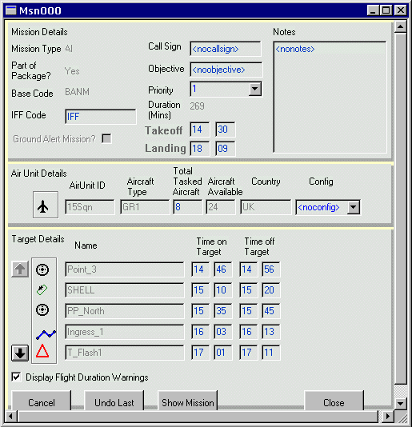
Msn000 in Firestorm NE Package

Technical Actions:

SCREEN1 - On MBP Ops (the active update version) call up "Msn000" in the "Firestorm NE" package. Look at timing of Ingress (1603) - 48 minutes away; and of the TOT (1701) - 106 minutes away. These times are notified to the JFACC and on to the JTFC.
        - For "establish time-to-cancel-mission":
        - Set "query mbp_ops :tot :commit" to:
        - "Done using query_mbp_ops".
        - Set "report i-leed time-to-cancel-mission :tot :commit" to:
        - "Do it using report to JTFC / I-LEED".
[??? Nothing happens here - should it? Where would we put in the values?]

Top, Part_1, Part_2, Part_3, Part_4, Part_5, Part_6, Part_7, Summary.

PART 3 - Time: 1520

Overview of Narrator's text: [??? Now need to locate elephants, explain transponders]
- Storyboard Slide 3 PPT on one projector, and talk through: "Combat Ops staff try to locate wildlife info - RFI initiated and Internet searched. Staff subscribe to the e-Gents service. MNBLI used to identify animal movement trends." (Optional second PPT slide showing sequence of events - Storyboard No 4)
- [Backup: run through first part of e_Gents screen cam (LakiFull4_TSCC.avi) to show MBNLI on other screen].

Technical Actions:

SCREEN2 - Following-on from the event "Ask Intel" - Combat Ops staff issued an RFI verbally and Intel staff are now trying to find a source of information about mammals in the Firestorm area.
- Use a browser to search the Internet and find the WFPW (World Foundation for the Protection of Wildlife) Laki Safari Park site. Then:
- Click on the MBNLI (Menu-based Natural Language Interface) link, then:
- <Right-click> on the window and select the following query:
- "<List the> <time> and <location> and <herd> of <elephants>"
[Pause to allow narrator to explain NLI].

- A query results window comes up. Observe the Lat-Long values and note that the data shows the herd normally migrates north at this time of year.

SCREEN2 - Now subscribe to the egents service by clicking on the "OBJS eGents System" link. We'll now show what what's happening in the background here:
- Enter "psm1@localhost" and "psm2@localhost" in the "Personal Status Monitor Client" window. This sends email to the elephant's transponders, which then send back the elephants status information to a form on a web page (See Storyboard slide 4). In this demo the info comes up in the two "Personal Status Monitor" windows.
- Now click on the "status" link on the Laki web page and the "Current Status of Animals you are Monitoring" form is shown. NB that the data is live and shows the elephants moving north.
Now this feed has been established, it needs to be made available to the Coalition shared information environment though SitViewer / C4I etc.

Top, Part_1, Part_2, Part_3, Part_4, Part_5, Part_6, Part_7, Summary.

PART 4 - Time: 1525

Overview of Narrator's text: [Time left: 38 to push / 96 to TOT]
- Storyboard Slide 5 PPT on one projector, and talk through: "Combat Ops staffs create feed to MBP Ops / SitViewer from Laki site using Ariadne wrapper and XLST Translator. Human updates Event Panel to show task achieved." (Optional second PPT slide showing sequence of events - Storyboard No 6 [Storyboard No 7 put in 'Spare Slides' section] ).
- [Backup: second part of e_Gents screen cam to show Herd data links on other screen].

Technical Actions:

SCREEN2 - Create the feed from the Laki web site to the Coalition shared data for use by C4I using Ariadne and XSLT (Extensible Style-sheet Language Toolkit) wrapper. [NB: The wrapper runs at the Ariadne server, but could be anywhere]. So:
- Ariadne 'scrapes' the page and the Translator Agent / XSLT Interface Agent queries the Ariadne wrapper by http, then
- The XSLT Interface Agent loads the stylesheet and associated translation tools (bespoke in this case). This translates the output into MBP Ops format.
- Then, set the translator tool to "auto". Now a NRT feed is generated and all in the Coalition who wish can see this info (eg: JTFC / JFACC etc).

SCREEN1 - Then this wrapped information about the elephants is sent to the other agents.
- So it appears on the Coalition SitViewer as neutral 'ground forces'. Show that this is 'live' data - note the northward movement as before. [Start with Globe, explain what SitViewer is and why it's useful - everyone can use it at any level].
- Also, show that the Coalition sensors are feeding information into the shared environment and so SitViewer displays the Firestorm packages beginning to form up.

SCREEN1 - Can now pass info to JFACC / JTFC about elephants being OK and outside Firestorm area (they can see it on their SitViewer).
- Return to I-DEEL and 'tick off' the "Ask Intel" issue as "Done".

Top, Part_1, Part_2, Part_3, Part_4, Part_5, Part_6, Part_7, Summary.

PART 5 - Time; 1526

Overview of Narrator's text:
- Storyboard Slide 8 PPT on one projector, and talk through: "JTFC authorises Firestorm 'Go' (NB: mission to NE area diverted to 2ndry target and re-tasked later). This event added to Event Panel. Dartmouth Observer info redisplayed on MBP Ops / SitViewer and made available to Gao."
- [Backup: run through last part of e_Gents screen cam to show SitViewer on other screen].

Technical Actions:

SCREEN1 - At the JTF HQ the JTFC decides to approve the Firestorm mission. So:
- Sets the Firestorm mission priority to "High" and Expand "Go" on I-LEED to "Done using send to I-DEEL", which appears on I-DEEL as authorisation to proceed.
- As a result an issue is activated in I-DEEL (part of providing shared Coalition SA):
- Order acknowledged by setting the issue to "Done" on I-DEEL.
- As a result of this conditional order the Firestorm NE Package must be diverted to it's secondary target and checked to see if it is still valid (was planned 2 days ago). So:
- Expand: "alter_plan_to_avoid :precise location" by selecting:
- "Expand using use_secondary_targets".
- The "note some primaries not targeted' " is set to "Done".
- The " select_secondary_targets_to_avoid :precise-location" will be actioned later because we need to review the information on the movement of ground forces first.

SCREEN1 - At this time Dartmouth Observer reports of ground movements start to arrive (Dartmouth Field Observer system has been set up as we saw for eGents):
        - Show the Coalition SitViewer and observe the Gao forces moving East and South and Agadez forces moving north and west.
        - On I-DEEL set "report I-LEED ground-activity" to "Done".
[How's this done: send a Grid Message from the Translator Interface Agent to subscribe to the Observer Agent which sends a stream back to the XSLT Translator which transforms the data and makes it available to SitViewer etc?]

Top, Part_1, Part_2, Part_3, Part_4, Part_5, Part_6, Part_7, Summary.

PART 6 - Time: 1535

Overview of Narrator's text: [Time left: 28 to push / 86 to TOT]
- Storyboard Slide 9 PPT on one projector, and talk through: "Change / diversion to 2ndry target must now be deconflicted with existing plans. Also, prioritisation of resource usage in the Observer domain is changed (via PP?) to hasten notification of ground movements." (Optional second PPT slide showing sequence of events - Storyboard No 10, plus then show 2 x MBP screenshots in PPT - P_Before_Binni_29Sep2012_5-1-3.jpg and after P_After_Binni_29Sep2012_5-1-3.jpg missions)
- [Backup: run through MCA screen cams MCA_Before_TSCC.avi and MCA_After_TSCC.avi to show options being available on other screen that relate to the change of missions].

Technical Actions:

[Check Stim clocks to see if they need pausing].

[Unload eGents stuff to release memory for MCA].

SCREEN1 - Prepare a changed plan for the Firestorm NE package to go to Suthertown WMD site (we won't show this live unless someone asks to see how it's done).
- MBP Ops is used to generate a changed plan which is sent to the MCA for deconfliction with along plans from the rest of the Coalition:
- Click on the "Firestorm_NE" Package in MBP Ops to show its current routing.
- Now load the "After" plan and click on the WMD_Suthertown package to show the new routing.
- Send the changed plan to MCA using the "Plan Convertor Agent".
[??? MBP Ops puts its changed plan in a specific folder ?where? and a 'helper app' picks it up and sends it to MCA]

SCREEN2 - Switch to MCA to see it receiving the plan options.
- Conflicts are detected with a short-notice helo flight (a MedEvac mission) and a planned Humanitarian Aid mission [??? What about the Ground Observer extraction from Laki]. So:
- Explain that MCA is showing what needs to be adjusted to fit in with the Firestorm 2ndry target change.
[??? need guidance from Ed 'again' on what is being shown and what we can do with it so can make a demo of it. Dave has observed that MCA takes the MBP Ops plan as the pivot point and arranges things round it - isn't that the other I-LEED / I-DEEL options?]

SCREEN1 - Switch to I-DEEL and:
- Show the "Number of plan options" messages (switch back to MCA if req'd).
- The "select_secondary_targets_to_avoid :precise-location" can now be 'ticked-off'.
- [Will not show the iteration of adjustments, but assume that the 2ndry is approved]
- AWACS would be notified to pass diversion info to the Package Leader.

[On Screen2, but not shown]. Send the changed plan to Stimulators using the "Plan Convertor" agent.

Combat Ops must now monitor execution and reports and will use SitViewer.

Top, Part_1, Part_2, Part_3, Part_4, Part_5, Part_6, Part_7, Summary.

PART 7 - Time: 1601

Overview of Narrator's text: [Time left: 2 to push / 60 to TOT].
- Storyboard Slide 12 PPT on one projector, and talk through: "Agadez fighters start HVAA - JSTARS must 'regress' - observer agents on board 'SCRAM' to an alternative processing platform". Degraded picture then shown on SitViewer [??? Not done yet?].
- The attack is noted in Event Panel, UNWAFB AD alerts activated and PP informed. [??? How do we do this? Want to show this being done on-the-fly.].
- [Backup: we don't have a screen cam! Does Jeff have a working demo here? Could put up Storyboard Slide 13 PPT on other screen and talk through? ].

Technical Actions:

SCREEN1 - SitViewer show that the Coalition sensors are feeding information into the shared information (which SitViewer displays) showing hostile fighters approaching from Agadez. This means that the JSTARS and the AEW will have to regress.

SCREEN??? - So:
- [??? Niranjan's demo here]

Top, Part_1, Part_2, Part_3, Part_4, Part_5, Part_6, Part_7, Summary.

SUMMARY

??? will now summarise.

<<< /Technical Script for 18-month >>>

