
DARPA CoABS PROGRAM - CoAX BINNI 2002 DEMONSTRATION


CoAX Partners: AIAI, BBN, CMU, Dartmouth, DSTO, GITI,
Lockheed Martin ATL, NRL, Potomac Inst., QinetiQ, U.Maryland,
U.Michigan, UT-Austin, UWF/IHMC.

With support from: AFRL, ARL, Boeing, DRDC, DSTL, ISX, Mitre, MIT Sloan,
NWDC, OBJS, Schafer, Stanford, TTCP, USC/ISI, US PACOM.

http://www.aiai.ed.ac.uk/project/coax/

To show, with conviction, that an agent-enabled infrastructure significantly aids the construction of a Coalition 'command support system' - and improves its effectiveness.

Demonstration technical objectives
The aim of the Coalition Agents eXperiment (CoAX) is to address the unique aspects of achieving coherent Coalition operations from diverse 'come-as-you-are' elements. The operational and technical objectives of CoAX are to:

- show how flexible, timely interaction between different types of (sometimes incompatible) systems and information 'objects' is effectively mediated by agents - leading to agile C2 and improved interoperability;
- show how ease of composition, dynamic reconfiguration and proactive coordination of Coalition entities leads to adaptive responses to unexpected events at 'run-time' - providing robustness in the face of uncertainty;
- show how loosely-coupled agent architectures - where behaviors and information are 'exposed' to the community - are more efficient and effective than monolithic programs.
- show how agent policies and domain management help facilitate:
- selective sharing of information between Coalition partners - leading to coherent operations;
- control of appropriate agent behavior - leading to an assured and secure Cyberspace environment;

Approach
The CoAX objectives are being met by developing and evaluating agent-based computing, including services for managing agent domains and tasks through:
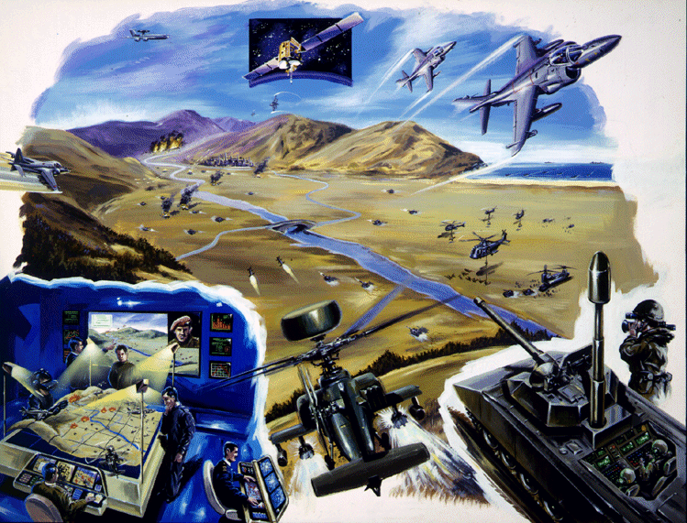
- technical demonstrations of increasing complexity involving the integration of legacy, heterogeneous and dispersed information systems in an agent-enabled environment;
- the provision of Coalition-oriented generic grid services enabling 'come-as-you-are' elements to participate effectively at short notice;
- the integration and use of existing / legacy military applications from different countries;
- the use of a varied set of both domain-management-aware and 'non-aware' agents;
- publishing technical reports and research papers.

What are Software Agents?
We define agents as semi-autonomous software entities which mediate or support the actions of humans or other agents. Agents can be organized to support individuals, military commands and virtual functional teams.

So, why are agents potentially so useful during conflict? Firstly, and most importantly, because they enable you to behave unpredictably - to 'wrong-foot' the opponent. Software agents are a way of providing so-called 'command agility', because they are designed to be able to cope with the Network-Centric Warfare environment which is event-driven, high-tempo, short-timescale, uncertain, diverse and dynamically varying.

Secondly, the opponent will impose unpredictable events / outcomes on the 'Battlespace', so it is impossible to plan all your requirements in advance. Hence, you must be able to adapt to the military imperative at 'run-time' - your command systems must not constrain your scope of actions.

Next, unlike traditional software which is reactive, agents are capable of being proactive and predictive. Although their autonomy and intelligence give them much more freedom, the actions of the agents and the flow of information among them is kept under strict control by human administrators through policies that are enforced in the domains to which they are registered. Agents can adapt to changing circumstances at 'run-time' and can use messages and events to act as triggers - hence they are not tightly restricted at design-time to what they do.

If we are to achieve full-spectrum dominance - then we must understand that Cyberspace is a battlespace like any other. Software agents provide a mechanism to act effectively inside Cyberspace and provide Cyberspace awareness.

TechnologIES on Offer
AIAI, University of Edinburgh, UK http://www.aiai.ed.ac.uk/project/ix/
I-X - Intelligent Task Support and Messaging - Process and Event Panel Technology - Augmented messaging between agents concerning issues, activities, constraints and annotations / reports (I-N-C-A) and intelligent planning aids to assist with task support for individuals and teams.

AFRL http://www.rl.af.mil/
The Consolidated Air-Mobility Planning System (CAMPS) has featured in earlier demonstrations in the role of an agent-wrapped legacy system successfully interoperating with foreign Coalition systems.

BBN Technologies http://www.bbn.com/
Mixed Initiative Agents and Dynamic Information Flow technologies. Simworld event driven built on OpenMap and the CAMPS tool mentioned above.

CMU http://www.cs.cmu.edu/~softagents/
Anaconda Grid Agent Communications Visualization of inter-agent messaging for building trust in a software agent environment and DAML-S Matchmaker.

DSTO, Australia http://www.dsto.defence.gov.au/
ATTITUDE is an agent system that will contribute to improved situation awareness through visualization, information fusion, automation of routine aspects of Joint and Coalition operational planning, INT/OPS execution, operational logistics, and COA analysis – as part of DSTO’s FOCAL (Future Operations Centre and Analysis Laboratory) program.

Dartmouth College http://agent.cs.dartmouth.edu/
Mobile Agents for Medical Monitoring allow medical personnel to monitor remote casualties without transmitting large volumes of data across the network. Only the monitoring code and highly filtered medical data ever cross the network. Medics can monitor large number of casualties (even Coalition partner casualties) without affecting other operations.

GITI / ISX http://coabs.globalinfotek.com/
CoABS Grid - a framework for federating heterogeneous agent systems. It enables rapid integration of heterogeneous applications and it is designed to meet the challenges of the military environment. Also, Verona - a powerful Knowledge Management tool that empowers users to easily capture, organize, manage and share knowledge-rich content.

Lockheed Martin ATL http://www.atl.external.lmco.com/
With the Interoperable Intelligent Agent Toolkit (I2AT), military IT staff can rapidly implement modified or entirely new agent behaviors. I2AT agents excel at integrating disparate stovepipe system and at assisting decision makers in the exploitation of their information and services.

University of Michigan http://ai.eecs.umich.edu/people/durfee/COABS/
Multilevel Coordination Agent (MCA) works top-down with plans developed independently by different coalition teams. MCA predicts unintended interactions, identifies candidate resolutions (such as merging steps that duplicate effort or inserting timing constraints to deconflict plans), and presents the commander with ranked candidates for selection.

MIT http://ccs.mit.edu/roma/
The MIT Robust Open Multi-Agent Systems (ROMA) develops multi-agent systems for open contexts where the constituent agents must run in the dynamic and potentially failure-prone environments at hand.

OBJS http://www.objs.com/agility/tech-reports/
eGents are agents which communicate over email using open communication languages and exploiting the robust (and pervasive) email infrastructure.

QinetiQ, UK http://www.qinetiq.com/
Decision Desktop (DD) augments decision-makers’ cognition by enabling them to acquire, visualize and manipulate diverse and dynamic information - however they wish and whenever they need it. DD uses software agents to acquire and translate data using Semantic Web technologies to reason effectively with the information - and behave more intelligently.

Stanford University http://www.stanford.edu/
Market Mechanisms Technology which investigates ways in which ‘market forces’ can be used to influence software-agent behavior.

University of Maryland http://www.cs.umd.edu/projects/impact/
IMPACT agents for reasoning with probabilistic temporal information - asset movement prediction agent.

University of Texas at Austin http://www.lips.utexas.edu/
Sensible Agents "Trustworthiness Evaluation" manages the inherent uncertainty associated with assessing the situational picture by asserting the perceived trustworthiness of information sources and their data. In a situation, "Adaptive Agent Organizations" works to form the best organization for each agent goal to efficiently respond to environmental dynamics.

University of Southern California / ISI http://www.isi.edu/ariadne/
Ariadne provides the ability to query on-line sources as if they were databases using machine learning technology to build "wrappers" for querying online sources and then ensuring that they continue to provide the expected data. In a Coalition environment, this capability is important for rapidly accessing data from both Coalition partners and open sources

UWF/IHMC and Boeing http://www.coginst.uwf.edu/kaos/
KAoS Technology provides agent domain management services and agent policy administration tools which enable warfighters to define suitable agent domains and ensure policy uniformity (and hence agent behaviors) across multiple platforms and hosts within a domain.

University of West Florida / IHMC http://www.coginst.uwf.edu/nomads/
NOMADS Technology provides two key enhancements: the ability to capture the execution state of agents and control the resources they consume and to provide support for strong or transparent mobility for agents. These control mechanisms can also be used to protect against denial of service attacks by malicious agents.

COAX BINNI 2002 Demonstration Storyboard
Two mythical countries, Gao (in the north) and Agadez (in the south), are in conflict over an area of land that was annexed by Gao and set up as a new state called Binni. Gao has called on the UN to protect Binni and a Coalition Force has been deployed to stabilize the region. In the previous CoAX Binni 2000 and 2001 demonstrations we showed the information gathering phase at the start of Campaign Planning and the execution of a so-called 'firestorm' mission.

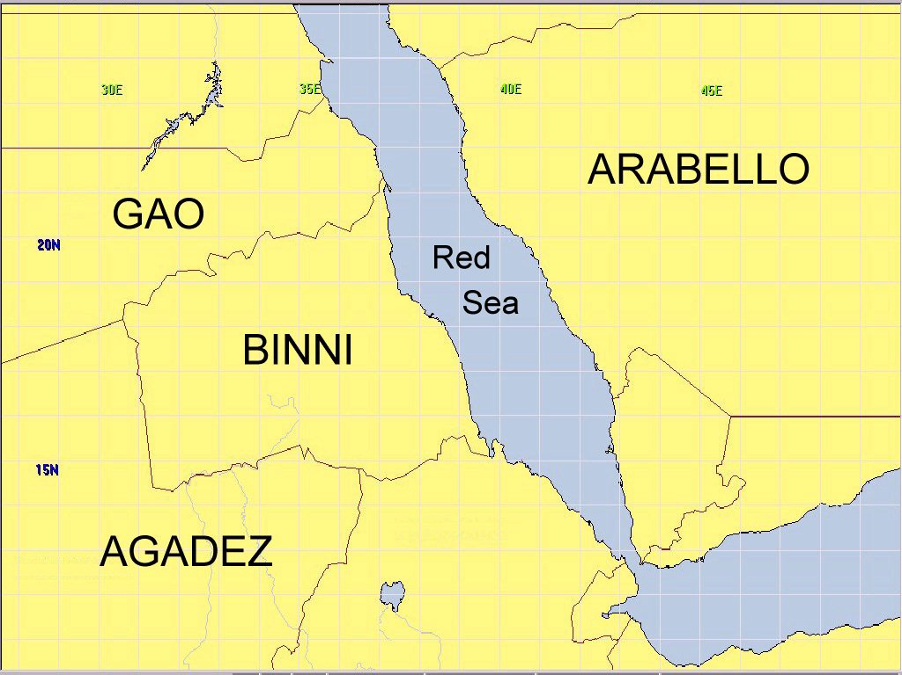

UN forces have been deployed for some time and we will focus on the challenging Execution Phase of conflict, on 29th Sep 2012, for which the plans have been produced and the orders issued. The execution of the Firestorm mission has completed and, earlier in the day, media concerns about the location of wildlife in the Laki Safari Park (near the Firestorm) caused short-notice replanning to take place with only minutes to spare. New orders were disseminated, plan elements deconflicted and events tracked and handled. Also, the opponents, Agadez, flew hostile air-to-air missions against UN 'high-value assets' (the AWACS and JSTARS) and both humans and agents responded. It is now early evening and a number of military events are about to unfold in the CoAX Binni 2002 Demonstration:

- Part 1 will show how a submarine attack on an Australian ship is reported to the Coalition C4ISR through the software agent network distributed across the Coalition;
- Part 2 will show the collection and distribution of casualty information by agents, triggering automated tools for planning and coordinating Medevacs with ongoing logistics operations - enabling timely rescue and treatment;
- In Part 3, a new country (Arabello), joins the coalition "on-the-fly" (using agents and the CoABS Grid) and agents provide interoperability - enabling the Coalition to use an information feed from an underwater sensor grid;
- Part 4 shows how agents assist with the fusion, sharing and employment of the information from Arabello's underwater array information with that from other Coalition ASW forces and sensors;
- Part 5 shows how agents help the Coalition disseminate the Arabello information, along with existing Coalition information and tools, to enable countermeasures to be deployed - resulting in a successful end to the conflict.

the software agent 'so-what'
We feel that the demonstration has shown how an agent-enabled infrastructure significantly aids the construction and employment of a Coalition 'command support system'. We also feel we have shown a number of clear benefits:

- How flexible, timely interaction between different types of (sometimes incompatible) systems and information 'objects' is effectively mediated by agents - leading to interoperability;
- How policies and domain management help facilitate selective sharing of information between Coalition partners and control of appropriate agent behavior - leading to an assured and secure environment;
- How the ease of composition, dynamic reconfiguration and proactive coordination of Coalition entities lead to adaptive responses to changes and unexpected events;
- How the loosely-coupled agent architecture - where behaviors and information are 'exposed' to the community - can be more efficient and effective than the monolithic programs usually procured.

