Chapter C-9

LEGAL

- Purpose. This chapter provides an outline of the CTF Legal Officer’s responsibilities and provides basic guidance to establish and operate the CTF Legal Officer section. It sets forth general guidance for the administration of legal support, military justice, international law, operational law, the law of armed conflict, rules of engagement, claims, administrative law, fiscal and contract law, and legal assistance. Legal advisors must be prepared to provide counsel on those aspects of exercises and operations involving the subjects covered in this chapter. Although each legal organization possesses similar functional capabilities (e.g., administrative law, claims, contract law, criminal law, and operational law), the specific tasks performed within each of these areas differ in purpose and scope depending on the assigned mission and the organization performing them.

Responsibilities. The CTF Legal Officer is the principal legal advisor to the CCTF and is a member of the CCTF’s personal staff. The CTF Legal Officer is responsible for the employment of legal personnel OPCON to the CCTF . The CTF Legal Officer provides the full spectrum of legal services to the CCTF and staff and coordinates with the Supported Strategic Commander’s Legal Officer to optimize legal support to the CTF through Coalition Legal Officers. The CTF Legal Officer’s responsibilities include:

- Provide legal advice to the CCTF and staff.

- Serve as a single point of contact, with Coalition Legal Officers, for legal matters affecting forces OPCON to CCTF .

- Ensure all plans, rules of engagement (ROE), policies, and directives are consistent with the law of armed conflict and other international law.

- Monitor claims activities within the CTF AO.

- Monitor criminal jurisdiction matters affecting personnel within the CTF AO.

- Advise the CCTF on differences and potential impact of the laws of participating nations.

Organization

- The organization and staffing of the CTF Legal Officer section depends on the CTF’s size, composition, and mission. The CTF Legal section must maintain situational awareness while planning and controlling operations.

- Depending on the CTF’s size, composition, and mission, the CTF Legal Office, in addition to meeting its own personnel requirements, must detail representatives to serve on the following board, center, and cells: the Force Protection, Information Operations, CPG, ROE Planning Cell, COC, CCC, CMOC, CTCB, and / or CFE.

- CTF Legal Officer Organizations.

a. An example of a CTF Legal Officers relationships within the multinational force is shown on the following page:

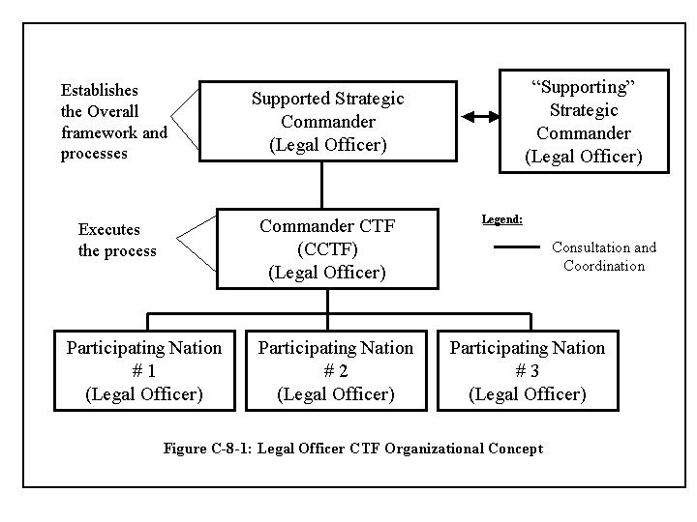

b.The suggested legal staff organization structure is outlined in the below diagram.

Tasks, functions, and procedures. The CTF Legal Officer’s specific duties and responsibilities will depend on the size, composition, and mission of the CTF . A list of duties and responsibilities that a CTF Legal Officer may be called upon to perform is set forth below.

- Formation, deployment, and management of the Legal Staff.

- Form, plan, deploy, employ, transition, and redeploy the Legal Staff.

- Train section personnel.

- Manage section operations, including information and security.

- Requisition and control section resources.

- Planning, coordination, and oversight

- Plan legal support for the CTF and contribute to the overall CTF planning effort. Prepare input to the CTF Operation Plans and / or Orders.

- Prepare the legal estimate

- The legal appendix should reflect the legal estimate developed during the planning process.

- Describe any legal considerations, authorities, and limitations that may affect implementation of the plan or order.

- Cite applicable host nation and reciprocal support agreements.

- Define key terms.

- State policies and procedures, assign responsibilities, and/or address the legal aspects of each of the following items, if applicable:

- Provision of legal services to the CTF , including claims, criminal law, legal assistance, trial defense, and trial judiciary. When coordinating support, consider ways to leverage limited resources (e.g., personnel, communications, logistics, and transportation) and avoid duplication of effort by establishing coalition legal organizations or colocating national legal organizations throughout the CTF AO.

- Submission of legal status reports.

- Authority under international law for military operations and the use of force, including freedom of navigation and overflight of international and national airspace in support of military operations.

- Responding to assertions of criminal jurisdiction over personnel.

- Identifying status of forces agreement issues.

- Negotiating and concluding international agreements.

- Reporting and investigating serious incidents (e.g., fratricide, violations of the law of armed conflict, and noncompliance with ROE).

- Responding to requests for political asylum and temporary refuge.

(i) Migrant and refugee operations.

(j) Civilian employees and contractor employees who accompany multinational forces abroad.

(k) Acquisition of real property, goods, and services during military operations.

(l) Accounting for captured weapons, war trophies, documents, and equipment.

(m) Property transfer or disposal.

(n) Provision of logistical support among coalition forces, host nation authorities, NGOs, and International Organizations (IOs).

(o) Legal review of plans, orders, and target lists at every echelon.

(p) Issues pertaining to weapons of mass destruction.

(q) Treatment of enemy prisoners of war and other detainees.

(r) Interaction with the International Committee of the Red Cross.

(s) Intelligence oversight.

(t) Information warfare and Information operations.

(u) Public affairs.

(v) Giving and accepting gifts.

(w) Environmental aspects of operations.

- If required, prepare the legal considerations paragraph of the basic plan or order.

- Establish coordinating and other administrative instructions.

- Ensure that the published plan or order is correct and complete. Prepare fragmentary orders to correct any errors or omissions.

- Continuously assess legal aspects of mission capability, organization, training, material, and education.

- Serve as single point of contact for all legal issues of coalition origin, that involve more than one nation, or that affect the external relations of the CTF .

- Capture, act on, and share coalition legal lessons learned, issues, and key observations from operations, training events, and other sources.

- Liaise with counterparts at higher, lower, and adjacent headquarters, government agencies, and International Organizations (IOs), including the International Committee of the Red Cross.

- Military Justice.

- The CTF Legal Officer, through Chief, Legal Services, shall supervise the administration of military justice throughout the CTF . The CTF Legal Officer is responsible for providing advice to the CCTF on issues of discipline and military justice. Coalition commanders should consult their Coalition Legal Officer on military justice issues.

- Court-martial and other disciplinary jurisdiction over Coalition personnel, units and detachments will be a national responsibility.

- Immediately report all incidents that may result in judicial action by civil authority to the Supported Strategic Commander.

- Recommend that CCTF implement uniform policies applicable to all nations within the command to maintain good order and discipline or preserve host nation relations (e.g., black market and currency control regulations).

- Advise the CCTF and staff concerning assertions of criminal jurisdiction over military personnel and civilians accompanying the force.

- Provision of Legal Services

- The CTF Legal Officer, through the Chief, Legal Services, will monitor and coordinate the provision of legal services throughout the CTF .

- Administrative Investigations. Advise the CCTF regarding administrative investigations over which the CCTF retains cognizance. Provide legal advice to investigating officers, review their reports for legal sufficiency, and make appropriate recommendations to the appointing and/or approving authority.

- Legal Assistance. Deployed legal officers from the different nations will provide legal assistance to their own deployed personnel when mission-essential tasks permit.

- Claims resulting from or arising out of the activities of forces assigned to the CTF will be investigated, adjudicated, and settled following the procedures of the nation whose activities generated the claim.

- The nation concerned will investigate claims arising from accidents involving personnel and activities and forward results to their legal officer for action.

- Supervise investigation and processing of claims arising from activities of the CCTF and staff.

- Contract Law. Advise the CCTF and staff concerning acquisition of real property, goods, services, and other contingency contracting issues.

- Advise the CCTF and staff concerning provision of logistic support.

- Funding Military Operations. Advise the CCTF , as appropriate, regarding the funding of military operations.

- Advise the CCTF and staff concerning transfers or other disposition of military property.

- Monitor accountability for loss, damage, or destruction of military property.

- Captured Weapons, War Trophies, Documents, and Equipment. Ensure the CCTF and staff are trained on the appropriate handling of captured weapons, war trophies, documents, and equipment. The CTF Legal Officer will provide guidance on the collection, identification, shipment, and return of authorized war trophies to CTF personnel.

- Environmental Law. Ensure compliance with applicable environmental laws and policies.

- Status of Forces and Relations with Host Nation

- The CTF Legal Officer, through the Chief, Operational Law, is responsible for providing legal advice on status of forces and host nation relations.

- Host Nation Support. Collaborate with designated CTF C3, C4 regarding host nation support and civil affairs personnel, work with HN authorities and appropriate coalition representatives to maximize HN cooperation and support of CTF personnel and the CTF mission.

- Operational Law Considerations

- Law of Armed Conflict. The CTF Legal Officer, through the Chief, Operational Law, will advise the CCTF and staff on the legal authority for, and constraints on, the conduct of military operations, including the use of force; Law of the Sea and Airspace, including freedom of navigation and over flight of international and national airspace; basing rights; foreign intelligence and counterintelligence activities; information operations treatment of wounded and sick, prisoners of war and civilian persons and property, including migrants, refugees, and internally displaced persons; conduct of tribunals under Article 5 of the Third Geneva Convention; government of occupied enemy territory; and storage, transportation, and use of weapons of mass destruction subject to special restrictions.

- Drafting and Legal Review of Rules of Engagement. The CTF Legal Officer will provide advice and guidance, in conjunction with the CTF C3, to the CCTF and his staff on the interpretation and implementation of ROE published by the Supported Strategic Commander, and the development and implementation of supplemental ROE.

- Assist the C3 or C5 in preparing ROE request and authorization messages.

- Ensure all plans, orders, policies, rules of engagement, and target lists issued by the command and its subordinate commands are reviewed by legal advisors for compliance with applicable law.

- Ensure alleged violations of the law of armed conflict, whether committed by or against CTF or enemy personnel, are promptly reported, thoroughly investigated, and, where appropriate, remedied by corrective action.

- Targeting. The CTF Legal Officer will support the targeting cell and the CTCB by providing a legal officer to attend meetings of the targeting cell.and the CTCB. All targets will be reviewed for compliance with the Laws of Armed Conflict.

- Man multiple boards, centers, and cells, including the Force Protection, Information Operations, JPG, ROE Planning Cell, JOC, CC -Center, CMOC, CTCB, and/or CFE.

- Political Asylum and Temporary Refugees. Advise the CCTF and staff concerning requests for political asylum and temporary refuge.

- Funding Military Operations. Advise the CCTF regarding the funding of military operations.

- Training. Provide training to the CCTF and staff on the law of armed conflict, ROE, standing and general orders issued by the commander, domestic law, ethics, procurement integrity, and other subjects as appropriate.

- Considerations

- The Law of Armed Conflict. Selected International Agreements, International Law of Armed Conflict, Treaties Governing Land Warfare, The Law of Land Warfare, and other applicable armed conflict legal guidelines and documents will govern CTF forces in the conduct of operations under this chapter. Commanders shall exert every effort to ensure persons subject to their authority are aware of the limitations and standards imposed by international law and that personnel adhere to such standards.

- CTF forces shall treat civilian detainees and the local populace of foreign countries per applicable international law and The Hague and Geneva Conventions. The obligation of the Supported Strategic Commander and CCTF to comply with the Geneva Conventions is not dependent on any other nation’s signing or compliance with these international treaties, but represents an unqualified obligation assumed by the Supported Strategic Commander and CCTF.

- Where applicable, international agreements entered into by the the Supported Strategic Commander and / or CCTF and the country concerned, i.e., Status of Forces Agreements (SOFAs), govern jurisdiction of multinational forces. These agreements should be reviewed prior to commencement of exercises and operations. If sufficient protections do not exist, consider proposing an exchange of diplomatic notes with the host nation. Prepare and brief cautionary instructions for host nation specific laws and customs before embarkation.

- Commanders shall ensure deployed detachments and indigenous forces under their control wear distinctive uniforms to ensure proper treatment as POWsfollowing applicable international law.

- Planning Rhythm. See Sample CTF Battle Rhythm. Chapter C-7

