Chapter C-4
LOGISTICS

- Purpose. To define likely concepts of logistics support, duties, responsibilities, and recommended organization of the CTF C4. This chapter will delineate relationships between the CTF C4, Supporting Strategic Commander, CTF components, IOs, NGOs, and governmental agencies of the host nation and participating nations in the CTF, and provide guidance on specific logistics issues that may affect the CTF.

B. Responsibilities..

1. Concept for Logistics Support. Ideally each participating nation in a MNF is responsible for its own logistic support. However, this is balanced by the varying capabilities of participating nations and the need to minimize the amount of logistic footprint in the area of operations. The appointment of a lead nation for logistic support, responsible for provision of common use logistic commodities and services, will reduce the impact of these issues. National unique items remain a responsibility of individual participating nations (i.e. specialized ammunition, uniforms etc.). In the event that participating nations are unable to provide all their logistic support needs, they will enter into Implementing Arrangements (IA)/ Acquistion and Cross Servicing Arrangements (ACSA) with the Lead Nation for reimbursment and/or exchange of services. Should the CTF operation transition into a United Nations (UN) Operation then guidance provided by the U.N. Troop Contributing Nations Handbook should apply.

2. Method. Logistics is a national responsibility; however, any actions / issues within the CTF theatre of operations has inherent CTF coordination and planning responsibilities. The development and introduction of coalition logistics operations into the CTF is a CCTF responsibility in consultation with the participating nations. Ability to determine and coordinate requirements for deployment, sustainment, and re-constitution to of forces during crisis operations is a critical aspect of all coalition operations. The CCTF will be informed of all coalition issues affecting the operation as they progress.

(a) To alleviate information sharing issues impacting logistics management , the C4 will establish two parallel organizations: the Logistics Operations Center (LOpC) for classified management of coalition logistics issues and the Coalition Logistics Coordination Center (CLCC) for MNF releasable logistics management. The CLCC is a useful organizational tool for the integration of coalition partners in CTF operations. Coordinated logistics operations are especially important during the initial crisis phases to allow different militaries, government agencies, international organizations (IOs) and nongovernmental agencies (NGOs) to synchronize limited resources such as communications and transportation assets.

(b) Using Automatic Identification Technology (AIT) and Automation Information Systems (AIS) to achieve asset visibility and logistics situational awareness are common objectives of many of our coalition partners.

(c) Where possible, ad hoc agreements to share information and capabilities will be negotiated between coalition nations. Use of a Coalition Logistics Network will counter some of the classified information sharing concerns of the participating nations in the CTF.

3. Support Responsibilities. Making critical logistics decisions early on is a key capability to more rapidly stand up and employ a CTF.

a. Early determination of the Supported Strategic Commander's Directive Authority for Logistics (DAL) and the determination of the CCTF's Limited Directive Authority for Logistics (LDAL) are critical for effective multinational logistics. It is very possible that "tailored" concepts of this "authority" may be required to capture the best mix of responsibilities and responsibilities for CTF logistics and, in turn, effective mission accomplishment.

b. Early determination of national responsibilities and sharing responsibilities for common item support or common service support will allow the CTF components to better prepare for deployment and sustainment operations. The CTF C4 should provide recommendations to the CCTF for the most effective means of providing logistics support to the CTF.

c. Logistics functional sharing is a key opportunity to exploit within multinational operations. Functional "leads" within the respective nations supporting the CTF effort may be warranted based upon specific nations expertise and resources. Sharing of funds in such situations should be planned for and coordinated to fully share the CTF fiscal burdens.

4. Endstate. The provision of an effective logistic support mechanism for all Participating Nations so that they can contribute effectively to the conduct of operations.

NOTE: The most critical factor in logistics coordination and planning is the establishment of "specific responsibilities and authorities" for logistics and for "logistics sharing". It must be clearly acknowledged that logistics within in a CTF will have many challenges. However, the potential for "sharing logistics" and "sharing logistics functions" will be an opportunity to exploit within the CTF as a whole. In this regard, the clear establishment of Directive Authority for Logistics at the Supported Strategic Commander level and Limited Directive Authority for Logistics at the CTF level will be one of the pivotal issues for early coordination and determination. Also, early establishment of the Coalition Logistic Co-ordination Centre (CLCC) within the CTF HQS will also be essential for rapid activation and timely CTF initial responses. See Chap 2, Annex C for the CTF HQs organization and the importance of the MJL-CC.

Definitions:
Combat Supplies: Water, rations, fuel, & ammunition
Common User Supplies: Those items identified and managed by CTF C4 as common to all/most participating nations likely to be interoperable.
Classes of Supply: Define NATO classes I – X.
Support Engineering: Horizontal and vertical construction and related funntions.
Combat Engineering: Combat aspects of engineering tasks such as demining, demolition.
National Support Element: That organization responsible for providing unique national support for each participating nation.
Demand Priority System (standardized format)

C. Responsibilities. To coordinate the logistics effort within the CTF the following responsibilities apply

- The SUPPORTED STRATEGIC COMMANDER C4 will:
- As lead nation exercise overall Directive Authority for Logistics (DAL). Limited Directive Authority for Logistics (LDAL) can be delegated to the CCTF as necessary to ensure effective execution of the operation, economy of operations, and to prevent unnecessary duplication of effort by subordinate commands.
- Provide logistics policy and procedural guidance to the CCTF, such as stocking levels (eg deploy; with "X” Days of Supply (DOS) for combat supplies), to include early identification of Component responsible for common item support and common service support .
- Manage coalition force planning, deployment, sustainment, closure, and redeployment issues.
- Provide logistics policy and procedural guidance for components and forces deployed with or in support of the operation.
- Serve as the CTF C4's primary source for coordination of logistics support among the supporting CINCs, other national government agencies, IOs, and NGOs.
- Coordinate policy level logistics matters with the Supporting Strategic Commanders and Lead Nation NCA, and validate and coordinate strategic transportation and allocation of intratheater lift in concert with CTF priorities.
- Coordinate host nation support plan with appropriate ministry of applicable host nation and immediately notify CTF C4 of HNS availability.
- Inform the CTF C4 of logistics support impacting mission accomplishment, monitor and synchronize CTF logistics through liaison with CTF Service component commands, CINC counterparts, and other agencies or organizations as appropriate in order to exchange information and resolve problems at the lowest practical level.
- Provide MPAT augmentees to support the CTF C4 staff.
- Provide a liaison officer (LNO) to CTF C4 in sufficient time to support crisis action planning.
- Provide fiscal guidelines addressing the means to capture incremental costs of the operation.\

2. The CTF C4 will:
- Manage the six broad logistics functional areas of Supply (including catering), Maintenance, Transportation (including movements, although this may be in the J3), Engineering (support? Beause this function is under the J3 in different countries), Health Service Support ((HSS) might be a separate function or under the J1 in some countries), and Other Services (including contracting, mortuary affairs,etc.). Engineering and HSS functions are organized based on the CTF mission or the CCTF’s desires and may not be under the staff purview of the CTF C4.
- Manage the Logistics Information Process of the CTF.
- Ensure C4 participation in the CPG cells (C5 Future Plans, C3 Future Operations (FOPS), and C3 Current Operations (COPS)).
- Establish the Multinational Joint Logistics Coordination Center (MJL-CC) within the CTF HQs.
- Formulate and implement logistical policy and plans within the CTF theatre of operations for forces assigned or attached to the CTF. Logistics policies and plans must conform to the Supported Strategic Commander's guidance promulgated in the applicable OPLAN or OPORD, and to applicable laws, regulations, and doctrine.
- Prepare a logistics estimate for the CCTF that develops, analyzes, compares, and then recommends the best supportable COA from the logistics perspective.
- Prepare and synchronize a Concept of Logistics Support, and prepare logistics annexes and appendices for the CTF OPORD.
- Publish logistics procedures to CTF components to reduce undesired duplication of capabilities and ensure responsive support. Clearly state the responsibilities for providing joint, common or cross servicing support requirements, and provide the location of key supply points.
- Emphasize and monitor the recording of incremental costs of operations within the CTF including managing the IAs/ ACSAs in consultation with the Comptroller.
- Recommend to the CCTF, within the guidelines established by the Supported Strategic Commander, priorities for the allocation of logistics resources among assigned forces within the CTF theatre of operations.
- With C5 and SJA, advise the CCTF concerning logistics matters affecting Coalition and Host Nation Support to optimize capabilities and availability of critical resources.
- Assess environmental consequences of proposed programs and actions; direct the preparation of environmental documents for specific proposed actions, when required.
- Keep the SUPPORTED STRATEGIC COMMANDER J4 informed of the logistics readiness, situation, potential issues, and shortfalls through submission of appropriate reports (LOGSITREPS, SPOTREPS (?), REPOLS, AND MUREPS)

3. National Support Element
- Coordinate logistics support unique to their particular nation

4. CTF Component logistics staffs will:
- Coordinate logistics support and sustainment of forces assigned, except where such support is otherwise provided for by agreements or assignments with national agencies or allies, or by common, joint, or cross-servicing agreements or directives.

b. Promptly identify anticipated logistics shortfalls that will affect CTF mission accomplishment.

D. Organization. The Lead Nation or the Nation providing the majority of forces normally provides the CTF C4 and the majority of the staff. The CTF C4 Division is organized functionally with key leadership positions staffed by representatives from the logistics functional areas of supply, maintenance, services, transportation, engineering, and health services. Other nations providing forces must be represented in the C4 and in any boards, offices, or centers stood up under the C4. This may be achieved through a LNO.. Liaison from the CTF components, Supporting Strategic Commanders and organizations, and other governmental, international, and nongovernmental agencies is desired based upon the CTF mission and logistical requirements. The C4 establishes two coordination centers for synchronization of CTF logistics:

1. The Logistics Operations Center (LOpC). This center is established at the "top level of classified information coordination and sharing" within the CTF HQs. In principle each functional area within the center will be commanded by a member of the lead nation, or a nation that is cleared for “top level of classified information .

2. The Coalition Logistics Coordination Center (CLCC). This center is established to address the "classified information sharing" issues that will likely present within multinational operations (see Part B, Chap. B-5). This issue is only compounded if many nations are involved. To acknowledge this challenge in the logistics arena, the CLCC will provide coordination of coalition / combined logistics issues for those nations not cleared for “top level of classified information coordination and sharing.”

- In alliance / treaty operations (i.e. combined operations) the establishment of the CLCC may replace the Logistics Operations Center (LOpC) internally due to the amount of integration that can be obtained within preplanned alliance operations.
- However, even in alliance operations, the introduction of additional nation's participation in the CTF may still present "classified information sharing" issues. In such situation, both coordination centers will be required to be activated as outlined above.

Note 1: CTF Levels of Effort. Chapter 1 outlined the ranges for the expected CTF levels of effort for this SOP as being "Small Scaled Task Force" (400 to 800 personnel; has a focus on the lower levels of MOOTW / SSC), and "Medium Sized Task Force" (20,000 to 30,000 personnel; has a focus on the higher levels of MOOTW / SSC and has clear combat operations inherent or implied in the CTF mission). This Annex does not outline an organizational option for the Small Scaled Task Force level and focuses on the Medium level of effort. In this manner task organizing the headquarters outlined below ensures "CTF logistical organization planning" doesn't miss any critical functions. The logistics functions outlined below are common for all envisioned levels of effort within the purview of this SOP.

3. Figure C4 -1 below depicts the notional CTF C4 organization for.

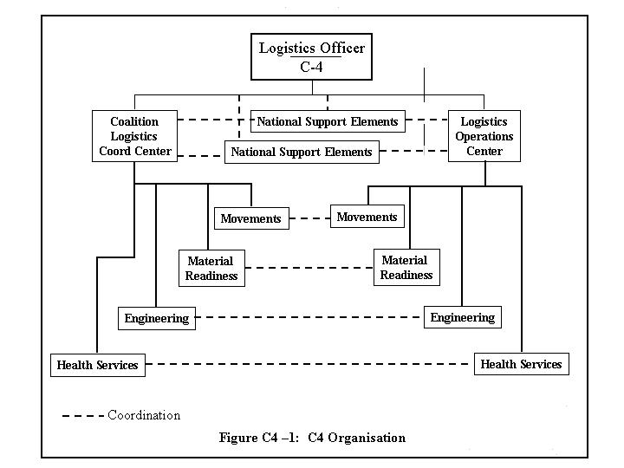

E. Tasks, functions, and procedures

1. Logistics Operations Center (LOpC)

- Mission. The LOpC supports the CTF C4 by providing oversight and management of operational logistics, and exercising "coordination authority" (minimum authority level that should be established) for all logistics matters in the CTF theatre of operations.

- Organization. The LOpC is organized to support the CTF C4, coordinate the functions of logistics within the CTF, between CTF components, the host nation, and SUPPORTED STRATEGIC COMMANDER J4, and Supporting Strategic Commanders J4s. The LOpC is composed of an Operations Section, Plans Section, and Administration Section. A Liaison Section composed of coalition and host nation representatives, other governmental agencies or nongovernmental organizations, may be established based on the CTF mission and the classified information sharing criteria. The LOpC, as well as the subordinate functional centers may also be augmented with MPAT cadre from supporting nation's staffs (see Chap 2, Annex D for MPAT details). The Logistics Operations Officer is responsible for operation of the LOpC.

(1) The LOpC oversees the establishment of boards, cells, or elements within the C4 Division, as required, and provides representatives to boards, cells, and elements outside the C4.

(2) The LOpC establishes direct and on-going coordination with the CLCC for effective coalition support.

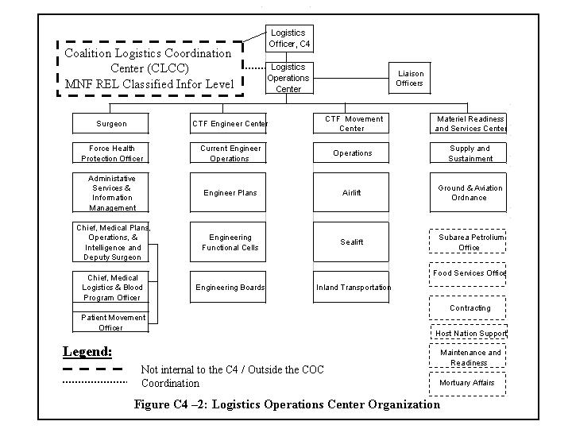

- Concept of Operations. The LOpC is task organized to accomplish the mission essential process of Logistics Synchronization. Logistics Synchronization is the process of ensuring logistics situational awareness is maintained within the CTF command and that logistics support is available to match anticipated requirements in time and space. This process encompasses all actions within the LOpC, completely integrating the functions of logistics into the battle rhythm of the CTF.

(1) Continuous coordination to the CTF planning cells (PLANS, FOPS, COPS) is essential in order to ensure logistics functions are represented at all stages of the planning process. This ensures that situational awareness is maintained by the CTF C4 and that logistics information is being pushed by the CTF C4 vice pulled by outside organizations.

(2) To support logistics synchronization and promote information flow, the LOpC will employ all available automated tools necessary for maintaining a Common Operational Picture. The LOpC will also ensure immediate "reach-back" capability, to include linkage to the SUPPORTED STRATEGIC COMMANDER J4, supporting nation's Logistics Operations Center, and to the Supporting Strategic Commanders' logistical planning staffs. The CTF C4 should consider establishing the LOpC as early as practical during the crisis to facilitate planning lead-time required by supporting nations and organizations. The LOpC will:

a. Facilitate operational logistics support to the CTF by supporting and coordinating the efforts of the Logistics Functional Centers that comprise the C4 organization.

b. Maintain situational awareness on all functions of logistics throughout the CTF to ensure responsive support and mission accomplishment.

c. Ensure synchronization of logistics support in operational execution by providing ongoing coordination with the CLCCand by providing battle watch personnel to the COC and planners to the CTF Planning Cells (PLANS, FOPS, and COPS).

d. Integrate logistics considerations in operational planning activities, ensuring that the C4 planning rhythm supports the CTF battle rhythm.

e. Prepare logistics estimates that develop and analyze COAs.

f. Coordinate with components, SUPPORTED STRATEGIC COMMANDER J4, and other agencies as appropriate to exchange information and resolve problems at lowest practical level.

g. Prepare the Concept of Logistics Support, and logistics annexes and appendixes to CTF OPORDs.

h. Prepare logistics status reports as required and provide input to the CCTF situation report (SITREP) and LOGSITREP.

i. Recommend policies and procedures to ensure logistics management, efficiency, and economy.

j. Recommend to SUPPORTED STRATEGIC COMMANDER J4, component responsibility for Common Item and Service Support.

k. Recommend activation of boards, cells, and elements within the C4.

l. Recommend host nation or contract support, where practical.

m. Provide logistics situational awareness to the SUPPORTED STRATEGIC COMMANDER J4.

(3) Summary. The LOpC is established and organized to manage and facilitate all logistics functions within the CTF. The most important activity of the LOpC is to provide timely logistics information to the CCTF for decision-making. This is accomplished through logistical interaction in CPG cells (C5 Future Plans, C3 FOPS, and C3 COPS).

2. Coalition Logistic Coordination Center (CLCC):

a. Mission. The mission of the CLCC is to provide for centralized coordination of multinational logistic functional areas within the CTF.

b. Organization. The C4 is responsible for developing the initial logistic guidance, planning for the logistic support of the operation, and promulgating logistic policies on behalf of the CCTF. The CLCC director (who reports to the C4) is primarily concerned with implementing the guidance, policies, and plans developed by the C4 and approved by the CCTF for coalition coordination and planning. The key baseline for effective coordination of logistics operations is staffing with skilled personnel within these functional areas with balanced multinational staffing of participating nations within the CTF

The CLCCis normally organized within common functions and should be established early on in the activation of the CTF.It is organized to support both the CTF C4 and participating nations to effectively integrate and coordinate the logistics within the CTF. This also includes CMO related issues of IOs, NGOs, and host nation civilian support issues beyond the capabilities of the host nation. The CLCC functions similar to the LOpC outlined above but has a more "focused near term" perspective based upon ongoing operations. Broadly speaking, the CLCC should be operated on a "functional basis" and tailored to best support coalition and CMO activities. Listed below are the starting point functions for the CLCC.

(1) Coalition Engineering Coordination Office (CECO) (May be Coalition Engineering Services Coordination Center (CESCC) if Combat Engineering is placed under C3)

(2) Coalition Transportation Control Office (CTCO), (May be placed under C3)

(3) Coalition Medical Coordination Office (CMCO).

(4) Coalition Contracting Office (CCO).

(5) Host Nation Support Coordination Office (HNSCO).

(6) Coalition Food Services Office (CFSO)

- Coalition Petroleum Office (CPO)

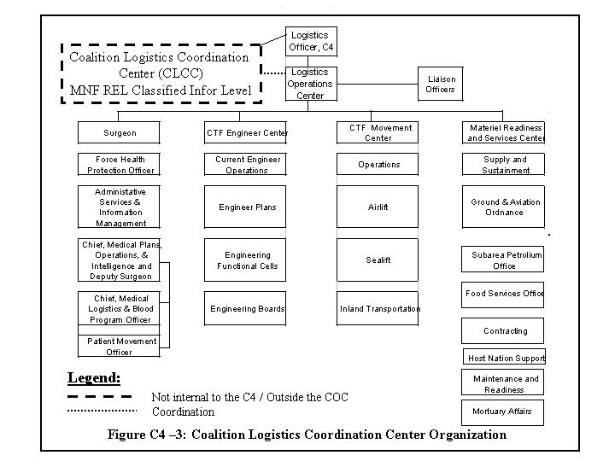

- Concept of Operations. The CLCC is task organized to accomplish the mission essential process of coalition logistical synchronization similar to the LOpC, but with more of a focus on the "immediate" requirements of the coalition partners.

(1) Continuous CLCC support and liaison to the CTF Planning cells (PLANS, FOPS, and COPS) IS CRITICAL to ensure coalition logistics functions are represented at all stages in the planning process. If there is an issue over information security this representation may be provided by the C4 Staff. The LOpC liaison SHOULD NOT REPRESENT THE CLCC within the CTF Planning Cells. If at all possible the CLCC shall directly participate in all CTF Planning Cells to ensure coalition support is fully stressed and prioritized within the CPG process for the CTF.

(2) To support logistical synchronization and information flow, the CLCC will employ all available automated tools necessary for maintaining a Common Operational Picture and a Common Coalition Logistics Picture. The CLCC will also ensure immediate "reach-back" capabilities exist to each respective nation's logistic support centers, to include linkage to the SUPPORTED STRATEGIC COMMANDER J4, respective nation's Logistics Operations Center, and to the Supporting Strategic Commanders' logistical planning staffs. CLCCneeds to be established early on in the activation phase of the CTF to facilitate coalition-planning lead-times required by supporting nations and organizations.

(3) Summary. The CLCC is established and organized to ensure FULL integration and coordination of the coalition logistics effort within the CTF.

3. Health Services Support (HSS):

- Mission. The mission of the CTF Surgeon is to provide Health Service Support (HSS) to the CTF and additional elements as required. The overarching tasks in support of the CCTF are to Plan, Organize, and Execute Health Service Support functions and provide advice to the CCTF on all matters pertaining to the health of the force.

- Organization. The organization of the CTF Surgeon’s Office, staff, and location(s) are mission and situational dependent, and will vary in response to the CTF Commander’s intent. During the planning stages of the mission the CTF Surgeon’s staff maps out the HSS requirements based on the mission. They then determine if medical augmentation to organic assets is necessary. Examples of this type of medical augmentation are; Theater Telemedicine Teams, Forward Deployed laboratories, healthcare providers for women and children, and supplies that complement a Humanitarian mission. Once the HSS Concept of Operations is determined the staff then develops the HSS staff structure and reporting requirements for all HSS forces attached to the CTF. For information security issues the following eight functional areas may need to be split between the LOpC and the CLCC: Health Services Support Logistics, Preventive Medicine, Medical Plans and Operations, Veterinary medicine, Blood Program, Medical Evacuation and Regulating Medical Information Management, and Dental services. If functional areas are split a suitably qualified person will exercise this responsibility in the CLCC.

- Concept of Operations. In large and small-scale levels of effort CTF operations the CTF Surgeon serves as a clearinghouse for all medical information and planning. The CTF Surgeon will send and receive medical reports, maintain medical situational awareness, track HSS activities and locations day to day, and process requests for HSS from the COC, LopC, or the CLCC. When required, the CTF Surgeon will coordinate/sponsor medical liaison groups / committees to include: Component medical units, coalition/allied medical units, Host Nation medical elements, and other HSS organizations. These groups will help develop policies, procedures, and direction for HSS in the CTF theatre of operations.

- Summary. The CTF Surgeon has staff responsibility for all aspects of Health Services Support to the CTF mission. The organization of the staff is functional, but should mirror the staff organization of the COC as much as possible to ensure close coordination. For information sharing reasons there may be a need to duplicate some or all of the Functional Areas within the CLCC.The responsible medical sections will coordinate with the Surgeon, their component counter-parts, and the internal CTF appropriate staff sections. Information Management and information technology support that ensures all of the linkage described in this document is the key to successful and seamless Health Service Support to the CTF.

4. Engineering

- Mission. The CTF Engineer is the staff officer directly responsible for CTF engineer operations. When established, the CTF Engineer Center (CEC) works for the CTF Engineer to plan and direct CTF engineer operations. Again, there may be a need for a duplicate center in the CLCC for information sharing reasons. The CEC assumes staff responsibilities for mobility, countermobility, survivability, civil engineering, environmental engineering, general engineering, and engineer services, to include water and fuel support, and electrical power generation and distribution, and explosive ordnance disposal. Depending on the type of operation some of these functional areas may fall under control of the J3.

- Organization. The organization of the CTF Engineer staff and its location within the CTF staff is mission and situation dependent, and may vary in response to the CTF Commander’s intent. Early in the formation of the CTF, engineer mission analysis must address whether engineer activities will largely support operational movement, maneuver and fires, or will predominantly support force sustainment and logistics. If mission analysis indicates that maneuver and fires support are the principal activities, then the CTF Engineer should be placed as an element directly under the C3 COPS within the COC. If logistics support forms the bulk of engineer work, then engineering should fall under the LOpC/ CLCC in the C4. Early engineer mission analysis must also address engineer staff size and composition. Options vary from having no designated engineer planner for very small CTF's to establishing a CTF Engineer Center (CEC). CTF operations involving mid to high intensity combined arms operations and those involving complex humanitarian assistance and disaster relief require robust engineer planning best provided by a CEC. The CEC is an engineer-planning center headed by the CTF Engineer. The CEC should mirror the functions of the COC and CPG, and includes current operations, future operations, and plans cells. Separate functional engineer planning cells are also established to cover environmental, facilities, fuels, water, electric power and explosive ordnance requirements. Additional mission dependent functional cells include engineer intelligence, targeting, demining, contingency real estate, and engineer contracting.

- Concept of Operations. In large-scale CTF operations, the CEC serves as the clearinghouse for engineer information and planning. The CEC will send and receive engineer reports, maintain situational awareness on engineer work, track engineer activities, engineer unit location and will process requests for engineer support from the COC or LOpC.

- Summary. The CTF engineer has staff responsibility for all aspects of engineering: mobility, countermobility, survivability, civil engineering, environmental engineering, and engineer services. In large-scale CTF operations, organizing a CEC under the CTF Engineer is the optimal means to conduct engineer staff work and provides engineer-planning depth to the CTF. CEC organization is mission and situation dependent, but should mirror LOC and COC organization, and should organize separate functional cells in engineer unique activities. The CTF Engineer, in consultation with the CECs within the LOpC and CLCC , serves as the single point of contact for engineer activities on the CTF staff.

5. Movements

- Mission. The CTF Movement Center (CMC) is the single coordinator of all transportation requirements for the CCTF. Included within this is the tasking of intra-theater transportation resources to support the concept of operations including air, surface, and sea assets allocated to the CTF.
- Organization. The CMC is located within the LOpC with a detachment in the CLCC; its composition is mission and situation dependent, varying in response to the CCTF's intent and priorities The CMC is functionally organized and designed for expansion in proportion to the size of the force. The Administrative Section, Plans and Programs Division, and Operations Division are normal elements of the CMC. The Operations Division may be further sub divided into Airlift, Sealift, and Inland Surface Movement Branches. l Movements planning LNOs from participating nations provide a key interface with these branches. The CMC staff will develop a system of reports to assist in managing the theater of operations transportation program.

- Concept of Operations. The CMC develops, coordinates, publishes and distributes a movement plan that allocates the available intra-theater common-user transportation assets according to the CCTF’s priorities. They will monitor the deployment flow requested and ensure there are sufficient assets in theater to support onward movement. CMC will identify to the CCTF any transportation limitations and advise on alternative courses of action within the CTF theatre of operations. The CCTF will request assistance from the Supported Strategic Commander if requirements are not being met.

- Summary. The CMC develops coordinates, publishes and distributes a movement plan within the CTF theatre of operations that apportions the available intratheater common-user transportation assets according to the CTF commander’s priorities. They will monitor the deployment of forces flow and plan for subsequent onward movement within the CTF theatre of operations using available assets. In addition, the CMC will analyze movement performance.

6. Supply and Maintenance

- Mission. The Supply and Maintenance Center (SMC) implements supply and maintenance policy and plans within the CTF theatre of operations for forces assigned or attached to the CTF. While unique logistics requirements are the responsibility of participating nations, the SMC coordinates the provision of common use items such as fuel, advises the CTF C4 of logistics support impacting mission accomplishment, monitors and synchronizes CTF logistics, and maintains liaison with CTF component commands, Supported Strategic Commander counterparts, and other agencies or organizations. When appropriate, exchange information and resolve problems at the lowest practical level such as the CLCC. Other functions to fall in this area include contracting, Host Nation support, and mortuary affairs.

- Organization. Supply and Maintenance is organized functionally with key leadership positions staffed by nation's representatives from the functional areas of supply, ground and aviation ammunitions office, fuels, subsistence, equipment maintenance, contracting, mortuary affairs, and host nation support. In addition, the receives personnel augmentation from respective nations, the Supported Strategic Commander, Supporting Strategic Commanders, national governmental agencies, other governmental and nongovernmental agencies, and MPAT cadre from respective nations. Where possible as many as the supply offices such as the Food Services Officeand the Petroleum Office should be located within the CLCC.

- Concept of Operations. In CTF operations, the SMC provides oversight of each participating nation’s supply and maintenance capability. This oversight ensures early identification of possible negative impact on CTF operations. and The CMC serves as the point of contact for all CTF forces within the CTF theatre of operations. . If the Supported Strategic Commander delegates Limited Directive Authority for Logistics to the CCTF, the SMC will recommend assignment of common item support agreements for the participating nations and components and monitor execution. When required, the SMC will also recommend activation of logistics boards and cell as required. These boards include component and coalition representation and help develop policies, procedures, and direction for logistics support within the CTF theatre of operations. Examples of logistics boards include the Coalition / Combined Munitions Planning Board, and the Coalition Logistics Coordinating Committee (within the CLCC).

d. Summary. The SMC has oversight responsibility for all aspects of supply and maintenance SMC organization should organize separate functional cells in the LOpC and CLCC as required.

- Considerations

- Logistics Information Management

- A critical aspect of C4 support to the CTF is appropriate management and timely distribution of logistics information. Logistics information systems must support movement of functional area data from subordinate C4 Centers, into the LOpC and CLCC for integration, and to CTF Planning cells (PLANS, FOPS, and COPS), and higher and supporting headquarters. The Logistics Information Manager, assigned to the LOpC, supports this effort. To provide optimum support, the Logistics Information Manager should have general knowledge of the various logistics information management systems currently used by participating nations as well as systems currently under development.

- Logistics information will provide commanders with read- only access to comprehensive combat support information from various databases to accurately portray combat support status.

(1) A CTF Logistic Network should be established by the lead nation that operates at the higher levels of classified information sharing. This network provides end-to-end information interoperability across both combat support and command and control functionsto support Supported Strategic Commander and CTF requirements. During CTF missions, the CTF Logistics Network approach functions as a tool for distributed information and collaborative planning throughout the MNF and CTF. This network should be available in the C4 and LOpC.

(2) A Coalition Logistics Network should also be established by the lead nation that operates in parallel with the CTF Logistics Network above. This network needs to operate at the "common" multinational releasable (MNF REL) level of classified information to effectively coordinate and provide for end-to-end coalition information interoperability across both combat support and command and control functions in support of the Supported Strategic Commander and CTF combat support requirements. This network will be available to the C4, LOpC and CLCC.

- Logistics planning. Logistics input to CTF planning actions will be accomplished by providing planners from the LOpC and CLCC who have appropriate security clearances . These planners will routinely support planning activities within the CPG process and CPG cells (with priority liaison with C5 Future Plans and C3 FOPS). During CTF initiation, the C4 must ensure logistics planners are involved in all CPG crisis action planning to facilitate rapid standup and requisite support of the CTF. Early logistics planning will be necessary to make prompt recommendation to the SUPPORTED STRATEGIC COMMANDER J4 on issues such as C4 personnel requirements and designation of common service support responsibility. MPAT cadre augmentation to the CTF from participating nations will be crucial.

- Planning Rhythm. See CTF Planning Rhythm (see Chap 2).

- CTF Logistics Checklist: The following checklist can be useful in CTF logistics planning.

- Alignment of participating nations’ logistics guidance with lead nation’s logistics guidance, including information requirements such as movement data, stocking level policies (e.g., number of days of supply (DOS) requirements for initial deployment), location of key logistics hubs and level of visibility required for various classes of supply.
- Notification to lead nation of common user support requirements [e.g., dietary and cultural issues] and identification of unique mission critical support items [e.g., supply timelines].
- Notification to lead nation of existing bilateral and multilateral arrangement for the exchange of goods and services [e.g., Acquisition and Cross-Servicing Agreements, Mutual Logistics Support Agreements, Implementing Arrangements, or Cooperative Defense Logistics Support Arrangements].
- In the absence of existing bilateral or multilateral support arrangements, notification to supporting strategic commander J4 of requirement to organize such arrangements.
- Notification to participating nations of initial agreed levels of available host nation support to be determined cooperatively by lead nation and host. Subsequent host nation support arrangements to be coordinated through the CTF C4.

- Reports. Reports developed by the CTF for submission to Supported Strategic Commander through the Theater Logistics Operation Center:

- Logistics Situation Report (LOGSITREP)
- Movements Planning Data Sheet
- Medical Casualty Report

- References. General logistics references are provided below.

- United Nations Troop Contributing Handbook
- America Britain Canada Australia (ABCA) Coalition Logistics Planning Guide
- ABCA Coalition Operations Handbook
- Australian Defence Publication (ADP) 00.03 Coalition Operations (Draft)
- U.S. Joint Pub 3-17, JTTP for Theater Airlift Operations
- U.S. Joint Pub 4-0, Doctrine for Logistics Support of Joint Operations
- U.S. Joint Pub 4-01, Joint Doctrine for the Defense Transportation System
- U.S. Joint Pub 4-01.1, Airlift Support to Joint Operations
- U.S. Joint Pub 4-01.2, JTTP for Sealift Support to Joint Operations
- U.S. Joint Pub 4-01.3, JTTP for Movement Control
- U.S. Joint Pub 4-01.5, JTTP for Water Terminal Operations
- U.S. Joint Pub 4-01.6, JTTP for Logistics Over the Shore (JLOTS)
- U.S. Joint Pub 4-01.7, JTTP for Use of Intermodal Containers in Joint Operations
- U.S. Joint Pub 4-03, Joint Bulk Petroleum Doctrine
- U.S. Joint Pub 4-08, Logistics Support of Multinational Operations (Draft)
- U.S. Joint Pub 5-03.1, Joint Operations Planning and Execution System, Vol 1, Planning; Policy and Procedures

