Annex L

LAND OPERATIONS

Chapter C-3 OPERATIONS

- Purpose. This Annex provides information concerning the operation of the Land Operations Cell within the Command Operations Center (COC) in the CTF HQs. Its primary purposeis to integrating land operations into the overall plan of operations.

- CTF Land Operations Overview. Land operations occur across the range of military operations during Military Operations Other Than War (MOOTW) and Small Scale Contingencies (SSC). The operational aim is to ensure Land Operations support the CTF Commander intent and guidance in achieving the CTF mission and at the same time, ensure land operations are integrated with the other major CTF operational functions of maritime, air, and SOF forces.

    - Land operation responsibility will be normally assigned to a Land Component Commander (LCC) or a Task Force (TF) within the CTF command structure (for example: TF South, TF North). Such Task Forces may be made up of one nation or multiple nations depending on the situation and the interoperability factors of the nations involved.

    - The CCTF will normally assign an Area of Operations (AO) to the LCC or TF based upon the concept of the operation.

    - The CCTF will also establish Supported and Supporting relationships between the LCC or TF and other CTF components (Maritime Component, Air Component, and SOF Component) based upon mission requirements to assist in prioritizing actions, assist in establishing the main effort, and to establish formal command / coordination channels between the components for a specific operation / mission or phase.

    - Land operations will be an integral part of CTF operations within the purview of the SOP because in the majority of MOOTW / SSC missions, the "physical occupation or physical support” of a given AO can only be accomplished by land forces (or stated another way, placing military personnel on the ground, at the site of the crisis to be able to directly influence the crisis action parameters).

    - A key aspect of Land Operations will be sustainability. The following factors will be dominant in the sustainability of Land Operations:

        - Manpower requirements
        - Mecical
        - Maintenance
        - Supply
        - Storage Facilities
        - Transportation
        - Technical Support and Requirements
        - Common Sourcing of Support

    - Land Operations provides the CCTF with a multifunctional force that can transition from "support operations" to "combat operations" quickly based upon the mission requirements. However, training of Land Forces within the CTF command for the specific mission parameters cannot be underestimated. The CCTF should consider establishment of common training modules or even certification training to ensure land forces are trained for the missions assigned. Such training and certification of land forces can occur prior to deployment to the CTF AO or occur after deployment.

- Responsibilities.

- Land Operations Cell. Performs those duties and responsibilities as directed by the C3 and under the supervision of the COC Chief. The land operation cell is normally an integral part of the COC Watch officer organization.

- Chief COC. The Chief, COC is responsible for the integration of all operations into the The CTF Commanders mission.

    - Maintain overview of CTF land operations.
    - Supervise the Watch Officer organization/ operation.
    - Advise the C3 on land operations.
    - Develop land operational and contingency plans.
    - Execute CTF land operations.
    - Maintain understanding of future planning direction for land operations.
    - Coordinate land operations between components and supporting organizations.

- Deputy Chief, COC. The Deputy COC Chief is the COC Chief’s primary assistant.

    - Assume duties of the Chief during periods COC Chief’s absence.
    - Responsible for day-to-day operations of the COC.
    - Supervise activities of operations watch officers.
    - Prepare and coordinate daily and shift change briefings, etc.
    - Monitors the Commander, CTF daily SITREP to ensure timely and accurate submission.

- Land Watch Officer in Charge (OIC). The Land Watch Officer OIC ensures the COC Chief is current on status of all ongoing land operations. Supervises Watch Officers to:

    - Monitor situation, locations, status and actions of all land forces in the CTF AO.
    - Maintain a land events log for each 24 operational period.
    - Prepare daily land situational reports.
    - Ensure communication with all land forces operating within the CTF AO.
    - Prepare operational plans and orders for land forces as directed by the Chief, COC.
    - Coordinate with air, maritime, and special operations Watch Officers.

(continued on the next page)

================================================================================

- Organization. The actual organization and manning requirements will be tailored and refined to meet the specific mission of the CTF Commander, functioning under a 24 Hour Watch Officer organizational system..
.
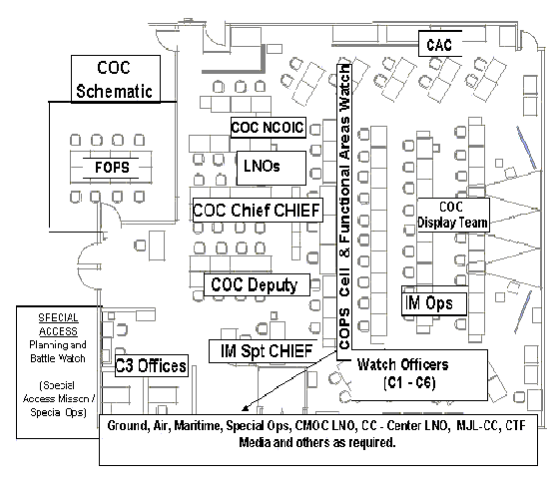
- The Land Operations Cell performs the following functions:
- Monitor situation, locations, status and actions of all land forces in the CTF AO.
- Maintain a land events log for each 24 operational period.
- Prepare daily land situational reports.
- Ensure communication with all land forces operating within the CTF AO.
- Prepare operational plans and orders for land forces as directed by the Chief, COC.
- Coordinates with air, maritime, and special operations Watch Officers.

- Tasks, functions, and procedures. Provides supervision, control and coordination for all land forces operating in the CTF AO. Develops plans and orders for Land Force Component Commanders to perform assigned missions and tasks.

- Maintain continuous picture of ongoing land operations.

- Establish/Maintain communication with all land forces operating in the CTF AO.
- Prepare required reports information,e.g. Situational Reports, Dailey Reports.
- Maintain land operations situational map.

- Prepare Plans and Orders.

- Prepare plans to support future operations
- Prepare and implement orders for land forces.
- Coordinate with related shift leaders.

- Prepare Briefings.

- Prepare land portion to daily briefings.
- Present situational briefings, as required.

- Maintain Ongoing Coordination with Air, Maritime, and Special Operations Cells.

- Standing Operating Procedures.

- The land operations cell will cover all aspects of coordinating land operations in the CTF AO.
- The land operations cell will be the focal point for all incoming / outgoing information on land forces operating in the CTF AO.

Considerations.

    - Threat environment.
    - Force structure and composition.
    - Current plans, annexes, operating instructions, requirements—adaptation of future plans coordination to current operations.
    - Technical and logistic support—Automated Data Processing (ADP) support, communications equipment, administration supply, and security.

- Planning Rhythm. See Part B of the SOP overview. The Land Operations Cell within the COC will maintain a planning rhythm that is supportive of the CTF Battle Rhythm.

- Checklists.. None.

- Reports. As established by the COC Chief and CTF reports matrix.

- References.

- 1. Joint Pub 3-16, Joint Doctrine for Multinational Operations, dtd 5 April 2000.

- 2. Coalition Operations Handbook, dtd 1 Nov 2001. Produced by the American-British-Canadian-Australian (ABCA) Program.

