Chapter B-3

COMMAND / CONTROL / COORDINATION
MULTINATIONAL RELATIONSHIPS
Focus & Foundation

- Focus & Foundation: This section focuses on command, control, and coordination relationships and organizational structures that are envisioned for a CTF. The national chains of command and strategic levels of command will be briefly covered to explain how strategic, operational, and tactical levels within a MNF work together to form an integrated organizational structure that works parallel with respective national chains of command.

  - Annex A to this Chapter outlines specific CTF Command and Control organizational options with specific responsibilities outlined for key personnel.

  - Key MNF Foundation - Two Chains of Command Always: Each nation’s forces fall under two chains of command at all times: (1) the national chain of command, and (2) the CTF multinational chain of command.

    - National command is NEVER relinquished to the multinational chain of command.

    - Multinational command will usually take the form of “control and coordination” within the CTF chain of command.

  - This chapter will outline types of "command authority" that the Commander of the Coalition / Combined Task Force (CCTF) may have delegated to him by MNF participating nations. All of these involve limited authorities (depending on the mission and nation concerned).
  - This chapter will also present solutions and options for CTF integration of national forces from nations that reject any form of foreign "command" of their forces. .

Multinational Chain of Command

- Multinational Chain of Command: There may be as many as four levels of command for multinational operations, (1) National Strategic; (2) Theater Strategic Military; (3) Operational (CTF); (4) Tactical (CTF Components). This SOP focuses on the first three levels.

  - Strategic Levels of MNF Command and Control.

    - The Lead Nation National Command Authorities (NCA) consults on and coordinates the “Essential Strategic Guidance”.

    - The Supported Strategic Commander and the Supporting Strategic Commanders coordinate / collaborate planning, support, and execution for the MNF mission.

Figure B3 – 2 on the following page depicts three of the four levels of multinational command. The diagram assumes Australia is the Lead Nation with the U.S. and Republic of Korea (ROK) as participating nations in the coalition. Note the difference in terminology between countries for the “Strategic Commanders” (CINC, CDF, ROK JCS). This reinforces the need for specified terminology for the “Supported Strategic Commander” and “Supporting Strategic Commander(s)”.

  - Operational Levels of MNF Command and Control.

- The CCTF is appointed by the Lead Nation in consultation with participating Nations’ NCAs.

- The CTF is the operational level of multinational command and control and is focused on detailed coordination and planning of operations plans, phasing of operations, and establishment of the conditions for conduct of decisive tactical operations.

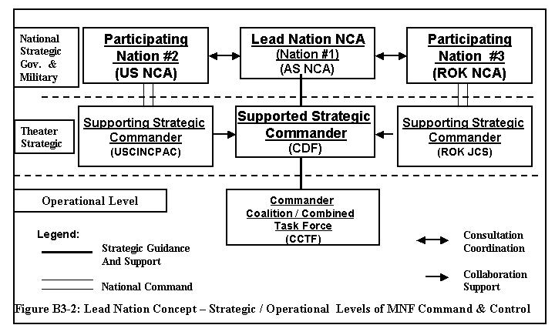
  - Operational Level of MNF Command Relationships: There are three command relationships used within this SOP for a CTF: OPCON, TACON, and SUPPORT (see Figure B3-3 below). These relationships are supported by “Other Supporting Authorities” concepts as outlined later in this chapter. Operating definitions and terms of reference (TOR) for OPCON, TACON, and SUPPORT must be fully addressed in CTF OPORDS / OPLANS. Further, Memorandums of Understanding / Agreement (MOU / MOA) concerning command relationships between participating nations should be finalized early in the CTF activation process.

Note: National Command Element – Each nation furnishing forces to the CTF establishes a “national command element” (NCE) within the CTF command: normally the senior officer in the CTF for a given nation. This establishes the “national command” link back to respective nations’ NCAs. The specific officer assigned as commander of this national command element may be dual-hatted with other CTF command / staff responsibilities or may be separately assigned (see Figure B3-3).

- Operational Control (OPCON): This is command authority to organize and employ forces, assign tasks, designate objectives, and give authoritative direction necessary to accomplish the mission. It does not involve direction for logistics or matters of administration, discipline, internal reorganization of a nation’s units or unit training.

- Tactical Control (TACON): This is command authority limited to detailed control of movements or maneuvers within the operational area necessary to accomplish assigned missions or tasks.

- Support: These command relationships are established by a higher commander / authority between subordinate commanders when one organization should “aid, protect, complement, or sustain” another force. At the broad level, there is a supported and supporting commander with four levels of support. See Figure B3-4 for these categories. Support relationships need to be defined in detail within OPORDs / OPLANs.

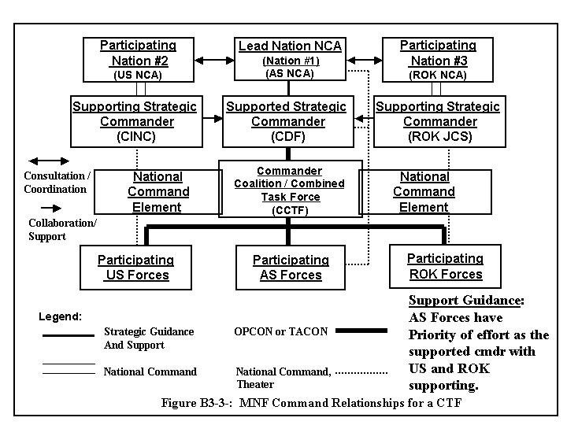
  - Support relationships can be exercised by any level of command.

  - Support relationships are especially important in MNF operations because they convey priorities for planning and exercising, and establish the key relationships between the national forces within the CTF.

  - Supported and supporting commanders within the CTF must fully understand the support relationships. LNO teams exchanged between supported and supporting commands can greatly assist in this support process.

  - Multinational support relations need to be kept simple and direct, and clearly outline the following:
Degree of control the supported commander has over supporting commander(s)

- Supporting commander’s authority and leeway in following support directives

- Supporting commander’s responsibilities, tasks, missions, and special guidance

- Other parameters for support such as forces and resources allocated (time, place, level, and duration for support effort) and relative priority

Figure B3 - 4 on the following page outlines four categories of support relationships that may be combined with other command relationships to enhance CTF operations.

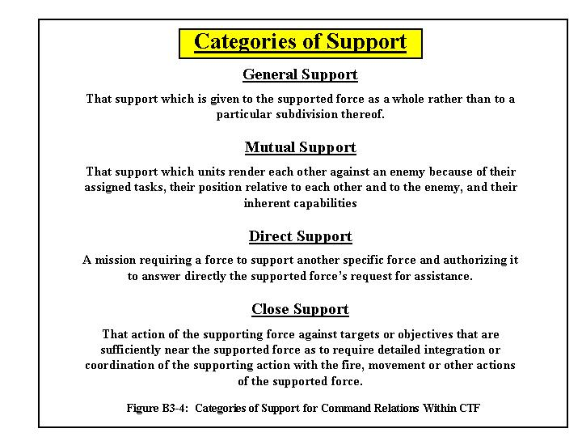

Operational Level MNF “Tailored” Command Relationships

  - Operational Level MNF “Tailored” Command Relationships: During initial CTF formation, “foreign command” of a nation’s forces may not be an option with all nations. This may work against unity of effort if such command relationships are insisted upon by the concerned nation(s). This concern for foreign command can be due to national pride, political limitations, constitutional / legal restraints, historical relations between nations, or sovereignty considerations. In such situations, “tailored” command relationships will be required to achieve and support unity of effort. Three tailoring options are presented below.

- Option #1 - Adjust Parameters: The first tailoring option is to adjust the “parameters” (operating definitions and authorities) for OPCON or TACON to address national concerns while ensuring that some degree of unified actions can be achieved within the CTF.

- Option #2 - Create New Operative Term(s): The second option is to create new term(s) to reflect the authorities the CCTF requires for the situation. The concept of “command” is simply replaced with the operative concept required.

Example: In the Republic of Korea (ROK), there was a need to ensure that ROK JCS had command of their forces on a day-to-day basis. At the same time, the Combined Forces Command (CFC – a U.S. and ROK combined command) required “some form of control of ROK forces” so that it could support its daily armistice responsibilities in accordance with national treaties and UN resolutions.

The result was creation of a term agreed upon by the U.S. and ROK that reflected the “nature of the relationship” required for unity of effort. This term was called Combined Delegated Authority (CODA). This term outlined CFC’s daily armistice authority over ROK forces while preserving the ROK command of its forces on a day-to-day. The “parameters” of CODA authority are outlined below:

- Combined Crisis Management for Deterrence, Defense and Armistice Compliance
- Deliberate Planning
- Combined Joint Doctrine Development
- Planning and Conducting Combined Joint Training & Exercises
- Combined Intelligence Management
- C4I Interoperability

- Option #3 - Tailored “Lead Nation” Organization: The third option is one of tailoring the “Lead Nation” concept in a way that maintains all the benefits of the Lead Nation organization (single command channel for planning and execution) while addressing selected nations’ concerns of foreign command of their troops within the CTF.

This is accomplished by addition of a tailored “parallel” command channel to the Lead Nation organization as shown in Figure B3-5.
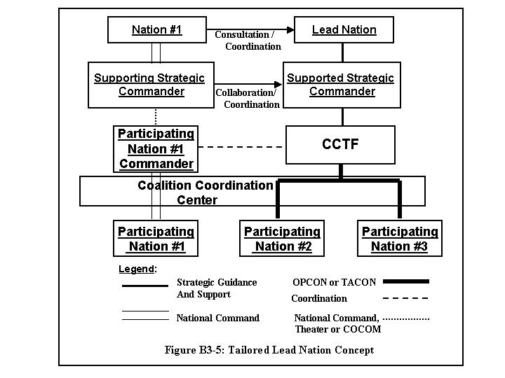
  - Tailored Lead Nation Concept

- The above CTF organization is not optimal but may be required due to specific nations’ concerns about foreign command of their forces. Such MNF command relationships should be kept to the absolute minimum.

- A Coalition Coordination Center is essential for such tailored approaches to the Lead Nation concept (see Part B, Chapter B-5, Annex B for a detailed outline on the Coalition Coordination Center).

Example: Coalition forces in the 1991 Gulf War effort (Operation DESERT STORM) used a “tailored” approach to the Lead Nation concept. The U.S. was the Lead Nation, with forces from France and Great Britain TACON to the U.S. headquarters (USCENTCOM). The Saudi Arabian command was a parallel command to USCENTCOM but accepted the Lead Nation’s guidance and coordination for the coalition’s effort. A Coalition Coordination Center and a Friendly Forces Coordinating Council (F2C2) were used for coordination of strategic and operational issues respectively. Both these organizations were a form of “coordination center” that USCENTCOM used for building unity of effort within the command.

Foreign Command Comments
Foreign Command Comment: Many different interpretations of command relations exist among countries. These must be addressed by clear definitions and concepts that are communicated, understood, and reinforced in all planning and execution. The key principle is that either “we agree” or “we agree to disagree”. Outlined below are comments concerning foreign command of a nation’s forces. Potential command relationship problems should be addressed early in the activation of the CTF.

- In terms of “foreign command” of a nations’ forces, it is helpful to remember that partial delegation of authority is temporary in nature for “agreed upon purposes between nations based upon shared interests”.

  - Such delegation may be a form of agreed upon “unity of effort” within the CTF and should actually benefit all nations within the coalition.

  - Effective military operations require unified actions. By having some level of unity of command, unity of effort can be enhanced throughout the command.

- Tailoring of command relationships is a viable approach to addressing the issue of "foreign command of a nation’ troops". "Control and coordination", and are really the essence of multinational relationships between nations. The parameters for such "control and coordination" can be established without reference to the term "command" if required.

- Within a CTF, the national chain of command is always present and operational. The following parameters reinforce the existence of the “national chain of command” and provide a communications channel for resolving "foreign command" issues.

#1: Respective nation’s commanders will maintain the capability to communicate separately to their higher level of national command in addition to the CCTF.

#2: For issues of legality, mission mandate, and prudence the nation’s NCE commander within the CTF should first attempt to “resolve” the issue with the CCTF. If issues remain unresolved, the respective national commander will refer the matters to the higher national commander.

#3: The Supported Strategic Commander and the CCTF need to clearly identify national responsibilities for CTF operations within OPLANs and OPORDs .

#4: Terms of Reference (TOR) for the CCTF's "control and coordination" authority needs to be clearly promulgated, and agreed upon, within the CTF command. OPCON or TACON is the desired authority, but tailored relationships may be required. As stated previously, CTF OPORDS / OPLANS will address the specific detailed TOR for these relationships to ensure full understanding by all CTF nations. Further, MOUs and MOAs between MNF nations can clarify CTF command relationships.

Other MNF Supporting Authority Concepts.

  - Other MNF Supporting Authority Concepts. To assist in planning and coordination within the CTF there are six other authority concepts that the CCTF can utilize to achieve unity of effort within the command. These are especially appropriate for a CTF involved in MOOTW / SSC when multiple nations and multiple governmental and non-governmental agencies are working together. Such agencies routinely reject any form of command concept over their respective agencies, but desire coordination channels to maximize their efforts within the crisis situation.

- Coordinating Authority: This is authority (NOT command authority) delegated to a commander or individual for coordinating specific functions and activities involving forces of two or more nations / agencies / elements. This is an extremely valuable concept since it carries with it authority to “require consultation” between nations / agencies involved, but does not have authority to compel agreement.

  - This can be authority for planning and / or execution. Good examples of this are “Coalition Rear Area Coordinator” or “Coordinating Authority for Logistics” for a given area, or coordinating authority for force protection of multiple nations and agencies working within a given area within the CTF’s AO.

- Coordination Center Concept: This is an organizational structure that builds upon the “coordination authority” concept outlined above. As such this is NOT a command authority but a form of “organizational consultation / coordination” that can be built into the CTF organization. A Coalition Coordination Center (CCC) is a critical organization for achieving coordinated and unified operations.

  - A CCC is normally established at the Supported Strategic Commander’s level to facilitate strategic coordination and preparation of national forces for handoff to the operational level so that they are immediately ready for employment.

  - A CCC will be established at the CTF for planning and coordination of operational and tactical coalition issues within the CTF AO. Subordinate component, functional, or Task Forces within the CTF may also establish CCCs as needed.

  - Normally an “alliance” based CTF (i.e. Combined) will not require such a coordination center due to the anticipated integrated CTF HQs organization (nations operating within a fully integrated staff structure) that can be achieved based upon agreements / treaties, deliberate planning, agreed upon command relations, and other standardized procedures that have been worked out in training exercises and SOPs,

  - Other “coordination centers” can be established as required within coalition / combined efforts. Examples would be the “Coalition Logistics Coordination Center” or a “Coalition / Combined Rear Area Coordination Center”.

    - Direct Liaison Authorized (DIRLAUTH): This is a coordination relationship, not a command authority. This is authority granted by a commander to a subordinate or unit to consult directly or coordinate an action with a command or agency within or outside of the granting command. DIRLAUTH is most appropriate for planning purposes . It carries with it the requirement of keeping the commander granting DIRLAUTH informed of liaison actions. This is a valuable tool for the CCTF to ensure operations are executed in a unified and coordinated manner.
    - Liaison: Liaison Officer (LNO) teams are a time-proven concept for improving communications, collaboration, planning, and execution of missions within MNF operations. Robust liaison structures are essential for building unity of effort and maintaining it. LNO teams are the official representatives of their respective nation. As such, they are not part of the CTF HQs staff or the Supported Strategic Commander’s staff.

- Robust liaison horizontally and vertically within the CTF HQs and command also reduces the friction and “fog of war” caused by incompatible communications systems, doctrine, and operating procedures. Further, they can help moderate the challenges of different languages and cultural factors of each nation.

- LNO teams with linguistic and local area knowledge are extremely useful. Special Forces personnel, national intelligence personnel, and even civilian experts with military backgrounds can also provide valuable assistance with liaison efforts to assist in coordination actions, planning efforts, and operations.

  - Consultation / Coordination: MOUs and MOAs between participating nations within the MNF effort can greatly assist in establishing base foundations for command relationships, support arrangements, CTF structure and key personnel manning, and establishing the roles of IOs and NGOs. Also, co-signing of plans, SOPs, directives and planning manuals are valuable tools for building unity of effort.

However, caution is warranted in the development of "formal agreement" at the CTF level for major policy / planning / organizational actions. Such major agreements normally will require Lead Nation NCA / Supported Strategic Commander level consultation and coordination. In developing "MOUs / MOAs" it is important to obtain national or diplomatic legal advice on such agreements prior to committing one’s nation to such agreements at the CTF level.

  - “Hand-Con”: This is an example of an informal form of control, or coordination, where OPCON or TACON may not be appropriate or acceptable to all MNF participants. This form of control / coordination can also be referred to as "local control" or other such operative terms for use in OPORDS / OPLANS.

    - This example recognizes the reality of crisis action situations. In some situations “command and control relationships” may be based literally upon a “hand shake” (“Hand-Con”) or informal agreement(s) among local coalition parties for coordination of operations.

    - Multinational crises may evolve among factions and peoples. Some potential friendly forces in today’s crisis action situations may be local tribes, clans, factions, nongovernmental entities, paramilitary, and even transnational elements friendly to coalition interests. Creative and unorthodox means of coordination may be required in such situations.

    - Standard military command and control relationships and coordination may not be appropriate in such situations. Friendly forces within the para-military / tribe / clan arena may not accept or even understand the concepts of OPCON or TACON. What they do understand is “their interests” and the need for leadership in crisis situations. The CCTF needs to identify the common interests of these factions and build respect, trust, and relationships by which coordinated operational and tactical battle plans can be planned and executed.

    - As an example, a mission statement to a friendly tribe / clan may be stated as follows: “... don’t shoot at any trucks or people on this road ... rather hold the town so I can bring food and supplies to you ... three of my people will be with you to support you with radios and logistics needs ....”.

    - Bottom Line: Coordination and control in such situations is built upon identification of mutual interests clearly understood by all parties. Respect, and trust must be developed.

=========================================================================

CTF Specific Command and Control Options.

- Specific CTF Command and Control Options. Specific and more detailed CTF Command and Control organizational options are outlined at Annex A. This Annex builds upon this chapter's command relationship basics and outlines the next level of CTF organization.

=========================================================================

Annexes:

Annex A: COMMAND AND CONTROL / CTF ORGANIZATIONAL OPTIONS.

Annex A

COMMAND AND CONTROL / CTF ORGANIZATIONAL OPTIONS
Chapter B-3 COMMAND / CONTROL / COORDINATION

MULTINATIONAL RELATIONSHIPS

- Introduction. This section describes concepts for command and control of a CTF effort within MOOTW / SSC. These concepts supplement and complement national procedures to provide effective command and control within a CTF structure. The command arrangements are intended to optimize CTF unity of effort without compromising National Command Authority (NCA) of MNF participating nations.

- Strategic Command and Control. The Lead Nation NCA for the MNF will appoint the ‘Supported Strategic Commander’, in coordination with respective NCAs of MNF participating nations. The Supported Strategic Commander will be responsible to the Lead Nation NCA for planning and directing operations at the theater strategic level of command. Note: some nations will not have a “theater strategic command”; rather, such nations will have a “national military command” that will provide the function or organize a tailored “theater focused” strategic headquarters. The Lead Nation will normally exhibit one or more of the following characteristics:

  - Jurisdiction over the area or territory under threat or where the crisis is present.

  - Vital interests are most directly affected by the threat and / or crisis.

  - Provides the preponderance of forces.

  - Most capable of carrying out diplomatic, planning, coordination and execution responsibilities for the MNF.

The Supported Strategic Commander, in coordination with the Lead Nation NCA and MNF participating nations, will designate the Commander, CTF (CCTF).

- Affected Nation. This is the nation where the crisis has occurred. The Affected Nation does not automatically become the Lead Nation. In some situations, the Affected Nation may be unable to be the Lead Nation due to the crisis’s impact.

- Host Nation. A nation in which CTF forces are present because of government invitation or international agreement to conduct CTF operations or stage CTF forces to provide support to another country. Normally, the host nation is the Affected Nation, but this is not always the case. It is possible to have multiple host nations due to staging of CTF forces in various nations to support mission requirements.

- CTF Command Relationships - Starting Point: Figure B3-A1 below depicts a “start point” for command relationships within a CTF. This diagram depicts Australia as the Lead Nation with the U.S. and Republic of Korea (ROK) as participating nations in the coalition.

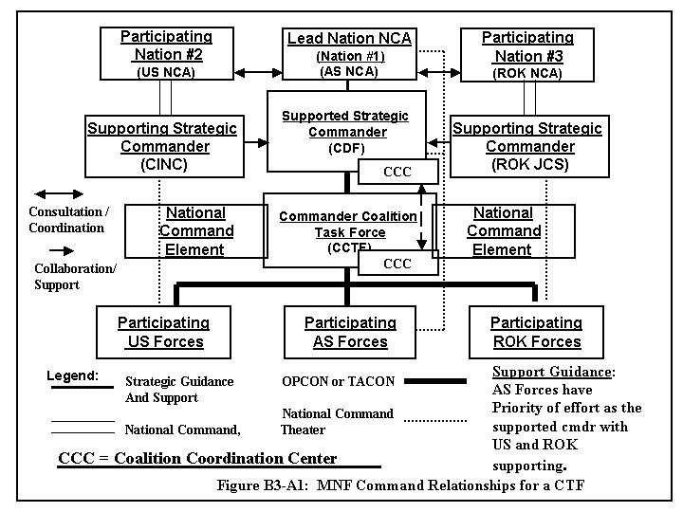

- Headquarters Manning. Upon designation of the Supported Strategic Commander and activation of the CTF, liaison teams deploy immediately to these commands’ location. Liaison may be required from all participating nations, or only from a few. Liaison teams’ requirements are normally based upon the level of force participation by respective nations, extent of logistics support requirement, and other coordination factors. For coalition efforts, the respective Coalition Coordination Centers (CCC) at each headquarters are also activated and resourced with personnel from MNF participating nations. The CCC Directors are assigned as soon as possible to have coordinating responsibility for these centers.
Note: Initially, the CCC is made up of LNO Teams. As the CTF HQs is formed, participating MNF nations deploy personnel to man this center on a 24-hour basis.

  - The Lead Nation will normally provide the majority of the initial CTF staff manning. Additional staff augmentation from the Supported Strategic Commander and Supporting Strategic Commanders deploys as required to help activate the CTF and provide staff augmentation support.

  - If requested, and when nations agree, MPAT cadres deploy to the CTF’s location (B-5, Annex C) to assist formation of the CTF, Crisis Action Planning (CAP), and developing the CTF’s initial responses.

- Responsibilities of Lead Nation NCA and Participating Nations’ NCAs. The CTF planning process is firmly based upon Essential Strategic Guidance agreed upon by participating MNF NCAs Final authority for employment of military forces in a crisis rests with the respective NCAs.

  - Responsibilities of the Lead Nation NCA:

    - Selects appropriate forum for consultation / coordination leading to collective decisions for Essential Strategic Guidance and for ongoing national strategic guidance as required.

    - Coordinates with participating nations’ NCAs for designation of the Supported Strategic Commander, Supporting Strategic Commander(s), CCTF, and other strategic guidance. The Lead Nation NCA activates and provides guidance to the Supported Strategic Commander and CTF effort by issuing the Warning Order (See Chapter C-5, Annex D, Warning Order format). The Warning Order tasks the Supported Strategic Commander to develop courses of action (COA) for the crisis in coordination with the CCTF.

Note – “Lead Nation NCA Issues Strategic Planning Documents and Directives”: The Lead Nation NCA will normally have their National Military Advisor (i.e. Chief of Defense - CHOD) prepare and issue Crisis Action Planning (CAP) documents; however, “express NCA approval” of all strategic directives is CRITICAL for multinational military operations. An alternative approach is to have a designated ‘Strategic Military Coalition / Combined Committee”, made up of MNF participating nations’ national military staff, prepare such directives for the Lead Nation NCA’s approval. Variations of this option may be used.. In all cases, it is a Lead Nation NCA responsibility to establish procedures and processes by which national strategic guidance and directives are issued to the Supported Strategic Commander and CCTF and is beyond the scope of this SOP.

    - The Lead Nation NCA promulgates approved COA by issuing the Alert Order (See Chapter C-5, Annex D, Alert Order format)

    - The Lead Nation promulgates the plan’s approval by issuance of an Execute Order (See Chapter C-5, Annex D, Execute Order format).

    - The Lead Nation promulgates guidance and additional forces / support via additional planning directive or messages.

Note: A “Planning Order” and / or “Deployment Order” can be also issued, but are NOT required – See Chapter C-5, Annex D for details and formats.

  - Responsibilities of the Participating Nations’ NCAs:

    - Coordinate with the Lead Nation NCA for forces and logistics support for the overall MNF effort and for specific support of CCTF requirements.

    - In consultation with the Lead Nation NCA, make decisions on strategic execution plans submitted for review by the Supported Strategic Commander.

    - In consultation with the Lead Nation NCA, maintain situational awareness of MNF operations providing guidance, forces, and support as requested or coordinated by the Supported Strategic Commander to the Lead Nation NCA.

    - Provide other national elements of power in support of the MNF effort and CTF operations (i.e. political, economic, and informational) in consultation and coordination with the Lead Nation NCA.

    - Conduct political / diplomatic coordination with MNF participating nations and nations outside the MNF to support crisis resolution in accordance with MNF end states, and MNF transition and termination planning.

- Responsibilities of the Supported Strategic Commander. The Supported Strategic Commander is the military commander responsible for the MNF operation at the strategic level and issues national strategic guidance to the CCTF. Listed below are the key responsibilities:

  - Designates the CCTF and Deputy CCTF (DCCTF) in consultation with the Lead Nation NCA / MNF participating nations and Supporting Strategic Commander(s). Specifies mission requirements, assists in transfer of OPCON / TACON of forces, provides planning guidance, and designates the CTF Area of Operations (CTF AO).

  - Ensures the Essential Strategic Guidance is formally promulgated and disseminated to the CCTF and Supporting Strategic Commanders (see Chap B-2).

  - Issues a Warning Order to the CCTF, activating the CTF and directing development of courses of action for the crisis (see Chapter C-5, Annex D Warning Order format).

  - Coordinates the deployment of tailored MPAT cadre from the Supporting Strategic Commanders to the CTF to assist in planning.

  - Assists the Lead Nation NCA in preparation and issuance of the Warning Order, Alert Order, and Execute Order. Additionally assists in the preparation of the Planning Order and Strategic Deployment Order if these planning documents are required.

  - Issues a Planning Order (optional), Deployment Order (optional), OPORD (or OPLAN), and Execute Order to the CCTF within the CAP Process (see Chapter C-5). Publishes follow-on orders and guidance, as required.

  - Maintains situational awareness of the MNF effort and CTF operations. Keeps the Lead Nation NCA and Supporting Strategic Commanders updated as required. Maintains close coordination and collaboration with the Supporting Strategic Commanders during planning and execution for support of the MNF and CTF ops. Coordinates additional assets and support for the CTF as requested by the CCTF.

  - Provides coordinated national and strategic guidance as it is refined and adjusted based upon the changing crisis situation and MNF participating nations’ NCAs input to the Lead Nation.

- Responsibilities of the Supporting Strategic Commander(s). The Supporting Strategic Commander(s) are the participating nations’ appointed strategic level military commanders responsible for military coordination and support to the Supported Strategic Commander (and, in turn, the CCTF). The Supporting Strategic Commander(s) are the national military points of contact for coordinating respective nation’s military forces and support. They can also assist in arranging non-military support from their nations. Listed below are key responsibilities of Supporting Strategic Commanders:

  - Provide forces and support in coordination with the Supported Strategic Commander, as approved by respective MNF NCAs.

  - Provide logistics, administrative, communications, and other support to activate, deploy, and employ MNF participating nations’ forces in support of the CTF.

  - Assist in coordination of interagency and non-military support from MNF participating nations as required.

  - Upon request by the Supported Strategic Commander provide LNO teams.

  - Initially augments the CTF CCC with LNO teams This is followed by CCC augmentation personnel for 24 hr operations as required.

  - Deploy tailored MPAT cadre to the CTF to assist in planning. Provide MPAT cadre to the Supported Strategic Commander as requested. Be prepared to expand MPAT effort if required.

  - In concert with the Supported Strategic Commander, support movement of CTF forces and other assets into the CTF AO.

  - Designate the National Command Element (NCE) within the CTF HQs. The NCE is the respective national chain of command link between MNF participating nations’ forces within the CTF and the respective NCAs.

- Operational Level Command and Control - Key HQs Personnel.

  - Appointment of Commander Coalition / Combined Task Force (CCTF). The Supported Strategic Commander in consultation with the Lead Nation NCA and with the Supporting Strategic Commanders appoints both the CCTF and Deputy CCTF (DCCTF).

  - Responsibilities of the CCTF. The CCTF is responsible to the Supported Strategic Commander for operational planning and CTF mission accomplishment. He accomplishes this by conducting campaigns or major operations to achieve MNF objectives and end states. He normally assumes OPCON or TACON of all forces assigned to the CTF as they enter the CTF AO. However, he does not exercise “full” command authority over other national forces, only “partial command” IAW command relationships established for the MNF effort (i.e. OPCON or TACON, or other forms of control and coordination authority).

  - Responsibilities of the DCCTF. The DDCTF will normally be from a different nation from that of the CCTF. The DCCTF is responsible to the CCTF for:

    - Management and supervision of the CCTF Battle Staff.

    - Chairing the Coalition / Combined Target Coordination Board (CTCB).

    - Duties as assigned by the CCTF.

    - Commands the CCTF Forward HQs if deployed.

    - He may also exercise national command authority, as senior officer from his nation’s forces assigned to the CTF command, over his own nation’s deployed forces, if appropriate.

- CTF Command Relationships. Two chains of command are always present within a CTF command structure – the national and multinational chains of command.

  - The MNF participating nations’ NCAs approve OPCON or TACON of forces to the Supporting Strategic Commander and, in turn, to the CCTF. OPCON is the desired command relationship for the CCTF. In addition, forces under OPCON or TACON may be qualified by caveats agreed to by respective NCAs (MOUs / MOAs).

  - OPCON or TACON is normally delegated below the CTF HQs level to the CTF component commanders. However, this is subject to approval of respective NCAs. Normally, the designated nation’s Supporting Strategic Commander coordinates respective NCA approval for OPCON or TACON delegation downward. This authority may also be delegated through the Warning Order to the Supported Strategic Commander’s control.

- CTF Component Organizational Options. There are several options for the specific “component” organization of the CTF (this encompasses the tactical level of planning and execution within the CTF).

  - For a “Small Sized TF” (Chapter B-4), the CTF may be a small coordination headquarters with limited components organized around the specific task (i.e. earthquake relief, etc).

  - For a “Medium Sized CTF” (Chapter B-4), this organization may require fully organized component structures. The options discussed below are for the “Medium Sized Task Force”. These options serve as a start point for organizing the CTF. Scaling down from these start point options may be warranted as the level of effort decreases.

  - CTF Component Options. The CTF component structure may be comprised of one of the four options below:

    - Service Components / Task Forces. See figure B3- A2.

    - Functional Components / Task Forces. See next figure B3-A3.

    - Combination of Service and Functional Components and Task forces.

    - Any special other groupings that best meet operational requirements (special tailoring based upon the level of effort, geographical areas, and other situational factors). Example: Task Force East, Task Force West, etc.

(see following page for CTF Component Options)

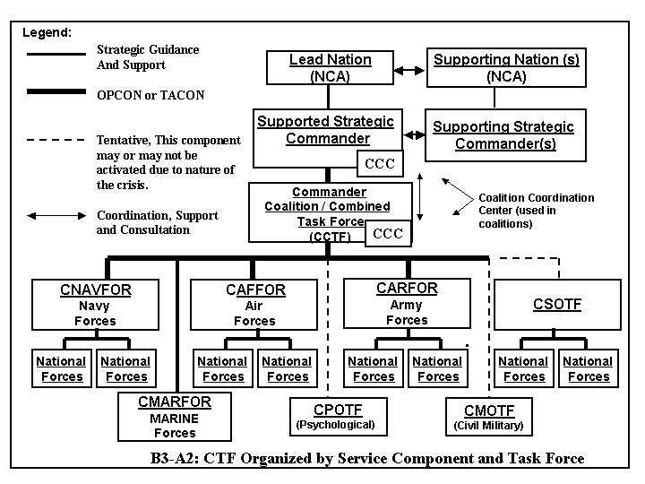

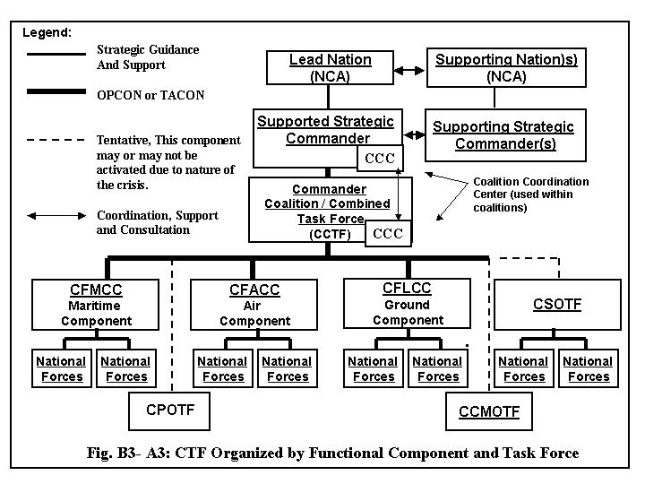
- CTF HQs and Component Command Organizational Considerations.

  - CTF HQs and Component Command Structure. The Supported Strategic Commander and Supporting Strategic Commanders will normally consult with one another on proposed CTF HQS and component command structure before the CTF is established. However, the CCTF is responsible for the final organization of the CTF HQs and component command structure in accordance with mission requirements, approval by and coordination with the Supported Strategic Commander.

  - CTF Considerations. The following factors are some considerations when determining the organizational structure of the CTF:

    - Responsibilities, missions, and tasks assigned to the CCTF.

    - Nature and scope of proposed operations (small scale TF or medium scale TF).

    - Distinguishing characteristics, service, and identity of national forces to be made available.

    - Location and physical environment of proposed CTF AO.

    - Threat situation / Enemy situation / Force Protection situation.

    - Time available.

    - Commander’s concept of operations.

    - IOs / NGOs, host nation agencies, civilians, displaced persons, and other civil-military support and coordination requirements in the AO.

    - Operational planning and execution security factors

    - Logistics and communications interoperability and coordination requirements.

    - Classified information- sharing policies with participating nations (i.e. some nations may not want their classified information shared with another partner for various reasons). This is a major determinant for CTF HQs organization that will be addressed in Chapter B-5 of this SOP.

- Appointment of CTF Component Commanders. The service or functional combined component commanders and their deputies should be appointed by the CCTF, in consultation with the Supported Strategic Commander, Lead Nation NCA, and MNF participating nations.

  - The deputy component commanders should be from a different nation than their respective component commanders in accordance with the level of forces commitments.

  - A balance should be achieved in appointment of commanders and their deputies within the CTF components. Composition of coalition / combined staffs should be roughly proportional to national force contributions.
- Responsibilities of CTF Component Commanders / CTF Task Force Commanders. The service and / or functional component commanders, Task Force Commanders are responsible to the CCTF for:

  - Recommending proper employment of assigned component forces to the CCTF.

  - Planning to employ, direct, and control forces assigned by the CCTF.

  - Executing tasks and missions assigned by the CCTF.

  - oordinating logistical support.

  - Augmenting CTF staff with LNO teams, as required by the CCTF.

- Location of Commanders. The CCTF should be located within the CTF AO. He coordinates closely with the host nation government of the territory under threat / crisis and with any diplomatic posts maintained by the coalition partners in the CTF AO. CTF component commanders and their staffs should be collocated with the CCTF whenever practicable, but this is not a requirement. When a component headquarters cannot be collocated with the CCTF, the component commanders should provide a LNO team to the CCTF.

- Task Force Organizations - Operational Considerations. Task Forces (TF) may be the next level of command under the CTF HQs level in special situations based upon situational factors. The CCTF will decide on the organizational structure based upon the mission. Outlined below are some operational considerations regarding TFs..

  - Special Operations Task Force. If there is significant employment of Special Operations / Special Forces units (SO / SF) envisioned within the CTF missions, a Combined Special Operations Task Force (CSOTF) may be organized to plan, coordinate, and control SO / SF units in support of CTF operations.

    - SO / SF forces will normally be assigned to the Commander of the Coalition / Combined Special Operations Task Force (CSOTF).

    - If the special operations tasks are very minimal (i.e. liaison tasks only, etc.), then SO / SF forces may be assigned to service, functional component commanders or other Task Forces in the CTF. If combat operations are envisioned for SO / SF units, such assignment is not optimal and should be avoided. A CSOTF should be formed and utilized in such situations.

    - SOF and SF will normally require shared access to intelligence, insertion assets and logistics resources of the other national forces. Special intelligence access areas may be required in the CTF HQs.

    - Experience has shown that interoperability can be achieved most effectively if SOF and SF units are not integrated below the combat element level (i.e. Special Forces Operations Detachment (SFOD)-A (US) and patrols (AS), etc).

  - Civil Military Operations Task Force. If there is significant requirement for civil-military operations (CMO), then a Coalition / Combined Civil-Military Operations Task Force (CCMOTF) may be organized as a component of the CTF organization.

    - Civil-Military agencies and organizations will normally “work with” this task force without any form of command relationships. Many elements of such a force may be IO and NGO in nature and are not appropriate for any form of “command”. Coordinating Authority relationships may be warranted for some agencies within the CMO arena. For example: the Commander CMOTF will be the "Coordinating Authority" for IO / NGO agencies within the CTF area of operations.

    - In some situations the CCMOTF subsume other component commands within the CTF organization. For example, in a humanitarian assistance operation, the CCMOTF may replace the Land and Air component (with these components being subsumed within the CCMOTF because of their requirements being entirely CMO related and very simple in execution).

    - It is key to recognize that IO / NGO agencies may not come to the CCMOTF on their own initiative and may even “resist/refuse” any form of coordination as a prerequisite for their operations. They may see the “military” (in the broad sense) as an obstacle to “their operations”. This underscores the requirement for the CCTF and the CCMOTF staff may have to seek out and establish liaison and positive relationships with these agencies. The concept of “Hand-Con” and other MNF supporting authorities concepts are very applicable for CMO situations.

  - Psychological Operations Task Force. If there is a significant requirement for psychological operations (PYSOPs), then a Coalition / Combined Psychological Operations Task Force (CPOTF) may be organized as a component of the CTF organization.

    - PSYOP units and personnel will be normally placed under OPCON / TACON to this component if there is a significant psychological mission within the CTF.

    - PSYOP units and personnel can be placed under the OPCON / TACON of the CCMOTF if CMO is the predominant operational function within the CTF mission with PSYOPs in support. In this case no CPOTF is required.

  - Geographical Task Force Designation. In some situations designation of geographical Task Forces may be warranted. For example: Task Force Alpha would be responsible for a group of islands in the eastern part of the CTF AO (with a humanitarian mission) and Task Force Bravo for another group of islands 200 miles to the west within the CTF AO (with a peace support mission). In such situations these Task Forces would need service / functional components underneath them based upon the situational requirements.

- In such situations, a subordinate-Task Force under the CTF HQs is assigned a specific geographical area within the CTF AO with specific mission responsibilities.

- For larger CTF operations, such an organization is not normally desired if the area consists primarily of one contiguous area (one land mass, one sea zone area, and so forth) since the integration of "service" or "component functions" are not under one commander as is the case in a "service component" or "functional component" (for example: no one ground commander or air commander for integration and coordination operations throughout the CTF AO).

- If geographical Task Forces are desired, consideration should made as to having the Task Forces under the command of "one" component commander (for example: under the Ground Component Commander if operations are focused on land operations or under the Maritime Component Commander if primarily sea based operations, with the other components "in support" of the Ground of Maritime Component Commander.

- The key point is "not to simply turn to geographical components" to keep national forces together. Service or Functional CTF Components allows for more "integration and coordination" of CTF operations and provides more flexibility over time for the CCTF.

