Chapter A-1

INTRODUCTION

ASIA-PACIFIC SHARED INTERESTS, MNF SOP OBJECTIVES, APPLICABILITY, AND MNF CONSIDERATIONS

- OVERVIEW
This chapter provides a broad introduction for this SOP. First, it provides the "shared interest" basis that is the foundation for this SOPs development among the MPAT participating nations. Second, it outlines the focus of this SOP and its operational applicability. Finally, it addresses the special nature of Multinational Force (MNF) operations that must be acknowledged "upfront" if one is to build and sustain unity of effort within a MNF effort.

For clarity, this SOP establishes the term "Coalition / Combined Task Force" (CTF) to describe the force that executes the operational mission within a MNF effort. Such a force is either "coalition" or "combined" in nature.

> The term “Coalition" applies to a task force that is based upon ad-hoc (non-treaty) multinational efforts and is normally "crisis action" in nature. This is the primary focus of this SOP.

> The term “Combined” applies to a task force that is based upon agreements / treaties among allied nations. This SOP can act as a supplement to existing plans and agreements in such situations.

Use of this terminology (Coalition/Combined Task Force) aligns this abbreviation (CTF) with current national doctrines and acknowledges this multinational convention used when addressing such a task force.

The term MNF describes the broad multinational efforts of participating nations, nations’ National Command Authorities (NCAs), higher echelons of strategic command, and supporting commands. It describes the entire multinational effort vice the CTF operational effort.

This page intentionally left blank

Section A
MNF SOP Foundation: Asia-Pacific Region Shared Interests

- Background
Over the last half-century, the Asia-Pacific region has generally been at peace, but with historical undercurrents of conflicts and conflicting national interests. However, the historical challenges of conflicting interests have greatly abated over the last quarter century, with expansion of trade, peaceful development, and increasing interdependence within the theater.

With the Asia-Pacific 1997 economic crisis, the trend of increasing interdependence among nations was clearly demonstrated. This crisis reinforced the shared interest for peace and prosperity that all nations have within the region. It also reinforced that these interests are inextricably linked. It has become increasingly clear that in the interdependent world of the 21st Century, every country has to work hand-in-hand to enhance common security and to combat common threat(s).

The current climate of cooperation in the Asia-Pacific region is conducive to further multilateral dialogue and for continual development of effective strategic, operational, and tactical planning and execution skills to meet the on-going and emergent security challenges. Many of the necessary planning skills and personal relationships used to form effective multilateral partnerships can be found within the Multinational Planning Augmentation Team (MPAT) program. The MPAT is made up of experienced, cross-trained in Crisis Action System (CAS) procedures and are capable of producing supportable and feasible Operational Plans (OPLANs) within constrained time parameters. Selected members of the MPAT will deploy early on in the activation of the CTF to accelerate CTF forming, enhance the planning processes, and provide timely initial multinational responses.

This MNF SOP development is an outgrowth of the MPAT process to enhance regional cooperation and multinational force readiness for crisis response. It recognizes the existence of shared national interests in the region and seeks to standardize some basic concepts and processes that will promote habits of cooperation, increased dialogue, and provide for baseline CTF operational concepts. Further, this SOP serves as a centerpiece for the MPAT workshops and exercises aimed at improving interoperability and CTF operational readiness within the spectrum of Military Operations Other Than War (MOOTW) and Small Scale Contingencies (SSC), which may include: Combating Terrorism (CT), Humanitarian Assistance (HA), Disaster Relief (DR), Peace Operations (PO) and other pertinent skills related to contemporary regional security challenges.

It must be fully acknowledged that we may not get full agreement on all aspects of this SOP with participating nations within the MPAT program; however, this does not lessen the value of this SOP effort. The “value” of this SOP is that it really represents a process for “moving forward” on key operational concepts and procedures. This process is conducted within a consensus framework for improving the unity of effort for multinational operations based upon shared interests for peace and prosperity.

This page intentionally left blank

Section B
MNF SOP Military Objectives, Applicability,
and Operational Focus

- MNF SOP Military Objectives: The following are the MNF SOP collective military objectives:

> Increase responsiveness in activating a CTF within a crisis action situation.

> Increase timeliness and effectiveness of CTF initial responses.

> Establish a framework for achieving “unity of effort” within the CTF HQs and CTF command.

> Increase interoperability among Asia-Pacific nations.

- Applicability and Focus: This SOP is applicable for all Multinational operations within the range of Military Operations Other than War (MOOTW) and Small Scale Contingencies (SSC). However, the primary focus is on MOOTW. (See Figure A1-1 below).

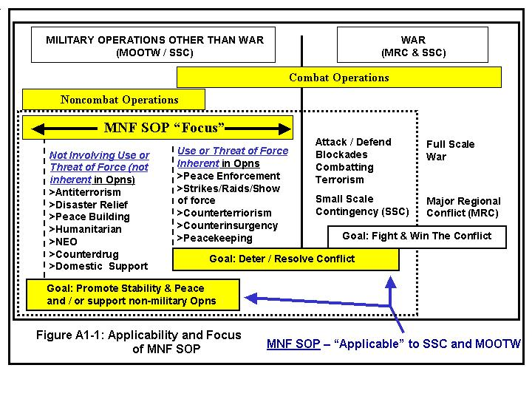

The above diagram suggests clear distinctions between War and MOOTW, and further divides MOOTW operations by the terms “use of force” versus “not involving use of force”. In reality, such distinctions may be unclear and can shift rapidly. In the end, a military’s basic function is to have the ability to use force to impose its will on an adversary. As such, MNF forces working within the ranges of MOOTW / SSC must be able to rapidly shift to the “use of force or threat of force” to ensure mission accomplishment. For example: Peace Keeping Operations (PKO) can transit quickly to Peace Enforcement (PEO) Terrorism because threat forces escalate their level of operations against the coalition. The MNF “must be ready to fight” (or transit to fight) at all times. All MNF planning and execution actions must acknowledge this.

- Operational Focus: This MNF SOP is focused on the CTF level of command (the operational level of warfare as depicted below in Figure A1-2).

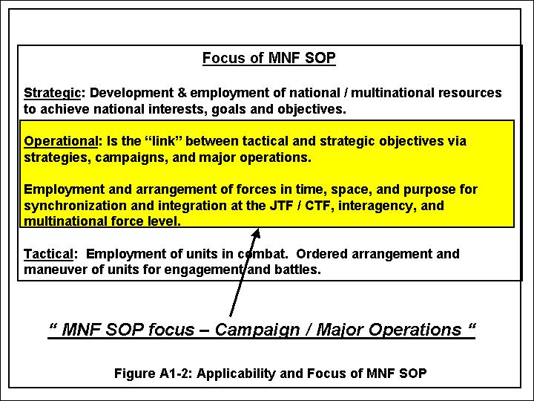

Section C
Complex Nature of Multinational Operations
&
Principles of Multinational Unity of Effort

- Complex Nature of Multinational Operations – “Unity of Effort” is Pivotal:
  - It is critical to understand the complex nature of multinational operations. The factors outlined below and on the next page need to be foremost in all CTF planning and execution actions to preserve unity of effort and effective mission accomplishment.
  - Many factors outlined below (Figure A1-3) are normally left “unstated” and are not always readily apparent. However, they have strong emotional dynamics that may have an impact on multinational efforts.

Nature of Multinational Operations

1. “Unity of Effort” is the number one priority for MNF mission accomplishment. This is primarily achieved by coordination and consensus building rather than by Unity of Command, as is the norm within a single nation’s Joint Task Forces (JTFs). However, participating nations should strive to achieve unity of command for the operations to the maximum extent possible. Unity of effort has broad implications on MNF planning and decision-making processes and execution of operations. A member nation can walk away from a MNF operation (consensus based command), can refuse to accept certain missions, or disagree with the commander’s guidance (i.e. Rules of Engagement (ROE), etc.). “Relationships versus command” is the dominating theme within a MNF (See figure A1-4 on the following page: “Principles of Multinational Unity of Effort”).
2. Nations “do not” relinquish their national interests by participating in multinational operations. Also, these interests are dynamic and may change during operational phases. Respect and understanding of these interests are paramount for unity of effort.

3. The “National” command authority for participating units is never relinquished. This is a key challenge for the CTF because units within multinational commands always have two command channels operating for “command direction” (national and multinational). Forms of “limited command” (see Chapter B-3) may be delegated, but such relationships must be clearly defined and understood by all.

4. Logistics (military and civilian support) will be pivotal for multinational operations because of the complex nature of MOOTW / SSC and differing units and equipment. Detailed planning, coordination, and agreements need special attention. Logistics in multinational operations require the special attention and coordination of the CCTF.

5. Multinational operations within MOOTW / SSC require coordinated application of all elements of national power for mission accomplishment.
6. Civil - Military Operations (CMO) are more complicated in a multinational, versus a unilateral operation. The CTF organization and processes should consider the use of a Civil Military Operations Center (CMOC) as appropriate for the situation. The CTF HQ must acknowledge that: (1) Non-Governmental Organizations (NGOs) / International Organizations (IOs) may not necessarily come to a “military” coordination center – the CTF staff may have to seek them out; (2) They may simply see the military as an obstacle in “their” operations; (3) They may have NO awareness of the military aspects of the situation; (4) They may not see the NEED for any military support or involvement in their operations.

- Finally, the different languages, cultures (values, religions, economic and social outlooks), and sovereignty issues will have tremendous impact upon unity of effort if not acknowledged and addressed continually in all planning and execution actions.

Figure A1-3: Complex Nature of Multinational Operations

  - As stressed in Figure A1-4, “Unity of Effort” is the number one priority for MNF mission accomplishment. This is primarily achieved within a MNF by coordination and consensus building rather than Unity of Command as is the norm within a single nation's Joint Task Force. Principles for MNF unity of effort are outlined below.

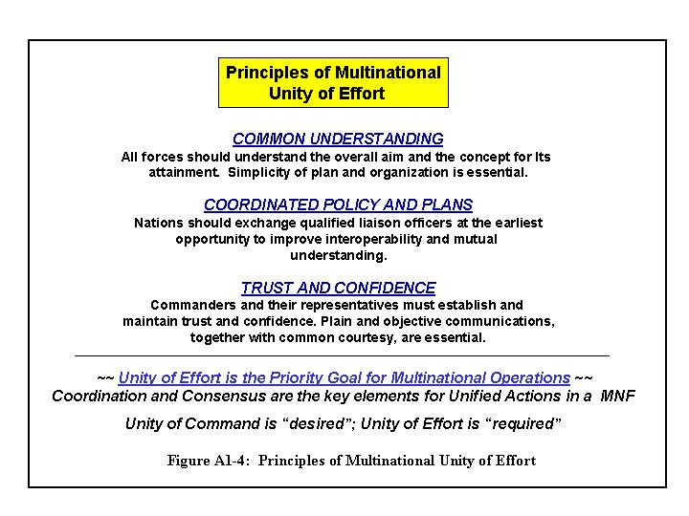

- Tenets of Multinational Cooperation and Partnership. Given the nature of multinational operations it is clear that an atmosphere of teamwork and partnership must permeate all aspects of the CTF and must be consciously sustained. This requires some intangible considerations for guiding individual and group behavior. These considerations are referred to as the “tenets of multinational cooperation” and are outlined below to assist in planning and execution actions.

  - Respect: Genuine respect of nations in a CTF is the cornerstone for addressing the challenges that commanders and staff will face during multinational operations. Partnerships require mutual respect.

  - Rapport: Commanders and staff need to form personal, direct relationships with their counterparts from partner nations.

  - Knowledge of Partners: Commanders and staff need to understand the doctrine, capabilities, strategic goals, interests, culture, and values of each partner. These factors must be integrated into the planning and execution processes for mission accomplishment.

  - Patience: Things simply take more time and effort within multinational operations. The different languages, cultures and sovereignty issues take time to resolve. This must be acknowledged within the planning and decision making processes.

  - Flexibility: Given the complexity of multinational operations, commanders and staff at all levels should exercise flexibility in the planning and decision making process.

