CDRL A002AA – Integrated Battle Command Decision Support Systems: Experiment B Report for Co-OPR Application

15-19 Nov, 2004, USJFCOM, Sussex, Virginia, USA

Co-OPR Project: Collaborative Operations for Personnel Recovery http://www.aiai.ed.ac.uk/project/co-opr/

Austin Tate, Jeff Dalton
Artificial Intelligence Applications Institute, University of Edinburgh, UK
Simon Buckingham Shum, Clara Mancini, Al Selvin
Knowledge Media Institute, Open University, UK

Co-OPR was used in the DARPA-funded Integrated Battle Command Program ‘Experiment B’ on 15-19 November 2004 at USJFCOM, Sussex, Virginia, USA.
The Co-OPR team members supporting the experiment were Austin Tate (AIAI, University of Edinburgh) and Simon Buckingham Shum, Clara Mancini and Al Selvin (KMi, Open University). Another team member, Jeff Dalton (AIAI, University of Edinburgh) provided remote support from Edinburgh, UK. Jeff Bradshaw, Renia Jeffers and Andrzej Uszok of IHMC, Pensacola, Florida provided support technologies.

Point of Contact:

Prof. Austin Tate, AIAI, University of Edinburgh,
Appleton Tower, Crichton Street, Edinburgh EH8 9LE, UK
E-mail: a.tate@ed.ac.uk Tel: +44 131 650 2732 Fax: +44 131 650 6513

Co-OPR Tool Roles in Experiment B
Co-OPR Tools involved Compendium and I-X. They were used on Tuesday 16th November 2004 only and addressed Vignette #1 of Experiment B: a Personnel Recovery (PR) event.
Compendium:
- A tool for the rapid construction of task-specific knowledge management environments, with specific emphasis on supporting collective sensemaking: the bounding of ill-defined problems, discovery and management of complex connections between ideas and data, and integration of potentially diverse perspectives.
- The Personnel Recovery (PR) application provides representational support in the form of interlinked Crisis Action Planning issue templates, including COA wargame analysis worksheets which led to a summary COA comparison worksheet.
- This is seeded in advance with relevant issues for consideration based on PR doctrine, and then used to capture in real time the ensuing discussions and decision rationale as ‘dialogue maps’.
- Diverse inputs from DIME analysts can be captured and interlinked within Compendium, creating a real time, but also long term, coalition memory resource.
I-X:
- Ability to deal with current situation knowledge and constraints
- Support for initial COA elaboration
- Ability to refine multiple COAs concurrently
- Support for issue handling and problem fixes at plan time in COAs
- Support for plan repair and add-in activities
Co-OPR Scenario
Co-OPR was used in Experiment B as a collaborative planning aid for the “aided” planning cell, which is to deal with a personnel recovery (PR) event in a fictional/training scenario set in Northern California. In this scenario, Oregon and California are nations between whom there is rising tension. The UN has sanctioned a peacekeeping force to stabilize the situation. Political intrigue is going on in California, and senior politicians are seeking to exploit the situation to further their own ambitions.
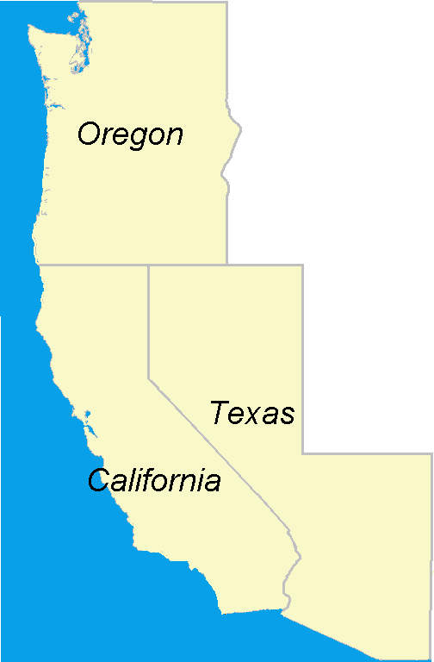
Brittan Ranch

A group of senior diplomats (ex prime ministers and diplomats of several countries) are visiting an UNESCO site of cultural importance in Northern California, and are being detained by local insurgents. The situation is becoming dangerous, and potential political, diplomatic and economic issues arise. The UN force is asked to effect a rescue without further exacerbating the situation.

Co-OPR Compendium
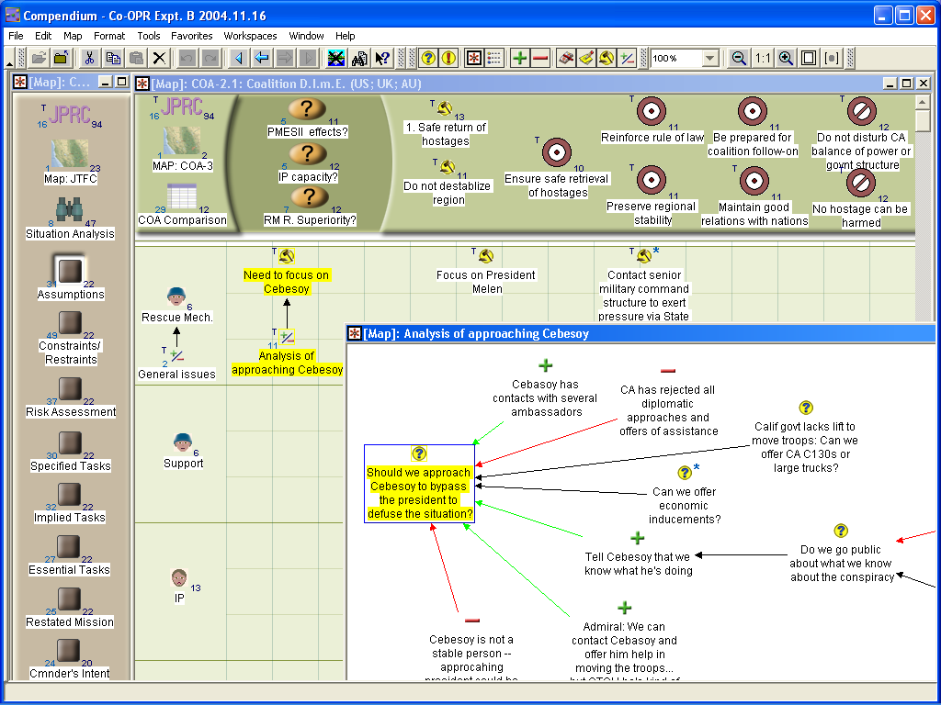
1
2
4
5
3

The above Compendium screen shows (1) the navigation bar for each step in Crisis Action Planning followed by the planning cell; (2) a COA worksheet grid in which key tasks, constraints and restraints are ‘docked’ at the top as visual reminders; (3) PR doctrine is available through issues which can be inspected; (4) ideas are developed for each set of actors in the COA. (5) The analysis of each idea (e.g. “Should we approach Cebesoy?”) is captured by the Compendium operator, and reflected back to the aided planning cell, as a dialog map of issues and arguments.
Summary slides with additional screenshots from Compendium’s deployment in Experiment B are at:
http://www.aiai.ed.ac.uk/project/co-opr/expt/Compendium/

The key Compendium results from the experiment are summarised below:
- 90 minutes before the mission briefing, the Plans Director distributed the Crisis Action Planning process he intended to follow. A navigational template to guide the planning cell through each CAP step was constructed by the Compendium team and ready when the mission briefing started at 1130.
- Compendium was used as we had envisaged, namely, as the primary working display by the Plans Director and his team as they developed their situation analysis and COAs. Informal feedback from other IBC tool operators suggests that they also found it useful to see, either via the main display or via IWS.
- Compendium was used to provide the Aided Planning Cell’s briefing back to JTFC, Joint Chiefs of Staff and Senior Mentors.
- Compendium received a range of Issues and Options from the I-X planning tool (see I-X results below).
- An example was shown of how an output visualization from the PMESII Effects Predictor (PEP) tool could be imported for subsequent analysis in Compendium (see slide on Co-OPR Experiment B website).
- We were pleased to note that the Planning Director enquired about the availability of Compendium for Vignette #2.

Changes to Compendium to model the Scenario
No changes were required to Compendium: it was usable in Experiment B as released. However, communications between Compendium and I-X were improved during the project. The primary work in developing the PR application was modelling PR doctrine and work processes, and designing the visual information environment to support coherent navigation, and different visual representational schemes at different stages in the PR planning process.

Co-OPR I-X
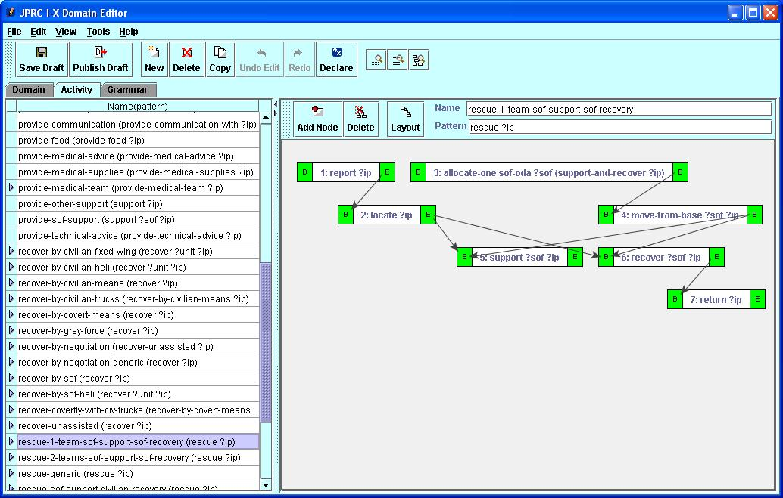
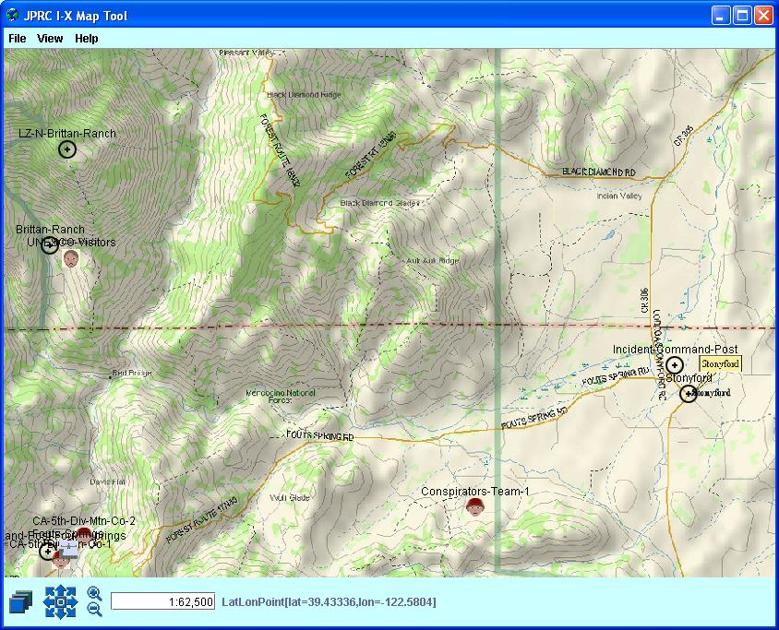
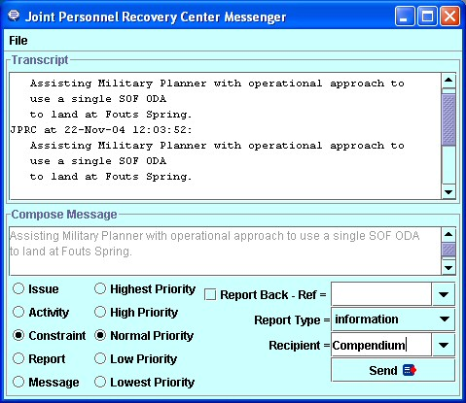
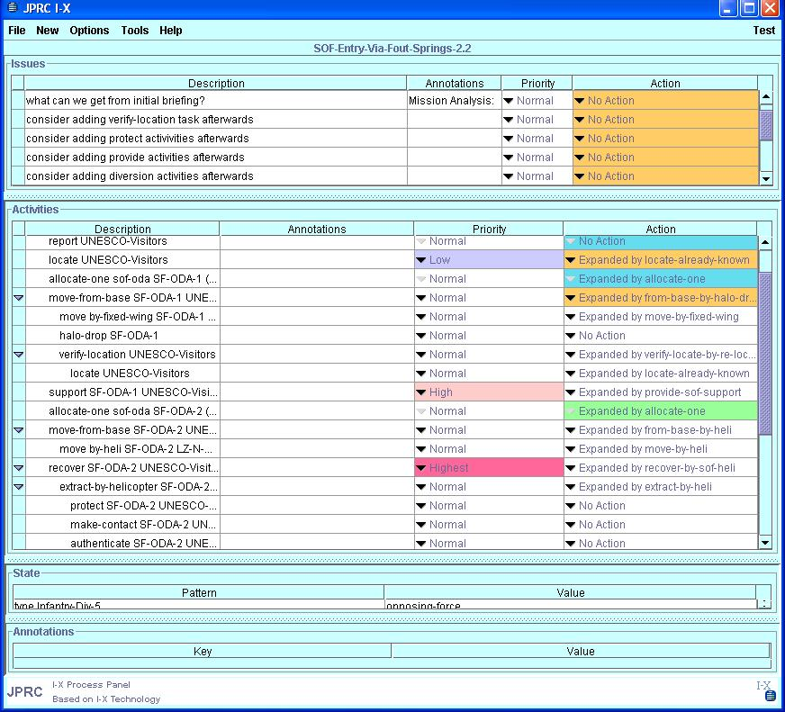
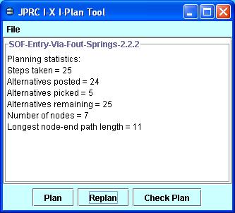
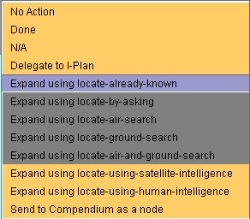
Process Panel
Domain Editor
Messenger
I-Plan
Map Tool

During Experiment B, all I-X products were placed on the Co-OPR shared web area accessible to all Assisted Planning Cell workstations. Products are shown in square brackets [...] in the activity log below. A copy of all I-X Experiment B products is at:
http://www.aiai.ed.ac.uk/project/co-opr/expt/I-X/Pub/
A log of I-X interactions with team members within the Assisted Planning Cell, with Co-OPR Tool Operators, and with the Co-OPR Compendium Tool is given here:
- I-X passed to Compendium an overview initial map situation showing disposition and status of blue forces, red forces, grey forces and isolated personnel. [coopr-ix-map-1.jpg]
- I-X passed to Compendium a close-in (to Brittan Ranch and Fouts Springs) initial map situation showing disposition and status of blue forces, red forces, grey forces and isolated personnel. [coopr-ix-map-2.jpg]
- Plans Director (Tom Sarles) asked I-X the question "What non-military recovery options do we have?". Within 1 minute, I-X posted 4 options. The option to perform a recovery using SOF covertly was removed by the Plans Director at this stage, so 3 kept. [coopr-ix-recover-actions.txt]
- Plans Director announces he prefers to use the term "recover" rather than "rescue". "Recover" is normally one of the 5 major steps in a rescue Standard Operating Procedure (SOP), so I-X was quickly modified in less than 2 minutes to introduce "bridging" terminology to ensure that all rescue SOPs from Joint Publication 3-50 were still valid.
- Military Planner (Major Jim Rupkalvic) suggests ising 2 SOF ODAs for an operational approach with fixed wing aircraft landing at Fouts Springs airfield. Fixed wing entry approaches were not in the I-X domain library, so such an option was added in 2 minutes.
- I-X is used to develop an outline plan with clandestine operations, discussed with Military Planner and some refinements were made. [IX-Clandestine-2-SOF-Plan.txt] [IX-Clandestine-2-SOF-Plan.xml]
- Plan thought to be too risky by SOF Planner with respect to potential for detection by and provocation of Californian forces. Work on this option suspended for now. Returned to later.
- UAV surveillance approaches were not in the I-X domain library, so such an option was added in 2 minutes.
- Plans Director asks I-X what grey forces recovery options are available. I-X domain model used to give examples over IWS speech network.
- Civilian and covert means of recovery were explored. 2 top level summaries were suggested from detailed options generated automatically by I-Plan. [coopr-ix-covert-approaches.txt]
- Safe house at Yuba City added to I-X situation maps for potential truck recovery use. Automatic association of suitable icon on map display.
- IWARS query via IWS chat facility to ask what is Lat/Long for safe house in Auburn. Response provided by IWARS and a suitable object added to I-X map display.
- Add-ins and diversions were suggested by I-X using its domain library and issues within individual SOPs. These were summarized verbally to the Plans Director via IWS speech. Plans Director felt they were at too "tactical" a level. [coopr-ix-additional-activities.txt]
- Note that the add-in activities facility had been added to I-X following Experiment A (September 2004) as a result of potential requirements identified during feedback provided by Ken Sharpe (SAIC).
- More add-ins, force protection elements and isolated personnel support provisions were explored in I-X. These were not raised to the level of the Planning Cell or Compendium, as they appeared to be too tactical.
- Added issue relating to "are we gathering intelligence?" proposed by Co-Web Operator (Doug Dyer) noted by I-X and raised through Compendium to attention of Planning Cell.
- Military Planner raised with I-X operator the issue of diplomatic means of recovery. There was nothing helpful in the I-X domain library. A "stub" refinement was created that could be expanded either manually or used as a reminder of more domain modelling needs later.
- Military Planner asks for reconsideration of 2 SOF approach again, but with alteration of means of entry and isolated personnel egress method. I-Plan used to generate 5 possibilities while Military Planner looks on. 2nd proves interesting to Military Planner who asks to go back to that option to address pevious SOF planner issues. Plan saved in simple text format and structured XML. [IX-Clandestine-2-SOF-Plan.txt] [IX-Clandestine-2-SOF-Plan.xml]
- Military Planner asks for a verification activity for location of the isolated personnel to be added at a specific point in the plan. This is possible in I-X and was done.
- I-Plan called again to complete the modified plan. Plan saved in simple text format and structured XML. [IX-Clandestine-2-SOF-Plan-with-Loc-Verify.txt] [IX-Clandestine-2-SOF-Plan-with-Loc-Verify.xml]
- Text form printed by Military Planner to use as a sample Operational Approach in briefing to JTF Commander.
- XML format plan imported to Co-Web by Co-Web Operator (Doug Dyer) to see what additional issues can be found.
Changes to I-X to model the Scenario
I-X was able to handle the basic scenario without change. Since it is a knowledge-based tool, the domain model had to be built to describe Standard Operating Procedures relevant to the Personnel Recovery area. A range of publicly available sources were used for this:
- Doctrine for Personnel Recovery - JP 3-50 (New version Draft 19 Jul 2004)
- Capt. Bill McRaven – Spec. Ops – 6 Principles
- Laurence Gonzales – Deep Survival Principle
- Maj. Marshall Eklund (US Army) and Maj. Michael McNerney (USAF), Naval Postgrad School thesis
- Lt.Gen. Zinni - 20 Lessons Learned
- Subject Matter Experts
  - JPR Familiarization and Requirements: Diane Barnette JFCOM/J9
  - JPR Guidance: Maj. Len Mackie JFCOM/JPRA
  - IBC Scenario and COAs: Mike Lytle, SAIC
Domain familiarization for the Co-OPR team took some months of background reading and understanding the area. But the core domain model took less than 10 man days to create to a level that was usable within Experiment B. The key publication used was Joint Publication 3-50.
However, in order to be more effective, significant new work was undertaken on the I-X tool in 4 areas:
- Further development of the automated planner, I-Plan, within the I-X tool, to complete outline plans and to generate legal options automatically.
- Development of, previously envisaged, capabilities to establish and work with multiple plan “options” concurrently.
- Improvements to the ways in which I-X and Compendium can exchange their results.
- A way to narrow the ways in which I-X communicates with other systems and tools, to allow restrictive networking environments to be accommodated.

Co-OPR Integration
I-X acted as an intelligent planning agent cooperating with Compendium to support the Planning Cell’s operations, although as noted, planning staff only saw Compendium’s graphical interface as issue maps were constructed (with the exception of Major Jim Rupkalvic who worked alongside the I-X operator). The following log of interactions between I-X and Compendium answers the question of what the tools were doing behind the scenes to aid the Planning Cell staff.
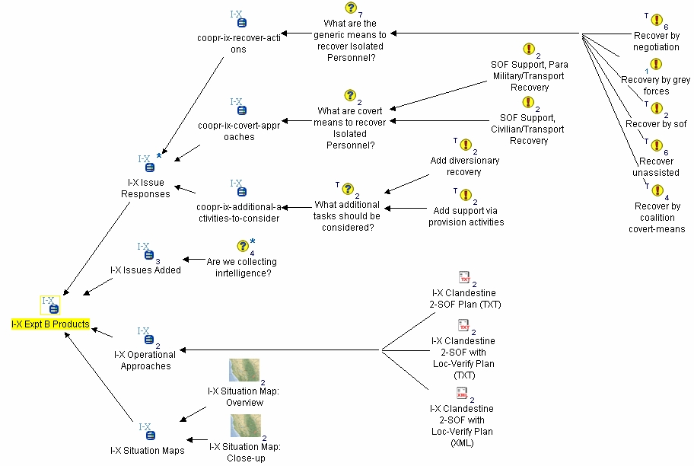
The types of information that could be passed from I-X to Compendium follow the core concepts within <I-N-C-A>, i.e.,
- Issues and Responses
- Activity Options
- Constraints/Maps
- Annotations/Notes

Co-OPR Evaluation
One member of the Co-OPR team, Al Selvin, who was brought into the project only for Experiment B. He was tasked with observing the Co-OPR-supported IBC Experiment B Vignette #1. He was asked to observe the experiment with the following points in mind.

The types of actions, modes of engagement, and interactions of the tool practitioners with the participants and each other (if applicable)
In the course of the day there were two periods where Compendium was the visual focus (up on the large screen) for participants in Experiment B, first in the morning for 11:35-13:05 (85 minutes), then for a longer period in the afternoon (13:48-16:35) (157 minutes). During these times, the following kinds of engagement were observed:
There were three main kinds of participant/Compendium interaction: Direct, Semi-direct, and Delinked.
In terms of the time involved in each mode, the primary mode of engagement was Direct: the Plans Director interacting with the evolving representation on the screen as managed by the Compendium primary operator. In this mode, the participants focused directly on the Compendium representation as the unfolding narrative and summary of the planning options being considered. In addition, the Plans Director took on a direct interactive mode with the representation, at first accepting what the screen showed at face value (i.e. that the tool was providing output that needed to be accepted as is), but increasingly instructing the Compendium primary operator to make changes to the text and/or layout of the representation. The Plans Director had an increasing level of engagement with the representation during the course of the day, first reading off the screen and making comments about how he would have liked to adjust some of the text, then directing the practitioner to navigate between screens (maps), then asking the practitioner to make textual adjustments, then requesting actual changes to the shape and form of the maps. Another type of Direct engagement was the Plans Director reading the materials off the screen and directing the Compendium primary operator to navigate between and around maps, at first often asking where certain previously captured/reviewed materials were, but increasingly giving explicit direction to navigate to particular locations within the Compendium database as he grew more familiar with the representation. This mode occurred frequently throughout the day. Direct engagement mode was observed for most of the 242 minutes when Compendium was the large-screen visual focus in the aided planning cell room.
A secondary mode was Semi-direct capture of planning discussions, in which the Compendium primary operator (supplemented by the backup operators) listened to the conversation in the aided planning cell room as well as monitoring the interactions over the headset and the IBC chat room, and represented key points on the screen as they occurred. This mode interwove at times with the Direct mode discussed above -- i.e., the participants would shift from direct consideration and involvement with what the screen showed to a mode in which they were speaking to each other without reference to the screen, but in which the Compendium operators continued to "capture" key points from the discussion.
A third, or "delinked" mode, was when the Compendium primary operator, supplemented by the secondary operators and results from the I-X Tool, was modifying the representation (e.g., changing the graphical backgrounds, assembling templates, etc.) and constructing summary materials, usually with Compendium not being shown on the large screen (i.e. the operators worked on their own workstations without a public display). This mode occurred, for example, early on in the day, when the Plans Director supplied a sheet of Crisis Action Planning questions to guide the planning exercise that was different from the ones Compendium had been prepared in advance with, causing the Compendium operator team to do a rapid amount of background work to alter the Compendium maps and templates to accommodate the new discussion form (occurred between 9:50 and 11:38). This mode also occurred later in the day in constructing the summary COA comparison maps.

Moments where the engagement and comprehension of what the tools or practitioners are bringing to the session for the participants seem especially high or low
High: 12:57: The discussion between the Commander and the Plans Director evaluating the Compendium maps after the morning session seemed to imply that a great deal been accomplished and represented. At 12:57 the Commander says he gives "high marks for what you've been able to do this morning."
High: From 14:08 to14:20 the Plans Director instructs the Compendium primary operator to construct alternative scenarios based on the I-X inputs (after directing the removal of the SOF option, and refinement of the "grey force" option). The Plans Director engages with the elements of the representation on the screen, supplying active direction to construct the scenarios exactly as he wants them. By 14:50, the Plans Director had "internalized" the locations and contents of the various maps and COA knowledge elements well enough that he became quite fluid in directing the Compendium primary operator where to retrieve particular items from and how to place them on the current map.
High: From 15:15 through 15:30, Plans Director instructs the Military Planner to supply verbal input for the Compendium primary operator to populate new elements on the Compendium COA Comparison worksheet (ratings and commentary on the various criteria), and for the other participants to provide their opinion on the unfolding representation.
These are only several of the moments of High engagement that it would be possible to analyze further. It was a surprising outcome of the session, given that this was the first encounter with Compendium for all of the participants, that so much of the day consisted of direct visual and "tactile" (that is, participant direction to the Compendium operators to alter the representation) engagement with the Compendium representation.

Ways in which participants, practitioners, and tools deal with unexpected events during the session
For Compendium, one example is discussed above in the "delinked" section of the engagement commentary.
I-X was able to respond to a change in terminology required by the Plan Director to use the term “recover” rather than “rescue”. This was done while still preserving the links to regular Personnel Recovery terminology used in the Standard Operating Procedures in the domain model used by I-X.

The kinds of artifacts produced/altered/discarded during the session
Several principle kinds of artifacts were produced during the session. Early on the Compendium primary and backup operators constructed new template maps (rapidly modifying old ones) to accommodate the new planning outline supplied by the Plans Director. These were then employed by the Compendium primary operator to capture the discussion, populating the following maps during the morning sessions: Briefing; Assumptions/Constraints; Risk Assessment; Specified Tasks; Implied Tasks; Essential Tasks; a Rationale map created on the fly to capture the reasons by which tasks were designated as Essential; Restated Mission; and Logistics Considerations.
In the afternoon, the following maps were created, modified, and/or populated; Wargame COAs (a summary map providing an overview navigation of each COA description and links to the worksheet maps and final comparisons); COA-1 Force; COA 1.1 Recovery by overt coalition forces (a worksheet map, which in turn included two discussion maps); COA-1.2: 12 agent paramilitary recruited by grey agencies, stationed out of truck terminal prepared to extract hostages and move them to safe houses (a worksheet map); COA-1.3: Recover by coalition covert-means which had been developed using I-X inputs (a worksheet map); COA-2.1: Coalition D.I.m.E. (US; UK; AU) (a worksheet map, which in turn included one discussion map, "Analysis of approaching Cebesoy"); COA-3: International D.I.m.E. (a worksheet map); the COA Comparison worksheet map; and a map titled "Prelim assessment of tool?"

Specific kinds of outcomes (expected and unexpected) both during the course of the session and at its conclusion, for both the participants and practitioners
JTF Commander comments at 16:10: "this is impressive and appealing, but I keep asking myself if the tool helped or if it would’ve been just as good with PowerPoint rangers… BUT if we had the following qualities, here’s where it would’ve gone beyond PowerPoint; can’t just have ‘it felt good and looked good but it didn’t make us any smarter.' "

Debrief discussions with both participants and practitioners afterwards (if possible)
Not conducted.

Summary
We have an empirical basis from our experiences in this experiment to propose that a semiformal representation for issues, options and arguments, supported by a hypermedia tool for visualizing the relationships between these and other knowledge elements (such as data from other tools), seems to be well suited for COA and DIME sensemaking. This knowledge-intensive activity requires the capture, structuring, analysis and integration of many kinds of issue, e.g. ranging from formal/hard logistics (e.g. “How long will it take a helicopter to get from A to B?”), to the more open ended, informal issues that are inherent in such discussions (e.g. “On what basis could we expect person X to react in this way?”). Possible answers to the latter questions may be proposed by DIME planning/simulation tools, but ultimately it is the human planners who must make the final judgements, and there will often be situations where only human expertise and wisdom (“grey matter”) must be brought to bear, which is either not yet formalizable in planning aids, or which has not yet been modelled. The above pattern accords with our experience in supporting collective sensemaking in many other domains.
Compendium provides a medium in which all factors under consideration can be laid out in a common space, relieving individual and collective memory load (especially under pressure), drawing attention to the articulation of good questions, and arguably, fostering a broader analysis of the situation which takes into account possible DIME COAs and PMESII effects.
I-X provides issue responses, outline operational approaches, refinements and fixes to operational approaches, and constraint information worked out collaboratively between the I-X Tool, the I-X Operator ad the Military Planner. It interacted behind the scenes with Compendium such that the use of the I-X tool was largely transparent to the collaboration that was taking place in the Planning cell.

Recommendations for Future Work
We consider the following as key targets for Co-OPR tools research:
Compendium:
- Deploy on a longer term to show how the whole sensemaking lifecycle can be supported for a mission: pre/execution/post
- Add deeper intelligence (as already started with I-X) to:
  - Raise new Issues, Options or Criteria
  - Retrieve data on the fly updating discussion maps
  - Guide analysts through templates like a tool ‘wizard’
- Explore alternative visualizations
- Grey matter and silicon: synergistic human and software input
- Acquire deeper knowledge of end-users in order to build more powerful templates to scaffold work practices
- Interoperability: Compendium as ‘sensemaking interchange’ format (already done with NASA) based on an underlying ontology
- Develop team process models (e.g., using I-X) to better understand how Compendium pays back in different contexts
- Training: it is most effective as a ‘power tool’ for skilled personnel (although many people use it as a personal knowledge management tool)
- As a by-product of discussion capture, generate relevant documentation/briefings
- Voice recognition for discussion capture is a long term challenge

I-X:
- I-X was mostly used in an off-line planning role for a single planning function in Experiment B. Its design allows it to support distributed and collaborative planning and execution. This should be explored in future work.
- I-X is a knowledge-based system. Its usability and value is improved with the availability of information about Standard Operating Procedures and domain knowledge of rules of engagement, constraints, etc.
- I-X developments for realistic military usage needs to intercept work on improved ways to codify military knowledge, and make more explicit, manageable and re-usable the knowledge available via lessons learned, doctrine, and procedural knowledge of tactics, techniques and procedures.

<I-N-C-A> Shared Model:
- Further work is required to integrate Compendium and I-X so that they can more effectively exchange information using the shared conceptualization of plans based on <I-N-C-A>.
- During the Co-OPR project it was realised that it would be necessary, in exchanges of <I-N-C-A> artifacts between systems, to give a context explaining the reason for the exchange. E.g., to say that it was a query for which options were required, or a suggestion for additional issues within a specific option being explored.
- <I-N-C-A> could have a major influence on the design of the core conceptualization/ontology used in the Co-Web for exchange of plan related information between confederated planning systems.

Co-OPR Summary
Co-OPR sought to use a number of technologies in a realistic personnel recovery mission, focusing on exploiting the respective strengths of human and software agents in the planning cell:
- Compendium - Collaborative sensemaking and group memory to integrate COA & DIME analyses
- I-X - Intelligent collaborative command, planning and execution support
- <I-N-C-A> - Underlying model for sharing of issues, activity nodes, constraints and annotations
The following results were achieved during IBC Experiment B:
- Compendium aided the Plans Director by integrating both informal and formal factors of COA and DIME analysis, in the process generating a structured group memory [as anticipated]
- I-X proved useful in aiding the Military Planner to identify and refine operational approaches, and propose these to the group [as anticipated]
- Compendium and I-X were both able to be adapted dynamically to the Planning Cell’s preferences for changes of approach and terminology
- Advanced knowledge and AI planning technologies were effectively hidden behind the scenes in order to preserve a simple visual interface for the planning team [as anticipated]
- Tools allowed effective use of “grey matter” and silicon during the experiment.
Co-OPR sought to illustrate a more collaborative planning framework:
- Linked collaborative planning and plan analysis aids share tasks, standard operating procedures, policies and current situation information
- Links between informal human-oriented outline planning and more structured semi-automated detailed planning
- Outer level: human relatable and presentable objective statements, sensemaking, advice, multiple options, argumentation and outline plans
- Inner level: detailed planners, search engines, constraint solvers, analyzers and simulators act in an understandable and controllable way to provide feasibility checks, detailed constraints and guidance
- Sharing of issues, activity options, constraints and annotations between humans and systems operating at various levels
- Context and current environment sensitivity
All results achieved during Experiment B and a summary report in PowerPoint format are archived at:
http://www.aiai.ed.ac.uk/project/co-opr/expt/

NASA Mobile Agents field trial: tool support for Mars-Earth scientific collaboration in a simulated manned exploration of Mars. RST-ComSys Report: www.marssociety.org/MDRS/fs03/0508 Other case studies are published at: www.CompendiumInstitute.org

