CDRL A002AA - Integrated Battle Command Decision Support Systems: Experiment A Report for Co-OPR Application
21-24 Sept, 2004, Edinburgh, UK
Austin Tate, Jeff Dalton
Artificial Intelligence Applications Institute, University of Edinburgh, UK
Simon Buckingham Shum, Clara Mancini
Knowledge Media Institute, Open University, UK
A Co-OPR workshop (‘Experiment A’ and formal project deliverable) was held 21-24 September 2004 with Ken Sharpe (SAIC), and Simon Buckingham Shum and Clara Mancini (OU) visiting Austin Tate and Jeff Dalton.
After an overview from Ken Sharpe on the objectives and technical configuration of Experiment B in November 2004, a Co-OPR demonstration walkthrough was given to Ken Sharpe (Appendix 1) illustrating how Compendium and I-X (constrained by KAoS policies) could support the staff of a JPRC in the specified scenario of a Non-conventional Assisted Recovery mission. This then led to detailed discussions and planning for Experiment B.
Outcomes from the meeting were:
- Clarification of different tools’ roles in Experiment B:
- Appendix 2 summarises the Co-OPR Process
- Compendium:
- Provide representational support in the form of linked, interactive COA wargame analysis and comparison worksheets based on the worksheets currently used (to be verified with SMEs)
- Bring to bear relevant issues for consideration based on JPR doctrine, and capture the ensuing discussions and decision rationale as dialog maps
- Integrate input from wider Coalition Task Force members (e.g. PMESII analysts critiquing COA worksheets)
- Share data in the form of interactive visualization n(in the form of Compendium “maps”) published to the local web server
- All of the above are interlinked within Compendium, creating a coalition memory resource
- I-X Process Panels (within the KAoS policy-management agent infrastructure):
- Ability to deal with multiple COAs
- Support for initial COA elaboration
- Support for issue handling and problem fixes at plan time in COAs
- Support for plan repair in the face of plan execution failures
- Co-OPR briefing: An outline for the scripted 1 hour Co-OPR briefing on Monday 15th Nov which Ken Sharpe /Mike Lytle will narrate:
- 5 min: Introduction
- 15 min: Compendium intro
- 15 min: I-X/KAoS intro
- 5 min: Summary
- October milestones:
- 9am EDT/2pm GMT on 19th Oct. – an SME-consultation telecon (not WebEx) with Ken Sharpe and Mike Lytle with any visual materials required circulated in advance, SBS, AT, KS, ML.
- 10am/3pm 28th Oct. – WebEx meeting with Ken Sharpe and Mike Lytle to agree Co-OPR Briefing slides and script
- Liaise with Tracy Monteith on hardware/software/network/services setup. Austin Tate to be on standby for phone support to Tracy Monteith on Thursday 10th November during setup at JFCOM.
- Flights now booked for Austin Tate and Simon Buckingham Shum to arrive in Norfolk for Experiment B on Sunday 14th Nov 2004, leaving mid afternoon of Thursday 18th Nov 2004

Appendix 1: Sample Co-OPR displays for JPRC as presented in Experiment A

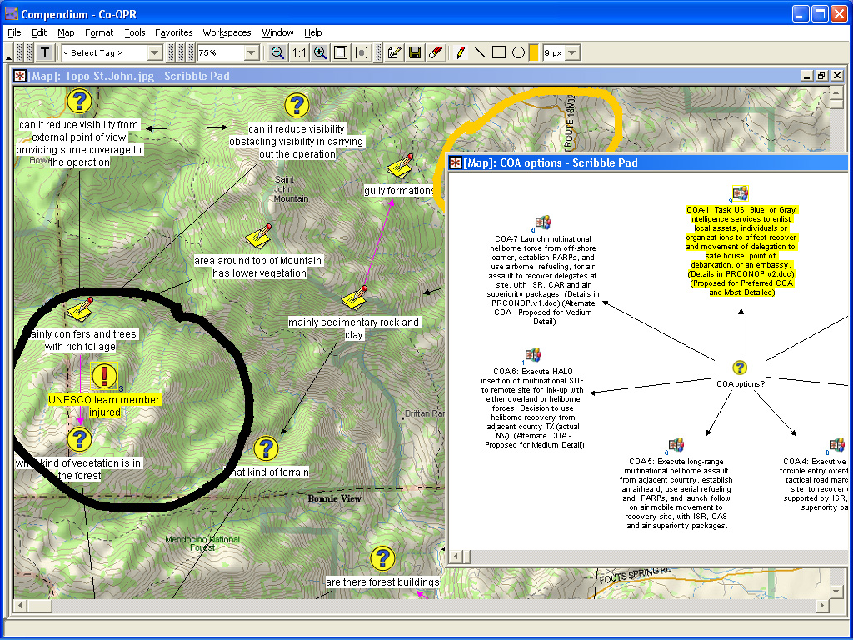 | 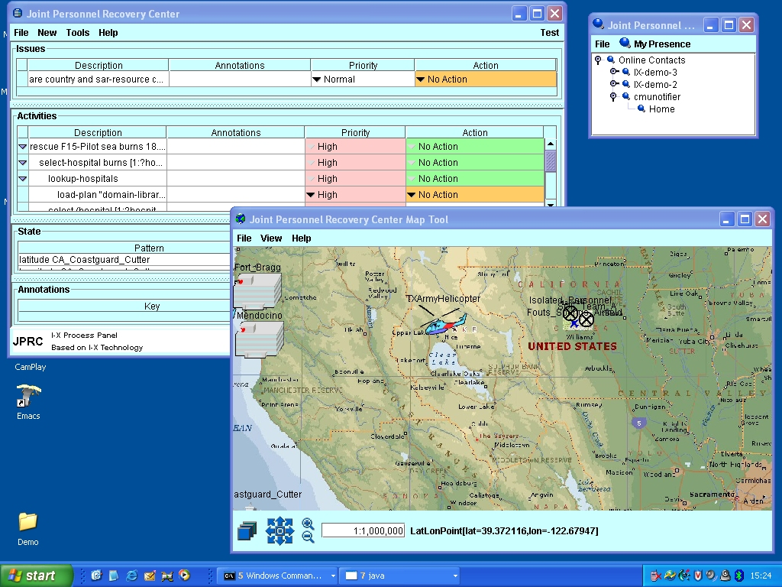 | 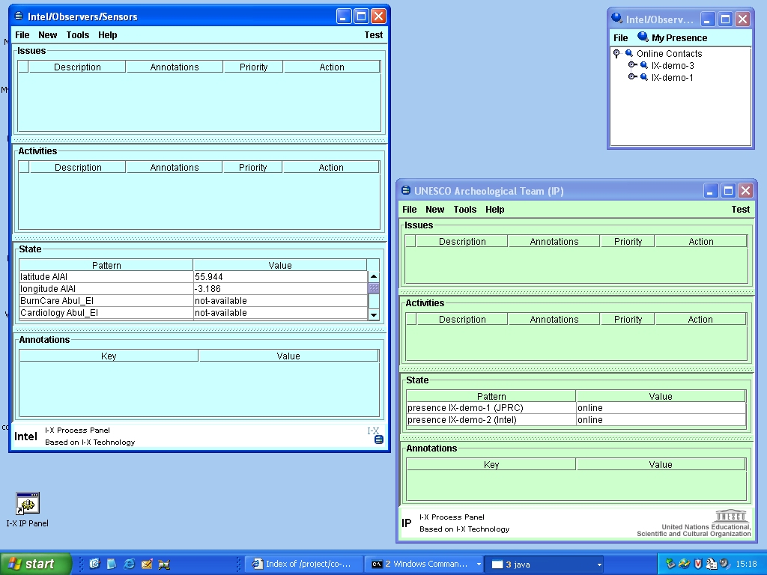
Left screen: Compendium intelligence database and discussion/rationale capture. | Middle screen: I-X Process Panels showing current state of plan execution and situation map | Right screen: I-X Process Panels communicating with the external world, e.g. Isolated Personnel

Appendix 2: Co-OPR Process for Experiment B

