I-X Process Panels – Quick Start Guide

Austin Tate and Jeff Dalton

Artificial Intelligence Applications Institute

Centre for Intelligent Systems and their Applications

Division of Informatics
The University of Edinburgh
80 South Bridge, Edinburgh EH1 1HN, UK

http://www.aiai.ed.ac.uk/project/ix/

12th December 2001

Introduction to I-X and I-X Process Panels (I-P²)

I-X Research Programme

I-X is a research programme with a number of different aspects intended to create a well-founded approach to allow humans and computer systems to cooperate in the creation or modification of some product such as a plan, design or physical entity – i.e. it supports synthesis tasks. I-X may also be used to support more general collaborative activity.

The I-X research draws on earlier work on O-Plan (Tate et.al., 1998; 2000; 2002). <I-N-OVA> (Tate, 1996) and the Enterprise Project (Fraser and Tate, 1995; Uschold, et.al., 1998) but seeks to make the framework generic and to clarify terminology, simplify the approach taken, and increase re-usability and applicability of the core ideas.

The I-X research programme includes the following threads or work areas:

- I-Core, which is the core architecture, the underlying ontology of activity and processes termed <I-N-CA>, and the terminology used to describe applications, systems or agents built in the I-X framework.

- I-PE, which is the I-X Process Editor, which is itself an I-X application but is also used to create and maintain the process models and activity specifications used elsewhere.

- I-P², which are I-X Process Panels used to support user tasks and cooperation.

- I-Plan, which is the I-X Planning System. This is also used within I-P² and other applications as it provides generic facilities for supporting planning, process refinement, dynamic response to changing needs, etc.

- I-Views, which are viewers for processes and products, and which are employed in other applications of I-X. I-Views can be for a wide range of modalities and types of user.

- I-Faces, which are underlying support utilities to allow for the creation of user interfaces (User I-Faces), inter-agent communications (Communications I-Faces) and repository access (Repository I-Faces).

- I-X Applications of the above work areas in a variety of areas. These currently include:
  - Coalition Operations (CoAX: I-LEED, I-DEEL)
  - Emergency and Unusual Procedure Assistance (I-Rescue)
  - Help Desk Support (I-Help)
  - Multi-Perspective Knowledge Modelling and Management (I-AKT)
  - Medical Best Practice Procedures or Protocols (I-Medic)
  - Natural Language Presentations of Procedures and Plans (I-Tell)
  - Collaborative meeting and task support (I-Me, I-Room and I-Space)

- I-X Student Projects, which are deepening and refining a number of aspects of the I-X research programme.

- I-X Technology Transfer, including work on standards committees, especially for process, plan, activity and capability models.

I-X Process Panels (I-P²)

The aim of an I-X Process Panel (I-P²) is to act as a workflow, reporting and messaging “catch all” for its user. It can act in conjunction with other panels for other users if desired.

- Can take ANY requirement to:
  - Handle an issue
  - Perform an activity
  - [later: Add a constraint]

- Deals with these via:
  - Manual (user) activity
  - Internal capabilities
  - External capabilities (invoke or query)
  - Reroute or delegate to other panels or agents (pass)
  - Plan and execute a composite of these capabilities (expand)

- Receives reports and messages and, where possible, interprets them to:
  - Understand current status of issues, activities and constraints
  - Understand current world state, especially status of process products
  - Help control the situation

- Copes with partial knowledge

Three example process panels are shown in the figure below. These panels are from a demonstration of agent systems within a military Coalition context – part of the Coalition Agents eXperiment – CoAX (Beautement et.al. 2001).
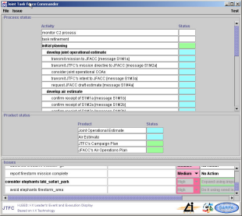

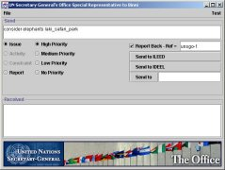

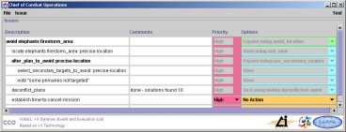

I-X Process Editor (I-PE)

The process descriptions used by I-X Process Panels are kept in a domain library. This can be loaded when a panel is started, and can be added to dynamically by a user of a panel.

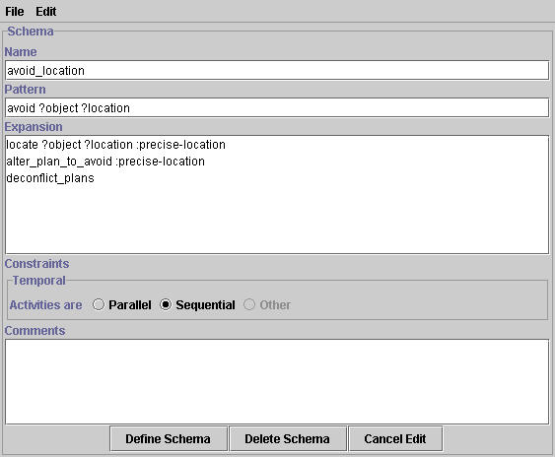Simple View - the process panels contain a simple view domain and process editor that allows simple task breakdown structures to be specified along with a temporal constraint that the sub-steps should all be sequentially ordered or all kept in parallel.

Advanced View - a more powerful domain and process editor allows for multiple perspectives and views to be used to create rich process models beyond those that can be created with the simple view editor. This can be reached by selecting advanced view from the simple domain/process editor. It is also available as a stand-alone application to maintain a set of domain and process libraries.

Use of XML and Text Editors - the process and domain models are maintained in XML. You can also modify them using an XML Editing Tool - such as the freely available Microsoft XML Notepad (see http://msdn.microsoft.com/xml/notepad/intro.asp) or a text editor.

Quick Start Guide

To quickly get started using the I-X Process Panels and run the demonstrations follow the following procedure. This is specifically for Microsoft Windows platforms – but a similar procedure can be used on Unix also.

- Ensure that you have a working Java Development Kit environment with the necessary Java programs on your current path, i.e. you should be able to run a command “java” from any location. You will need to alter the scripts provided to set the path explicitly if this is not the case.

- Obtain and uncompress the I-X system distribution. This will create a single directory with all necessary files. It can be placed anywhere.

- An example for using the I-X Process Panels is available in apps\isample. You can start up a demonstration by executing (e.g. by double clicking on) 3 of the batch script files in this sub-directory called: scripts\win\isample-startup-itest.bat (run first to provide a simple name/address lookup service to the other process panels), isample-supervisor.bat and isample-oerator.bat.

- You can then test the panels by sending sample issues between panels – one way to do that is to use the Test menu on I-Test to send sample issues to other panels.

Creating your own I-X Process Panel

A single process panel or a small cluster of panels in superior, peer or subordinate relationships to one another can be quickly adapted to a new application. We will later support more dynamic and adaptable combinations of multiple panels in more complex organisational structures (which we called I-Spaces), but much of the necessary support for this is not yet sufficiently generic to provide in an easily altered form.

An example I-P2 application is provided in the apps\isample directory, which can be copied and adapted as follows:
- Copy the whole Isample directory to become a new directory with a name of your choice (e.g. apps\app-name).
- You can rename the ix\isample directory to be ix\appname and, in that directory, rename Isample.java to be AppName.java or whatever you wish. Deelete the compiled class files included there.
- Edit this renamed file to change the package name from ix.isample to ix.appname.
- Change the class name Isample to AppName where it occurs.
- Change any strings that refer to I-Sample to App-Name as you wish.
- In the directory scripts\win (and unix) alter the script names and script contents as necessary to refer to the new name rather than Isample.
- Recompile the AppName.java code with the compile script provided.
- In the directory config alter the property file names and contents as you wish.
- In the directory images add in any logo or logos for panels as you wish. Replacing the logo images\ip2-logo.gif will mean the default logo is amended without further changes.

A wide range of parameters can be specified to simply customise a range of things about each panel. These are documented separately. A property file for a panel can specify most of these and can be set using, e.g.,

ix.isample.Isample -load config/isample-supervisor.props

For example, the file config/isample-supervisor.props contains:

display-name=Supervisor
symbol-name=Supervisor
logo-line-1=Supervisor I-X Process Panel
logo-line-2=Based on I-X Technology
logo-image=images/ip2-logo.gif
domain=isample-supervisor.xml
subordinate=Operator

or you can set one property individually when the process panel program is started using a command-line argument, such as

"-display-name=App-Name Whatever"

The process descriptions available to the panel can be preloaded from a domain library file (e.g. as in the case above which loads the isample-supervisor.xml file describing sample processes that the panel is made aware of and can use to “expand” entries put onto the panel.

The I-X Process Panels can have a number of “issue handlers” which can handle issues in specific ways. One type of handling is to reroute the issue to other users or panels. The Isample.java code includes simple handling for delegation to subordinates, handover to peers and escalation to superiors. Part of this code is shown here. You can amend this and recompile Isample.java or your version of it using the provided compile-isample.bat script.

protected void addIdeelIssueHandlers() {
super.addIdeelIssueHandlers();

// Delegate to subordinate, require report back
if (subordinate != null) {
controller.addUniversalIssueHandler
(new ForwardingIssueHandler
("Delegate",
subordinate, // who to send to
true)); // report-back
}

It can be convenient to provide some example issues that can be added to a panel, which could have come from other systems or panels. This allows simple demonstrations and testing to occur. The contents of the "Test" menu for an example I-X Process Panel such as Isample are set by a method in BasicIdeel (which does nothing), overridden, for example, in Isample.java like this:

protected void addTestMenuItems() {
super.addTestMenuItems();

frame.addTestIssue(PRIORITY_LOW,
"note example issue", // issue text
"Add a note issue"); // menu text
}

Use all lower case in the issue strings. This test menu customisation feature will be expanded upon in greater detail in future versions.

Creating your own I-X Process Library

Each I-X Process Panel cane make use of a domain model or process library which describes ways in which issues can be handled or high level activities can be broken down into more detailed activities which may be performed. A panel can operate without such process descriptions, but becomes more useful and helpful if it has such knowledge. A process library can be loaded when a panel is started up, and additional process descriptions can be provided while it is running, and indeed they can be saved at any stage to amend the stored version for later preloading.

You can create the process descriptions with the I-X Domain and process Editor provided. It can be run on its own or can be called from within a Process Panel from the Tools menu. Since the process descriptions are actually stored in a simple XML format, it is also possible to use any XML editor to change the descriptions if you wish.

…

Using an I-X Process Panel

To be written.

References

Allsopp, D., Beautement, P., Bradshaw, J.M., Carson, J., Kirton, M., Suri, N. and Tate, A. (2001) “Software Agents as Facilitators of Coherent Coalition Operations”, 6th International Command and Control Research and Technology Symposium, US Naval Academy, Annapolis, Maryland, USA, 19-21 June 2001.

Fraser, J. and Tate, A. (1995) "The Enterprise Tool Set -- An Open Enterprise Architecture", Proceedings of the Workshop on Intelligent Manufacturing Systems, International Joint Conference on Artificial Intelligence (IJCAI-95), Montreal, Canada, August 1995.

Tate, A. (1996) "The <I-N-OVA> Constraint Model of Plans", Proceedings of the Third International Conference on Artificial Intelligence Planning Systems, (ed. Drabble, B.), pp. 221-228, Edinburgh, UK, May 1996, AAAI Press.

Tate, A. (1998) “Roots of SPAR”, in "Special Issue on Ontologies", Knowledge Engineering Review, Vol.13 (1), March 1998, Cambridge University Press.

Tate, A., Dalton, J. and Levine, J. (1998) "Generation of Multiple Qualitatively Different Plan Options", Fourth International Conference on AI Planning Systems (AIPS-98), Pittsburgh, PA, USA, June 1998.

Tate, A., Dalton, J. and Levine, J. (2000) “O-Plan: a Web-based AI Planning Agent”, AAAI-2000 Intelligent Systems Demonstrator, in Proceedings of the National Conference of the American Association of Artificial Intelligence (AAAI-2000), Austin, Texas, USA, August 2000.

Tate, A., Levine, J., Dalton, J. and Nixon, A. (2002) “Task Achieving Agents on the World Wide Web”, in “Creating the Semantic Web”, Fensel, D., Hendler, J., Liebermann, H. and Wahlster, W. (eds.), MIT Press, 2001.

Uschold, M., King, M., Moralee, S. and Zorgios, Y. (1998) "The Enterprise Ontology", in "Special Issue on Ontologies", Knowledge Engineering Review, Vol.13(1), March, 1998, Cambridge University Press.

Appendices

Appendix 1: I-X Approach

The I-X approach involves the use of shared models for task directed cooperation between human and computer agents who are jointly exploring (via some processes) a range of alternative options for the synthesis of an artifact such as a design or a plan (termed a product).
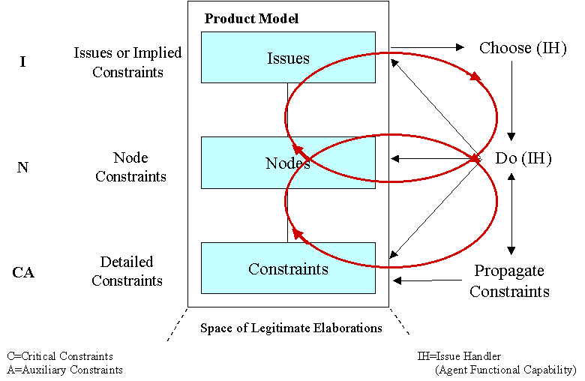

- An I-X system or agent has two cycles (as shown in the figure above which shows an abstract or algorithmic view):
  - Handle Issues
  - Respect Domain Constraints

- An I-X system or agent carries out a (perhaps dynamically determined) process that leads to the production of (one or more alternative options for) a synthesised artifact.

- An I-X system or agent views the synthesised artifact as being represented by a set of constraints on the space of all possible artifacts in the domain.

I-X also involves a modular systems integration architecture (as shown in the figure below) that strongly parallels and supports the abstract view described above. These are summarised in a document and illustrated through tutorial examples and codings delivered in phase 1 of the project. By way of a summary of these earlier deliverables, the HTML document is attached as an appendix to this final report and is available on-line at http://www.aiai.ed.ac.uk/project/ix/architecture.html

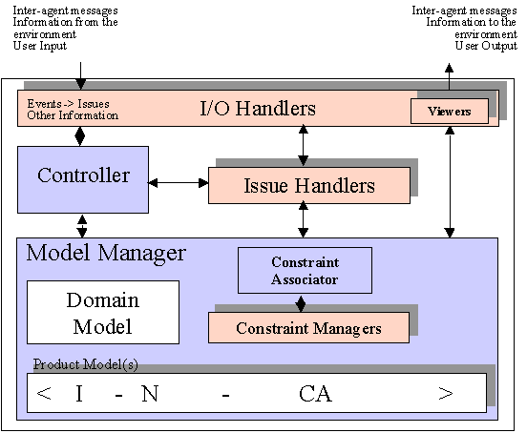

Appendix 2: What does I-X Offer?

I-X can be considered to make contributions at 3 levels. These are:

- An outer level approach of handling issues and respecting constraints in the domain model gives an intelligible approach to what an I-X system or agent does.

- A middle level provides a fractally composable cell which employs a model/viewer/controller systems integration approach.

- A detailed level provides an approach which represents and reasons with constraints on the space of all possible artifacts, and allows for the provision of specialised solvers for some or all of these detailed constraints.

I-X makes novel contributions at level 1 and 3, and is compatible with other approaches at level 2.

History and Comparison of I-X to other Approaches

I-X is based on ideas that have emerged in research on O-Plan since 1983 and the Enterprise project in the mid 1990s. At the time of its design in 1983, O-Plan (the Open Planning Architecture) was intended to offer a more flexible and modular way to build planning systems over those being created in the mid 1970s (Nonlin, NOAH, Deviser). In particular it sought to make the plan in a partially developed state be an entity that could exist separate to the planner. Previous planners maintained lists of flaws, interactions or “criticisms” that were to be fixed in their internal control data structures. This was made explicit and declarative in O-Plan using an “agenda” associated with each plan being developed.

Over the years the modules and components in O-Plan have been clarified and made more generic, a process accelerated by trying to use the design in other applications:

- for a scheduler, TOSCA (The Open Scheduling Architecture), in a system for practical uses in Hitachi;

- for a system for planning and dealing with execution failures by repairing plans, OPTIMUM-AIV for the European Space Agency;

- and especially for the Enterprise Architecture which took O-Plan ideas into business process management and support – including some manual process support at Unilever that has had enormous commercial benefits.

This re-use of the concepts led us to feel the original module or component definitions had their limitations, and their terminology was too orientated towards support to the planning task.

At the time of its design, O-Plan had similarities to the Blackboard Architectures (see for example Hayes-Roth and Hayes-Roth, 1979). O-Plan was specifically designed to avoid aspects of that architecture in the indirect way in which it mapped Knowledge Source Activation Records (KSAR) to the Knowledge Sources (KS) available. O-Plan had an agenda whose entries mapped quite directly to its Knowledge Sources. I-X terminology now refers to these as the List of Issues and Issue Handlers (so not committing to an agenda style of implementation). O-Plan also differentiated between general and maximally capably Knowledge Sources which could write any type of information into the Blackboard (where the plan or product was being created) and more limited special functionality embedded in “Constraint Managers” which could just check the information in the Blackboard/product and give yes/no/maybe answers on the validity of the Blackboard or product description. This information could then be used by other later Knowledge Sources to carry on processing. Decision-making in the system was thus located in Knowledge Sources and not the special, limited Constraint Managers. As in Blackboard systems, the O-Plan controller dealt with ordering decisions on which agenda entry to handle next – localising such control information too. These features enabled O-Plan to scale better to larger realistic tasks. This work was presented and the O-Plan approach contrasted to Blackboard systems at a scientific workshop on Blackboard architectures run by SPL Insight programme in the UK in the mid 1980s.

O-Plan also attempted to create a software engineering structure and systems integration framework for building practical planning systems. The design proved to have much in common with the contemporary work in the early 1980s at NASA and the National Bureau of Standards (NBS) on layered reference architectures for space station telerobotics and for flexible manufacturing cells. See for example the NASREM work (Albus et.al. 1987) and its later military version generated by Hayes-Roth (DICAM). This work has continued over the years with many variants of systems that can take architecture “cells” and compose them in various ways, recursively, peer-to-peer and fractally. The most recent work on this was done in a working group on architectures by people engaged on many of these earlier architectures (Hayes-Roth, Tate, etc) in a group set up by DARPA to look at next generation Intelligent Battle Force Management which reported to DARPA in 1999.

O-Plan had a very optimistic and forward looking target for its delivery platforms when first designed in 1983. It was designed for significant distributed systems implementations utilising:

- geographically distributed systems (perhaps far distributed with some elements in deep space and others being ground based with 8 hours message transmission times);

- symmetric local processors on which to mount parallel versions of the principal components of an O-Plan agent or system – allowing for multiple platforms to be running concurrently for dealing with agenda entries on one or more concurrently developed shared product models;

- fine grain parallel systems for constraint management, graph algorithm processes and similar lower level functions. Implementations were even prototyped and fabricated in silicon to add in as specialised co-processors for constraint handling.

Much of the resulting structure and overhead for distributed implementations turned out to be far ahead of the time at which realistic implementation was possible, and this became a burden within the implementation. I-X allows for such sophistication in implementation, but does not clutter the elegance of the approach by embedding it into the interfaces and component boundaries designed.

<I-N-OVA> did not emerge until the mid 1990s, although the components of its design had been in O-Plan since its inception. A terminology change to call agenda entries Issues was suggested by a DARPA programme manager in the early 1990s, and led to very profitable interaction with the engineering issue-based design community as a result. A joint interest in emerging standards for process modelling in IDEF-0 (and later IDEF-3) between DARPA, AIAI and ISX Corporation also led to clarifications of how a plan was represented in O-Plan and how it could be a basis for rich and enrichable process and activity representation standards. Discussions between the theoretical and practical AI planning communities (in particular Subarao Khambampati, David Joslin and Austin Tate) led to many clarifications and terminology changes (the notion of auxiliary constraints arose at this time).

Involvement in emerging standards for planning in the military, process modelling, project management, etc., led to the description of <I-N-OVA> as a wholly constraint based ontology that could underpin a strong and simple representation for describing behaviour and activity of all types. Its power was validated by a study of 26 different representations of plans and processes from a wide range of fields as part of the background studies for the creation of the NIST process Specification Language (PSL). <I-N-OVA> came out as having maximum coverage of the detailed requirements list for PSL of all the representations studied. See http://www.nist.giv/psl/ or Schlenoff et. al. (1999). Indeed those elements it did not cover were related to items meant to be handled by plug-ins to <I-N-OVA> and deliberately not committed to within <I-N-OVA> itself. A description of the relationships between these various standards efforts and the role <I-N-OVA> played in this is in Tate (1998).

I-X was conceived of in the late 1990s as a way to draw on the best of this earlier work, while making it much more generic and suitable to many kinds of product synthesis or modification tasks. <I-N-CA> is an even more flexible and general purpose constraint-based representation (compared to <I-N-OVA which is a specialisation) of any synthesised artifact. The need for <I-N-CA> emerged during the discussions for the design of I-X and I-Core.

To summarise:

I-X draws on the best aspects of work over a 20 year period on O-Plan which provided a flexible component architecture and was an early example of a number of other similar approaches (Blackboard Architectures, NASREM and DICAM).

I-X simplifies and makes more generic the component boundaries and naming conventions used to make the concepts more re-usable.

I-X is based on the <I-N-CA> constraint ontology - a powerful and extremely flexible representation of the products of the process that an I-X system supports. This represents a product as a set of constraints on the space of all possible products within the model of the domain which the I-X system has. This ontology relates well to emerging standards for process representation and interchange (e.g. in PIF, NIST PSL, DARPA SPAR).

Scalability

Composability and the ability to link I-X agents or systems together admits great flexibility – but of course this can only be achieved with intelligent use of the design concepts and well engineered implementations. This makes claims about the scalability of I-X difficult to substantiate in isolation. Instead we have to consider the scalability of systems of the type I-X is designed to allow to be created. We have evidence that these can be large and efficient systems at the limits of what is possible in their own fields.

An example is O-Plan, which is a state-of-the-art practical AI planner whose design has been used for real tasks. OPTIMUM-AIV which uses the O-Plan design and plan representation is a system in practical use for planning the assembly, integration and test (verification) of spacecraft assembly for Ariane IV for the European Space Agency. The O-Plan design was used as the basis for TOSCA (The Open Scheduling Architecture) used to build a scheduler and rescheduler able to deal with 24 hours of orders in an electromechanical assembly (electronic calculators) for Hitachi in Japan. This system deals with tens of thousands of time and resource constraints.

I-X clarifies the components used in such earlier systems and would make their construction simpler and more easily added to and maintained. But it goes further and is designed to integrate better with the user and incorporates the need for intelligibility of the processes carried out and the state of the products being synthesised as a strong requirement. I-X is thus better suited to the design of systems where humans and machines work in a mixed-initiative or cooperative manner.

Appendix 3: I-P² and its Relationship to the I-X Design

[This text relates to version I-X/I-DEEL version 1.1 and needs updating.]

The I-P² and I-DEEL (a sample I-X process panel) Java package structure is as follows:

ix I-X software.
ix.examples A simple version of an I-X framework (PicoIX) plus usage examples.
ix.icore I-X core classes.
ix.icore.domain Domain descriptions.
ix.icore.domain.event Interfaces and classes for events related to domains.
ix.icore.process Classes for representing processes.
ix.ideel I-DEEL application.
ix.ideel.event Interfaces and classes for events fired by Issues within I-DEEL.
ix.iface.domain Domain parsers.
ix.iview Viewers.
ix.util General-purpose utilities.
ix.util.context Context-layering mechanism.
ix.util.lisp List-processing utilities.
ix.util.match Pattern-matching utilities.

I-DEEL 1.1 also contains a more developed version of the I-X utility packages. There is an initial version of the I-X context-layering mechanism, although it is not needed in I-DEEL, and the list classes used as general-purpose sequential collections, and for representing data, such as KQML message contexts, that has a Lisp-like syntax, have been brought into the Java 1.2 collection framework.
I-DEEL Components and Java Implementation

I-X is an abstract architecture that does not specify any particular mapping onto programming language constructs. In an object-oriented language, the principal I-X entities, such as the controller, constraint-managers, constraints, issue-handlers, and issues, will tend to be implemented as objects, but that it not the only possibility. In a Java implementation, for example, an issue-handler might just be a method. In I-DEEL, which is implemented in Java, most I-X entities are implemented as objects, but some are not.

The main I-X-significant parts of I-DEEL are listed below. Where it is not obvious how the entity would be described in I-X terms, an explanation is given.

- The I-DEEL system itself (an I-X system)
- The I-DEEL controller.
- Issue-handlers.
- Issues. In I-DEEL they function both as issues and as activities in an optionless product model and hence will appear again below.
- Model-management functionality
- Domain model
- Product model functionality
- Issues, this time regarded as activities
- Ordering constraints between issues.
- The parser for domain descriptions (an I-Face).
- Viewers (I-Views):
- The table of issues with handling options in the user-interface (a process I-View).
- The issue-editing panel.
- The domain editor.
- The schema-editing panel in the domain editor.

The model-manager is implicit (not represented by an object). However, the domain model (the domain-modelling aspect of the model-manager) is an object. It holds the schema definitions that specify how issues can be expanded into subissues and the ordering constraints that apply to the subissues. The constraint-manager for the order constraints is also implicit. (It’s provided by methods of the PNode class.)
The I-DEEL system itself is represented by an instance of the class I_DEEL in the ix.ideel package. The main program is a static method of that class that does little more than instantiate it. Member classes are often used as a structuring device in the I-DEEL implementation. For instance, the controller is an object, an instance of the member class I_DEEL.Controller.
There is also some planning and execution-support functionality represented by methods of the PNode class. They provide expansion into subnodes (planning) and propagation of status changes (execution support). As the I-X code base develops, the planning functionality will be replaced by the explicit use of a planner (I-Plan).
The PNode class, mentioned above, is a very simplified version of the process model used in the current implementation of I-P² and in ACP³. While the full version could have been used in I-DEEL, it would have added considerable complexity that was not actually needed in the I-DEEL system.
Some aspects of I-DEEL will now be examined in more detail.

The Controller and Issue Handlers

I-DEEL is primarily a system for managing issues, which gives the controller a central role. The I-DEEL controller has two features that distinguish it from others that might be used in typical I-X applications. First, it never invokes an issue handler automatically, only when it is told to do so. In I-DEEL, these instructions are given via the user interface, but they could also come from other sources. Second, the various ways in which an issue can be handled are explicitly represented as objects, called “issue options”, attached to issues and made visible to the user interface. This allows the user (or, in principle, some other external agent) to control not only when issues are handled but also how.

A natural way to implement issue handlers in an object-oriented language is to have a class for each different way of handling issues, with the handler itself being an instance of that class, often the only instance. For instance, in the PicoIX examples delivered in phase 1, an issue handler was usually an instance of an anonymous subclass of PicoIX.IssueHandler. These anonymous classes would each have only once instance. It is also possible to have a handler class with more than one instance while still using the convention that each (general) way of handling issues corresponds to a class. That is what happens in I-DEEL.

I-DEEL supports three ways of handling issues.

- “Done” or “Done by <action description>.” The issue is handled by the user, who then indicates to I-DEEL that it has been handled. From I-DEEL’s point of view, internally, this corresponds to the invocation of an issue-handler that simply marks the issue as handled by changing its status.

- “Do it using <capability description>”. The issue is handled using one of the capabilities that I-DEEL knows about. This may involve sending a request to another agent; the point is that I-DEEL knows how to do this.

- “Expand using <expansion description>”. The issue is handled by breaking it down into subissues.

The capabilities that I-DEEL knows about are provided by issue handlers that can handle matching issues; but these handlers are not used directly, because the user might choose a different way of handling those issues. Instead, the I-DEEL controller creates issue handlers dynamically by instantiating issue option classes that correspond to the three possibilities described above, plus another class that is presented as “No action”, to remind the user when nothing has yet been done to handle an issue.
These classes are, respectively, ManualOption, AutomaticOption, ExpandOption, and NoActionOption. AutomaticOption and ExpandOption are member classes of I_DEEL.Controller.
When a new issue is given to the I-DEEL controller, the controller gives the issue a set of issue options, each of which can also be considered an issue handler. This is done as follows:
- The issue is given an instance of NoAction.

- The issue is given an instance of Manual.

- For each “agent capability” issue-handler that could handle the issue, the issue is given an instance of AutomaticOption.

- For each known way to expand the issue into subissues, the issue is given an instance of ExpandOption.

New options can be added to an issue later on when new expansions are defined. A similar mechanism could be added to support the addition of new capabilities that the I-DEEL system knows about.
Each issue option has a short description that is presented in the user interface. When the user selects a way to handle an issue, the controller is told to handle the issue using the selected option. The controller does this by calling the option’s handleIssue method. In the case of an agent capability, that option will be an instance of AutomaticOption which then invokes the handler that represents the capability by calling its handleIssue method in turn.

Issues

Another feature of I-DEEL is that the issues are explicitly structured by before/after order constraints and by issue-subissue relationships.

In any I-X system, the issues represent a process that is being carried out by the system as the issues are handled. However, those agent-level issues are normally distinct from any issues that are part of a product (such as a plan) the system is constructing. The issue structure described above reflects the fact that I-DEEL is using a simple form of planning as one way to handle issues and hence is manipulating issues in some of the ways a planner would manipulate the activities in a plan. From this point of view, I-DEEL is constructing parts of the very process it is carrying out.

Issues also have a status to indicate whether they have been handled (COMPLETE), are in the process of being handled via the handling of their subissues (EXECUTING), could now be handled (POSSIBLE), are waiting to become handleable (BLANK), or cannot be handled unless some problem is fixed (IMPOSSIBLE). The IMPOSSIBLE status does not at present occur in I-DEEL.

A future development will be to give issues a priority. It is expected that three values will be supported initially: high, medium and low priority.

CoAX Demonstration

The COAX Binni Demonstration is accessible via apps\coax\scripts\win.

You can test the panels by sending an issue or a report from the UN Secretary General’s Office (UNSGO – UN I-TEST) panel to the Joint Task Force Commander’s Panel (JTFC – I-LEED) panel or to the Chief of Combat Operations (CCO – I-DEEL) panel. You can simulate a number of messages coming in from other agents normally connected in the Coalition Agents eXperiment (CoAX) project demonstration using the UNSGO panel Test menu (inn the top right hand corner).

The following is a script to follow to repeat how the panels are used in the CoAX Binni 2001 (Fall 2001) demonstration:

The action takes place in a fictional country Binni bordering the Western edge of the Red Sea in 2012. Gao and Agadez are neighbouring countries who are disputing the region, and UN approved Coalition peace keeping force is planning a “Firestorm” mission to clear an area separating the two opposing forces to make observation of their separation easier.

Simulate the events of agents sending messages to the JTFC as shown in the CoAX Binni 2000 (Fall 2000) demonstration using the UNSGO test menu entry “send to JTFC/ILEED MBP status reports”. Watch these indicate the status of execution of activities by the QinetiQ “Master Battle Planner (MBP)” agent as change in the process/activity status sub-panel. Orange indicates that an action is available for execution; green means its executing; blue means it has terminated successfully; red would mean a failure to be fixed (which does not occur in this demonstration).

For the ongoing command process assume we have already considered alternative COAs and decided on the firestorm option. So indicate these are “Done” on the JTFC/I-LEED panel.

Send an issue “consider elephants laki_safari_park” from UNSGO to JTFC. Note it appears on the JTFC/ILEED issues sub-panel.

Laki_safari_park is a region that does overlap the firestorm area within Binni, so select a process that has been provided to deal with this…”expand using impact_on_firestorm_area_laki”.

Note that this makes available an issue that can be actioned by sending the issue onto the CCO/I-DEEL panel which has the capability of handling it. Select this option and note that an issue to “avoid elephants laki_safari_park” appears on the CCO/I-DEEL panel’s issue sub-panel.

The process is followed in the CCO panel. In short, chose the steps to “expand using avoid_location”, and then for the first 4 of the sub-steps introduced in turn select “done using ask_intel”, “expand using secondary_targets”, “done” and “done”.

Now a step to deconflict plans is executable (status orange). This is a link to an external agent that performs plan conflict detection and proposes alternative sin the CoAX Binni 2001 demonstration. Invoke this with the option provided.

In this demonstration no actual connection to the external agent is made. However, we can simulate the “report backs” which occur from this agent to the CCO/I-DEEL panel by using the Test menu on the I-TEST (UNSGO) panel. Use the test menu labelled “send to CCO/IDEEL MCA reports for 10 solutions”.

Using the mouse click on the line for deconflict plans in the CCO/I-DEEL panel. A window appears showing details of the entry and, after a short delay (10 seconds or so), you can watch the messages from the “Michigan Coordination Agent (MCA)” appear as they are received. Note the content of the last message received also appears in the Annotations field directly within the panel row itself. When the final successful conclusion message is received, the CCO/I-DEEL process panel itself indicates the “deconflict plans” step has been completed (it turn blue).

The “report time-to-cancel-mission” has a process suggestion (“done using mbp_ops”), but say you wanted to note a different way I which that was to be done. Click on the line in the panel to get the issue editor details window up. Click “Edit Sub-issues” button to be able to add sub-issues. List a few steps that are the way you want to do this, say…

Ask Sgt. Brown
Check with Lt. Green
Report to JTFC

Choose to have these constrained to be executed in sequential order. Then click the button to “Add sub-issues”. An alert appears to indicate a new way to action some item already on the panel appears and the relevant line is highlighted (in deep blue). Indicate that you have seen the alert with the “OK” button. Then, as the steps are taken, you can indicate they are “Done”.

If you later decided the way you defined to handle the issue was a good reusable method, you could bring up once again the issues editor by clicking on the line labelled “establish time-to-cancel-mission”, make sure the sub-issues are visible (hit “Edit sub-issues” if they are not visible. Then under the windows “File” menu you can select “save as schema”. You are asked to (at least) add in a schema name (no spaces but you can use hyphens or underbars) and then hit “Define Schema” to have this new schema be added to the previously (initially) loaded domain model/process library. Note that this adds to the schemas usable while the panel is running only. It does not overwrite the original process library at this stage. You can save the extended process library using the domain editor’s “save domain” menu item under its “File” menu bar entry. Give a postfix of “.xml” to save the file in its XML format. (An alternative Lisp syntax format is available by specifying “.lsp” as the file name postfix.

Creating and Using an I-X Process Panel

For each panel do the following (more detailed instructions to add):

1. Copy the sample panel directory to one with the name you wish to give the panel agent.

2. If you wish to use a custom logo or graphic on the panel, put it in directory images.

3. The panel can be customized via its windows title bar and a logo pane that resides along the bottom of the window.

Edit xxxx.java to alter the following:
Panel System (Agent) Name - a suitable CoABS Grid Agent Name
Panel Display Name - A string used as a header on the panel window, etc.
Panel Symbol Name - a symbol (no spaces) designating the role or user supported by the panel (e.g. JTFC, user initials, etc)
Panel Logo
Panel Label Line 1
Panel Label Line 2
Window size and proportion to allocate to the 4 major window panes - activity/product-state/issues/logo

4. Edit yyyy.java to specify the external capabilities that will be known to the panel. These are used in invoke and/or query functions. Detail to follow.

5. Edit zzzz.java to specify the other panels that are to be known to this panel for "pass to" functions. This might be dynamically configured and adaptable via a grid logging capability in future versions - which would just require a connected panel strategy to be defined - NONE, ANY, ASK, LIMIT (with list).

6. Edit aaaa.java to specify the initial startup activities to perform, process product and other state information and issues.

7. Edit bbbb.java to specify whether a Test menu entry is to appear, and if so what its contents should be, as a convenience for testing and demonstrating the panel and its connection to other panels.

8. Make the process library file (XML) that will be loaded when the panel starts to give it an initial set of ways to expand or handle issues and activities placed on the panel. This can be done with the Process

Editor included, or by using an XML tool (such as the included freely distributed Microsoft XML Notepad) or a text editor. You can create a new process library or copy and modify an existing entry in the demonstration and samples process library.

9. Compile the following files:
xxxx.java
yyyy.java
zzzz.java
aaaa.java
bbbb.java

10. Make a startup script to call the panel and load the initial process library desired.

11. You may also want to create a customized version of the I-TEST test panel. This can be done in a similar way to the above.

Sample I-P2 I/O XML Formats

An I-X Process Panel can be sent a number of XML format messages to give it issues to address, activities to perform and reports to note. A Test agent (called I-Test) is provided to give a simple way to try this out. The format of these messages is as follows:

<issue ref="reference-id" sender-id="agent name" report-back="yes/no">
<statement>issue statement</statement>
<priority>high, medium, low or none</priority> (may be absent)
</issue>

<activity ref="reference" sender-id="agent name" report-back="yes/no">
<activity-spec>activity statement</activity-spec>
</activity>

<constraint ref="reference" sender-id="agent name" report-back="yes/no">
<statement>constraint statement</statement>
</constraint>

<report ref="reference" sender-id="agent name"
report-type="completion or progress"
result="success or fail" (only for completion reports)
<statement>
report content
e.g. begins/ends/exception activity-statement
attribute(process product ref)=value
</statement>
</report>

Report Contents Statements

<state>
<value ref="product reference" attribute="symbol">value</value>
and/or <activity activity-ref="reference">begin or end</activity>
</state>
Description of a New Process Product

<product ref="reference" short-name="symbol" display-name="string">
<attribute id="symbol"> initial value</attribute>
...
</product>

Note: should we add priority also to activity, constraint and report?
<priority>high, medium, low or none</priority>

Panel Capabilities Statement

<capabilities id="agent name" short-name="symbol"
display-name="string">
<capability type="issue or activity">
statement pattern
</capability>
...
</capabilities>

I-DEEL Demonstration

The following screen images show an example I-X Process Panel (I-P²) called I-DEEL being used on a simple scenario related to a Coalition Agents eXperiment (CoAX) demonstration in the Binni scenario – CoAX Binni 2001. I-DEEL was initially created on a project funded by DERA (now QinetiQ) in Malvern, UK and subsequently reused as part of the DARPA sponsored CoABS CoAX project. [Note that the screen images below may not reflect the current appearance of I-X process panels.]

The demonstration starts with loading a “Domain Model” including the processes which are known in advance for handling issues and for further expanding actions. A single issue is put onto the panel to initiate the demonstration – which is to avoid elephants in the Laki Safari Park. The test menu (in the top right of the window) can be used to do this quickly, or the issue could have come from another agent or have been entered manually by the panel user.

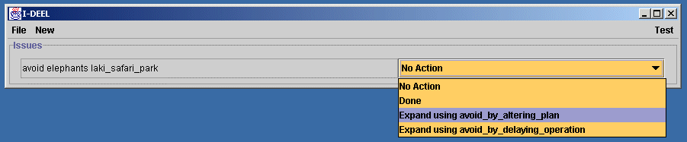

We might choose to handle this using the method of avoid_by_altering_plan – though an alternative of avoid_by_delaying_operation is available. In all cases a “manual” method of just saying it is “done” is available so that activity outside of the knowledge of I-DEEL can be accommodated.

The choice of avoiding the elephants by altering the plan is a process known to I-DEEL which brings up its expansion and inserts its steps indented to reflect the dependency. The top level issue is outlined in green to indicate it is currently being performed or is executing (i.e. its sub-steps are being handled or executed). The first of the sub-steps is coloured orange to show it is currently executable. The other two steps must be done after that first step, so are shown as white (not currently executable). I-DEEL, even in its current state of development, is capable of maintaining and using processes and expansions which have more sophisticated partial ordering constraints, though the user interface simply shows one possible linearisation of this. The status colouring however does reflect the real partial order in the underlying process models.

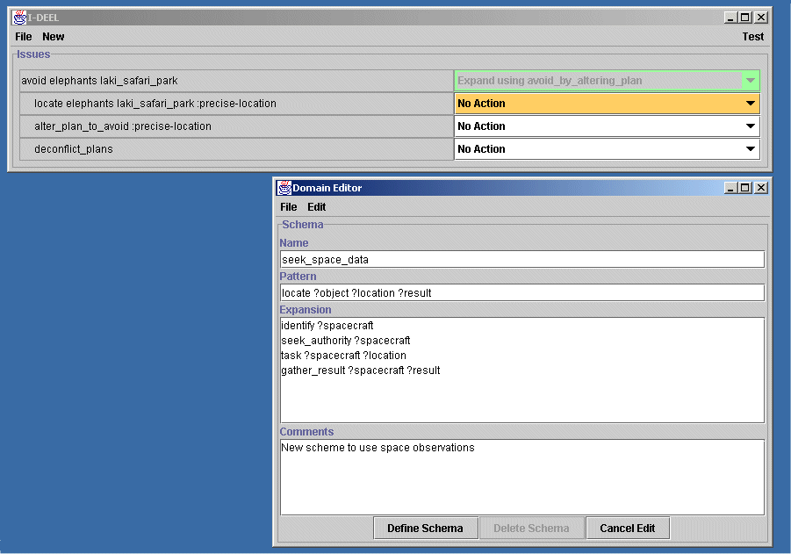

We now move on to a substep of this process, which is a way to get a precise location for the elephants. Before we decide to use one of the inbuilt processes (ask_intel or ask_observers) for that though, we demonstrate the capability to dynamically add new user given processes and expansions.

Let’s say we decide to add information about how to use spacecraft observation assets. We can do that through adding a new schema in the Domain Editor (or viewer) that is part of I-DEEL. The domain editor is simple, but could eventually be a sophisticated and user tailorable domain and process editor such as is being researcher and developed in the I-PE component of the I-X programme.

Once the schema is defined, it is noted as being relevant to outstanding issues still to be handled, so a notification to the user is given that a new method for addressing an issue already on the I-DEEL panel is available.

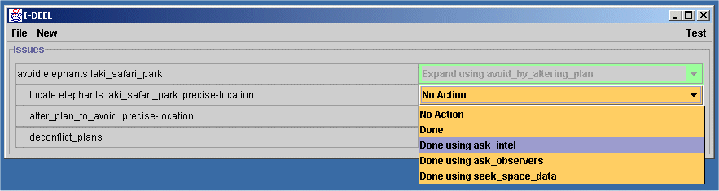

In fact though we decide to use one of the originally available methods for locating the elephants by using ask_intel. This process would be conducted outside of the control of the user of the I-DEEL panel, and would just be ticked off as “done using ask_intel” when the precise location was known and the results were reported to be available.

We carry on selecting ways to address issues, or simply say that primitive actions are “done” when they have been completed (normally done by others who would report to the panel user in some way). In some cases, e.g. in using the method of use_secondary_targets to address the issue of alter_plan_to_avoid:precise-location, we can use prior domain model knowledge of how we should go about that to remind the user of the steps that should be performed. This information is drawn from the relevant schema read in from the domain model or created dynamically using the define schema facility in the Domain Editor. These are shown further indented.

Whenever anything is complete, its status colour turns into an outline blue.

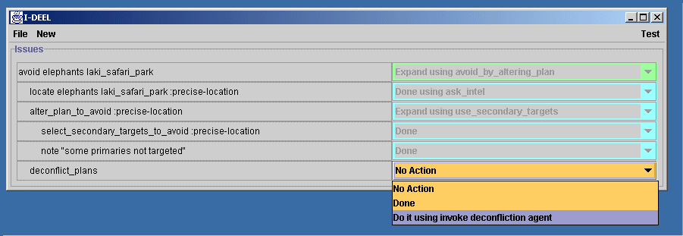

After a number of these steps, we are at the stage of deconflicting the plans that have been altered. Here the system is able to recognise that it has an inbuilt capability (in the form of an Issue Handler) which allows it to offer to do this step for the user using that capability. It has knowledge of how to invoke_deconfliction_agent. Note though, that even in this case the I-DEEL panel user still has the option to do this some other way outside of the knowledge of the panel and to indicate this via “done”. This is an important aspect of the design philosophy behind such I-X Process Panel systems. The user now allows I-DEEL to invoke its capability to address this issue and we are through. Everything is coloured blue, including the original avoid elephants in the Laki Safari Park issue, indicating that this issue and all sub-issues and activities generated as a result have been completed.

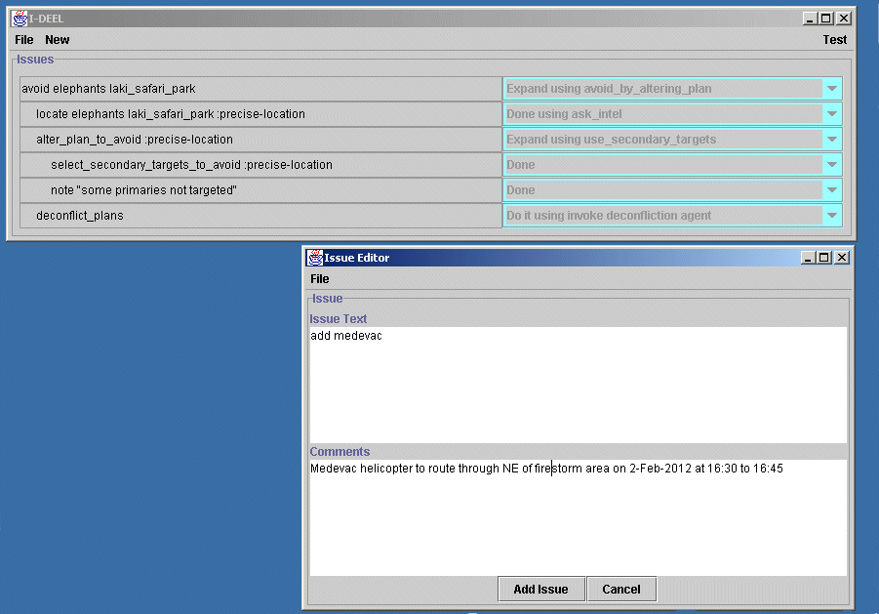

However, the user now manually adds a new issue, which might have come from a command level. In the CoAX Binni 2001 scenario, this might have been passed to this panel via messages coming from other agents or higher command authority panels. This is done using an Issue Editor or viewer as shown above.

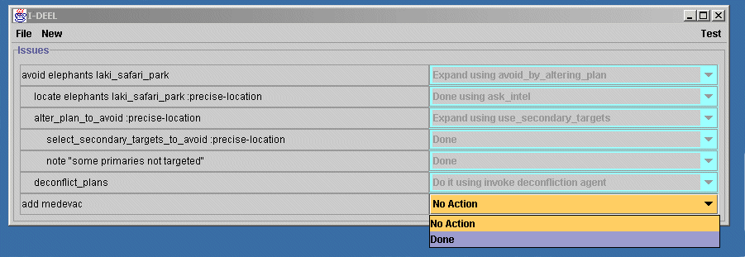

In this case, no inbuilt process knowledge is available to help the user. The user could offer a task breakdown and enter that via the Domain Editor, which would have the beneficial effect of making it available for re-use later on by this user or others. This would be done in a way which is identical to the addition of the spacecraft observation scheme added earlier. However, to complete the demonstration, the user performs this step without further panel assistance, and indicates when its been completed by selecting (manually) “done”.

Full References

Albus, J.S., McCain, H.G., and Lumia, R. (1987) “NASA/NBS Standard Reference Model for Telerobot Control System Architecture (NASREM)”, NBS Technical Note 1235, National Bureau of Standards, Gaithersburg, MD, USA.

Allsopp, D., Beautement, P., Bradshaw, J.M., Carson, J., Kirton, M., Suri, N. and Tate, A. (2001) “Software Agents as Facilitators of Coherent Coalition Operations”, 6th International Command and Control Research and Technology Symposium, US Naval Academy, Annapolis, Maryland, USA, 19-21 June 2001.

Fraser, J. and Tate, A. (1995) "The Enterprise Tool Set -- An Open Enterprise Architecture", Proceedings of the Workshop on Intelligent Manufacturing Systems, International Joint Conference on Artificial Intelligence (IJCAI-95), Montreal, Canada, August 1995.
Hayes-Roth, B. and Hayes-Roth, F. (1979) “A Cognitive Model of Planning”, Cognitive Science, 1979, pp. 275-310.
Schlenoff, C., Gruninger, M., Tissot, F., Valois, L., and Lubell, J. (1999) “The Process Specification Language (PSL): Overview and Version 1.0 Specification", NIST Internal Report (NISTIR) 6459, National Institute of Standards and Technology, Gaithersburg, MD, USA

Tate, A. (1996) "The <I-N-OVA> Constraint Model of Plans", Proceedings of the Third International Conference on Artificial Intelligence Planning Systems, (ed. Drabble, B.), pp. 221-228, Edinburgh, UK, May 1996, AAAI Press.

Tate, A. (1998) “Roots of SPAR”, in "Special Issue on Ontologies", Knowledge Engineering Review, Vol.13 (1), March 1998, Cambridge University Press.

Tate, A. (2000a) “<I-N-OVA> and <I-N-CA> - Representing Plans and other Synthesized Artifacts as a Set of Constraints”, AAAI-2000 Workshop on Representational Issues for Real-World Planning Systems, at the National Conference of the American Association of Artificial Intelligence (AAAI-2000), Austin, Texas, USA, August 2000.

Tate, A. (2000b) “Intelligible AI Planning”, in Proceedings of the Twentieth British Computer Society Special Group on Expert Systems International Conference on Knowledge Based Systems and Applied Artificial Intelligence, Cambridge, UK, December 2000.

Tate, A., Dalton, J. and Levine, J. (1998) "Generation of Multiple Qualitatively Different Plan Options", Fourth International Conference on AI Planning Systems (AIPS-98), Pittsburgh, PA, USA, June 1998.

Tate, A., Dalton, J. and Levine, J. (2000a) “O-Plan: a Web-based AI Planning Agent”, AAAI-2000 Intelligent Systems Demonstrator, in Proceedings of the National Conference of the American Association of Artificial Intelligence (AAAI-2000), Austin, Texas, USA, August 2000.

Tate, A., Dalton, J., Jarvis, P. and Levine, J. (2000b) "Using AI Planning Technology for Army Small Unit Operations", Poster Paper in the Proceedings of the Artificial Intelligence Planning and Scheduling Systems Conference (AIPS-2000), Breckenridge, Colorado, USA, April 2000.

Tate, A., Levine, J., Dalton, J. and Nixon, A. (2001) “Task Achieving Agents on the World Wide Web”, in “Creating the Semantic Web”, Fensel, D., Hendler, J., Liebermann, H. and Wahlster, W. (eds.), MIT Press, 2001.

Uschold, M., King, M., Moralee, S. and Zorgios, Y. (1998) "The Enterprise Ontology", in "Special Issue on Ontologies", Knowledge Engineering Review, Vol.13(1), March, 1998, Cambridge University Press.

Though in the current I-DEEL demonstration this is simply a stub which indicates that the facility has been invoked and does not actually connect to a plan deconfliction capability, this facility is meant to be provided by the University of Michigan during the CoAX Binni 2001 demonstration.

