Concept Mapping between Compendium and I-X

Jessica Chen-Burger, Austin Tate and Michelle Bachler
18th March 2003

This document extends the short description of issues discussed during the Co-AKTinG workshop at Open University, October 10-11, 2002. Its content is based on a follow-up Edinburgh meeting and described based on the new I-X v3.0.

I. Conceptual Mapping Summary:

- Compendium Question nodes are mapped to I-X Issue nodes. As compendium question nodes may contain sub-questions, these sub-questions are mapped to I-X sub-issues.
- Compendium Decision (with an Activity tag) nodes are mapped to I-X Activities. As compendium decision nodes may contain sub-decisions, those sub-decisions (with the Activity tags) are mapped to I-X sub-activities.
- Compendium Note nodes that are with a constraint tag are mapped to I-X Constraints.
- Compendium List and Documentation nodes are mapped to I-X Annotations. (I-X annotations may need structure to regulate this.)

II. Primitives:

Concept Mapping between Compendium Argumentation and I-X Notation:

A. Model Primitives in Compendium: [1]

- Main Node
  - Question Node
  - Answer Node
  - Decision Node
- View Node
  - Map Node
  - List Node
- Argumentation Node
  - Argument Node
  - Pro Node
  - Con Node
  - (Pro and Con Node types are specialisations of Argumentation Node type)
- Documentation Node
  - Reference Node
  - Note Node
- Link Connecting Node
  - Directed (arrowed) link connecting all node types

B. Model Primitives in I-X: [2][3]

- Issue
  - Sub-issue (This captures the problems to be solved or issues to be resolved.)
- Activity:
  - Sub-activity (This captures activities in a process.)
- Constraint
  - Constraint (hard constraint)
  - Preference (soft constraint)
- Annotation

III. An Initial Mapping Between Compendium and I-X Process Model:

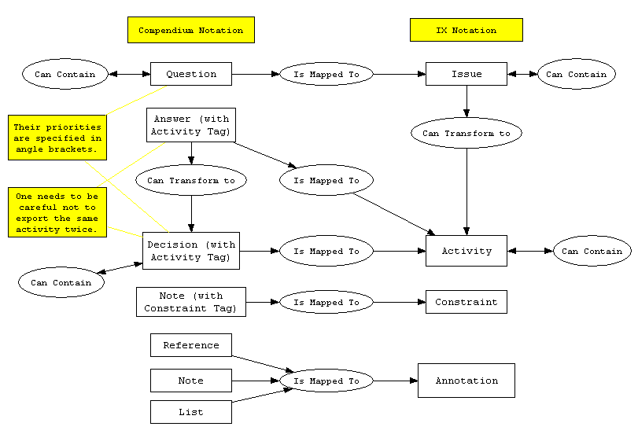

Figure 1: Mapping between Compendium and I-X Primitives

Points about Tagging, Mapping and Communication:

- As illustrated in Section I and Figure 1, most Compendium node types are mapped to I-X primitives without the need of adding tags to Compendium nodes. This indicates a conceptual equivalence on the semantics and the use of primitives in both methods. There are, however, exceptions when such equivalence is not found. See below for more details.
- Although a Compendium Decision node is largely similar to an I-X activity, not all of Compendium Decision nodes are about activities to perform. It is therefore sensible to map across only those decisions that are truly the equivalent of I-X activities. Those Activity Decisions will be tagged with Activity Tags.
- At the current time, Compendium does not have a constraint node type, although this information is often captured in other forms, such as a Note or Decision node. We therefore propose that those Compendium constraints to be mapped to I-X are captured in a Note node (or something similar) with a Constraint tag to provide a clear mapping mechanism.
- It may also be desirable to keep track of Compendium nodes that have been exported to I-X and store feedbacks that may be received from I-X. We propose the export information to be entered using a user interface (that may store the information in the attributes of the corresponding node). This is mainly to provide a communication and tracking mechanism and not to be confused with the above conceptual mapping tags as illustrated previously in points 2 and 3.

IV: Collaboration and Advanced Topics:

A possible division of effort between Compendium and I-X is for Compendium to provide the argumentation for questions and answers including their rationale and justifications, while I-X describes the activities decided upon as well as providing assistance to carry them out. In other words, Compendium may be describing the “Why” and “What” to do in an organisation, where as I-X stores the “What” and “How” to do it information as well as having the execution capabilities of actually doing them.

A few possible collaborations and considerations about them are described here:

- Issue Tracking:
- When I-X finishes its tasks it may feed back to Compendium some indication that a particular task is finished. As the original Compendium node information is recorded on the I-X side, this information can be fed back to Compendium and linked to the original Compendium nodes.
- Discovery of and Dialogue about Missing Information:
- After receiving a particular issue or activity from Compendium, I-X may find (based on its process knowledge) that additional information must be provided in order to carry out the task. Such information may be authorisation needed for tasks or unknown resources used, etc. Such missing information may be resolved by I-X itself, or instigate feedback to Compendium to request more information.
- After receiving feedback from I-X, Compendium may subsequently provide additional information to I-X. I-X will record this new information and use it to help its operations;
- Compendium may send new or complimentary information on its own initiatives when it feels necessary. I-X should also be able to deal with such information and decide what to do with it.
- Annotations:
- During a transmission, Compendium may send I-X an “attached” annotation message that is associated with a Question or Decision node, or a “stand-alone” annotation message that is not attached to other Compendium nodes. I-X may treat the former as an annotation to the appropriate issue or activity, and store the latter in a separate annotation node. Compendium may also send an entire sub-tree of argumentations to I-X - as this information may be written in free-style plain text, I-X may treat the entire information as an annotation to the appropriate issue/activity or store it in a separate annotation node.
- Shared Ontology:
- A Meta-Ontology is shared between Compendium and I-X. This Ontology describes the mapping of the two methods as described in Figure 1.
- A (partially) shared Domain Ontology may be also constructed between Compendium and I-X. This Domain Ontology describes things in the problem domain that both Compendium and I-X work on.
- I-X will provide a process library based on its process ontology, e.g. the types of activities/meetings/events, the verbs used for processes and their semantics.
- Event and preference: an individual may like to specify interesting events and wish to be alerted when they happen.

References:

[1] Compendium Web Site http://www.compendiuminstitute.org/
[2] <I-N-C-A> Web Site http://i-x.info/inca/
[3] I-X Web Site http://i-x.info

