A Summary Note about Concept Mapping Efforts Between Compendium and INCA

Jessica Chen-Burger

October, 2002

This document gives a short description about issues discussed during the Co-AKTinG workshop at Open University, October 10-11, 2002.

Part I: Concept Mapping between Compendium Argumentation Notation and INCA for Process Model:

A. Modelling Primitives of Argumentation using Compendium: [1]

- Main Nodes:
  - Question Node
  - Answer Node
  - Decision Node
- View Nodes:
  - Map Node
  - List Node
- Argumentation Nodes:
  - Argument Node
  - Pro Node
  - Con Node
  - (Pro and Con Node types are specialisations of Argumentation Node type)
- Documentation Nodes:
  - Reference Node
  - Note Node
- Link Connecting Nodes
  - Directed (arrowed) link connecting all node types

B. Modelling Primitives of INCA for Process Model: [2]

- Issue
  - (This captures the problems to be solved or issues to be resolved.)
- Nodes:
  - (This captures activities in a process.)
- Constraints
  - Constraints (hard constraints)
  - Preference (soft constraints)
- Annotation, Statements, Arguments and Reports
- Options:
  - (An Option may stay as it is, i.e. being just an idea or option under consideration. It may also be converted into alternative activities when more information is available)
- Evaluation Criteria
- Evaluation (Results)
  - +
  - –
  - =
  - (Options for the activity to be performed may be evaluated against evaluation criteria. The evaluation result may be Pro (+), Con (-) or neutral (=). In the case of neutral it does not contribute to the support or against the option, but is merely a piece of relevant information that is worth of recording. This information may later on contribute to the explanation, reasoning or justification of a particular decision that has been made to act upon. )

C. An Approximate Mapping Between Argumentation Notation and INCA Process Model:

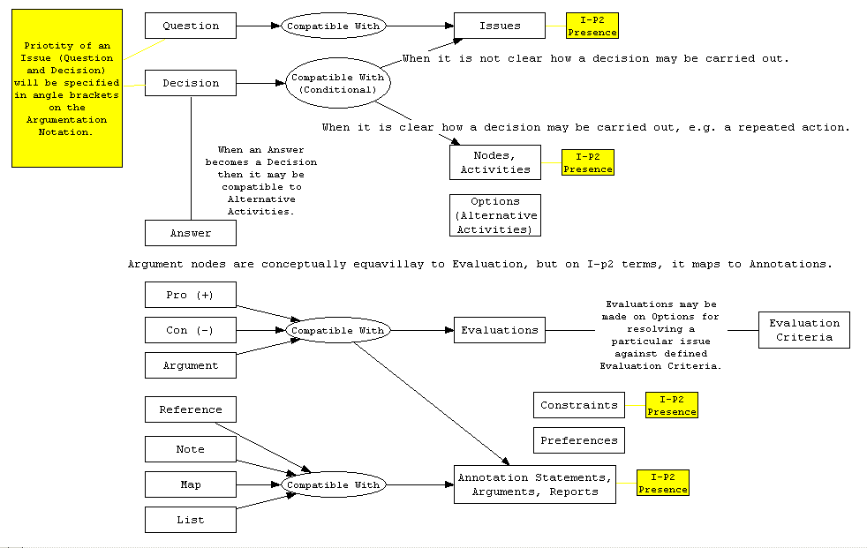

Figure 1: An Approximate Mapping Between Argumentation Notation and INCA Process Model:

The relationship “compatible with” that has been used here to map primitives between different modelling methods follows the convention and definitions used in [3]. This mapping is also recorded using Compendium maps and available on-line at [4].

D. One Use of INCA Process Model:

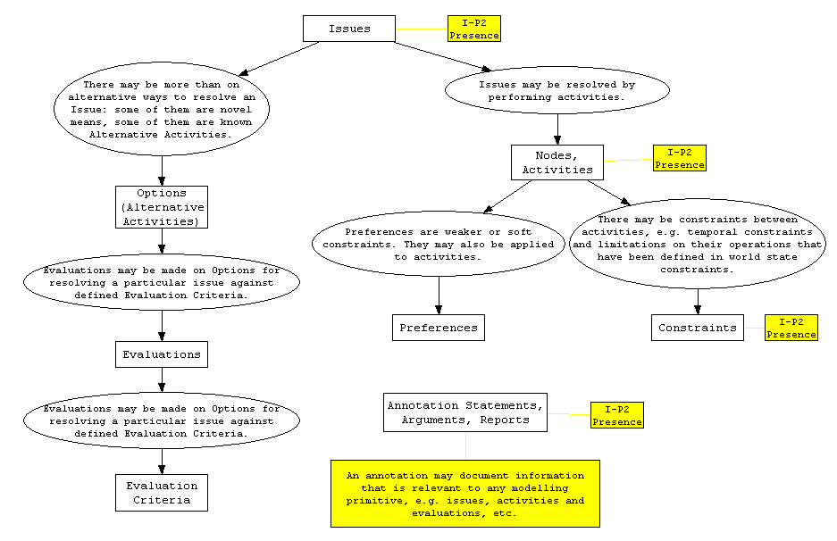
Figure 2: One Use of INCA Process Model

Part II: Possible Collaboration Scenarios:

A possible collaborative effort between Compendium and I-X is for Compendium to provide the rationale and justifications for task at hand or to be carried out, while I-X describes the operations as well as carries them out. In other words, Compendium may be describing the “Why” and “What” to do in an organisation, where as I-X stores the “What” and “How” to do it information as well as having the execution capabilities of actually doing them.

A few possible collaborations and considerations about them have been made below:

- The communication between Compendium and IX:
- When Compendium communicates with I-X, a specialised node may be used to indicate this communication. This node may be denoted using an I-X icon when it sends a message to IX and using another similar icon when it receives a reply from IX. By doing so, the communication and boundary between the two systems are being defined and highlighted.
- When a Compendium “issue” (e.g. a question or decision) is being sent to I-X, a few information may also be sent as a package to allow the issue tracking and feedback from I-X back to Compendium. The information may include:
  - The Compendium Node ID;
  - The Compendium View ID;
  - The Compendium Database ID;
  - Priority of the “issues” at hand;
- Michelle will/may produce a format/syntax to communicate with I-X
- Issue Tracking:
- When I-X finishes its tasks it may feedback to Compendium indicates that a particular task has been finished. As the original Compendium relevant node information has been recorded at the I-X side, this information is able to feedback to Compendium and linked to its originated Compendium nodes.
- Discovery of and Converse about Missing Information:
- After receiving a particular issue or task from Compendium I-X may find based on its process knowledge that additional information must be provided in order to carry out this task. Such information may be authorisation needed on tasks, unknown resources used for the tasks, etc. Such missing information may be resolved by I-X itself, or feedback to Compendium for more info;
- After receiving feedback from I-X, Compendium may subsequently provide additional information to I-X. I-X will recorded this new information and use it to help its operations;
- Compendium may send new or complimentary information on its own initiatives when it is necessary. I-X must be able to deal with such information and decides what to do with them.
- Annotations on Issues:
- Compendium may send “simple” or “leaf node” annotation messages to I-X, where I-X may simply treat them as annotation to the appropriate issue or activities. Compendium may also send an entire sub-tree of argumentations to I-X, as this information may be any plain text of free style, I-X may ignore the content and treat the entire information as one annotation to the appropriate issue/activity.
- Shared Ontology:
- A partially shared Meta-Ontology may be shared between Compendium and I-X. This Domain Ontology describes the mapping of the two methods as described in Figure 1;
- A partially shared Domain Ontology may be shared between Compendium and I-X. This Domain Ontology describes the problem domain that both Compendium and I-X works on;
- I-X needs to create a process library based on its own process ontology, e.g. the types of meetings/events/alarms, the verbs used for processes and their semantics;
- Alarm and preference: individual may specify the interested events and may wish to be alerted when it happens – this was initially suggested by Marc for the recording and playback of video recording, yet this may be relevant to I-X operations.

Reference:

[1] Simon Buckingham Shum, “Compendium: Making Meetings into Knowledge Events”, Compendium tool web site: http://www22.verizon.com/Search/DetailedResults/

[2] INCA Web Site: http://www.aiai.ed.ac.uk/project/ix/inca/

[3] Yun-Heh Chen-Burger. “Knowledge Sharing and Inconsistency Checking on Multiple Enterprise Models”: The 17th International Joint Conference on Artificial Intelligence, IJCAI, Knowledge Management and Organizational Memories Workshop and its proceedings at Seattle, Washington, August 2001. Also available as Informatics Report Series, University of Edinburgh, EDI-INF-RR-0037, Feb 2001.

[4] Simon summary in Compendium for Co-AKTing: http://kmi.open.ac.uk/projects/coakting/meetings/2002-10-11/2002-10-11-maps.html

