(1) Title:

Edinburgh-Aberdeen AKT-TIE:
A Distributed Knowledge-based Workflow and Constraint Solving Joint
Effort

(2) problem context:

Modern organisations are virtual entities. People working in the
organisation are located in different places, each with different
capabilities and responsibilities. They need to work collaboratively
to accomplish tasks and together to achieve common organisational
goals. Tasks that are required to be accomplish are often not trivial
but they often require specialised expertise and sophisticated technology
that is based on local knowledge and experiences. It, therefore,
can not be taken for granted that the co-ordination among distributed
sites are always carried out smoothly and effectively, that in fact
much organisational effort must be made.

(3) The aim and the relevant technologies:

Workflow and Business Process Modelling techniques are well-recognised
for their values for promoting and achieving effectiveness and
efficiency of co-ordination of distributed organisational operations.
These technologies have been offered by AIAI, The University of Edinburgh.
The aim is to provide a distributed knowledge-based (and agent-based)
workflow (virtual) system that is open-architecture. Its ability can
be enhanced by arbitrary knowledge-based intelligent agents when
appropriate. One such specialised intelligent agent has been provided
by the Department of Computer Science, Aberdeen University. A
constraint-based problem solving agent (KRAFT System) has been used to
integrated with the distributed workflow system. Figure 1 illustrates a conceptual overview of the integrated system and one user scenario
between them:

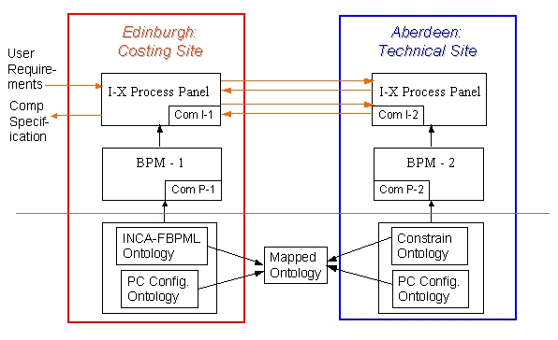

Figure 1: PC Configuration Domain
Collaboration Efforts between two types of Agents

(4) The Ultimate Goal of our effort: To provide a comprehensive
support for a Virtual Organisation and operations between businesses

a. To provide distributed knowledge- and semantic-based manipulation
and collaboration;

b. To provide an environment and means where multiple tools may be used¹
that multiple methodologies and disciplines are involved, and
information in different domains is shared. Most importantly,
people with different responsibilities and capabilities can easier
work together to accomplish tasks, solve problems, and achieve common
organisational goals.

c. The final aim is to increase the effective and efficiency of
organisation operations that leads to the ultimate organisational
performance.

^{1:} Example tools that may be linked to this system are OU and Southampton's
hyperlink tool, processor modellers in general, AKT-0, AKTbus, Netmeeting, AIAI’s I-X system, Aberdeen's tool "KRAFT" and its Constraint-Solver.

