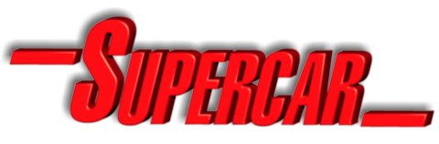
Supercar Schematics

Supercar was created by A.P. Film Studios in association with ITC (now ITC Studios).
Supercar internal schematic technical concept, text and drawings by Shane Pickering 1999 with technical assistance from Austin Tate. Original Supercar designed by Reg Hill of A.P. Films.
Supercar exterior based on Phil Rae Blueprints and 3-D model by Mick Imrie and Austin Tate.
This is fan produced material to promote the shows of Gerry Anderson and provided
for your enjoyment, and should not be used for any commercial purpose.
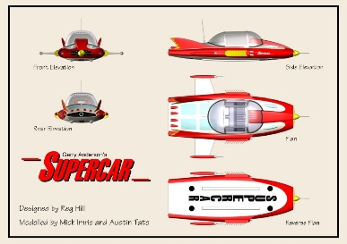
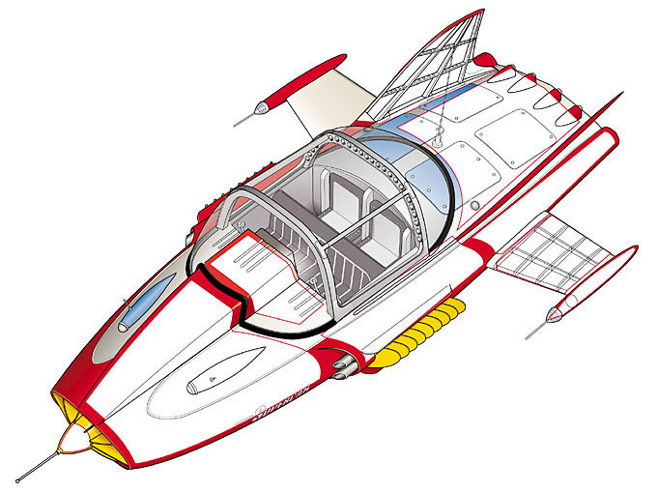Version: 21-Nov-1999. Minor Update: 9-Mar-2021.

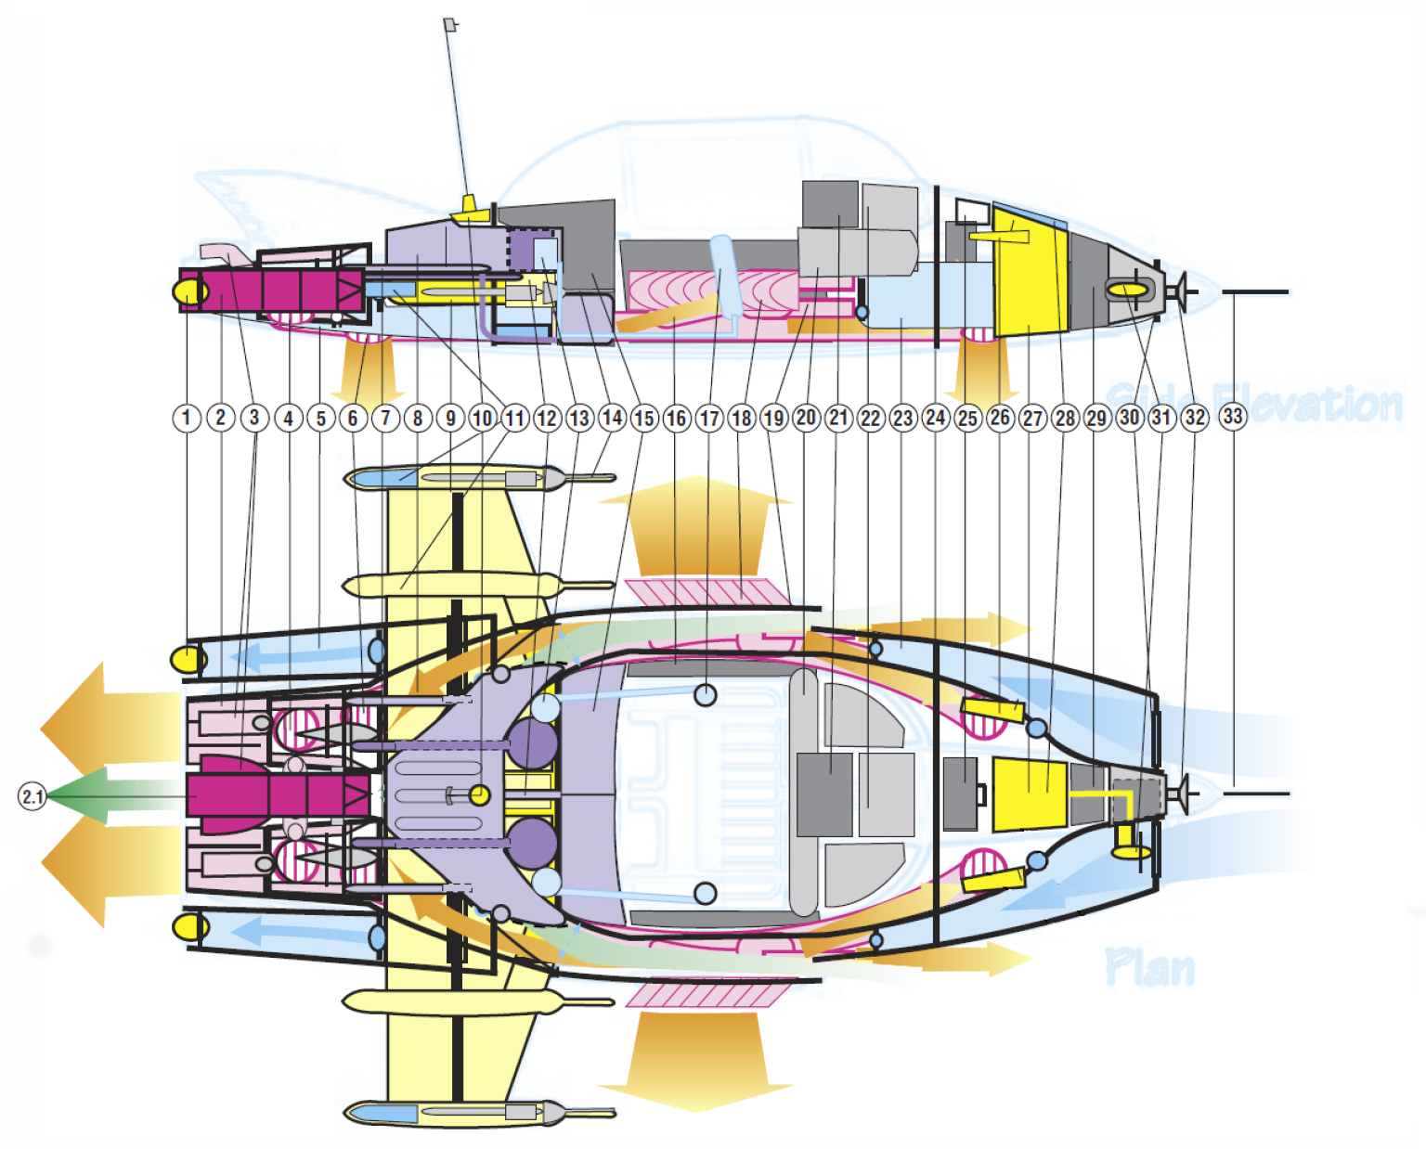1. GENERAL SCHEMATICS – OVERVIEW

1. Rear Navigation Lights (2) Port & Starboard, with rear ballast eject through valve surround.

2. Twin Hybrid, Vectored Thrust, Stratified Turbine Ramjets with Afterburners (Turbo Boost), each developing in excess of 19,000 lbs static thrust (total power output classified). Ceramic Vectored Exhaust Nozzles (rotatable) and interconnected via thrushaft “Interlock®” transverse driveshafts, gearbox and wastegates in the event of engine failure. Contains oil injectors for Smoke Screen deployment.

2.1 APU (Auxiliary Power Unit) & Highly Classified EMH® (Electro-Magneto-Hydrodynamic) 0.5 Megawatt Capacity Powerplant between Ramjets (dark red central unit) which cross feeds and “boosts” the Ramjets for Space Flight, and is a fully self-contained Water Propulsion Unit. Also used to electrically charge Supercar’s hull plating or send electrostatic charges via the Hi-Band Antenna - see 10.

3. Vectored Flight Attitude Nozzles controlling pitch and yaw movement (4).

4. Ramjet Vectored Thrust Outlet Nozzle from Ramjet Engines ducted through to Retro Jets and Adjustable VTOL Nozzles (4).

5. Rear Ballast Tanks with Ram Intake Valves (2), Port & Starboard.

6. Rear Vectored VTOL Jet Nozzles (2) interconnected to Fwd. VTOL Jet Nozzles (2), featuring CAD (Cushion Augmentation Devices) for added Roll, Pitch control and Ground Effect Mode. Independently computer controlled depending on selected Flight Mode and fed from main Ramjets & EMH® Powerplant.

7. Main Fuel Feed Injector Lines (6), Port & Starboard, to Ramjets with Emergency Cutoff Valves.

8. Main Fuel Tank containing Classified AvGas® and tapered to airflow ducting. Separate Liquid Oxygen & Hydrogen Tanks (Circular units) with built in refrigeration units for Spaceflight & Marine operation. Auxiliary Fuel Tank under Luggage Compartment - see also 15.

9. Retractable Wing Box Surround & hydraulics.

10. Combined Hi-Band UHF/VHF Antenna and ClearVu® Periscope Receptor (detachable at top of aerial), with Electrostatic discharge coil from EMH® unit.

11. Rear Ballistic Parachute Recovery Pack (2), Port & Starboard, housed in wing nacelle cones (fired in unison with front mounted unit – see also 28.

12. Wing Extenuator Engine Pump & Backup.

13. Oxygen Regenerators, Pressurisation & Airconditioning Pumps (2), Port & Starboard, fed to main pressurised cabin through Rear Bulkhead “Firewall”.

14. Wing Nacelle Multi-mode Avionic & Marine Sensor Probes (2), Port & Starboard, connected to ClearVu® Read outs. Includes INS (Inertial Navigation System) aerials for position fixing and ground terrain sensors for moving map display read-out.

15. Split Luggage/Equipment Storage Bay behind rear folding seats. (Auxiliary Fuel Tank under Luggage Compartment - see 8.

16. Electrically operated Flexiglass® Canopy Storage & lifters. (Top Canopy splits into two halves and slides down tracks “inside” side windows). Entire Canopy removable for maintenance.

17. Oxygen Bottles and Pressurisation outlet & recirculation systems embedded into Front Seats, fed directly from Oxygen, Pressurisation and Airconditioning Units in rear - see also 13.

18. Retro Jet Heat Extractor Vanes (2) Port & Starboard, containing vectored thrust vents for sideways movement.

19. Twin Retro Jets (2), Port & Starboard, fed from main VTOL ducts with EMH® (Electro-Magneto- Hydrodynamic) accelerators giving enormous braking power.

20. Main Flight Avionics Bay and Marine instruments including triplicated Flight Computer Backups with built in Communication Array. Microphone is simply voice activated from pilot.

21. Multi-mode ClearVu® CRT instrumentation, flight data, and systems status read-out.

22. Main Computer Core Processor Unit.

23. Fwd. Ballast Tanks (2), Port & Starboard with Ram intake valves (front), and bleed pumps into main duct inlets. Closed at front when Ballast Tanks are operational allowing them to be “flooded”, drained and trimmed.

24. Fwd. Pressure Bulkhead “Firewall”.

25. Fwd. Mounted Multi-Purpose Optional Equipment Bay, (which can contain Removable Rocket Gun Mount and armament unit (under), additional Oxygen Supply for Space Flight, etc.).

26. Navigation/Landing/Search lights (2), Port & Starboard, with ILS (Instrument Landing System) sensor antennas.

27. Main 24-volt Batteries (2) with backup, insulated electronics and power coil. Used to initially start APU (which charges each engine).

28. Fwd. Ballistic Parachute Recovery Pack (hidden under flush panel).

29. Main Sensor Probe Circuitry and “Remote®” Receiver.

30. Fwd. Ram Intake Valvegate (for air or water feed) can be regulated (opened or closed) for ballast operation. Also cools Avionics Bay.

31. Emergency Generator, wind/water driven with folding turbine blades (retractable - shown in extended position, normally housed in centre unit). Used only if other electrical systems completely fail and if Supercar has forward motion in atmosphere or water.

32. Main Radar/Sonar/Sensor Array and “Remote®” pick-up connected to ClearVu® Read-out.

33. Fwd. Flight Instrument and ClearVu® Pitot Boom Antenna.

More detailed schematics follow.
Please refer to the main diagram in section 1 for key number cross references.
2. AVIONICS/ELECTRICS – OVERVIEW
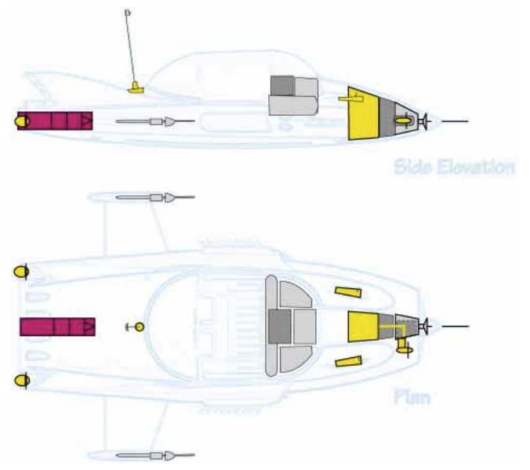
Supercar’s main power supply originates from two high capacity 24-volt batteries situated in the nose (27). These provide the initial power for the APU (Auxiliary Power Unit) when away from Black Rock Laboratory or when external power supplies are unavailable.
Electrical power is fed to the APU and EMH® powerplant (2.1), which charges each RamJet engine (2), port and starboard, up to 15,000 rpm when the Interlock® mechanism is activated, interconnecting the two engines.
The 0.5 Megawatt capacity EMH® powerplant is also the primary electrical “generator”, in itself, a highly advanced superconducting powerplant. It is the self-contained marine motor for water operations and boosts the power rating of each RamJet engine for space flight, scooping up hydrogen in the thin atmosphere where oxygen is unavailable.
The EMH® powerplant can also electrically charge Supercar’s Hull and transmitting the charge via a capacitator to the High-Band Antenna Aerial (10), used for frightening off animals or predators which may otherwise damage Supercar while on the ground.
The Avionics Bay (20) houses complex triplicated Flight computers, connecting vital flight status data via the highly sophisticated ClearVu® CRT Computer Display (21).
Sensors in the nose (32), (33) and wing nacelles (14) provide advanced data including radar, sonar, moving map displays, Inertial Navigation, Remote® and video link-ups directly to Black Rock Laboratory.
Flight instruments and control readouts are also transmitted to Black Rock Laboratory, and digitally controlled via a sophisticated FBW (Fly By Wire) computer system from pilot inputs using a simplified control column which interconnects all pitch, yaw and roll movements.
Depending on selected Flight Mode, the onboard Flight Computer relays information to sensors built into the engine nozzles providing precise control of Supercar’s movement, attitude and velocity.
Powerful Navigation Lights are mounted in the rear fuselage (1), with combined front navigation, search and landing lights enclosed in two streamlined fairings (26) forward of the cockpit windscreen. Each of these pods house ILS (Instrument Landing System) antennas.
In the unlikely event of catastrophic hydraulic or electrical failure, a back-up wind/water powered Emergency Generator (31), folds out from the nose centre structure (behind the front intake cowling, shown in the extended position), into the intake cowl slipstream, providing Supercar with Hydraulic/Electrical capability provided she has forward movement, enabling her to continue operating safely.

3. BALLAST & WATER FLOW – OVERVIEW
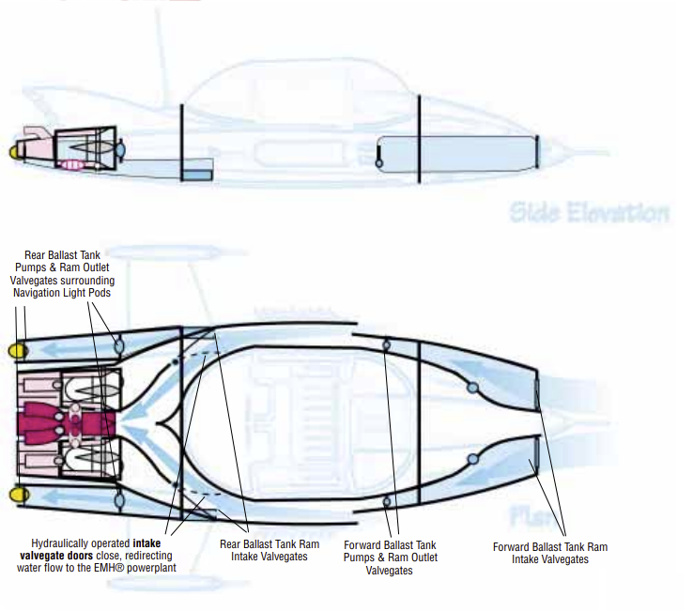
Supercar’s ability to become a submarine or high-speed “hoverboat” is achieved with the four ballast tanks (5 & 23) and the EMH® powerplant, or the VTOL Jets in “Ground Effect Mode” respectively.
Just before entering a water environment, the pilot switches from “Flight Mode” to “Marine Mode” using the far left lever on the centre console. This instantaneously shuts down the RamJets, and valvegates close off both the VTOL and RamJet Exhaust Nozzles preventing water from entering.
Hydraulically powered valvegate intake doors mounted within the side intakes, (depicted by dotted lines and blue arrows to the sides and rear of the cabin) close off and seal water from entering the RamJet, and redirect the incoming water directly to the EMH® powerplant which now becomes the primary engine. Computers switch the EMH® powerplant (via the Interlock®), to “Crossfeed,” allowing all rear ports to be utilised.
Just before Supercar enters the water, Valvegates at the front cowling (30) and front of the rear ballast tanks (5) are fully opened. Water is instantaneously rammed into these tanks as she dives directly from the air into the sea. The valvegates are closed off and electric pumps independently regulate the capacity in each tank.
Moving the control column conventionally displaces water in each tank altering pitch, roll and yaw, just like it does when Supercar is flying. To dive, the tanks are left fully flooded. To surface, the pumps displace water with oxygen from the air pressurisation system (13).
Oxygen regenerators (13) continue to purify and recirculate pressurised air into the cabin (17).
The EMH® powerplant operates much like a jet, sucking water in and accelerating it out the rear outlet ports. The directional nozzles located in the rear ports not only accelerate Supercar up to 70 knots, but also assist her directional movement, i.e., water thrust is directionally vectored.
To launch Supercar directly into the air, the front ballast tanks are pumped dry and the pilot selects Flight Mode. This powers up the RamJets with direct internal oxygen vented into the RamJet combustion chambers. Full power is selected for both the EMH® powerplant and RamJets, the appropriate attitude is selected and Supercar literally launches like a Polaris Missile.
Once airborne, the onboard computers and sensors reopen the RamJet intakes and valvegates, providing atmospheric air directly to the RamJet and instantly dumping excess water from the ballast tanks. The EMH® powerplant returns to “normal” mode.
As a high-speed hover-boat, the pilot can choose to land conventionally or vertically onto the surface. Once on the surface, Ground Effect Mode is selected and the CAD (Cushion Augmentation Devices) are activated. Supercar hovers 4- 6 ft or so off the surface and is propelled at high speed by the RamJets - See VTOL & Vectored Thrust Sections 8 & 9.
Conventional or vertical takeoffs can then be selected in the usual way by switching back to Flight Mode.

4. EMH POWERPLANT – OVERVIEW
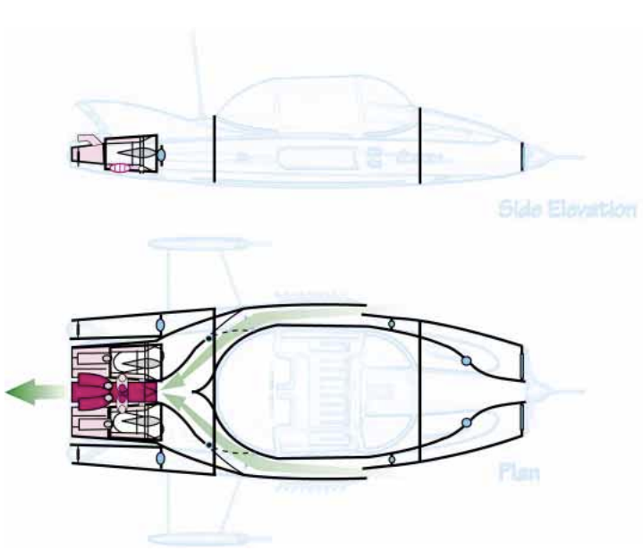
Literally decades ahead of its time, the highly-classified experimental EMH® (Electro-MagnetoHydrodynamic) powerplant (2.1) is the heart of Supercar’s advanced design – a compact, lightweight, super-conducting generator with a power output of at least 0.5 megawatts.
Developed from “classified” technology, the EMH® powerplant is the “secret” to Supercar’s ability to achieve large power output and range from relatively small engines, fuel supply and vehicle.
Although Supercar’s RamJets run on a specially formulated AvGas® fuel, the EMH® powerplant’s primary source of fuel is hydrogen, collected by ram scoops in small, safe and manageable quantities. The collected hydrogen is supercooled and stored in small tanks onboard Supercar only as required. This minimises the obvious size, weight and safety problems encountered by conventional rockets (which have to carry a full fuel load), or inferior superconducting generators (where compactness and light weight are difficult to achieve).
Initially powered-up by Supercar’s batteries, APU and then its twin hybrid RamJets, the EMH® powerplant is essentially self-contained once it has attained “optimum running speed” (hence the necessity to “charge” each RamJet engine via the Interlock® mechanism to achieve full power). Once the RamJets have reached normal idle speed, they begin to fully power up the EMH® powerplant. The EMH® powerplant then begins producing enormous energy, cross-feeding and “boosting” the power rating of the RamJets by as much as 500%.
Tested beyond an altitude of 108,000ft msl (with a submerged depth of 400 feet – both considered conservative measures as to it’s true potential), and with an abundance of Hydrogen well beyond Earth’s atmosphere or in any water environment, the EMH® powerplant increases its hydrogen intake and power output in the thin or fluid atmospheres where conventional gas turbines or pure ramjets would have long starved for air.
The EMH® powerplant is also completely “clean” giving off only water vapour as an exhaust byproduct. With virtually no moving parts, it creates a powerful vortex of electrically charged particles (either air, water, or the gases that exist naturally in space). This is the source of the unusual “throbbing hum” heard in unison with the more conventional sound of its RamJets.
Additional advantages of the EMH® powerplant include its ability to store up enormous amounts of static electricity, and then via a capacitator, release it through the insulated alloy hull, electrifying it, or literally discharging “lightning bolts” from the High-Band Antenna (10).

5. FUEL SYSTEMS – OVERVIEW
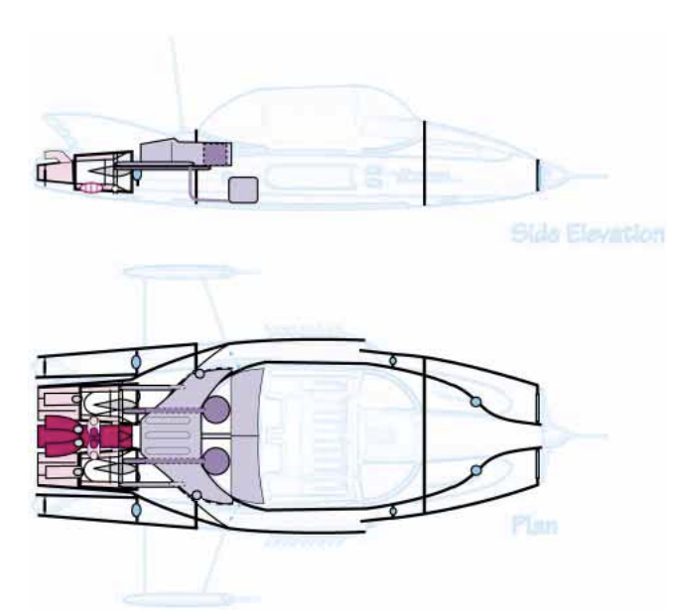
Supercar uses two fuel systems; one for its advanced RamJet engines (2) and another for the classified experimental EMH® (Electro-Magneto-Hydrodynamic) powerplant (2.1).
Supercar’s RamJets usually run on a specially formulated AvGas® fuel which provides superior fuel economy and power compared to existing fuels. This “classified” AvGas® is constantly being refined and stored at Back Rock Laboratory. Under “normal” situations, Supercar has a transatlantic range at supersonic cruise speeds in excess of Mach 6. Because Supercar’s RamJets are “stratified”, they can, if necessary, run on almost any fuel type from auto gas to A-1 Jet Fuel. However, range and performance are significantly reduced.
Supercar is fuelled conventionally via a dual refuelling ports on the port and starboard side, near the vertical fins, just to the left and right of the rear windscreen. Supercar originally used a single refuelling point on the port side only.
The main fuel tank (8) is a forward-swept, aerodynamically shaped pressurised tank, specially designed to handle high G-forces and completely differing environments and pressures from atmospheric, deep underwater and the vacuum of space.
Centrally positioned above the wing extenuator box, which is in itself part of Supercar’s rigid structure, fuel is fed via twin pumps and fuel lines (7) and is injected electronically into each RamJet engine. For safety purposes, each fuel pump has a backup, cross feed capability, and the fuel lines themselves are equipped with emergency cut-off valves.
As already discussed in “EMH Flow - Overview” in section 4, the EMH® powerplant’s primary source of fuel is hydrogen, collected by ram scoops via the side air intakes, in small, safe and manageable quantities. The collected hydrogen is supercooled and stored in small, circular, refrigerated pressurised tanks just forward of the main fuel tank. This minimises the obvious size, weight and safety problems encountered by conventional rockets which have to carry a dangerous and large full fuel load.
Oxygen is also collected and supercooled in a similar manner by the ram scoops and used for augmenting the fuel burn for space flight or marine use where the air supply is obviously non-existent.
In an emergency situation, both fuel supplies can be purged (dumped) by the pilot, minimising the possibility of explosion should a forced landing be necessary. Again, Supercar’s fuel systems, like the rest of its advanced design, leaves nothing to chance, and even should this dangerous situation develop, passengers are well protected by a solid and completely sealed firewall bulkhead.

6. RAMJET ENGINES – OVERVIEW
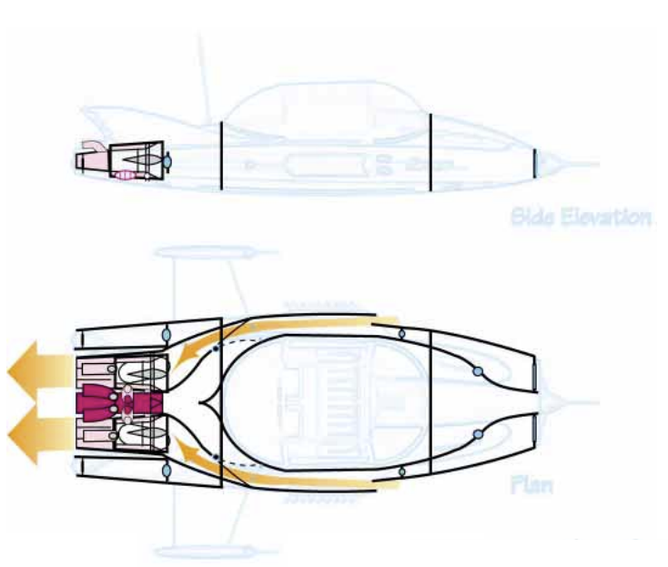
Almost as impressive as the EMH® powerplant, Supercar’s more conventional twin hybrid, stratified RamJet engines (2) are nonetheless, unique. Purpose designed for Supercar, they are both a powerful jet turbine with full afterburning, and ramjet, (hence the name hybrid “RamJet” when applied to Supercar) and can operate on almost any type of fuel, (although for maximum efficiency burn the classified and specially formulated AvGas®).
Air intakes at the front and along the sides of Supercar, provide air directly to the engines. Producing in excess of 19,000 lbs static thrust each, they feature adjustable pitch turbine blades, vectored thrust, afterburners, ceramic exhaust nozzles and oil injectors for producing smoke screens.
At normal sub-sonic operating speeds they perform and behave like any other gas turbine up to an altitude of 55,000ft msl. At higher altitudes and speed, the pitch angle on the turbine blades is adjusted enabling the engines to become almost pure ramjets, producing several times the power output of any other turbine currently available, (tested to a maximum “atmospheric” speed of 3,000 mph).
For VTOL operation, adjustable valvegates within the actual combustion chambers are opened, and thrust is completely or partially vectored through the base of the engine via a large ceramic outlet exhaust nozzle (4), through ducts and vents to the VTOL jet exhausts (6) and Retro Jets (19) (they are not as such, equipped with reverse thrust).
In normal horizontal mode, RamJet thrust is vectored out of the rear of Supercar through two sets of three smaller ports, each containing ceramic vector nozzles giving yaw and pitch control. For additional manoeuvrability, extra thrust is boosted through the four smaller jet nozzles (3) mounted on top and at the very rear of Supercar. These combined outlets eliminate the need for conventional flight surfaces such as rudder or elevators.
For safety and stability, both engines are interconnected via the Interlock® mechanism with transverse shafts and gearbox, so in the event of single engine failure, Supercar continues to operate and fly safely from VTOL transition right through to high speed horizontal flight (although with reduced performance).
The RamJets also generate electrical power to the EMH® powerplant via the Interlock® mechanism, which in itself can then “boost” the power of the RamJet engines for space flight by burning collected hydrogen via cross flow ducting in the Ceramic Exhaust Ports. In a virtual vacuum, Supercar’s “boosted” power is astonishing, allowing it to reach the altitude and speeds that only large rockets could achieve. During marine operations, the RamJets are shut down temporarily except for “Ballistic” take-offs, which then briefly use Oxygen stored in tanks to re-ignite the engines enabling Supercar to launch into the air. With low noise and emissions coupled with light weight, compact size, and enormous power output, Supercar’s RamJet engines are like Supercar itself, decades ahead of their time.

7. LIFE SUPPORT SYTEMS – OVERVIEW
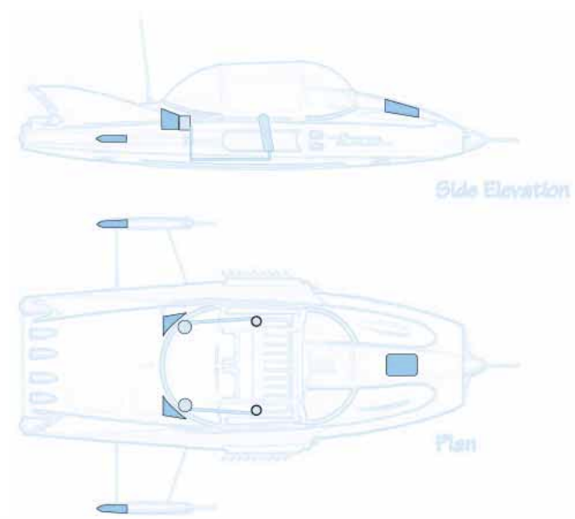
Supercar’s Life Support Systems (8, 13 & 17) are unrivalled, featuring a fully pressurised cabin, twin oxygen systems with oxygen regeneration capabilities, air conditioning and a Whole Vehicle Ballistic Parachute Recovery System (11 & 28).
Constructed from Aerospace hardened, double glazed and solar reflective acrylic glass, Supercar’s “all-glass cockpit” seats four comfortably. The top panel is constructed in a classified material called “Flexiglass®”, which seals itself electrically, creating a virtually invisible seam. All “glass” in the cockpit’s construction measures 1” thick, is bullet-proof and can withstand enormous pressures and temperature extremes.
In addition to an ingenious split sliding roof, Supercar’s central canopy also slides back conventionally on hydraulic struts, allowing easy entry or egress. Its twin pressurisation system can maintain a comfortable sea level pressure right up to 108,000ft msl and beyond, or in the ocean’s depths at 400 ft plus, below sea level.
A full warning system alerts the pilot to any oxygen or pressurisation malfunction and all critical systems are duplicated for safety. A full oxygen system includes twin standard refillable oxygen bottles (17) (embedded in the backs of the front seat) linked to an oxygen regeneration system, i.e., as Supercar travels along in the atmosphere or water, the ram intake scoops are constantly collecting and replenishing the oxygen system. The air is then filtered, purified and recycled as needed.
Full oxygen masks are available for four, and each occupant is protected with double point full safety harnesses. The twin airconditioning system keeps Supercar’s cabin at a temperature selected by the pilot (between a chilly 16C degrees or a toasty 30C degrees), irrespective of the outside temperature.
Supercar also carries a transponder, full locater beacon and homing device so that Black Rock Laboratory can, in most cases, always locate Supercar’s whereabouts via the Remote Control Console.
In the unlikely event of total power plant failure, Supercar is fitted with three Ballistic Parachutes (11 & 28), one in the rear of each wing nacelle, and another hidden under a flush panel in the front of the ClearVu® fairing (21). Capable of saving the “Whole Vehicle”, the system can be deployed at speeds under 350 mph and is effective at altitudes above 900ft msl.
Likewise, if power fails while underwater, an emergency ballast flotation system comes into play, allowing Supercar to surface without power (or if flooded due to leakage). Although neither of these devices has been needed to date, both have been tested fully, providing Supercar’s occupants with an added measure of safety presently unavailable in any other craft.

8. STORAGE COMPARTMENTS – OVERVIEW
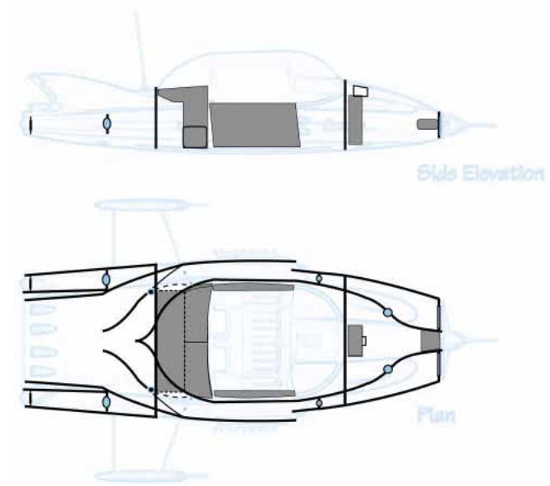
Despite Supercar’s compact size, its storage facilities are relatively generous and feature full seating for four adults, a large Luggage/ equipment Storage Compartment behind the rear passenger seats (15), and a clever Fwd. Mounted Multi-Purpose Optional Equipment Bay (25).
The Luggage/Equipment Storage Compartment is accessed from inside Supercar’s cabin. By unlocking the split rear seats, as in most modern cars – either independently or together – the seats fold forward and flat, turning Supercar into a two seater with generous in-cabin storage, or allowing items to be stowed behind them. This compartment is retained within the cabin bulkhead and is fully pressurised, as is the cabin. Oxygen and pressurisation lines safely pass under this area, which also contains the Auxiliary Fuel Tanks.
But perhaps the most interesting storage facility is the Fwd. Mounted Multi-Purpose Optional Equipment Bay (25), situated just forward of the front windscreen and running the entire depth of Supercar’s nose. This cleverly-designed compartment allows Supercar to be fitted with purpose designed-optional equipment as a particular mission dictates. Such equipment includes a powerful Rocket Gun (with storage facilities underneath for other types of armament and ammunition), additional oxygen equipment for extended marine or space flight missions, or specialised tracking equipment.
At the very front of Supercar’s nose, and mounted just behind the Main Radar/Sonar Sensor Nose Cone (32), is the Emergency Generator Compartment (31). Normally retracted, in an emergency the pilot can extend the wind/water-powered generator out into the starboard ram intake slipstream. Still hidden from external view, and thereby eliminating drag, the generator’s free-spinning turbine can provide Supercar with electrical and hydraulic power provided it still has sufficient forward motion.
A “hidden” addition to Supercar’s storage abilities are the Twin Landing Skids mounted on the lower fuselage floor. By accessing flush panels, these skids become “inverted equipment racks”, allowing Supercar to be fitted with Magnetic Hoists, Bomb Racks, Additional Storage Containers or heavy lifting equipment, much like larger (and less powerful) conventional helicopters.
Capable of vertically lifting three times its own weight, Supercar again, far exceeds conventional vehicles in terms of ability and agility. New optional equipment is constantly being refined and developed by the Black Rock Laboratory team as the need arises.

9. VECTORED THRUST – OVERVIEW
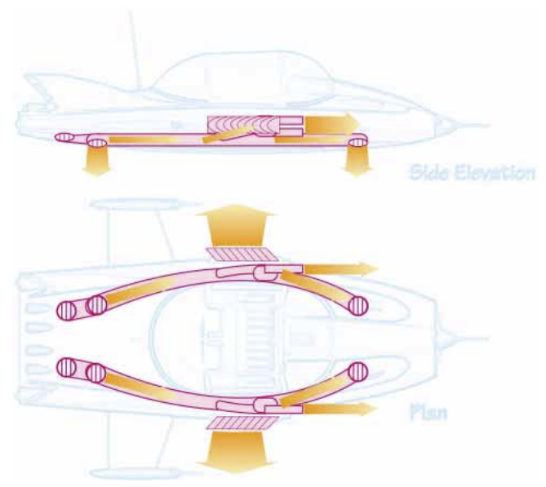
Probably Supercar’s greatest agility lies in its Multiple Mode VTOL capabilities. Far exceeding conventional “jump jet”, hovercraft or helicopter performance, Supercar’s VTOL thrusters are state-of-the-art computer controlled and linked via the CAD (Cushion Augmentation Devices) to a relatively simple mode selector lever operated by the pilot. This system, combined with ease of use, eliminates the complicated multi-control aptitude flying associated with helicopters or other VTOL craft.
Supercar’s RamJets, in combination with the EMH® powerplant and Interlock® mechanism, redirect or “vector” most of the powerful thrust through Outlet Nozzles in the base of the engines (4) to a series of computer controlled nozzles and wastegates both at the rear of Supercar (2 & 3), and primarily through four large VTOL Jet Nozzles (6) under the fuselage, and to the Retro Jets (19) on each side of the fuselage. Each nozzle has complete rotational ability, allowing Supercar precise manoeuvring control in any mode.
Essentially, four main “flight modes” are available to the pilot; Ground Effect, Normal “Flight”, Marine Mode and Space Flight (although the VTOL thrusters are not used in Marine Mode). These modes are selected by the pilot using the lever to the left of the twin power levers, much like a “gear shift” in conventional cars, boats or aircraft. The right most lever controls the percentage of power being vectored to either horizontal or vertical thrust from -15 degrees vertical right through to full 100% horizontal.
Conventional flight controls (steering columns and rudder) provide Supercar with directional movement much like conventional pitch, roll or yaw).
The twin power levers (or throttles), depending on selected mode, also control the Retro Jets, similar in operation to thrust reversers while in horizontal mode or Ground Effect. These also allow Supercar to “crab” or move sideways by venting thrust through small nozzles hidden between the Retro Heat Extractor Vanes (18) and controlled by the steering columns in Vertical Ascent or Descent or Ground Effect Modes.
The power levers (throttles) are configured much like a powerboat or aircraft equipped with reverse thrust. The halfway position is “neutral or idle mode”. Moving the power levers forward (up) increases power to forward or vertical thrust, and rearward (down from neutral) is Retro power with VTOL thrust remaining constant or neutralised depending on selected mode.
In Ground Effect Mode, Supercar becomes a powerful hovercraft. The four VTOL Jet Nozzles (6) each rotate out to 45 degrees from centre, providing it with an extremely “rigid” feel, unlike the drift effect encountered with hovercraft or helicopters.
The sophisticated CAD (Cushion Augmentation Devices) are automatically activated, and onboard sensors constantly regulate ... continued in section 10.

10. VECTORED THRUST - cont’d
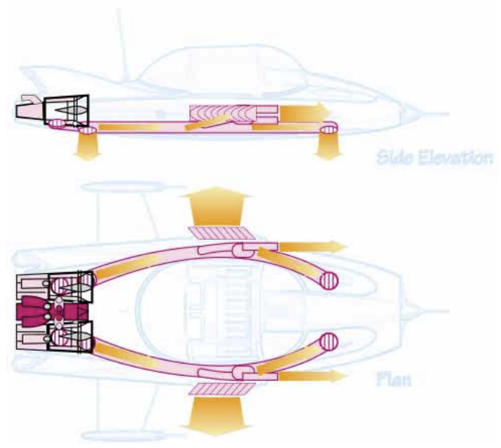
Supercar’s horizontal attitude and height, instantly compensating for wind, gusts or uneven loads. Vertical thrust is constantly controlled to keep Supercar “level” at a constant hovering altitude of 4 - 6 feet above the terrain or surface. The CAD system is linked to forward terrain following radar and sonar allowing safe movement at horizontal speeds in excess of 250 mph over hills, walls or relatively low obstacles that may be in its path. Forward or reverse velocity is then controlled by the twin power levers, and sideways and yaw control is provided through the steering columns and rudder respectively. For “braking”, the pilot simply brings the throttles into the rearmost position (down), activating the Retro Jets or “reverse thrust”.
In “Flight Mode”, the pilot begins with the throttles in idle position and the VTOL lever in 0 degrees or Vertical position. By gently increasing power, Supercar lifts off vertically to a designated height. (In this mode in fact, Supercar can fly much like a helicopter although directional speed is limited. Moving the control column left or right banks Supercar in that direction. Moving the control column forward or backwards moves Supercar respectively forward or backwards). Usually however, the transition is smoothly made from 0 degrees vertical to full horizontal with the power being increased as Supercar accelerates. The reverse is done for landing. (Micro switches prevent Supercar from “dropping” should the pilot move the VTOL thrust levers into Horizontal mode too quickly). Yaw, roll or pitch control is then controlled through all of these nozzles working in combination.
At “in-between” settings, i.e., plus or minus 15 degrees Vertical Thrust, Supercar can land or takeoff from very “tight” surroundings and/ or at very steep attitudes such as hills etc. Regulating between horizontal and VTOL thrust also empowers Supercar with spectacular manoeuvring ability while in horizontal flight, i.e., Viffing, where VTOL mode is applied in forward flight allowing extreme vertical climbs and descents. Likewise, extreme “braking” or forward deceleration can be applied in horizontal mode by bringing the throttles all the way down into “Reverse” or Retro Mode.
Selecting “Space Flight” mode then activates the EMH® powerplant into full power, automatically augmenting Supercar’s RamJets with stored Oxygen and Hydrogen. The controls work in much the same way, with full directional thrust being utilised through the horizontal and VTOL thrusters.
For safety, the Interlock® mechanism provides full transition from vertical to horizontal flight in the event of single RamJet engine failure in any mode.

11. RETRACTABLE WINGS – OVERVIEW
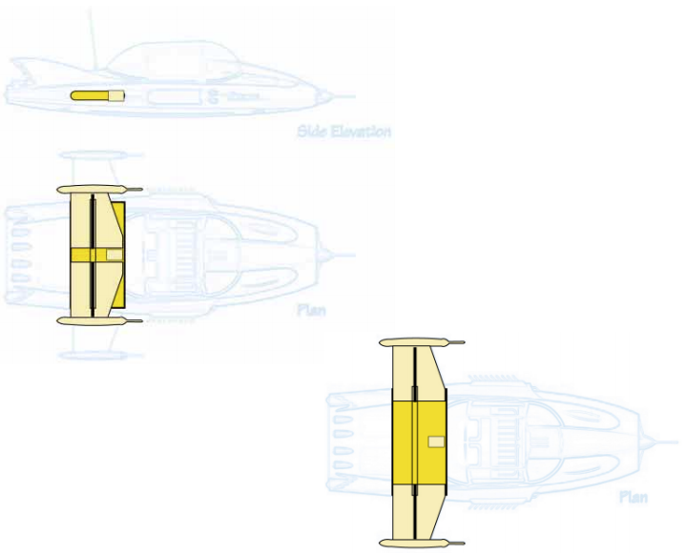
Largely due to its compact design, Supercar is uniquely equipped with retracting wings (9), a feature which is more efficient than conventional folding or scissor-type wing mechanisms.
Supercar is itself an aerodyne, or ‘mechanical lifting body’. The shape of Supercar’s entire fuselage generates aerodynamic lift due to its advanced profile design, thus requiring only relatively ‘small’ wings to provide extra lift at the rear to compensate for most of its weight being rear-biased. (Because of the vectored vertical thrusters, additional forward ‘canard’ wings were found unnecessary).
Only two positions are available, either fully retracted or fully extended. This operation is controlled by a single switch mounted on the pilot’s control panel.
Usually retracted while on the ground or in Ground Effect Mode, the wings are normally extended after reaching a safe altitude and before transitioning to horizontal flight. (Although under certain situations Supercar can be flown with wings retracted, this is not recommended as in-flight stability becomes seriously affected and Supercar may unexpectedly loop at high power settings).
The wings themselves are extremely light yet strong, containing neither conventional flight surfaces such as spoilers, ailerons or flaps, nor fuel.
Streamlined nacelles at each wing tip house sensitive Avionics and Marine Sensor Probes and the INS (Inertial Navigation System) (14). Each nacelle contains a Ballistic Parachute Recovery Pack (11), which work in unison with the front mounted unit (28), (hence another reason why Supercar’s wings were designed to handle extreme loads).
Both wings are extended or retracted evenly by the Wing Extenuator Mechanism (12) which is electrically and hydraulically powered with back up. The entire mechanism and the wings themselves are fixed to tracks inside the Wing Control Box (9), a rigid planform which doubles as Supercar’s overall ‘backbone’, providing great strength and high G-loading capability. The entire housing is aerodynamically shaped in profile cross-section, further ‘shaping’ the airflow to the engines.
With the wings fully retracted, Supercar takes up little more width than a large car, enabling it to be ‘parked’ in confining spaces.
The twin vertical tail fins are also carefully designed, compressing rearward moving air as it moves over the upper fuselage between the fins, and providing greater stability, thrust and lift.

SUPERCAR CONTROL PLANS
Supercar operates in any of a set of "Control Plans" which set up the various systems such as hydraulics, valves, wastegates, instruments, sensors and control computers to respond in appropriate ways to the environment and the pilot's (or remote console's) control inputs.
The Control Plans are selected by the Control Plan Selector (CPS) which operates in steps (each of which click into position and engage quite firmly). There is an off position at the top, and 8 control plans below that. The positions inform the control computers and do not mechanically go through the intermediate modes when a new selection is made. Safety constraints within the control computers ensure that inappropriate modes cannot be selected.
There are 8 Control Plan Indicators (CPI) on the dash panel, one of which lights up to show which control plan is active. Other permitted modes that can be simultaneously used may also be indicated.
The Control Plans are configurable and can be uploaded to the control computers in advance or even dynamically during a mission. However, there is a "standard" set of usual assignments for these which is the default if no mission specific set is installed.
Plan Number | Full Name | Short Name Used by Pilot | Description
Plan 1 | Standby Plan | Off | Supercar set to its parked mode, minimal power use.
Plan 2 | Vertical Flight Plan | Vertical | Vertical ascent, descent and landing mode.
Plan 3 | Horizontal Flight Plan | Horizontal | Normal horizontal flight.
Plan 4 | Surface Effect Plan | Ground or Surface | Surface skimming mode over land or water.
Plan 5 | Air to Marine Dive Plan | Dive | Set up for high speed water entry. Automatically switches to Marine Plan on surface penetration.
Plan 6 | Marine Plan | Underwater | Set up for submerged operations and instruments.
Plan 7 | Marine to Air Launch Plan | Launch | A very complex plan that allows for a ballistic launch of Supercar from underwater. Automatically switches to Horizontal Flight Plan on surface penetration.
Plan 8 | Space Flight Plan | Space | Stratospheric and space flight plan.

Supercar was created by A.P. Film Studios in association with ITC (now ITC Studios).
Supercar internal schematic technical concept, text and drawings by Shane Pickering 1999 with technical assistance from Austin Tate. Original Supercar designed by Reg Hill of A.P. Films.
Supercar exterior based on Phil Rae Blueprints and 3-D model by Mick Imrie and Austin Tate.
This is fan produced material to promote the shows of Gerry Anderson and provided
for your enjoyment, and should not be used for any commercial purpose.
Version: 21-Nov-1999. Minor Update: 9-Mar-2021.

