Moving Content from Second Life/OpenSimulator via Unity3D to new Social Virtual Reality Platforms

Austin Tate, Virtual University of Edinburgh
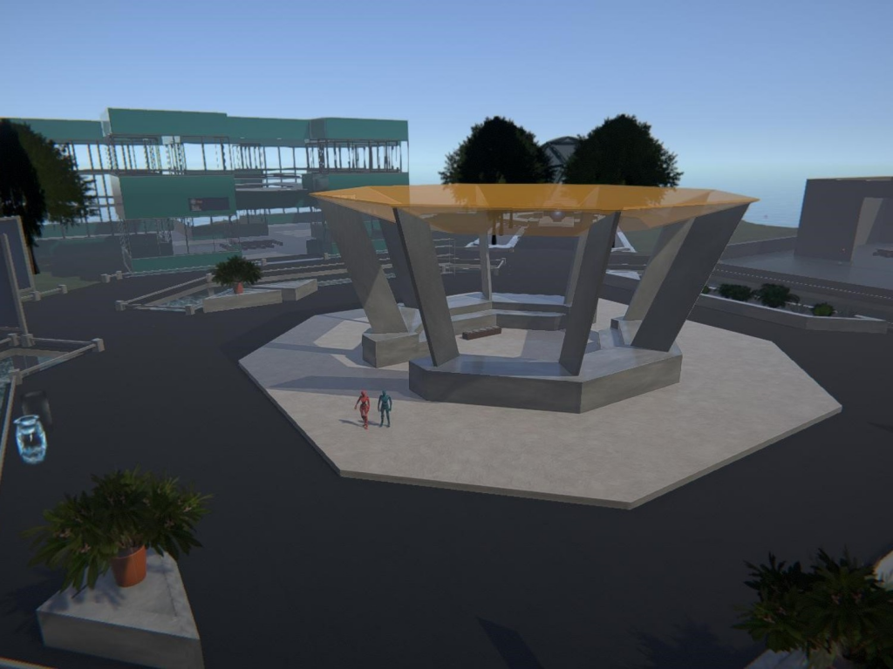
Vue Experiments with other Virtual Worlds Platforms
Even before Second Life began to be used across the University of Edinburgh, groups in Business Studies, Education and Artificial Intelligence had been exploring virtual worlds platforms for a range of educational and research project uses.
Platforms (now long gone) such as “There” and commercial virtual world simulators such as “Forterra” had been in use, and Second Life itself had been used even in its very earliest incarnation.
When we began using Second Life for Virtual University of Edinburgh (Vue) purposes back in 2007 we could not have imagined the platform would remain stable for such a long period (over a decade and it is still available and being actively developed).
Even at the earliest stages we envisaged moving onto new platforms as they arose and experiments have taken place with quite a lot of potential platforms, Many we were involved in at closed alpha and open beta testing stages. Not all of the platforms tried made it to full open public release. A number of these experiments are documented in my blog posts at http://blog.inf.ed.ac.uk/atate/
Current platforms under investigation include:
- High Fidelity (http://highfidelity.com)
- Sansar (http://sansar.com)
- Sinespace (http://sine.space)
Moving Content to New Virtual Worlds Platforms
We have used or been involved in the creation of a number of tools to assist in moving content across various virtual world platforms…
- Where possible content was originated in tools such as Paint, Paint Shop Pro and PhotoShop and more recently in 3D mesh modelling tools such as 3D Studio Max or the open-source Blender to create Collada DAE or FBX meshes.
- Second Inventory – was a useful tool to back up Second Life and OpenSimulator inventory items owned fully by a specific avatar. This tool is no longer available, but at the time was helpful to archive and reload builds (e.g. of the Vue buildings).
- OpenSimulator Archives (OARs) and Inventory Archives (IARs) have been a very useful aid to preserve regions and inventory content.
- The OAR Converter tool has provided a route to export content from OpenSimulator into Collada DAE (a portable 3D model format) and via that to allow its import to Unity3D. See http://blog.inf.ed.ac.uk/atate/oar-conv/
- Unity3D is a widely used development platform and a useful conduit to transferring content into newly emerging virtual worlds and social virtual reality platforms. Unity has add-on tools available to export FBX format meshes even when the original content is in other 3D formats. See http://unity3d.com

Virtual Worlds Development Paths
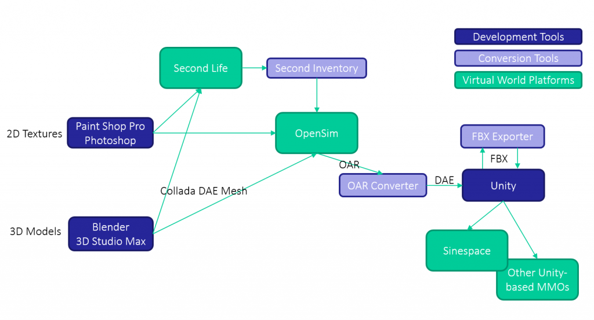OpenSimulator to Unity3D Conversions
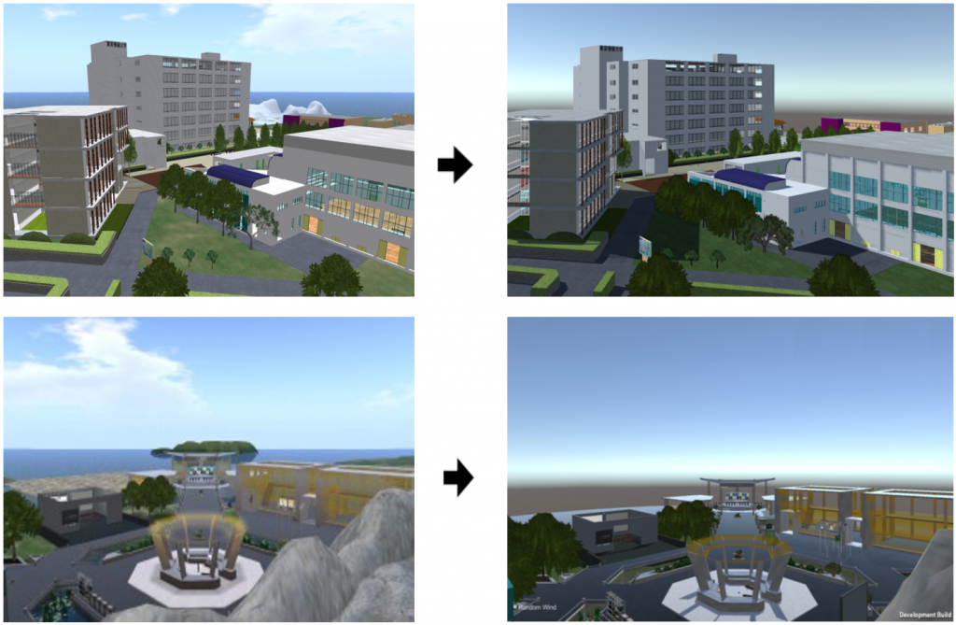Tokyo University of Information Sciences and Virtual University of Edinburgh OpenVCE
Appearance in OpenSim
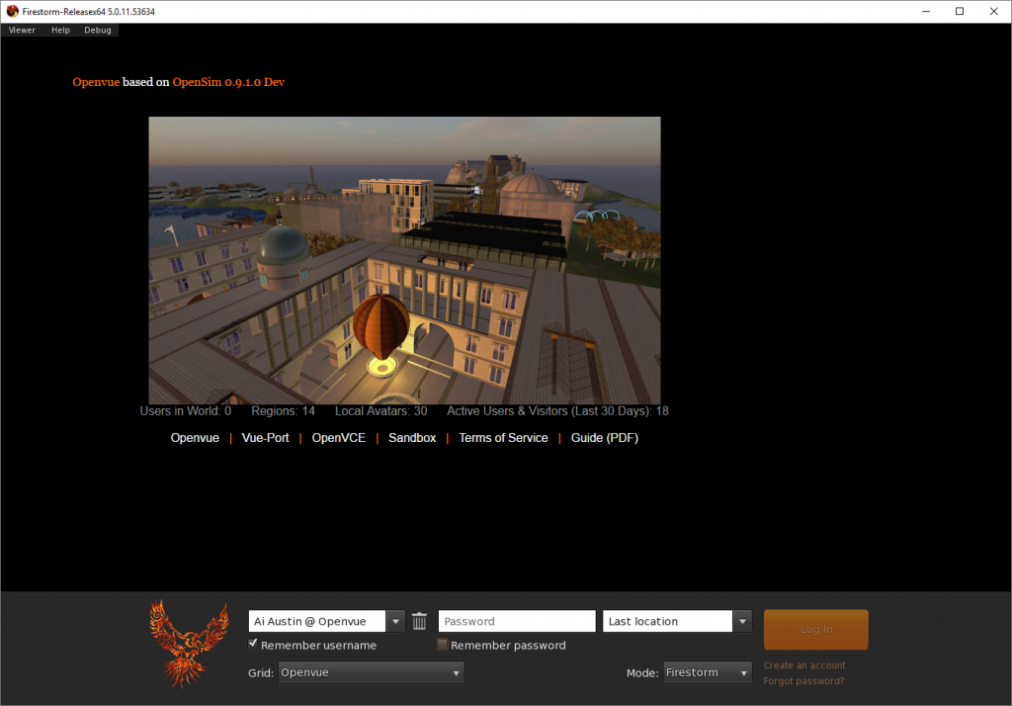
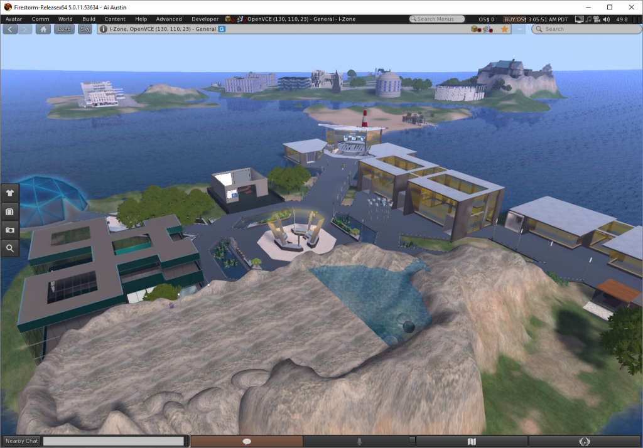
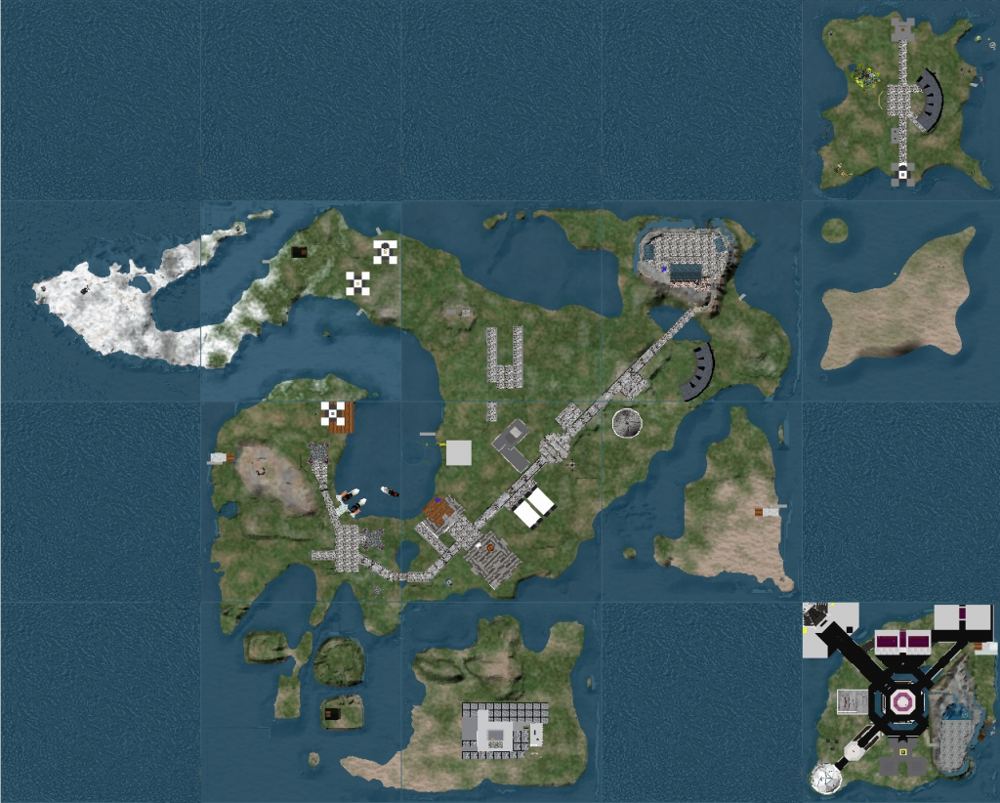

Appearance in Unity3D Editor
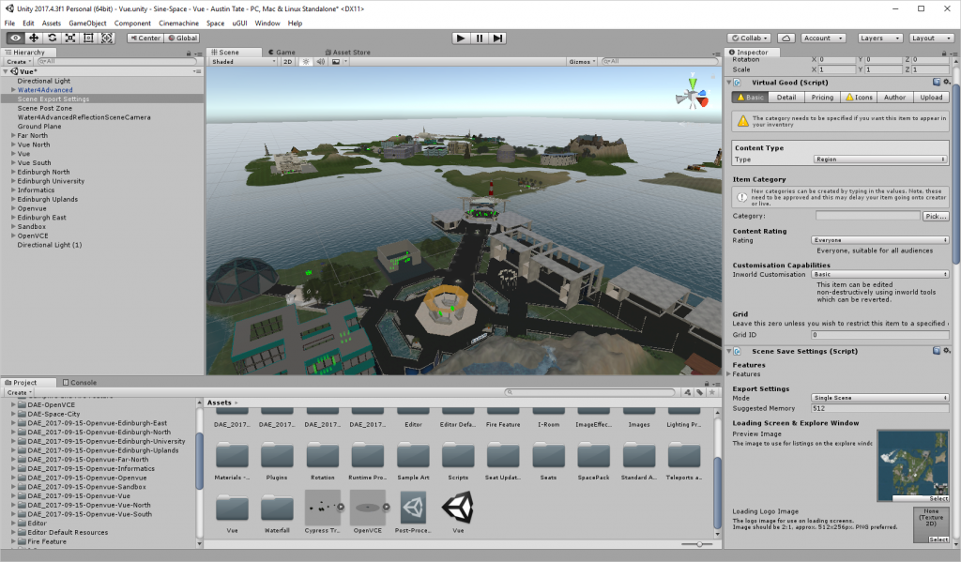

Appearance in Sinespace
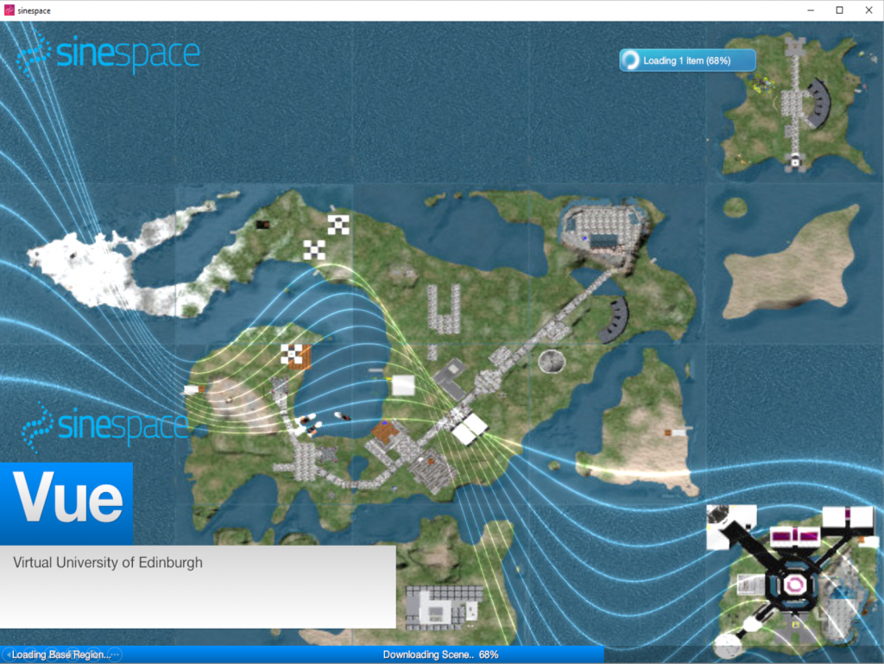
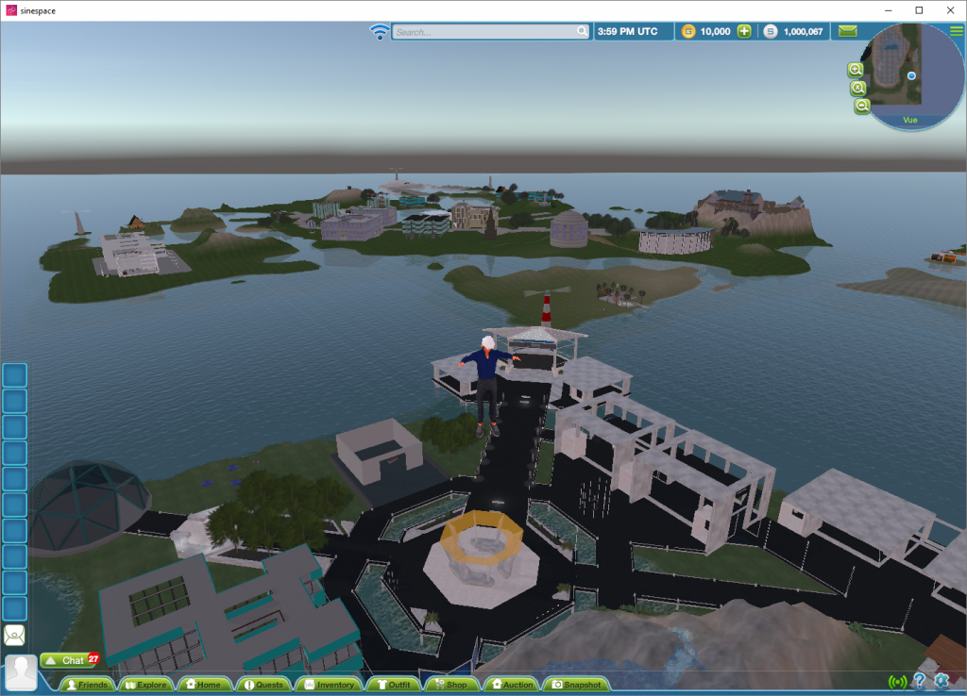
Issues in Moving Content between Platforms
- One of the biggest issues in making content portable (even when full permissions are available and content is built by teams working together) is that unless one avatar owns all the content and the various textures archiving and externalizing content can be a problem.
- 2D image formats and the ways in which transparency handling works may vary between different platforms.
- The 3D model formats used in transferring content between platforms, such as Collada DAE and Autodesk FBX do have many variants and some platforms may limit the number of vertices or polygons that can be included in models, or the ways in which sub-meshes can be hierarchically included.
- Ways in which 3D meshes are textured, or limits on the number or type of textures that can be used may be imposed.
- Dynamic and scripted behaviours need to be recreated in the new environment.
More Information
More information at http://blog.inf.ed.ac.uk/atate/ and http://vue.ed.ac.uk
Acknowledgements
The University of Edinburgh and members of the Virtual University of Edinburgh are authorized to reproduce and distribute reprints and online copies for their purposes notwithstanding any copyright annotation hereon.

Original submission to Virtual Education Journal, June 2018 Issue.

