Co-OPR: Design and Evaluation of Collaborative Sensemaking and Planning Tools for Personnel Recovery

Austin Tate¹, Simon J. Buckingham Shum², Jeff Dalton¹, Clara Mancini² and
Albert M. Selvin²
¹Artificial Intelligence Applications Institute, The University of Edinburgh, UK
²Knowledge Media Institute, The Open University, UK
Keywords: Collaboration, Sensemaking, Planning, Decision Support, Dialogue Mapping, Decision Rationale, Search and Rescue, Personnel Recovery

Abstract
Personnel recovery teams must operate under intense pressure, taking into account not only hard logistics, but ‘messy’ factors such as the social or political implications of a decision. The Collaborative Operations for Personnel Recovery (Co-OPR) project has developed decision-support for sensemaking in such scenarios, seeking to exploit the complementary strengths of human and machine reasoning. Co-OPR integrates the Compendium sensemaking-support tool for real time information and argument mapping, with the I-X artificial intelligence planning and execution framework to support group activity and collaboration. Both share a common model for dealing with issues, the refinement of options for the activities to be performed, handling constraints and recording other information. The tools span the spectrum from being very flexible with few constraints on terminology and content, to knowledge-based relying on rich domain models and formal conceptual models (ontologies). In a personnel recovery experimental simulation of an UN peacekeeping operation, with roles played by military planning staff, the Co-OPR tools were judged by external evaluators to have been very effective.

Introduction
We are, sadly, becoming all too familiar with news from conflict zones around the world reporting the capture or isolation of both civilians and military personnel. The Personnel Recovery agencies in different countries are responsible for deciding what to do in such situations. In today's world, it hardly needs emphasising that actions taken by one country within another can have complex political effects, which may even exacerbate the situation. A critical issue for Personnel Recovery research is, therefore, to investigate tools which can help assess the 'messy impacts' of candidate courses of action, especially when interventions may be by other than military means – using diplomatic, social or economic routes for example. There is then the need to follow through to execute the chosen plans and adjust them as circumstances alter.
The Co-OPR (Collaborative Operations for Personnel Recovery) integrated two decision-support tools in a realistic personnel recovery mission, focusing on exploiting the respective strengths of human and software agents in the planning cell:
- Compendium¹: Hypermedia concept mapping tool to support real time, collaborative sensemaking and group memory by linking argumentation and information; uses an extended version of the IBIS² (Issue-Based Information System) notation for raising issues, options and arguments.
- I-X³: Intelligent collaborative command, planning and execution support to assist in creating options and accounting for procedural knowledge and planning constraints; uses the <I-N-C-A>⁴ underlying model for sharing issues, activity nodes, constraints and annotations.
These tools were deployed in a realistic, detailed personnel recovery scenario specifying political, historical, geographical and resource constraints on a UN peacekeeping operation. Commanders, ambassadors, political analysts and other stakeholders role-played the chain of command from US Secretary of State down. As we will illustrate, Compendium was used as the personnel recovery planning cell's primary information visualization, capturing the issues, options and arguments in real time, linking them together through a set of custom designed templates to support a crisis action planning methodology, shared synchronously with online team members via a collaboration environment. I-X was used to support more structured problem solving, proposing options using its knowledge base of Standard Operating Procedures (SOPs) and allowing those to be adjusted to account for issues raised by other members of the planning cell. Issues, options for activities, and constraint information were passed between Compendium and I-X during the process. The trial systems were packaged so that they could be installed immediately before the experiment on relevant computing hardware and the users communicated via the existing collaborative software systems during the experiment. Feedback from external evaluation experts, brought in to assess the impact of the tools, confirmed that Co-OPR was highly rated by the military planners, with potential for further development.

Co-OPR: Collaborative Human-Machine Planning
Co-OPR demonstrates a collaborative planning framework that seeks to maximise the synergy between the unique sensemaking and decision-making abilities of expert human planners, and the capabilities of artificial intelligence planning aids to manage complex constraints. Thus, while there are known cognitive limitations to human planners in their ability to monitor and assess large amounts of information, especially under the sort of time and political pressure associated with personnel rescue in life-threatening situations, humans will in our view also remain unique in their ability to weigh political, social or economic factors which cannot be meaningfully modelled in a planning/decision-support aid (or in a dynamic environment, factors which have not yet been modelled). In short, the human planning team must remain ‘in the loop’, able to pass well defined but complex planning tasks to automated planning aids, but equally, able to overturn an automated aid’s recommendations in the light of important other factors. Critically, we recognise that there is often more than one view about how to proceed and why, and we seek to actively support the team’s deliberations and argumentation, capturing this where appropriate as decision rationale which can be communicated and critiqued if necessary.

Co-OPR therefore emphasises the following attributes:
- Linked collaborative planning and plan analysis aids that share tasks, standard operating procedures, policies and current situation information
- Links between informal human-oriented outline planning and more structured semi-automated detailed planning
- Outer level: involving human relatable and presentable objective statements, sensemaking, advice, multiple options, argumentation and outline plans
- Inner level: involving detailed planners, search engines, constraint solvers, analyzers and simulators which act in an user understandable and controllable way to provide feasibility checks, detailed constraints and guidance
- Sharing of issues, activity options, constraints and annotations between humans and systems operating at various levels
- Context and current environment sensitivity

Co-OPR tools: Compendium
Compendium is a concept mapping software application. It comes ‘pre-loaded’ with node and link types for using the Issue-Based Information System (IBIS)² and QOC.⁵ IBIS focuses a team on key issues, possible responses to these, and relevant arguments. Figure 1 shows the default node types, which include additional nodes beyond IBIS for Lists and Maps (containers for nodes), Decisions, Notes, and References that can hyperlink to open a web page or other document.
Compendium maps are not ‘flat’ drawings, but views onto a relational database that can be rendered in multiple formats. A given node (e.g. representing an idea, argument, entity, or document) can appear and be updated in multiple views (the number in the lower right corner shows how many views it is in). Since any application document or URL can be dragged and dropped into a map as a Reference node, so an external document can be linked into one or more discussions and tracked – that is, given one or more meaningful contexts where it plays a role. Corrections or updates to a node are immediately updated in every context in which it appears. This provides precisely the representational capability needed to build semi-structured models in which a particular object is systematically reused (e.g. an idea, plan, person, system, location).
Dialogue Mapping⁶ is a set of skills for mapping ideas as IBIS structures in real time during a meeting in order to support the analysis of “wicked problems”, as defined by Rittel.² Conversational Modelling⁷ extends Dialogue Mapping by deriving the issues raised from whatever modelling approach one wishes, and building a conversational modelling environment with libraries of reusable nodes, metadata tags and linked issue templates. The combination of Dialogue Mapping with Conversational Modelling enables the capture of both expected, well-structured information through the use of issue templates, but in real time, and with the facility to capture unexpected, ad hoc information and discussions as they arise.
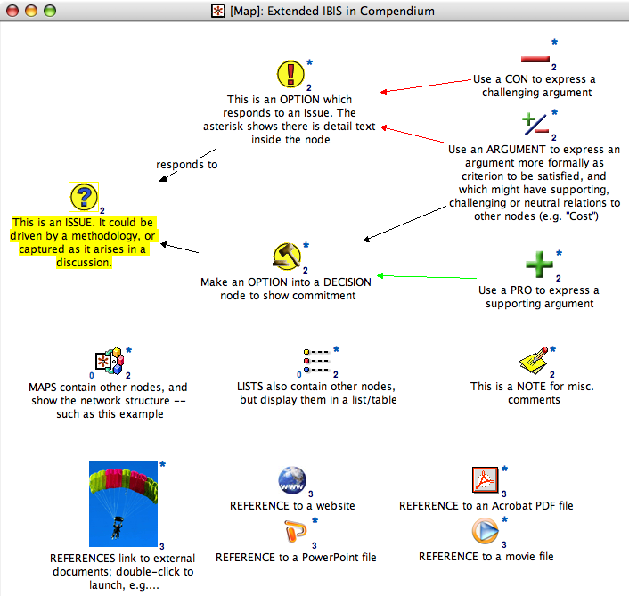
Figure 1: IBIS plus additional node types rendered in Compendium. Any application document or website can be dropped in to create a hyperlink. Nodes can contain text content, and links can be labeled if desired.

Co-OPR tools: I-X
I-X is a suite of tools³ whose function is to aid in processes which create or modify one or more “products” (such as a document, a plan, a physical entity or even some desired changes in the world state). The main user interface is the I-X Process Panel which, in its simplest form, acts like an intelligent “to do” list (Figure 2). The panel shows users their current issues and activities, for which Standard Operating Procedures can be selected or combined to manage complex and long-running processes. Constraints can be imposed, and rationale or other information kept as annotations. An intelligent planning system, I-Plan, is included to generate novel options.
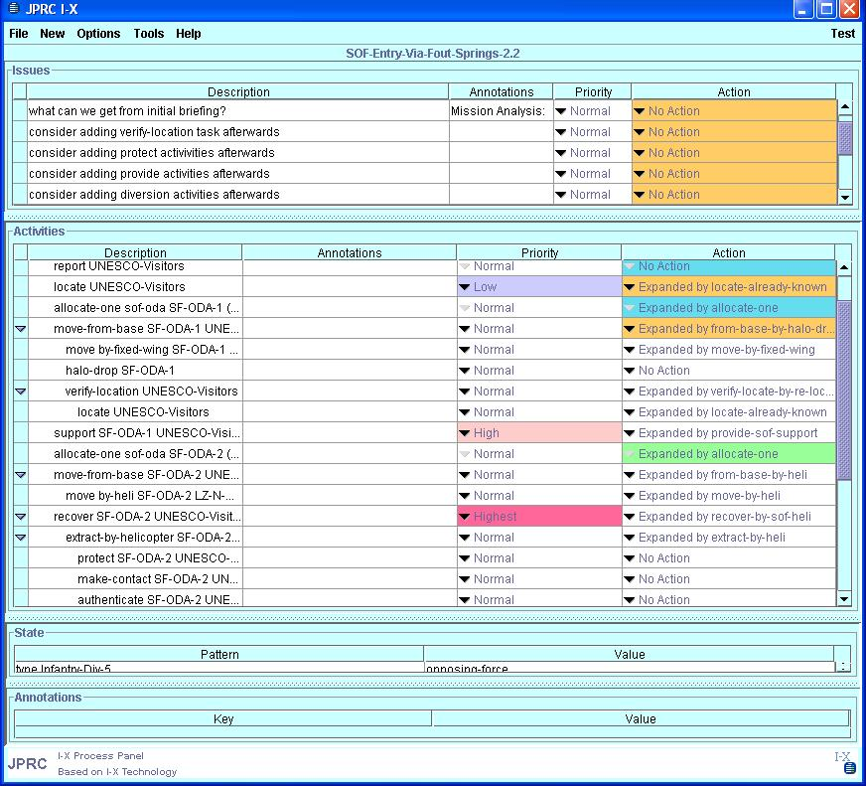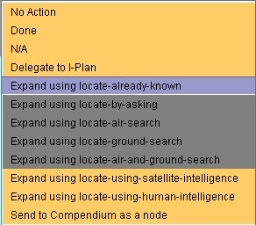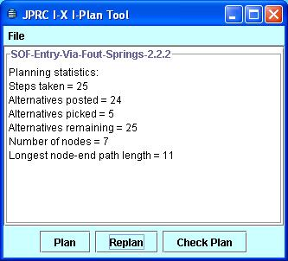
Figure 2: I-X Process Panel with its Action Selection Menu and the I-Plan Planning Tool

I-X also has a collaborative element to it, in that issues and activities can be passed between different process panels to support workflow across an organization using tools such as a structured messenger (). Web services can be called to gather information or automatically enact steps of the processes involved. Progress and completion reporting between panels and external services is possible. The underlying model on which I-X is based is the <I-N-C-A> (Issues – Nodes – Constraints – Annotations) Ontology (Tate, 2003).

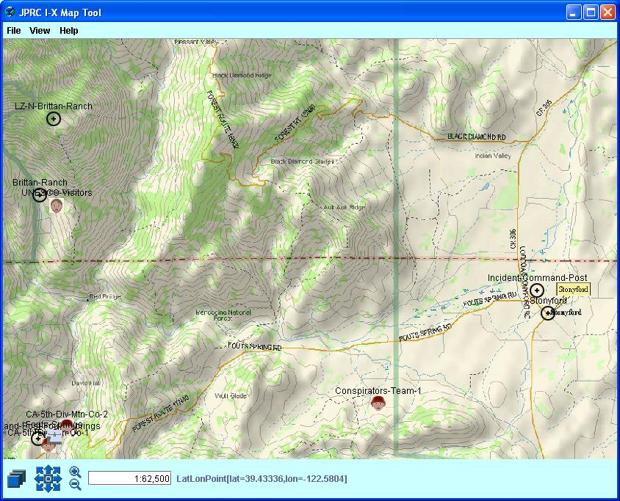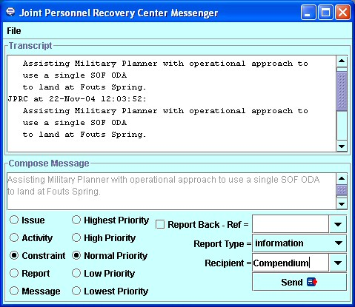
Figure 3: I-X Tools: Map Tool and Messenger

Co-OPR Tool Integration
The goal of integrating these tools was to support the planners’ fluid movement between modes where they drove the reasoning, and where they could pass/receive issues/options/constraints to the I-X planning tool. We discuss integration at two levels: user interaction with the tools, and their shared ontological foundation.

Shared foundations in issue-based ontologies
Compendium and I-X have their foundation in issue management systems, whereby issues are raised as questions, options generated to address these, arguments formulated for and against options, and criteria applied to support decision making. We have already introduced Compendium’s basis in the IBIS issue management notation. Work on decision making in planning and recording the decision rationale behind such plans has been at the heart of Edinburgh planners such as Nonlin, O-Plan and I-X/I-Plan since the mid-1970s.⁷ The “Questions-Options-Criteria” notation for design space analysis⁵ was used in O-Plan.
In Co-OPR, I-X acted as an intelligent planning agent used to support the generation or refinement of options by the military planners (in particular an overall military planner and a specialised special operations forces planner). Compendium was used to support the Planning Cell’s operations. The types of information that could be passed from I-X to Compendium follow the core concepts within the <I-N-C-A> ontology, i.e.,
- Issues and Responses
- Activity Options
- Constraints (e.g., world state information related to maps)
- Annotations/Notes

User interaction
Figure 4 shows how the different tools can be presented for a planning cell with a large format display, although in the experiment reported next, this display arrangement was not possible. Compendium’s visual concept maps were projected as the primary working representation for the whole planning cell and its Director of Plans, while I-X was used on a separate workstation working with a military planner and a Special Operations Forces (SOF) planner both supported by the I-X operator.
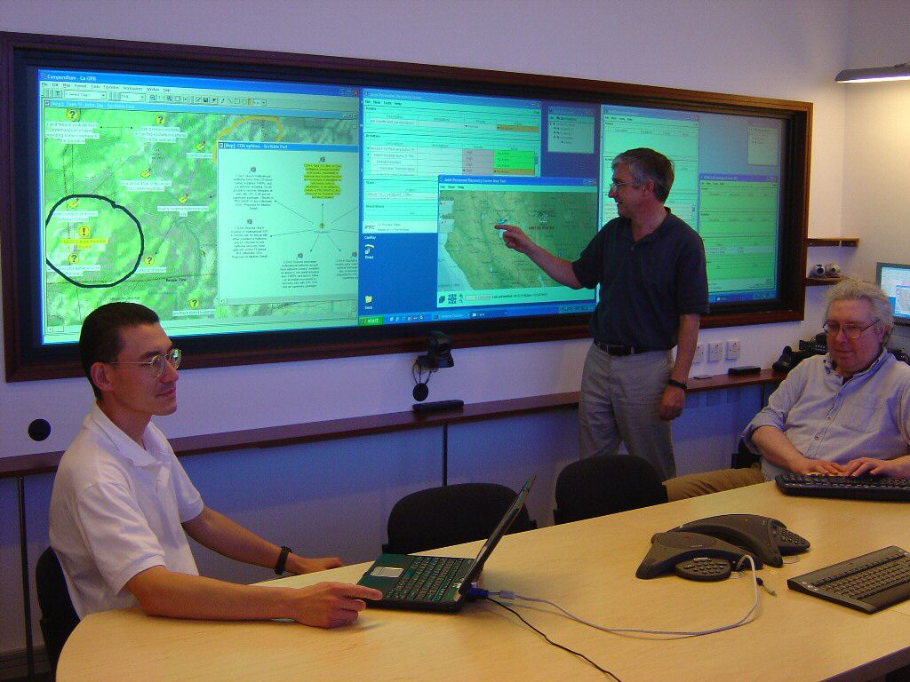
Figure 4: Members of the Co-OPR project team during a preparatory ‘Experiment A’
Issues that could be interpreted by the I-X planning aid were passed by the Compendium operator to the I-X operator, who would translate them into a more formal syntax, query the planner, and pass back candidate Option nodes (or even fragments of plans) for the Compendium operator to link into the evolving dialogue map for the planning team to assess. The I-X operator could also proactively pass issues and options for activities to Compendium if personnel recovery doctrine specified that these were important to consider. I-X could also keep Compendium updates with information about constraints (including especially current world state information).

Personnel recovery simulation experiment
The context of the Co-OPR project is the US DARPA-funded “Integrated Battle Command” Program. The “integrated” refers to the investigation of ‘DIME’ analysis: ways to expand Military decision-making to take into account the wider (but ‘messier’ and harder to model) Diplomatic, Informational and Economic dimensions to actions. It was in this context that the Co-OPR toolset appeared to hold potential, given the range of factors which it could model, reason about and render as decision support. Compendium can bring together diverse sources of information and constraints within a common visual space. After initial internal trials on preset scenarios (‘Experiment A’), Co-OPR was used in ‘Experiment B’ on 15-19 November 2004 at the US Joint Forces Command (USJFCOM), Sussex, Virginia.
The experiment involved an “aided” planning cell of human planners and analysts, supported by a number of planning and decision aids which were being evaluated for their effectiveness. Another “unaided” planning cell worked concurrently without the aid of the systems under evaluation. Co-OPR was used as a collaborative planning aid for the “aided” planning cell, dealing with a personnel recovery (PR) event in a fictional training scenario which specified in some detail the history of the countries between which tensions were rising, the logistical support available, and the political, economic and information infrastructure which the planners and supporting analysts had to negotiate and exploit in dealing with the hostage situation.
A range of publicly available sources was used to model the Decision Making, Doctrine and Standard Operating Procedures relevant to Personnel Recovery. These were modelled in both Compendium (as templates of issues to consider, extracted from the documents) and in I-X as Standard Operating Procedures. The Crisis Action Planning methodology that the planners were going to use was disseminated originally in advance of the experiment, and modelled in Compendium as a series of issue templates through which the team could step through systematically. However, when the methodology was changed an hour before the experiment started, it was straightforward to generate a new set of issue templates ready for the team when they arrived.

Co-OPR Evaluation
Under the conditions of this personnel recovery simulation, how did the Co-OPR tools perform? We evaluate this in three ways:
- firstly, the performance of the Co-OPR tools in the Experiment B simulation;
- secondly, we report the data gathered by external evaluators who interviewed the Experiment B planners and analysts who experienced Co-OPR tools;
- thirdly, we draw together conclusions from our experiment logs and direct experience as the operators of the tools, although we recognise that these reflections are not as objective as (ii).

Tool performance
In Experiment B, I-X provided the following capabilities:
- Ability to deal with current situation knowledge and constraints, including visualisation on maps
- Support for initial selection of a Course of Action (COA) and refinement of initial COAs
- Ability to refine multiple COAs concurrently
- Support for issue handling and problem fixes at plan time in COAs
- Support for plan repair and add-in activities to address issues or extra support requirements
Figure 5 illustrates the I-X Domain Editor used to manage the library of Standard Operating Procedures used within I-X and I-Plan.
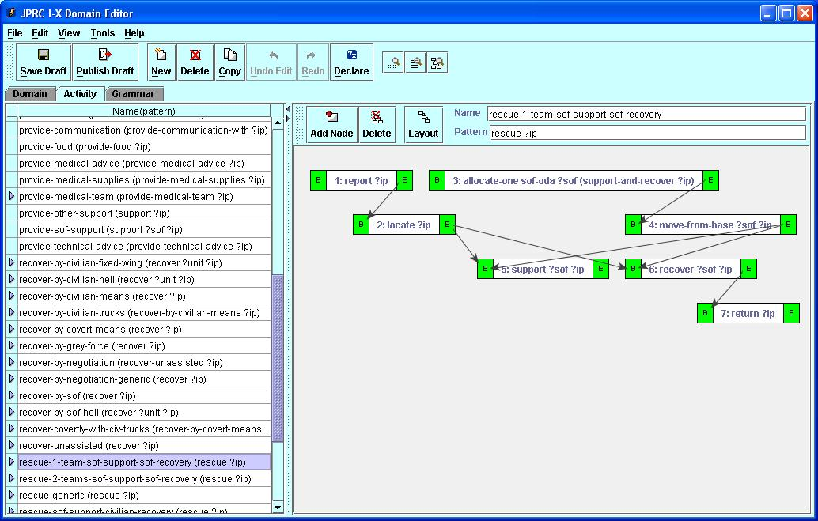
Figure 5: I-X Domain Editor to manage the library of Standard Operating Procedures
In Experiment B, Compendium provided the following capabilities:
- A tool for the rapid construction of task-specific knowledge management environments, with specific emphasis on supporting collective sensemaking: the bounding of ill-defined problems, discovery and management of complex connections between ideas and data, and integration of potentially diverse perspectives.
- The Personnel Recovery application provides representational support in the form of interlinked Crisis Action Planning issue templates, including COA wargame analysis worksheets which led to a summary COA comparison worksheet.
- This was seeded in advance with relevant issues for consideration based on PR doctrine, and then used to capture in real time the ensuing discussions and decision rationale as ‘dialogue maps’.
- Diverse inputs from plan analysts were captured and interlinked within Compendium, creating a real time, but also a longer term, memory resource.
Information integration for decision making: Compendium’s role is to enable planners and political analysts to link to relevant information from any source, which should be taken into account in making a decision. One form this took was representing PR ‘doctrine’. We were able to model aspects of personnel recovery doctrine, that is, the recommended or mandatory practices to follow in a given situation, as issue templates. Key issues, options and criteria to consider were extracted from source documentation, and linked into the planning templates. By representing them as granular ‘knowledge elements’ within Compendium, they became accessible from any map, and could be linked into any discussion (Figure 6).
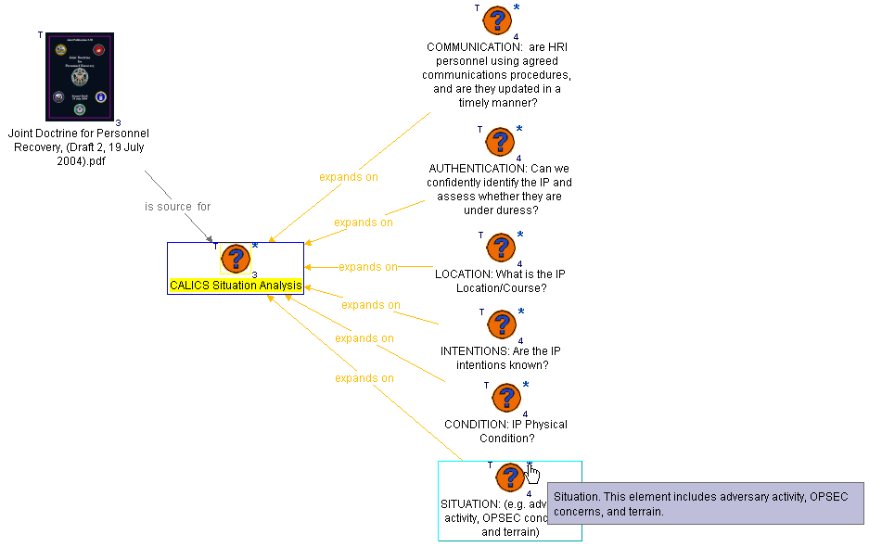
Figure 6: Mapping personnel recovery doctrine as an issue template which can be linked into COA/DIME analysis discussions as required.
Similarly, one would expect an integrated decision-support environment to include connections into all relevant intelligence databases. Although there was not scope to implement interoperability, one can ‘drag and drop’ data from Microsoft Excel spreadsheets into Compendium, which are then rendered as issue templates. Figure 7 illustrates how this was done to show data on the military forces in the region.
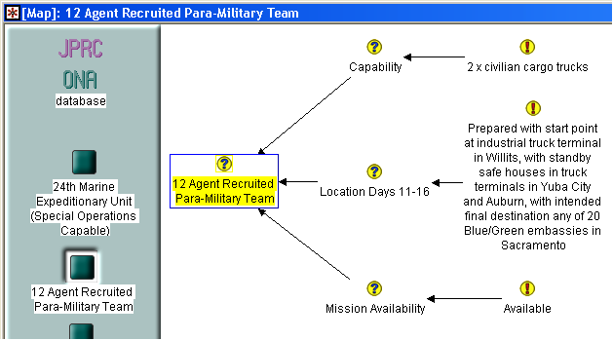
Figure 7: Mapping the contents of an external database as nodes which can be linked into COA/DIME analysis discussions as required.
Again, once information is imported into the hypermedia tool, it can then be linked into one or more discussions as required, further enriched with notes, and tagged with metadata (e.g. we created an Unreliable Intelligence tag to track all information about which there was doubt, and harvested all these nodes into a single view for ease of inspection).
Real time Dialogue Mapping+Conversational Modelling: Our own experiences as the tool operators supporting the planners and analysts in this experiment suggest that in the hands of a trained user, Compendium performed well as the team’s primary working representation under intense, sustained time pressure. The Dialogue Mapper was able to support the planning team without disrupting their work, maintaining maps which were displayed at the front of the planning room, and shared digitally with remote members of the team who could hear the discussions orally, and see the contributions as they were added in Compendium.
The following extract illustrates how the collective intelligence of the co-present planning cell, plus online political analysts, was pooled to create a structured, but not over-rigid, mission memory. Figure 8 shows an example of a custom Compendium template to support a Course of Action worksheet, in this case, exploring options for a non-military coalition COA to recover the hostages. This grid layout was derived from interviewing a domain expert on the representations normally used by planning teams (on paper or in generic office tools). The dock at the top displays links to the JPRC (Joint Personnel Recovery Center) mission briefing, relevant maps, three kinds of doctrinal issue template (as introduced in Figure 6) and the constraints/restraints earlier established (these nodes are also linked back to the discussions about these). The main grid shows the start of an analysis with the three highlighted nodes representing three possible options recommended by the political analysts (accessible online to the planning cell). The first of these considers applying political pressure on a member of the fictional hostage-holding government, named ‘Cebesoy’. Detailed analysis of this option was mapped in the Dialogue Map in Figure 9.
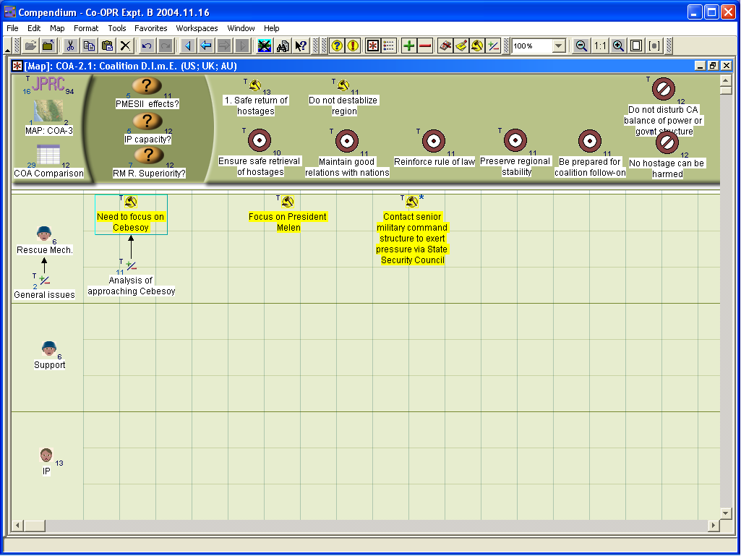
Figure 8: A worksheet to analyse a possible Course of Action (COA). The first option was: Need to focus on Cebesoy, a cabinet member of the fictional government holding the hostages. The details of this idea were then explored (Figure 9).
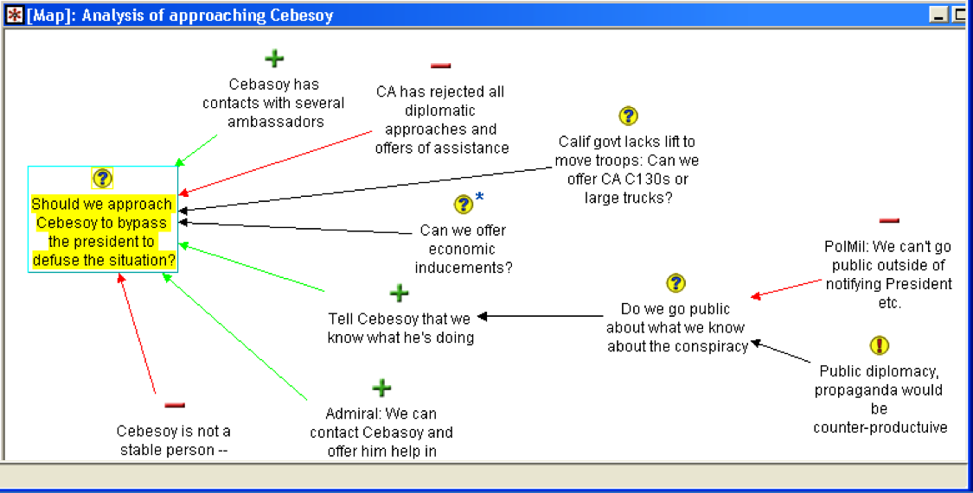
Figure 9: Issues, sub-issues and pro/con argumentation about how to apply political pressure to “Cebesoy” (expanding on the option in Figure 8).
A worksheet for each COA was developed, and then they were all compared against the key mission objectives (Figure 10).
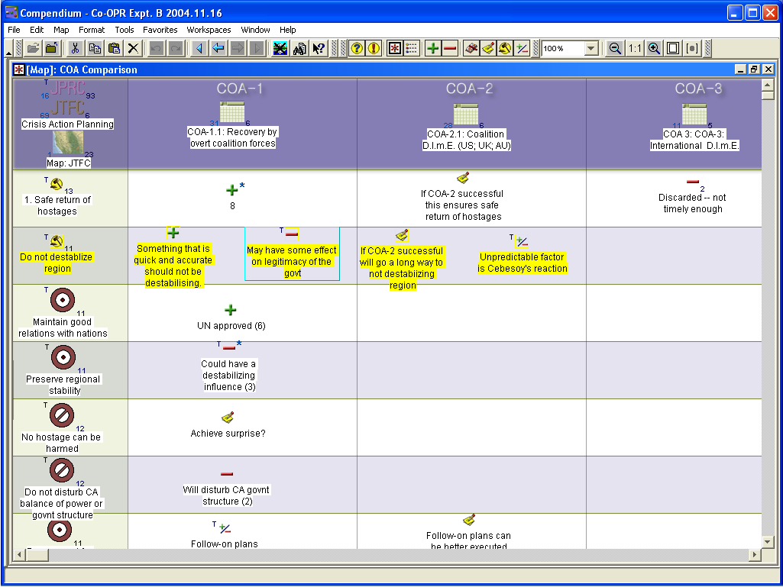
Figure 10: A COA comparison matrix, assessing all the COAs against the key mission objectives. All nodes are linked back to the individual COA worksheets.
Communication between Compendium and I-X: All the information that passed between Compendium and I-X during Experiment B was noted, and is summarised in Figure 11. The issues, shown as question nodes, were passed by I-X to Compendium as relevant factors to consider at specific points in the mission (as defined by mission doctrine), and the options shown responding to the issues are candidate Courses of Action offered by I-X (again, as defined by doctrine). The files linked at the bottom of the map are executable plans generated by I-X. All of these can be classified according to their contribution in terms of the <I-N-C-A> ontology constructs described earlier.
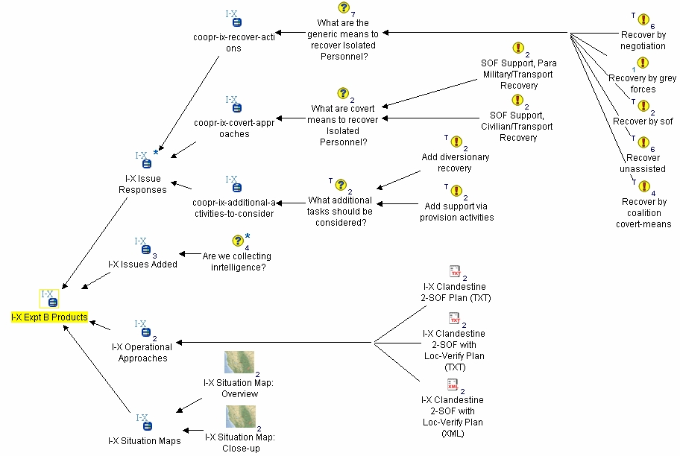
Figure 11: Information passed from I-X to Compendium during “Experiment B”

End-user evaluation
Co-OPR was evaluated during Experiment B by two separate evaluation contractors, and by using feedback questionnaires given to members of the aided planning cell. Feedback, as summarised in Table 1, indicated that the planning and analyst staff rated the tools as adding value in most respects.

Table 1: Evaluation ratings from six members of the planning cell who were supported by Co-OPR tools in the personnel recovery simulation. (Numbers indicate the number of planners assigning the rating.)
6
This tool would help JTF CMDs & Staff and should be further developed
8
6
The tool helped me choose a COA
7
1
2
2
1
The tool made me aware of consequences I hadn’t thought of
6
1
1
3
1
The tool enabled me to explore the consequences of different options
5
1
3
2
The tool helped me to identify potential COAs
4
5
1
The tool helped me understand the situation
3
5
1
The tool helped me find the information I needed
2
2
1
3
The tool was easy to use
1
No Opinion
Strongly Disagree
Disagree
Agree
Strongly Agree

Other feedback gathered on Co-OPR is summarised in Table 2.
Table 2: Answers to the post-Experiment B questionnaire issued by the evaluation team.
Which Features did you like best?
I-X planning feature allows for drill down into specifics of the COA
[Compendium’s] graphic representation, organization, COA comparison information
List features you would add to the tool:
Expand the I-X tool to include response activities beyond Military operations, such as Diplomatic, Informational, and Economic.
Automatic input feeds [to Compendium].
List Features you would remove from the tool:
Limit the operational planning level of the [I-X] tool – too detailed.
Change some [Map View] icons [in I-X].
Comments:
Good [I-X] tool, ability to develop a COA, prompting for choices, and sequencing advice were outstanding.

All evaluations have their limitations, of course. Experiment B was six months in the planning and modelling of quite a rich scenario, but the tools were still operating on relatively small models and datasets. Co-OPR’s deployment as a real time support tool was operational for only one day, and as we note in the discussion of potential future directions below, there is the need for longitudinal studies of Co-OPR tools (though elsewhere we have summarised multi-month and multi-year case studies of Dialogue Mapping and Conversational Modelling⁹). As one would expect in use-contexts of this sort, skilled end-users are required to operate the software tools effectively, and we have studied in detail the nature of the learning curve for Dialogue Mapping.¹
To be most useful, I-X requires knowledge of the domain, usually prepared in advance from manuals, or previous “lessons learned”. As a knowledge-based tool it is intended to be deployed in situations where organisational knowledge is made available in a computer usable as well as human readable form - which in many domains is not yet the case. I-X is also an experimental tool and its user interfaces are not yet supportive enough for direct use without significant background experience. For this experiment an I-X operator familiar with the limitations of the planning system and its message syntax was necessary.

Future Directions
Future work aims to investigate the following issues:
Compendium:
- Deploy on a longer term to show how the whole sensemaking lifecycle can be supported for a recovery mission: pre/execution/post
- Add deeper intelligence (as already started with I-X) to:
  - Raise new Issues, Options or Criteria
  - Retrieve data on the fly updating discussion maps
  - Guide analysts through templates like a tool ‘wizard’
- Develop team process models (e.g., using I-X) to better understand how Compendium pays back in different contexts
- Training: it is most effective as a ‘power tool’ for skilled personnel (although many people use it as a personal knowledge management tool)
- As a by-product of discussion capture, generate relevant documentation or briefings
I-X:
- I-X was mostly used in an off-line planning role for a single planning function in Experiment B. Its design allows it to support distributed and collaborative planning and execution. This should be explored in future work.
- I-X is a knowledge-based system. Its usability and value is improved with the availability of information about Standard Operating Procedures and domain knowledge of rules of engagement, constraints, etc.
- I-X developments for realistic military usage needs to intercept work on improved ways to codify military knowledge, and make more explicit, manageable and re-usable the knowledge available via lessons learned, doctrine, and procedural knowledge of tactics, techniques and procedures.

<I-N-C-A> Shared Model:
- Further work is required to integrate Compendium and I-X so that they can more effectively exchange information using the shared conceptualization of plans based on <I-N-C-A>.
- During the Co-OPR project it was realised that it would be necessary, in exchanges of <I-N-C-A> artifacts between systems, to give a context explaining the reason for the exchange. E.g., to say that it was a query for which options were required, or a suggestion for additional issues within a specific option being explored.

Conclusions
A semiformal representation for issues, options and arguments, supported by a hypermedia tool for visualizing the relationships between these and other knowledge elements (such as data from other tools), was well suited for human sensemaking in this domain. The knowledge-intensive activity involved in DIME analysis of COAs required the capture, structuring, analysis and integration of many kinds of issue, ranging from formal/hard logistics (e.g. “How long will it take a helicopter to get from A to B?”), to the more open ended, informal issues that are inherent in such discussions (e.g. “Do we go public on what we know about the conspiracy?”). Options for answers to the former class of question could be proposed by more structured planning/simulation tools, such as I-X, but ultimately it was the human planners who made the final judgements, and there were often issues which only human expertise and wisdom could address.
The above pattern accords with our experience in supporting collective sensemaking in many other domains.⁹ Compendium provides a medium in which all factors under consideration can be laid out in a common space, relieving individual and collective memory load (especially under pressure), drawing attention to the articulation of good questions, and arguably, fostering a broader analysis of the situation which takes into account the range of possible consequences of a course of action.
I-X provided issue responses, outline operational approaches, refinements and fixes to operational approaches, and constraint information worked out collaboratively between the I-X Tool, the I-X Operator, the Military Planner and the Special Operations Forces Planner. It was used in early stages of the planning to use doctrinal knowledge to look at the range of options open to the planners. During the live simulation, it mostly interacted behind the scenes to supply results to or answer queries expressed through Compendium’s visual interface, such that the use of the I-X tool was largely transparent to the discussions taking place in the Planning cell.
To summarise, the following specific results were achieved during Experiment B:
- Compendium aided the Plans Director by integrating both informal and formal factors from COA and DIME analysis, in the process generating a structured group memory. Compendium was so effective that in the subsequent vignette of the scenario (in which Co-OPR was not due to participate) it was requested to replace PowerPoint as the information management tool.
- I-X proved useful in aiding the Military and SOF Planners to identify and refine operational approaches, and propose these to the group
- Compendium and I-X were both able to be adapted dynamically to the Planning Cell’s preferences for changes of planning methodology, and terminology
- Advanced knowledge and AI planning technologies within I-X/I-Plan were effectively hidden behind the scenes in order to preserve a simple visual interface for the planning team as presented by Compendium
- Although not illustrated in this paper, Compendium was able to take data graphics from other tools being trialled in the scenario, for annotation with IBIS nodes, e.g. to raise an issue over a visualization.
- The Co-OPR tools allowed effective use of “grey matter” and “silicon” during Experiment B.
Full details of the experiment and the results achieved are recorded on the Co-OPR project web site at http://www.aiai.ed.ac.uk/project/co-opr/

Acknowledgements
Work on Co-OPR and the experiments reported were sponsored by the Defence Advanced Research Projects Agency (DARPA)’s Advanced Technology Office in joint work with the United States Joint Forces Command (USJFCOM). The I-X project is sponsored by the Defense Advanced Research Projects Agency (DARPA) under agreement number F30602-03-2-0014. Compendium is implemented by Michelle Bachler of the Knowledge Media Institute.
The U.S. Government, the University of Edinburgh, and the Open University are authorized to reproduce and distribute reprints and on-line copies for their purposes notwithstanding any copyright annotation hereon. The views and conclusions contained herein are those of the authors and should not be interpreted as necessarily representing the official policies or endorsements, either expressed or implied, of other parties.

References
- Buckingham Shum, S., Selvin, A., Sierhuis, M., Conklin, J., Haley, C. and Nuseibeh, B. (2006). Hypermedia Support for Argumentation-Based Rationale: 15 Years on from gIBIS and QOC. In: Rationale Management in Software Engineering (Eds.) A.H. Dutoit, R. McCall, I. Mistrik, and B. Paech. Springer-Verlag: Berlin
- Rittel, H. W. J. (1972/1984). Second Generation Design Methods. Design Methods Group 5th Anniversary Report: DMG Occasional Paper, 1, 5-10. Reprinted in Developments in Design Methodology, (Ed.) N. Cross (1984) (pp. 317-327). Wiley & Sons: Chichester
- Tate, A., Dalton, J., and J. Stader, J. (2002) I-P² - Intelligent Process Panels to Support Coalition Operations. In Proceedings of the Second International Conference on Knowledge Systems for Coalition Operations (KSCO-2002). Toulouse, France, April 2002.
- Tate, A. (2003) <I-N-C-A>: an Ontology for Mixed-Initiative Synthesis Tasks. In Proceedings of the Workshop on Mixed-Initiative Intelligent Systems (MIIS) at the International Joint Conference on Artificial Intelligence (IJCAI-03). Acapulco, Mexico, August 2003.
- MacLean A, Young R, Bellotti V, and Moran T (1991) Questions, options and criteria: Elements of design space analysis. Human-Computer Interaction, 6, (3&4), pp 201-250
- Conklin, J. (2005) Dialogue Mapping: Building Shared Understanding of Wicked Problems. Wiley & Sons: Chichester
- Selvin A (1999) Supporting Collaborative Analysis and Design with Hypertext Functionality. Journal of Digital Information, 1 (4): http://jodi.ecs.soton.ac.uk/Articles/v01/i04/Selvin/
- Polyak, S. and Tate, A. (1998) Rationale in Planning: Causality, Dependencies and Decisions, The Knowledge Engineering Review, 13, (3), pp. 247-262.
- Compendium case studies: available online in the Compendium Institute library: www.CompendiumInstitute.org

